**RF Systems Design and PCB Implementation of an FMCW/Doppler Radar**

By Naveed Edalati

**Introduction**

The primary objective of this paper is to outline, in detail, the process of completing the system level design and PCB layout for the RF end of an FMCW/Doppler radar. The RF portion of the FMCW radar will be analyzed element by element, and the determination of the critical performance parameters of the system will be discussed. Once the system level design is thoroughly explained, the important aspects of the RF PCB layout will be explored. It’s important to note that this paper only focuses on the system design and PCB implementation of the RF end of an FMCW/ Doppler radar. It excludes the detailed antenna design, the baseband filter and amplifier design, and signal processing that are required to build such a system.

**RF System Design**

This section will begin by presenting the process taken to obtain the overall system specifications and block diagram for an FMCW radar. It will then explore how each element in the system was chosen based on the critical parameters of the devices. The section will conclude by analyzing the overall performance parameters of the system.

Design Specifications

The system specifications for this FMCW radar were constrained by the ISM (Industry, Scientific and Medical) radio band. Therefore, it was chosen that the radar would operate within the 2.4GHz band and ramp between 2.3-2.6GHz. The 5.8 GHz and 24 GHz bands weren’t chosen due to the smaller variety of available parts as well as the increased losses prevalent at these frequencies. The total transmit power was dependent on the preferred average range of the radar. The system was designed to receive approximately

-70dbm at 20 meters. Using Frii’s equation, the required transmit power, when considering a .3 square meter target, was determined to be 15dbm.

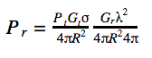

In summary, the system was chosen to operate at 2.4 GHz with an output power level of approximately 15dbm.

Block Diagram

The first element required in the RF system design is a VCO (Voltage Controlled Oscillator). The tuning voltage of the VCO allows for the output to vary within a specified frequency range, which is a fundamental requirement for an FMCW radar. Generally, a power splitter is required after the VCO in order to supply the Transmit and LO (Local Oscillator) paths with the signal being generated by the VCO. Amplifiers (PAs and/or LNAs) are needed to amplify the signals that are being transmitted and received. Lastly, to determine an objects location the instantaneous signal being transmitted must be compared with the received signal. This is achieved by taking the difference of the said signals using a Mixer.

With the fundamental building blocks known, the block diagram of the system can be established. A variety of software tools can be used to form the block diagram. In this case, Microsoft Excel was utilized to form the following three iterations of the block diagram.

**1st Iteration**

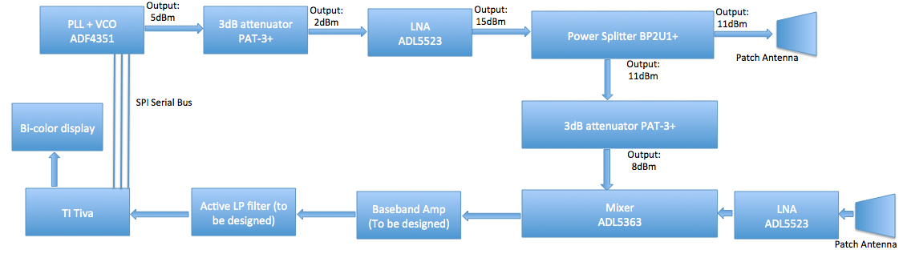

**2nd Iteration**

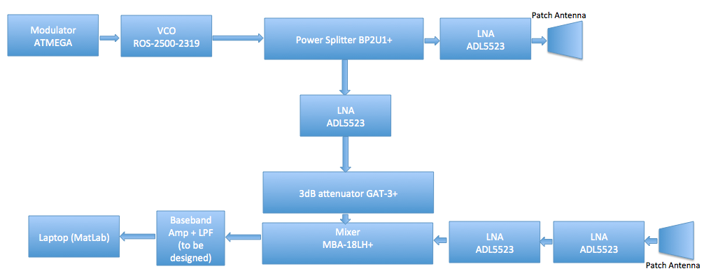

**3rd Iteration (Final Design)**

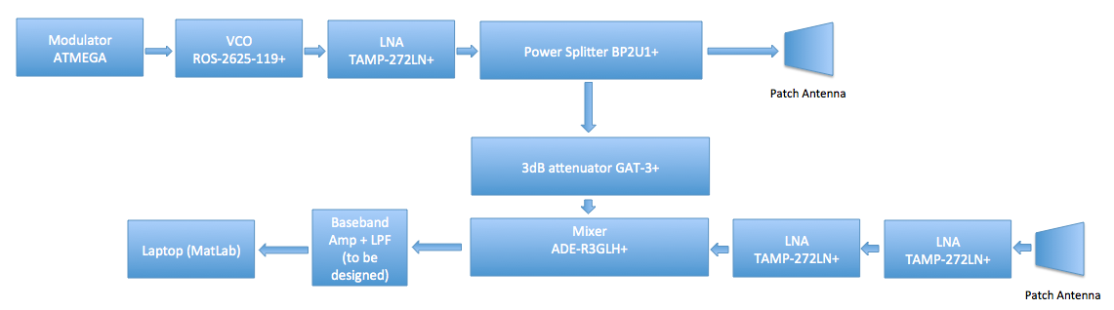

The 1st iteration included onboard signal processing. This specification was later eliminated due to the challenges it presented in regards to the programming required to drive the VCO and analyze the baseband signal. The focus was rather turned to establishing a strong RF system design in the 2nd Iteration. Nevertheless, after designing and manufacturing the 2nd iteration it was discovered that the ground pads for the LNAs hadn’t been properly connected in the PCB layout. Instead of remanufacturing the 2nd iteration, the design was improved upon and a modular LNA was utilized. The design that this report will focus on is the 3rd and final iteration.

The 3rd iteration is meant to optimize the output power of the system while conserving ideal matching characteristics, low noise, and low power consumption. A VCO with low phase noise suffices for such an application. Nevertheless, if a VCO with low phase noise isn’t available, then using a PLL (Phase Lock Loop) is recommended. Three LNA’s were chosen to insure a low noise figure. The reason why a PA (Power Amplifier) wasn’t used at the transmit end was due to an attempt to stay consistent with part selections. The TAMP-272LN+, which will be analyzed later, provides substantial gain and a low noise figure. Therefore, there was no need to purchase a Power Amplifier. Two LNA’s were cascaded in the receive path because the RF power is considerably low and substantial gain is required. The purpose of the 3dB attenuator is to minimize reflections in the system. Most mixers, especially those that are passive, have poor matching characteristics at the LO port. As a result, a 3dB attenuator should be placed prior to the mixer in order to reduce the reflected power at the LO port by a factor of two. This insures the safety and stability of the components in the transmit path.

RF Component Selection

The next step in the RF system design is to identify a VCO, Power Splitter, LNA, Mixer, and 3dB attenuator that yield the required design specifications.

The VCO is the first device that should be selected, as it’s the first RF element in the block diagram. The characteristic parameters of interest in selecting the VCO are the phase noise, the linearity of the output frequency vs. tuning voltage, and the relationship between the output power and tuning voltage. Phase noise distorts the IF spectrum, which in this system contains all of the information regarding the location of a perspective object. Therefore, it’s important to minimize such noise. Typically, VCO’s with low phase noise will provide -70dBc/Hz at an offset of 1kHz and -140dBc/Hz at an offset of 1MHz. The VCO chosen in this particular design was the ROS-2625-119+ manufactured by Mini Circuits. The following tables and graphs found in the datasheet were analyzed in order to confirm the low phase noise characteristics of the device as well as its linearity.

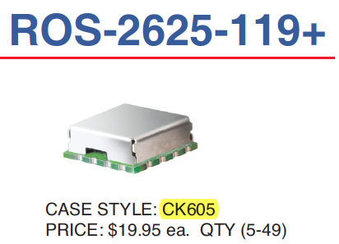

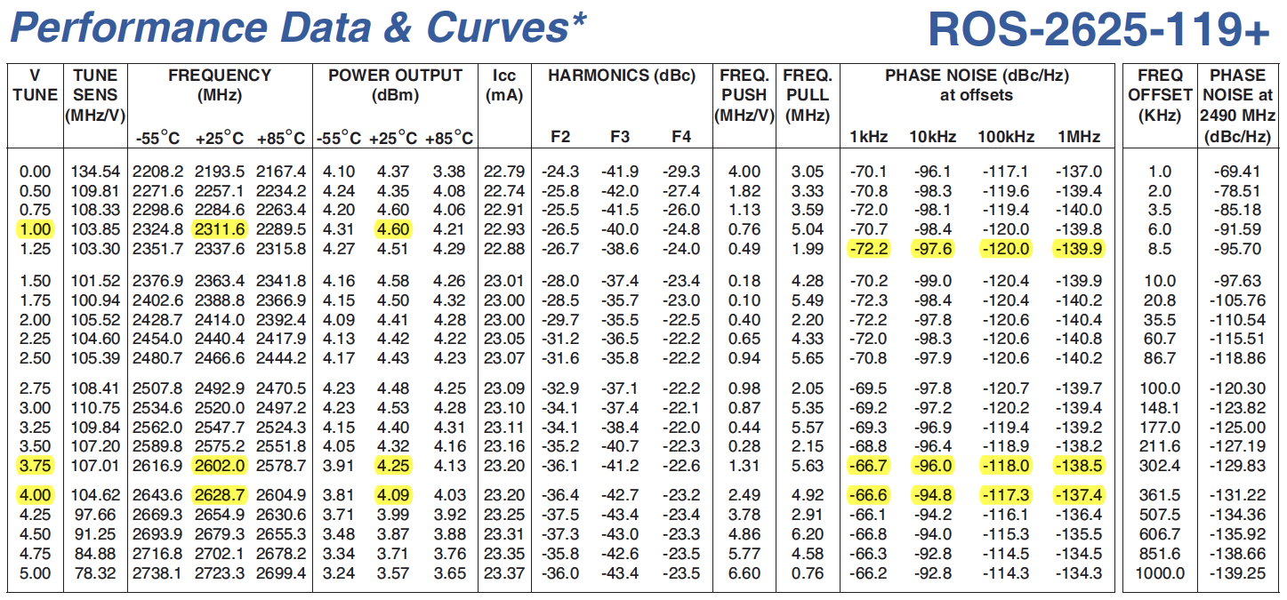

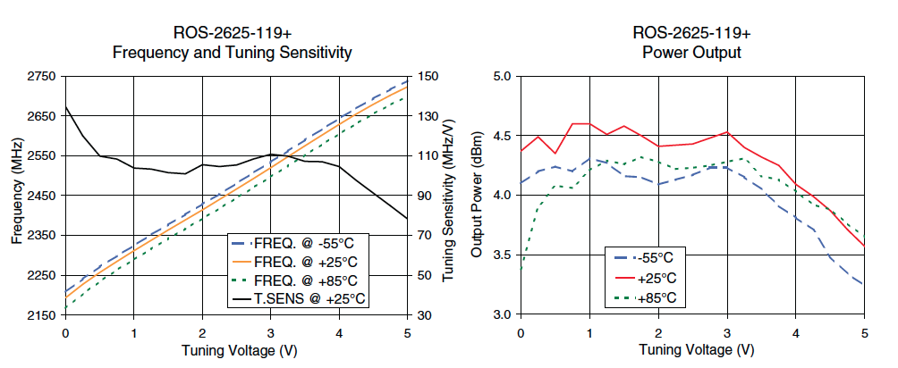

The operation frequency range is between 2.3-2.6 GHz, the output power is quite high, and the phase noise is quite low. This particular component is designed for PLL IC’s; thereby it inherently has low phase noise. The output frequency ramps linearly when increasing the tuning voltage. This is required for an FMCW radar because the frequency is meant to span a certain range using equivalent increments. Furthermore, the output power and tuning voltage have a relatively constant relationship. Therefore each frequency is given equal weight, and the range of the radar is kept consistent.

The selection of the Power Splitter is dependent on the insertion loss, isolation, phase unbalance, and VSWR of the device. The phase shift of the prospective device can be chosen to be zero degrees, the insertion loss should be 3dB (typical for a 2-way splitter), the ideal isolation should be large, and the VSWR should be lower than 2. The device that was determined to satisfy the aforementioned characteristics was the BP2U1+ manufactured by Mini Circuits. In order to make this selection, the following tables and graphs from the datasheet were closely examined.

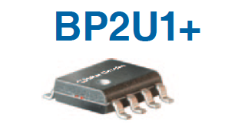

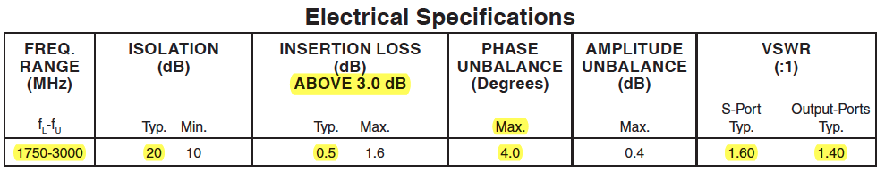

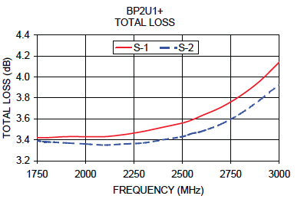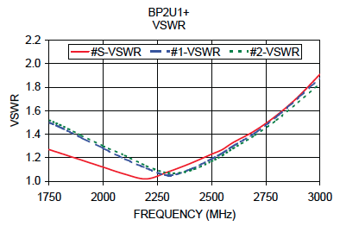

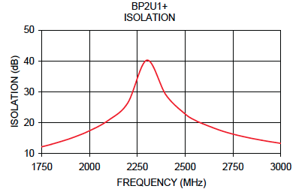

The frequency range of this Power Splitter is compatible with the 2.4GHz system that was being designed. The Isolation around the operational frequency of 2.4GHz is above 30dB, which is quite large. The total loss is only slightly above 3dB. The maximum VSWR within this systems region of operation is less than 1.4, which indicates that the device has good matching characteristics.

Determining a LNA is primarily dependent on the value of its gain, P1dB, noise figure at the systems operational frequency, and the complexity of external networks that may be required. The gain of the device should be chosen to be large, as long as the P1dB remains high and the noise figure remains low. The P1dB will indicate the point at which the small signal gain is 1dB lower than the expected value; essentially indicating the point at which the amplifier saturates. Therefore the P1dB restricts the gain. The noise figure indicates the reduction in the Signal to Noise Ratio (SNR) as a result of the noise introduced by the device. A low noise figure implies that the device generates minimal noise. The following equations define the Noise Figure in terms of the Noise Factor.

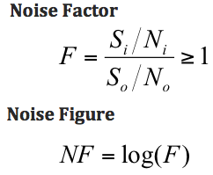

The low noise characteristic is crucial for the receive end of the system, because the signals being received are heavily attenuated and may be overshadowed if an excess amount of noise is present or generated by the radar itself. Lastly, the complexity of external networks must be considered when choosing an LNA. Biasing networks as well as matching networks may be an added complexity, which certainly increase the probability of mistakes made in the design and assembly process. This was a lesson that was learned the hard way, in this particular project, when designing and manufacturing the system in 2nd Iteration. A simple grounding error, which was made due to a poorly written data sheet, caused catastrophic failures. To avoid such a mistake in the final design, a modular LNA was utilized. In projects with limited time and resources, a modular LNA is highly recommended because the matching and biasing networks are built internally. The TAMP-272LN+ LNA manufactured by Mini Circuits was chosen to serve as the LNA for this system. The following graphs and datasheets were studied in order to arrive to this decision.

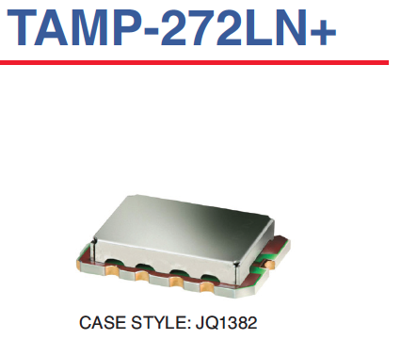

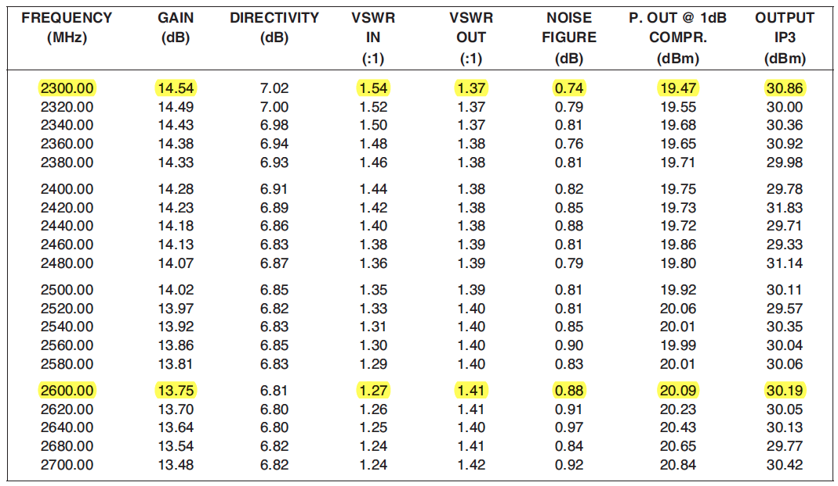

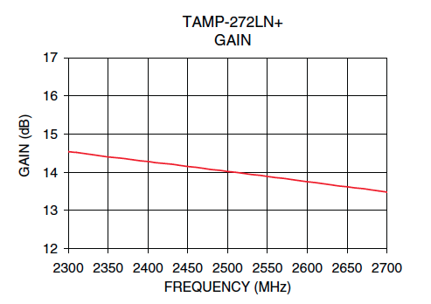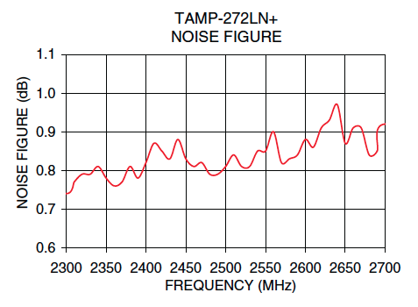

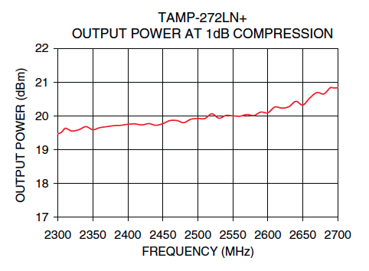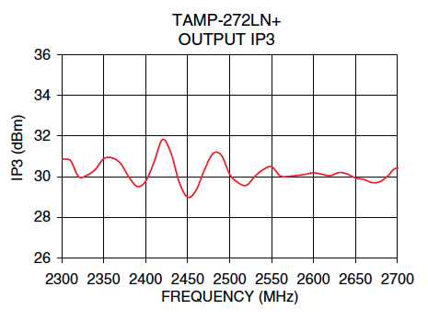

The gain of this LNA is essentially a constant 14 dB around the operational frequency range. The uniform gain allows for each frequency to be given equal weight. The P1dB is around 20dBm, which is well above the power provided by the combination of the LNA and VCO in the transmit end (where the highest power level will be generated). The noise figure of the device is a mere .9dB. Overall, the device provides sufficient gain without being limited by the P1dB point, and without introducing considerable noise. The high gain and low noise figure of the device allow it to be utilized for both the Transmit and Receive ends.

The selection of a 3dB attenuator is governed by the uniformity of the attenuation and the VSWR within the operational frequency range. The attenuation should be a constant 3dB between 2.3 – 2.6 GHz and the VSWR should be very close to unity. The VSWR is of crucial importance because the attenuator is being used to reduce the effects of mismatching due to the mixer. If the attenuator itself has poor matching characteristics the purpose of using it would be defeated. The GAT-3+ manufactured by Mini Circuits was chosen to be the 3dB attenuator that would be used for this system. The following tables and plots helped in choosing this product.

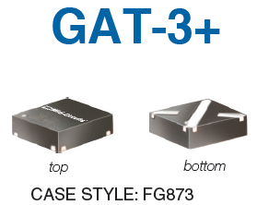

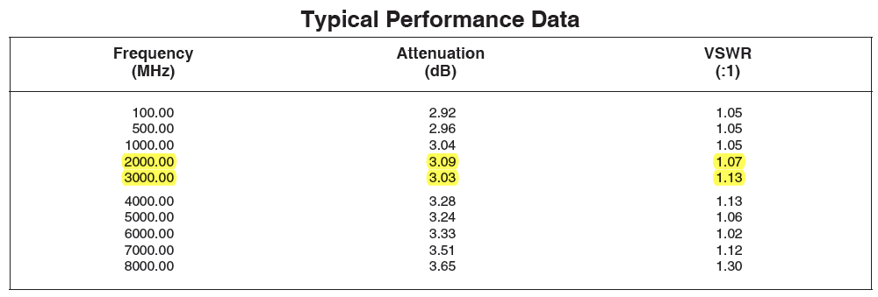

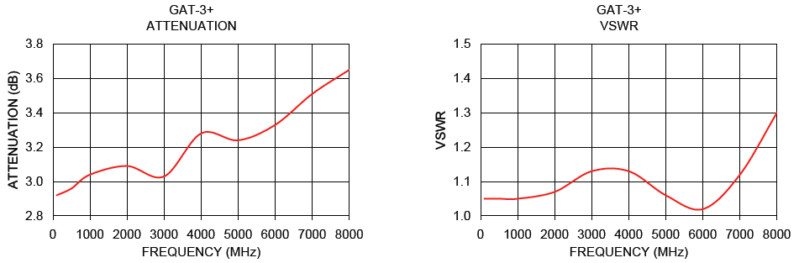

Between the operational frequency range of 2.3-2.6GHz the attenuation doesn’t vary by more than .05dB, while the VSWR varies by less than .06. Additionally, the VSWR is around 1.1 indicating that the device is almost perfectly matched for a 50-ohm system.

The process of choosing a mixer consists of considering the conversion loss, isolation, VSWR, and required LO power. The conversion loss of the mixer should be constant so that each frequency being accessed is equally attenuated. Both the LO-RF and LO-IF isolation values are important, because they insure that the signals at each port aren't interfering with one another. However, the most important isolation specification is that of the LO-RF ports. This is because the signal at the RF port is heavily attenuated due to the natural losses imposed onto the original signal that’s transmitted. As a result, the radio frequency signal at the LO port is substantially more powerful than the signal at the RF port. If the isolation between the LO and RF ports isn’t at least equivalent to the amount of power present at the LO port then the signal at the RF port can potentially be distorted. Additionally, the VSWR at both RF and LO ports shouldn’t be close to 2 for the matching characteristics of the system to be conserved. Studying the table and graph shown below, the ADE-R3GLH+ manufactured by Mini Circuits was chosen.

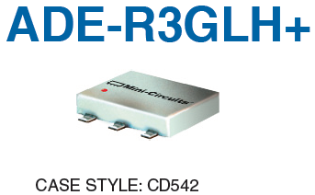



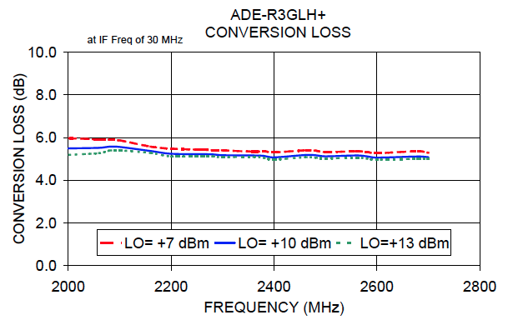

Since this is a passive mixer, 10dBm of power is required at the LO port. This requirement was noted in the overall system by choosing an LNA, Splitter, and Attenuator that would allow for the delivery of around 10dBm of power to the Local Oscillator. The conversion loss is a constant 5.8dB between 2.3-2.6GHz. The LO to RF isolation is around 36 dB, which is well above the amount of power that will be supplied to the LO port of the mixer. Therefore, the likelihood of interference between the LO and RF ports is limited. The VSWR of the LO port is very close to 2; specifically it’s 1.8 on average. This indicates that the matching characteristic of this port is fairly poor. It’s important to note that this is an issue that’s prevalent throughout most passive mixers. As previously mentioned, to reduce the excess reflections that can be caused by the poor matching characteristics of the LO port, a 3dB attenuator was placed prior to it. This mixer satisfied the key criteria required for this system. The conversion loss is constant, the LO-RF isolation is large, and the poor matching at the LO port can be remedied by using a 3dB attenuator.

Overall System Performance

The overall RF System performance was determined through a Link Budget analysis as well as calculating the overall DC current draw of the system. The Link Budget was completed using ADIsimRF, while the overall current draw involved summing the DC current required by each component.

ADIsimRF is an RF signal chain calculator provided by Analog Devices. The Cascade Gain, P1dB, Noise Figure, IP3, and total power consumption of a system can be obtained using ADIsimRF. It’s highly recommended to use such a calculator when completing the design for a Radar. The System was divided into two sections so that cascade analysis could be completed. The two sections included the transmit path and the RF path. The datasheets for each element in the respective paths were reviewed to obtain the individual characteristics of each component. The individual characteristics were then entered into the ADIsimRF calculator to obtain the overall system characteristics. An example of an ADIsimRF calculation for the transmit path can be examined below. This path includes the VCO, Power Splitter, and LNA that were to be used.

**ADIsimRF calculation for Transmit Path**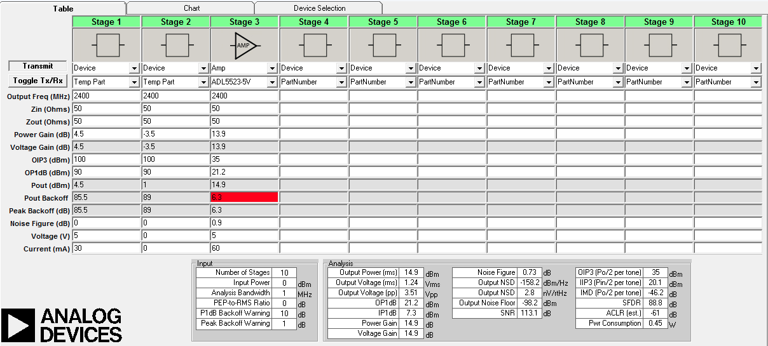

In addition to utilizing ADIsimRF, a link budget for the transmit path was completed by hand and is summarized by the calculations, table, and the final system diagram shown below. It’s important to note that the link budget is dependent on the response of the devices across the frequency range. In other words at the lower and upper frequencies the output power for each device is slightly different. To accommodate for this discrepancy and illustrate the power swing of the overall system, the link budget was completed to indicate the power levels for each stage at 2.3GHz as well as 2.6GHz.

**Link Budget calculations at 2.3GHz and 2.6GHz for Transmit Stage**

**Link Budget for LO path**

**Link Budget for RF (transmit) path**

S**ummary of Link Budget Analysis for LO and Transmit paths**

|  |  |  |
| --- | --- | --- |
| **Frequency** | **Local Oscillator**  **Power** | **RF transmit**  **Power** |
| 2.3 GHz |  |  |
| 2.6 GHz |  |  |

**Final System Diagram**

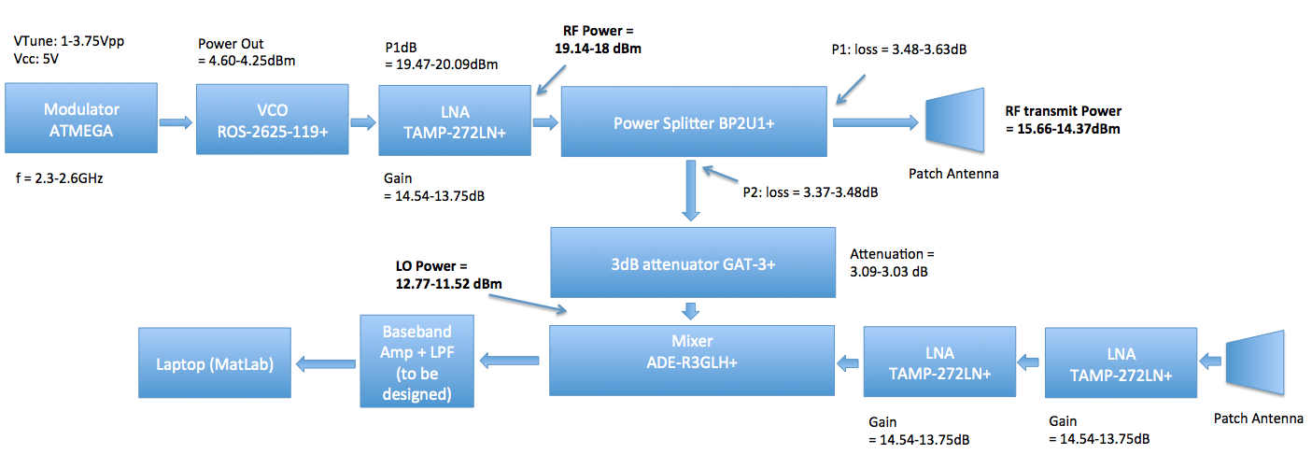

Similar calculations were completed for the Receive path. The calculation for the Receive path is dependent on the power that’s received by the system. While the power being received is dependent on the operating range. Therefore, Frii’s equation was utilized to obtained the received power when a target is set at 1,10, 25, and 50 meters away. The calculated power was then used as the input power for the ADIsimRF calculations. Thus, for the RF path four calculations were completed on ADIsimRF depending on the range of the object. Since a patch antenna was to be used in this system, the antenna gain was estimated to range between 6-8dBi. The following tables summarize the Link Budget analysis completed using ADIsimRF.

**Received Power vs. Range**

|  |  |
| --- | --- |
| **Range** | **Power Received** |
| 1m | -21.58dBm |
| 10m | -65.53dBm |
| 25m | -81.44dBm |
| 50m | -93.28dBm |

The table above indicates the power that would be obtained at the patch antenna on the receive end based on the transmit power of 14.9dBm, a metal target of .3 square meters, and an antenna gain of 6-8dBi. These values were all obtained using Frii’s transmission equation. The final results of the Link Budget were meant to estimate the voltage and power level at the mixer output. This data would later be used to determine the gain required for the baseband amplifiers.

**Finalized Link Budget (Receive Power)**

|  |  |  |  |
| --- | --- | --- | --- |
| **Range** | **Power Received** | **Mixer Output Power** | **Mixer Output**  **Voltage** |
| 1m | -21.58dBm | -3.53dBm | 420.74mVpp |
| 10m | -65.53dBm | -43.53dBm | 4.21mVpp |
| 25m | -81.44dBm | -59.44dBm | 673.78uVpp |
| 50m | -93.28dBm | -71.48dBm | 168.47uVpp |

The final portion of the overall system performance analyzes the amount of DC current required to drive the entire system. The only active elements in the RF section of this system were the LNA’s, the VCO, and the components in the modulator circuit. All of the values for the required DC currents were obtained from the respective datasheets, and are summarized in the table below.

**DC Current Specifications**

|  |  |
| --- | --- |
| **Component** | **Current Draw** |
| LNA (x3) | 60 mA |
| VCO | 35 mA |
| ATMEGA processor  (Modulator circuit) | 4 mA |
| DAC  (Modulator circuit) | 250 uA |

Therefore, the total DC current required for this system is 219.25mA. This value is of key importance when determining the trace width of the power rail on the PCB layout.

**RF PCB Layout**

When designing RF PCB layouts there are several factors that must be considered, which aren’t prevalent in typical baseband layouts. The two key factors are matching and grounding. Nevertheless, these issues will be touched upon within the following step-by -step analysis of the RF PCB Layout design in KiCad. KiCad is an open source software for electronic design automation (EDA) that is recommended for those who may not have in-depth knowledge of PCB design. The learning curve is much less than using cadence or Eagle.

The first step in this process is to build the schematic. The picture below depicts the entire schematic for the final design.

**PCB Schematic**

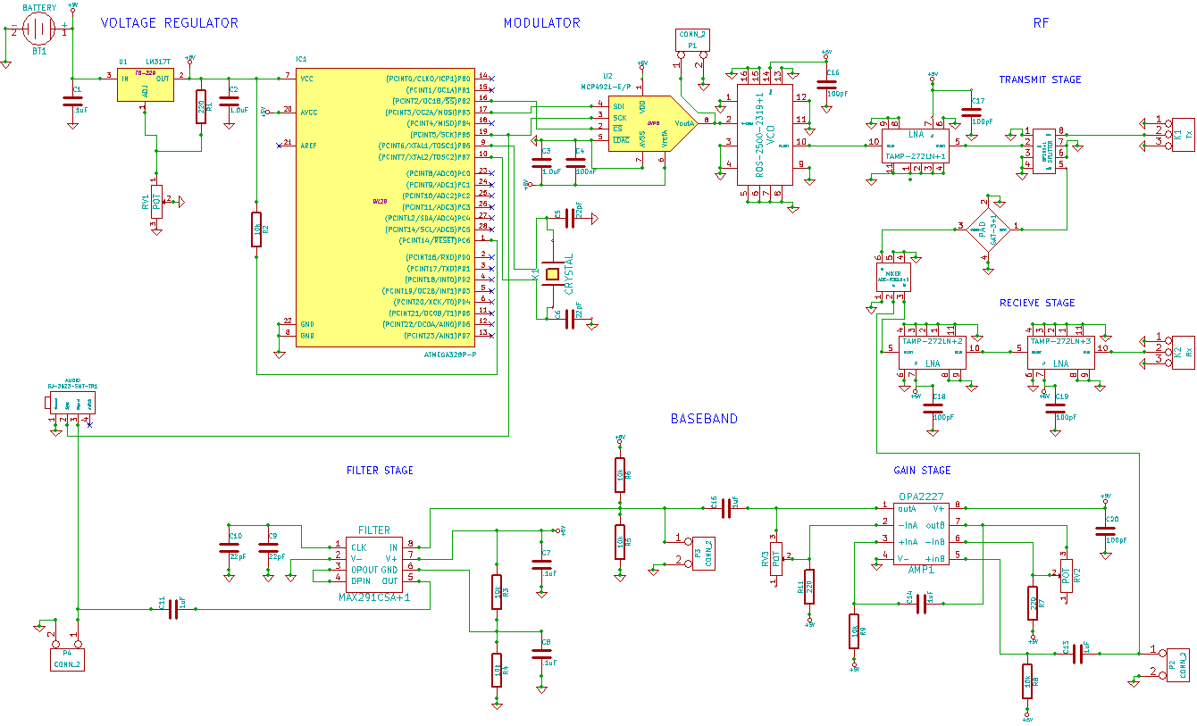

The RF portion consists of the Modulator (ATMEGA and DAC), VCO, Splitter, LNA, Attenuator, and Mixer. Other than the components themselves, the RF portion didn’t require any external networks. Nevertheless, bypass capacitors were placed at the biasing pin of the VCO and LNAs. These bypass capacitors would serve to conduct any AC signals on the DC rails to ground. The VCO and LNAs are critical areas for bypass capacitors because they require the most current. Although the bypass capacitors aren't required, due to the internal biasing networks in the modular devices, it’s a best practice to include them to minimize noise from the DC supply. After the schematic was assembled, the footprints for the RF components had to be put together. To accomplish this the footprint dimensions in the datasheets had to followed precisely. The following are all of the RF footprints that were created in KiCad.

**RF Component Footprints**

|  |  |  |
| --- | --- | --- |
| Macintosh HD:Users:naveededalati:Desktop:Application Note :RF PCB Design:VCO.PNG | Macintosh HD:Users:naveededalati:Desktop:Application Note :RF PCB Design:Splitter.PNG | Macintosh HD:Users:naveededalati:Desktop:Application Note :RF PCB Design:PAD.PNG |

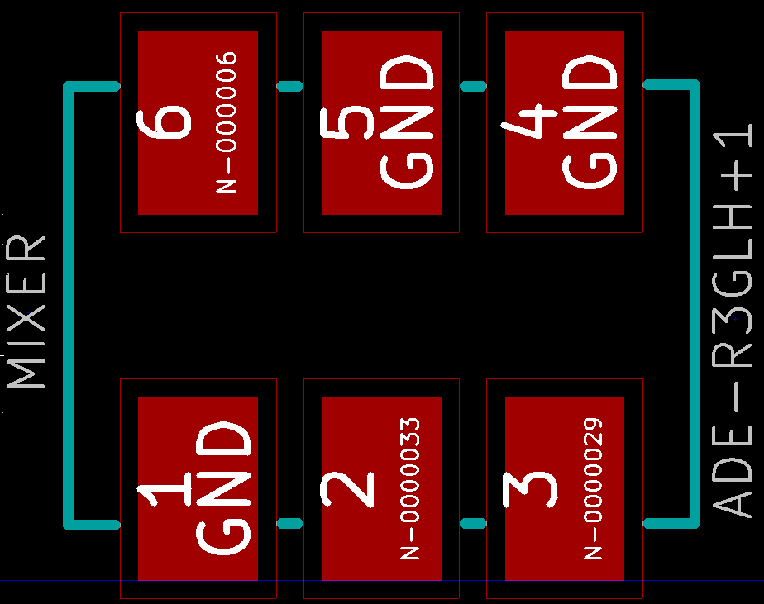 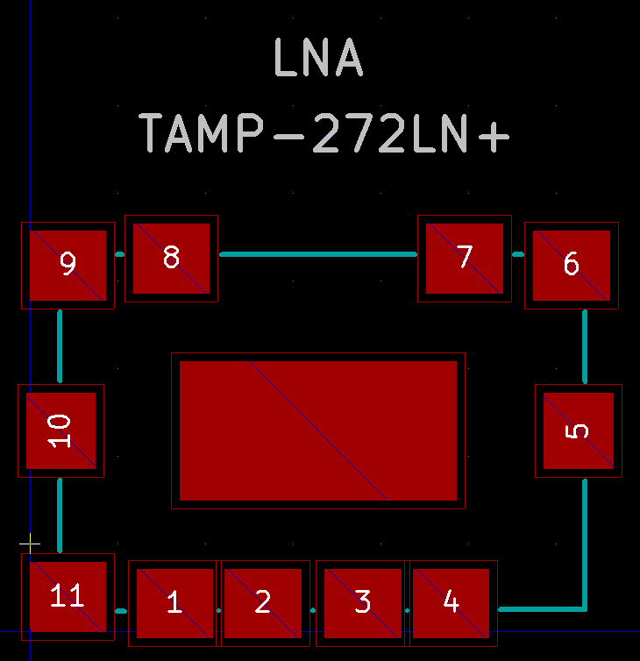

With all of the footprints for the individual components completed, the CvPCB tool in KiCad was utilized to assign each component in the schematic to a respective footprint. The final CvPCB window was as follows.

**Final CvPCB Window**

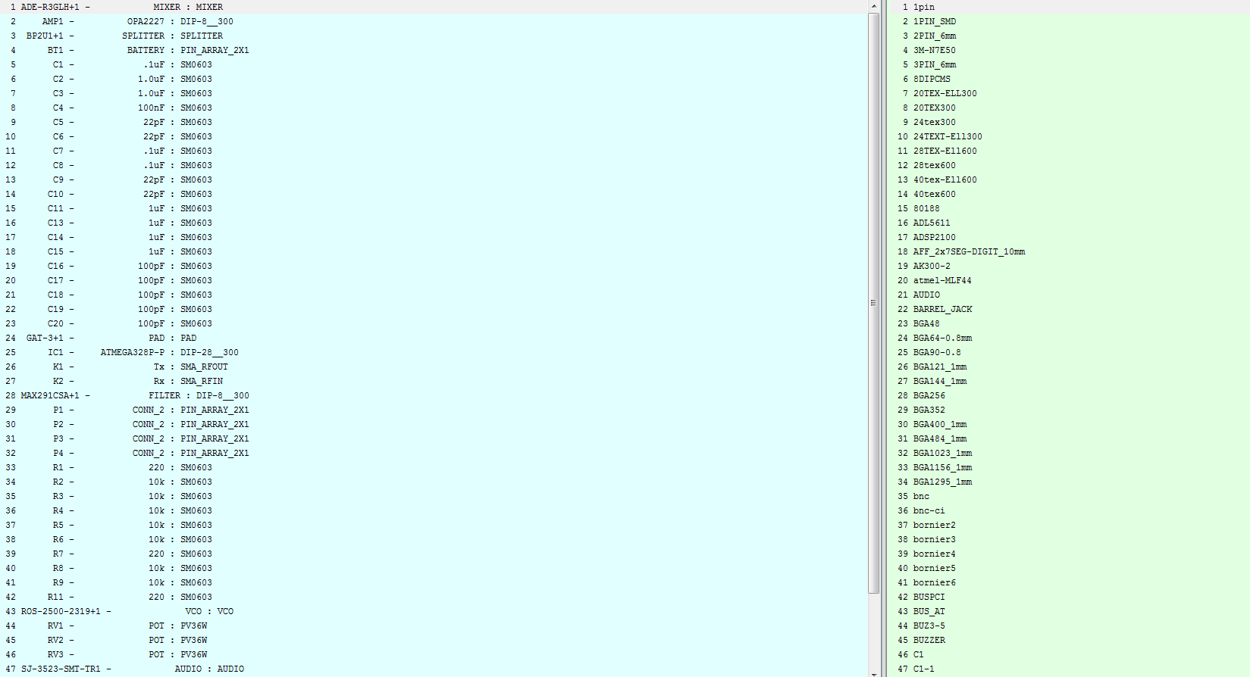

The final and most important step in the PCB process is setting up the layout. For the RF portion of the layout there are several factors that must be considered. The primary concerns are the matching characteristics of the system as well as the grounding. The matching characteristics aren't of crucial importance, mainly because the distances separating the components are short. The equation for the input impedance of a terminated lossless transmission line demonstrates the validity of this claim.

When the length of the transmission line ( is small the above expression simplifies to

Therefore, when the distances between components are small, matching isn’t critical. Nevertheless, to insure the proper operation of the system it’s always best to match components. A typical microstrip line at a frequency of 2.4GHz would be too wide for this particular design. This is demonstrated in the diagram on the next page, where the width of a Microstrip Line was calculated using the board and system specifications. The following calculations were obtained using the PCB calculator in KiCad.

**Microstrip line Calculations**

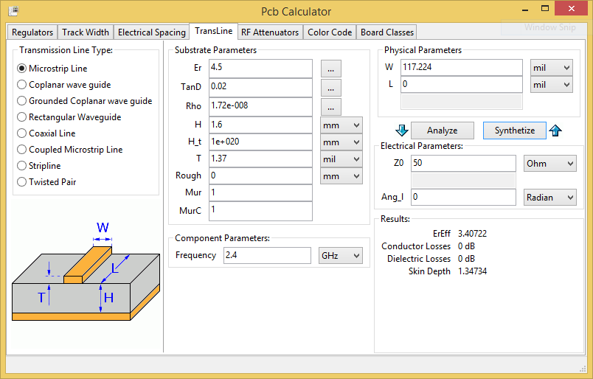

A grounded coplanar waveguide is a more practical alternative. The Diagram below outlines the physical dimensions required for the coplanar waveguide used in this design.

**Grounded Coplanar Waveguide Calculations**

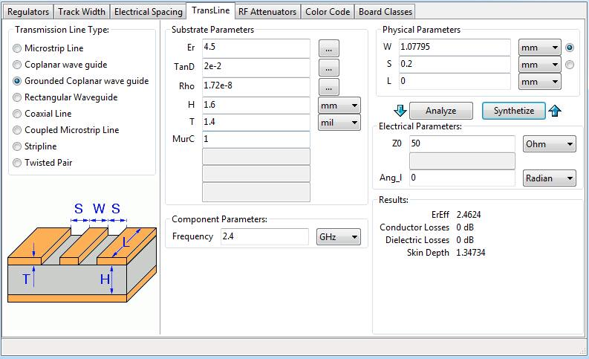

The above diagram confirms that the grounded coplanar waveguide requires a thinner trace than the microstrip line. Using thin traces on PCB boards is ideal, because it allows for a more compact design. The usage of the grounded coplanar waveguide required for ground plans on the top and bottom layers of the board as well as a specified separation between the conductor and the upper ground plane. The required separation can be obtained by setting the trace clearances in KiCad to be equivalent to the desired separation. Before continuing with the design of the overall PCB layout the dimensions of the coplanar waveguide obtained through KiCad were recalculated using the LineCalc tool in ADS. Using ADS to make or confirm RF related calculations is highly recommended, due to the accurate modeling that it provides.

**Confirmation of Coplanar Waveguide Calculations in ADS**

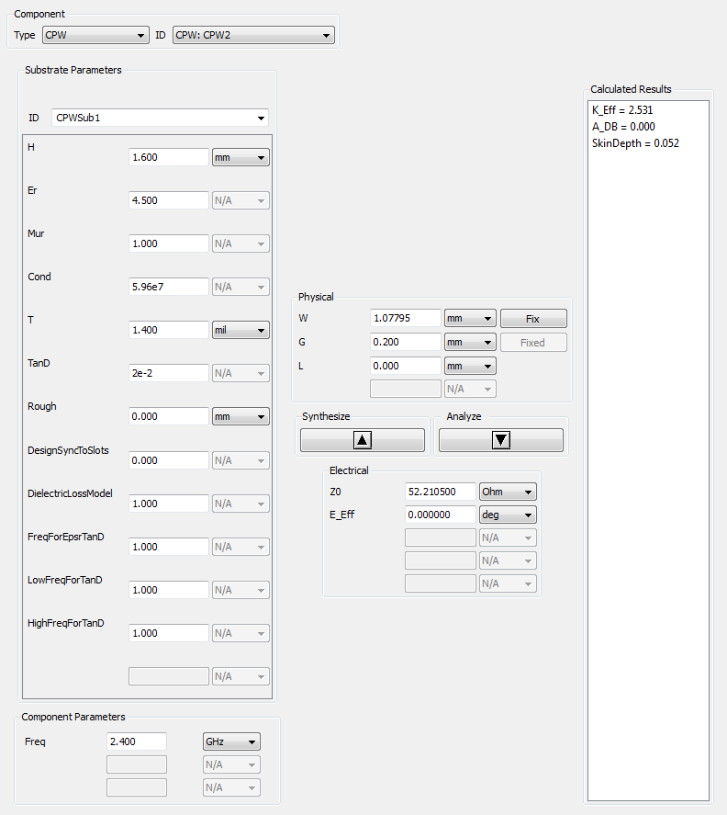

The usage of a coplanar waveguide leads to the second consideration that must be noted when designing RF PCB’s. Insuring continuous grounding between the top and bottom layers of the coplanar waveguide is of crucial importance. To enhance the grounding of the board, particularly the RF portion, vias are used to stitch the two layers together.

Thus, through insuring perfect matching and continuous grounding the PCB layout can be completed. The picture below outlines the PCB layout for the final PCB design.

**Final PCB Layout**

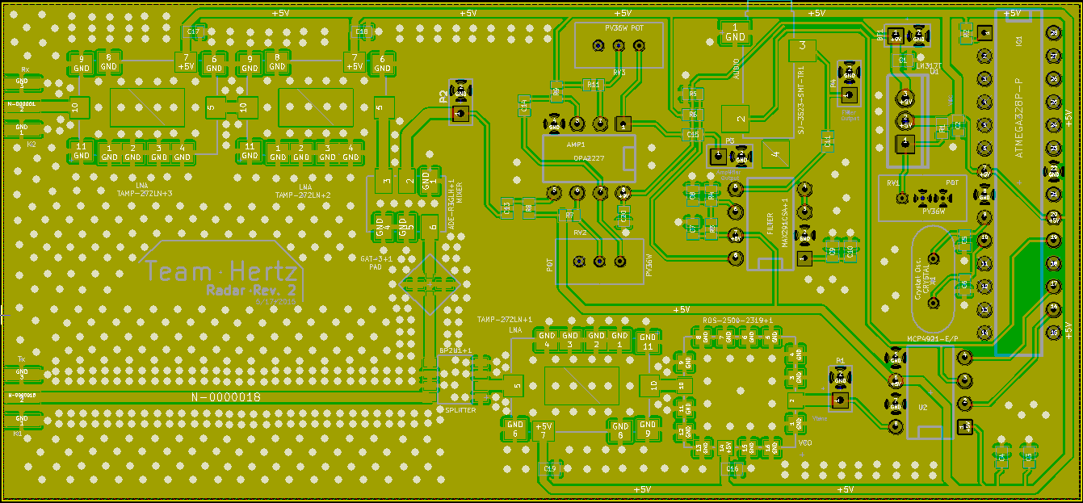

The RF portion of the layout begins at the bottom center of the board and continues onto the left side. As it can be seen, the thickest traces in the layout resemble the coplanar waveguide. Additionally, the distances between each RF component were kept as small as possible to reduce the effects of possible mismatches. Furthermore, the entire RF portion of the layout was filled with vias in order in insure that the ground planes were stitched together and continuous. A three dimensional view of the layout can be examined below.

**3D view of Final PCB Layout**

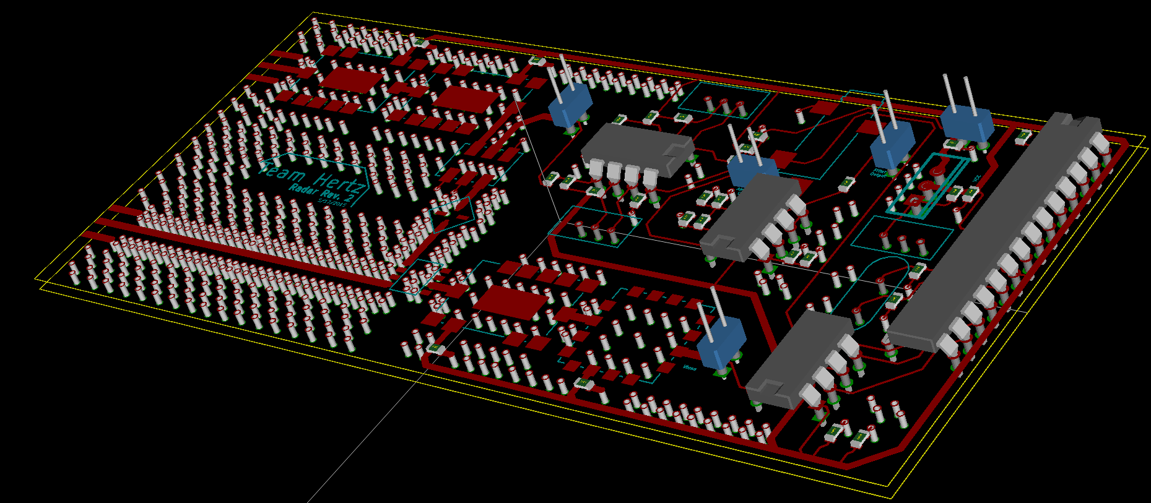

With the completion of the PCB layout, the Gerber files can then be generated and the PCB can be manufactured.

**Conclusion**

This paper presented a comprehension outline of what is required to successfully complete the RF Systems Design and PCB Implementation of an FMCW/Doppler Radar. First, the System design was outlined through examining the required components and specifications to build a functional radar. After outlining the nuances of the system design, the PCB layout process was discussed, and the important considerations when designing a RF PCB were presented. Radars are intricate systems that require a great deal of analysis to design. The RF portion of the Radar defines the capabilities of the overall system. The range and resolution of the radar are all dependent on the design of the RF System. This paper tackles the critical aspects of such a design, and reduces the complexity of realizing a functional FMCW/Doppler Radar.