Charles Paulekas  
997496468  
EEC 134  
Professor Liu

EEC 134 Application Note: Wideband Patch Antenna

For the purposes of the radar project the student desires a lightweight antenna with a relatively wide band. Due to the Doppler shift in the oscillation test the frequency span for our frequency was 10% bandwidth about 2.4 GHz. We decided on a patch antenna for its lightweight and relatively easy fabrication process. The process of designing a wideband patch antenna requires the use of HFSS and a paper by Ang and Chung titled “A WIDEBAND E-SHAPED MICROSTRIP PATCH ANTENNA FOR 5–6GHZ WIRELESS COMMUNICATIONS” in order to fully understand the underlying theory behind this patch antenna design.

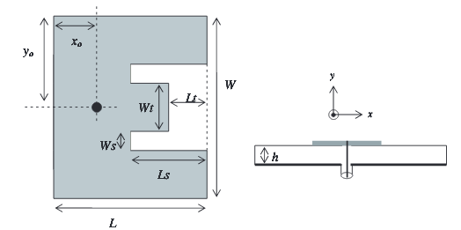

The basic idea behind this design is to create two paths for radiation: one in the middle section of the E shape and a second along the outer arms. The resonant frequency of these sections can be modified by changing the relative lengths of the above variables. Changing the variables Ws and Ls influences the resonant frequency of the outer arm sections by forcing the signal to travel along a farther path, which increases an inductive effect on the frequency response. Changing Wt and Lt influences the resonant frequency of the middle section by largely the same principle as the outer arms. In order to achieve a wideband response the resonant frequency of these two points must come within a certain frequency difference about the desired center frequency in order to create the desired wideband response.

First and foremost in patch antenna design is to choose a suitable substrate. We chose the Rogers RO4725JXR substrate specifically designed for antenna use which has a dielectric constant of 2.64 from 1.7 to 5 GHz, which was perfect for our purposes. We chose a variant of the substrate which had a thickness of 1.542 mm and a copper cladding of 35 μm for the best available response. Although we found that a higher dielectric constant and thicker substrate results in a larger patch antenna, we decided to go ahead and go with the thickest materials available for sampling since patch antennas are some of the lightest antennas currently available. Now that we had a substrate in hand we could move on to finding baseline dimensions of the patch. We used some basic antenna design equations for a patch antenna in order to find the length and width of the antenna structure. The relevant equations are:

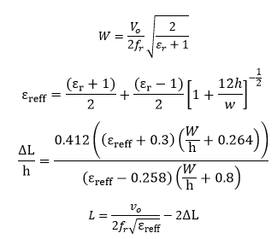

Where W is the width of the patch, vo is the speed of light, εr is the relative dielectric constant, h is the substrate thickness in meters, and L is the length of the patch. With our substrate and frequency the length and width come out to be 37.86 mm and 46.33 mm, which is a starting place for the patch. The next step is to scale the measurements of the introduced cuts from the values given in Ang and Chung to the size of the antenna calculated by using the above equations. I found that scaling Ls, Lt, and xo with respect to L and scaling Ws and Wt with respect to W was the most surefire way to achieve good baseline measurements. yo should be left as W/2 in order to provide symmetry for the two outer arms. Once all these values have been calculated the next step is to turn to HFSS to create a model for simulation:

The first step in the design of a microstrip patch antenna is to open the project variables and enter all the values you calculated in separate variables. Basing the dimensions of the patch on these variables will allow you to quickly change the size of the patch without having to click through all the individual pieces of the model. At this point it is also useful to determine if X and Y will be along the width or length of the patch, as this will influence whether the X or Y sizes in the model will be used for each of your dimensions.

The next step is to create the substrate and groundplane we will be building upon. Start by creating a box which will be the dielectric material. Set its length and width to be equal and a fair bit larger than the larger of L and W in the X and Y directions. Its height, the Z measurement, should be set to the dielectric thickness you chose earlier. To keep things simple set its position to -0.5 its length and width to center at 0 and its Z position to 0. Set its material to the material you chose for the substrate of your antenna.

Now the groundplane should be added. Create another box whose length and width are equal to that of the dielectric material. Set its position to -0.5 its length and width as with the dielectric to keep them aligned. It is easiest to set its position to 0 in the Z plane and set its Z height to the negative of the copper cladding thickness which avoids unnecessary position algebra for the groundplane. Set the groundplane’s material to copper and choose a color for it. With these two components in place we can move on to the patch itself.

Begin by creating a box and setting its X and Y values to the length and width of your patch, minding the X and Y assignments you decided on earlier. The box’s height should be set to the copper cladding thickness and its position in the X-Y plane should be -0.5 the width and length to keep it centered. Its Z height should be set to your dielectric thickness so that it rests on top of the dielectric as it would in reality. Set this box’s material to copper and set its color to whatever you think looks nice as it doesn’t matter to the simulation. You will now need to make the necessary cuts in this patch to achieve the final E shaped design.

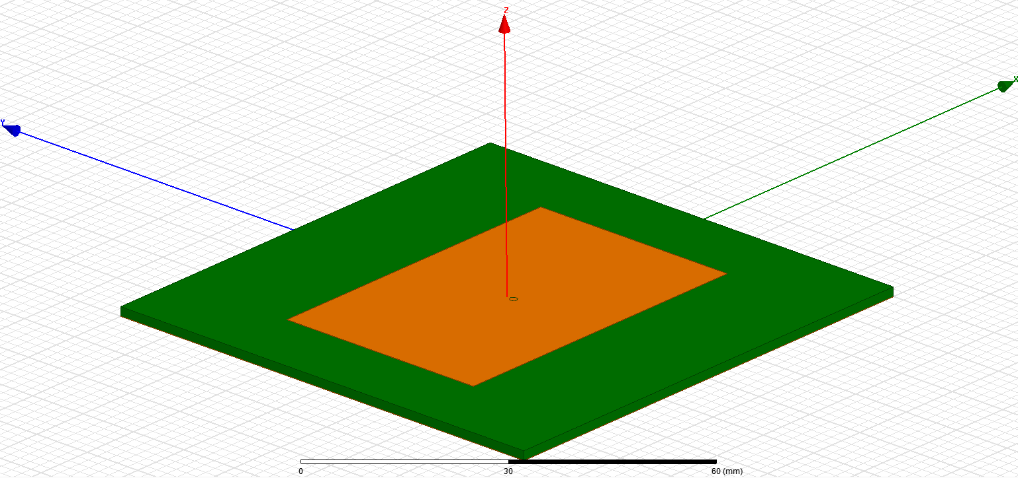

In total there will be three main cutting boxes which we will use with the Boolean-subtract HFSS feature to shape the patch. The easiest to begin with is to shape the middle portion of the patch. Create a box with the same Z size and same Z position as the rest of the patch. Set its length to Lt and its width to Wt. The formula for its X-Y position will be dependent on how you oriented the patch in the X-Y plane. For example, if the length is in the Y direction this block’s position can be centered on the patch by setting its X position to -Wt/2 and it can be positioned at the edge of the patch by setting its Y position to –L/2. Once this box is in place you have to subtract it from the patch by first selecting the patch in the model window, holding control on the keyboard, and then selecting the newly created cutting box. Then right click and select *Edit->Boolean->Subtract*. Make sure that the two boxes in question are in the correct areas in the Subtract window and press OK. This will make the necessary cut in the patch.

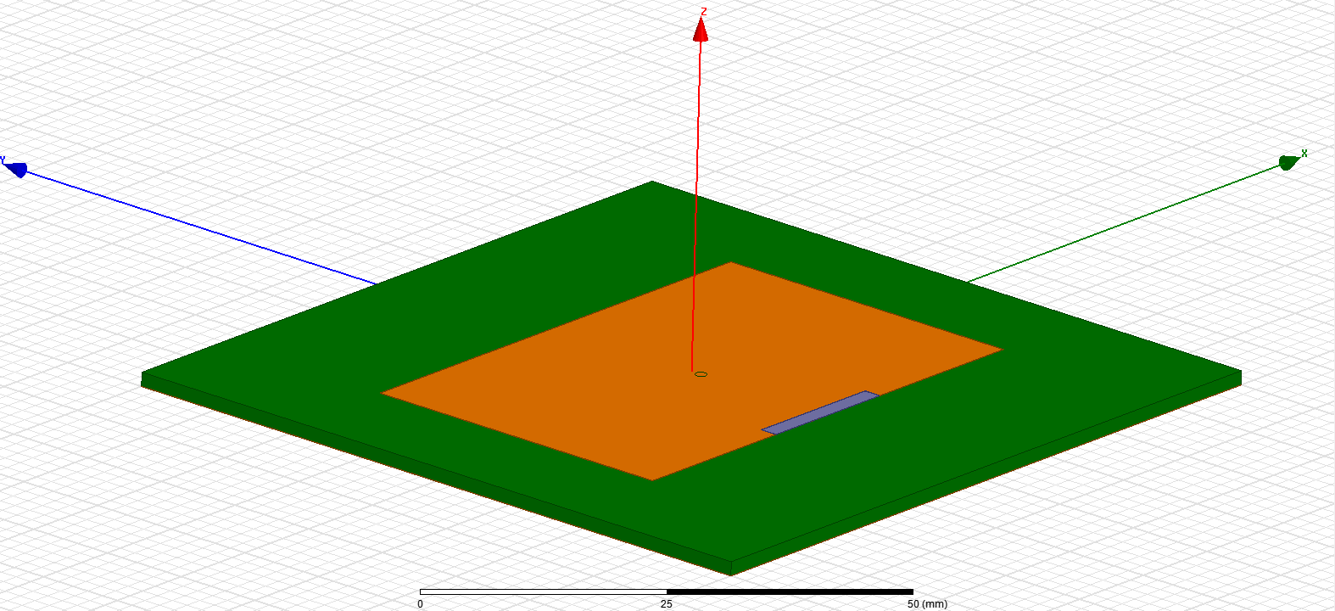

The next two cuts can be and should be done together. There are two ways one can do this, one is by creating two boxes and setting their values individually and the other is by setting one box in place and using the mirror tool to create an identical box over some predetermined line. In either case one would have to start by creating an initial box with a height of the cladding, and X-Y dimensions of Ws and Ls. The lengthwise position of this box should be set to just touch the edge of the patch, at-0.5\*L, and the widthwise position should be set to just touch the outside of the middle tab, so it should be set to +Wt/2. This should create one of the slots to form the outer arms. The other arm can be set by largely the same method except that its width should be set to –Ws and its position should now be –Wt/2 so that it creates a symmetric arm. This final cut can also be done by using a mirror tool, but that method will not be covered here.

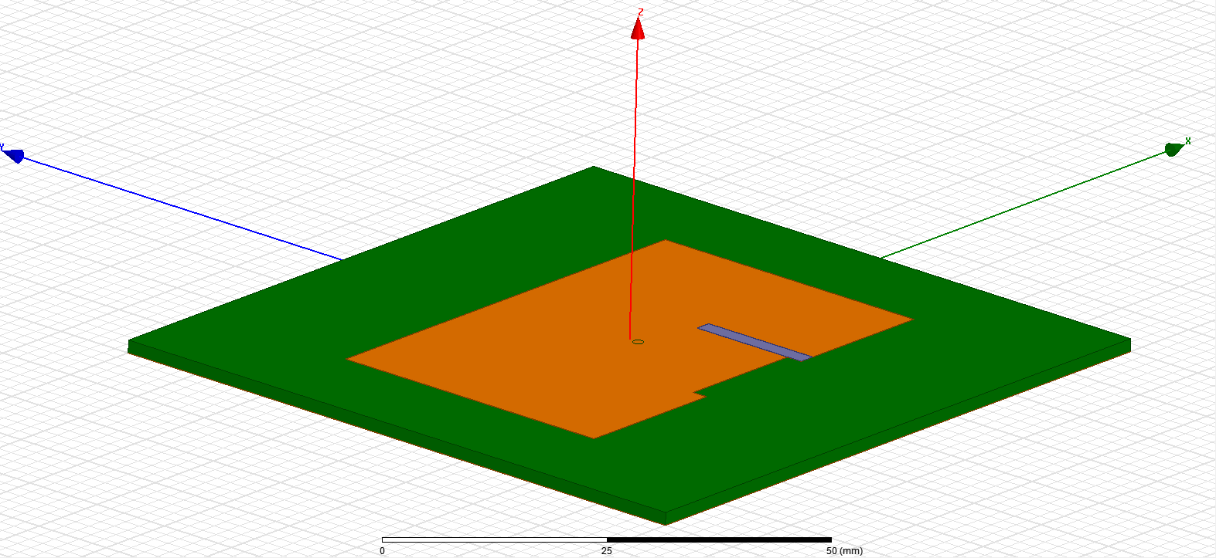

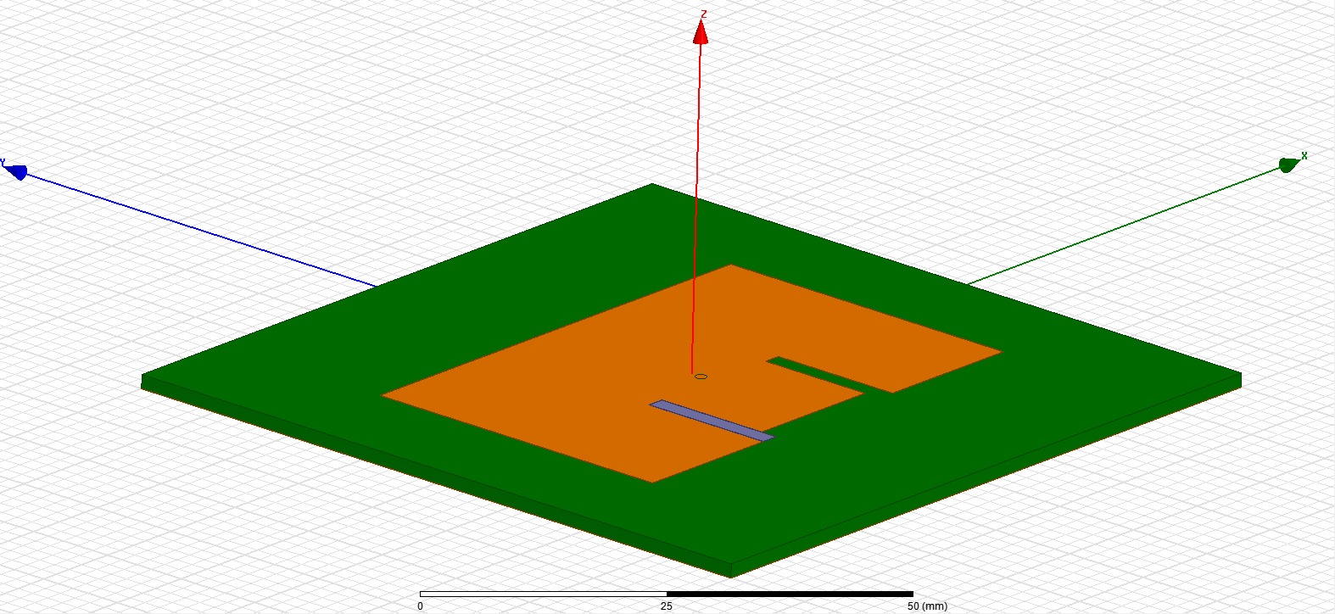

With the patch fully formed we then move to its feeding structure. The patch is fed using a cylindrical center conductor from an SMA jack which is connected through the ground plane and is soldered to the patch. This SMA jack and center conductor are modeled by creating three concentric cylinders with centers given by xo and yo. The global position will likely be given by L/2-xo for its xo postion and 0 for the yo position. As for the construction of the feed: begin by creating a cylinder and setting its radius to the outer radius of your chosen SMA jack and its material to the material of the SMA jack. Next, create two cylinders of the radius of the dielectric within the SMA jack. Place them at the center of the first cylinder and use one of the new cylinders to subtract from the largest cylinder to make room for the other and set the second new cylinder’s material to Teflon, which is likely the dielectric material for your chosen SMA connector but should be changed to the appropriate material should that not be the case. Finally, create two more cylinders with the radius of the center conductor of the SMA jack. Subtract one of these newest cylinders from the dielectric cylinder you made and set the other cylinder’s material to the material for the center conductor of your SMA jack. The cylinder set to the SMA jack’s center conductor material must be made long enough to go through the ground plane, the dielectric, and the patch. It should then be combined with the patch itself to avoid collision errors by doing *Edit -> Boolean -> Merge* once the center conductor and patch are selected The cylinder which was used to subtract from the first cylinder should also be long enough to go through the ground plane completely used to subtract from the groundplane so that the center conductor and the groundplane do not touch. If you created this structure using variables you will be able to move it as a unit, which will be important later since xo will have to be varied in order to provide a better match to the 50 Ohm SMA jack. Once this structure is set in place just below the ground plane you can verify that there are no errors by setting a radiation box and running a single simulation to see if it completes successfully. The final product should look like this:

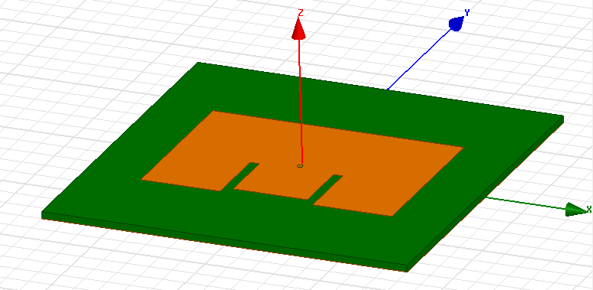

Bottom:

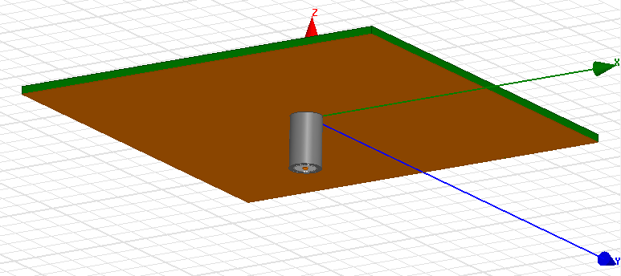

Once the patch has been set up you can move onto the analysis of the structure. Setup HFSS to analyze at a large range about your center frequency run a simulation to see where your baseline values place the resonances. Change one of the variables of Ls, Ws, Lt, and Wt in order to see which of the resonances responds to which pair of variables. From here it is up to the user’s individual S(1,1) response to determine what to do next. Ls, Ws, Lt, and Wt will have to be changed parametrically in order to change the resonance frequencies, but you would have to be careful that these values make sense in the context of the model. For instance: it is possible to set Wt and Ws to such large values that the E shape is lost and you are left with a rectangle with a smaller rectangle stuck to its side. You can also set Ls so large that you actually are left with three separated rectangles. Bear these geometric constraints in mind when you are doing your parametric simulations so that you don’t waste time and computing power on fruitless simulations. It may also be necessary depending on your design to increase L and W to accommodate larger Ws, Wt, Lt, and Ls values. If your model was created using variables to keep all positions relative this will be a simple change. That can be done along with other variables in your parametric analysis.

Once you have set the resonant points close to your desired response you can improve the response by varying xo. This changes the amplitudes of the two resonant points which allows you to change the response in-band to find a response that suits your needs.