Ruchika Jingar

997407538

EEC 134

Application Note: Antenna Design & Soldering Techniques

We first learned how to design and simulate a patch antenna in EEC 133 for 2.4 GHz on HFSS. Since our radar system is also operating at 2.4 GHz, we decided to use a similar design for the receiving and transmitting antennas. Having familiarity with HFSS helped me a lot when designing since I already knew how to create a new project and the different features available in HFSS. There are a couple of basic equations that are needed to design the patch antenna such as:

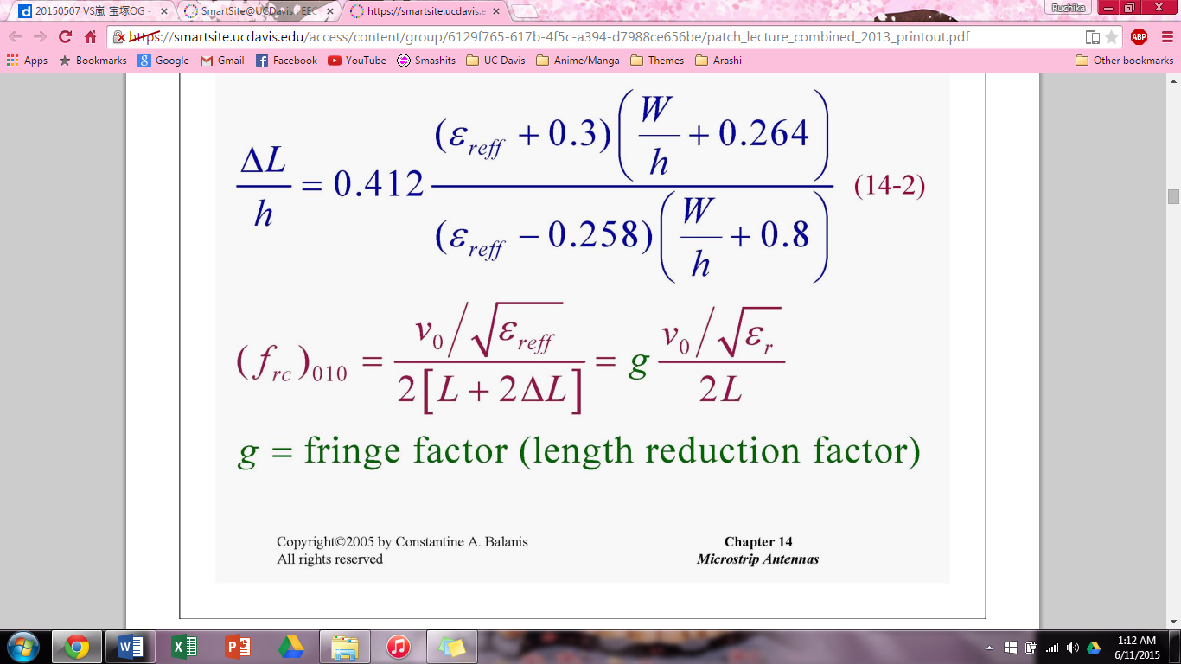

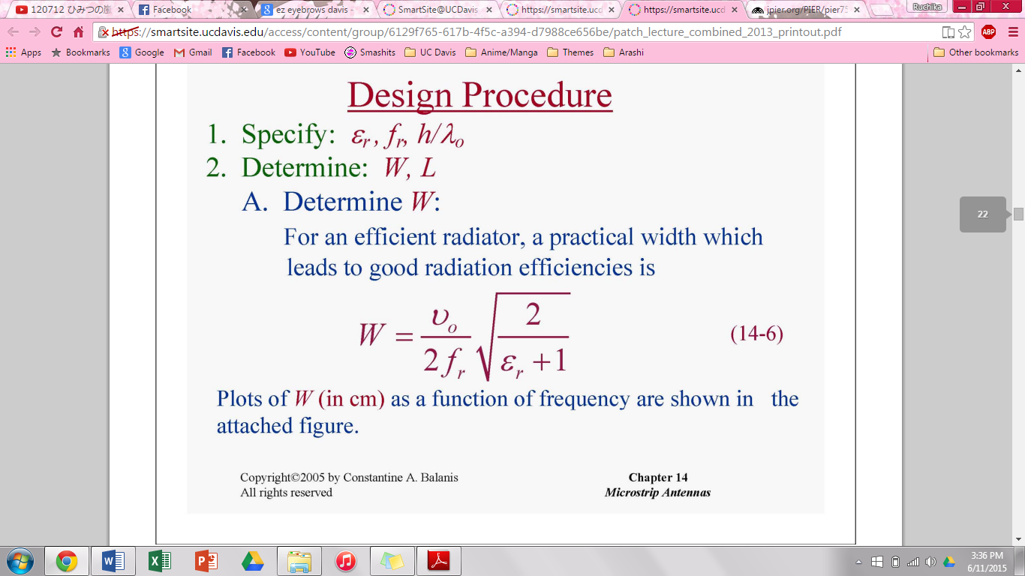

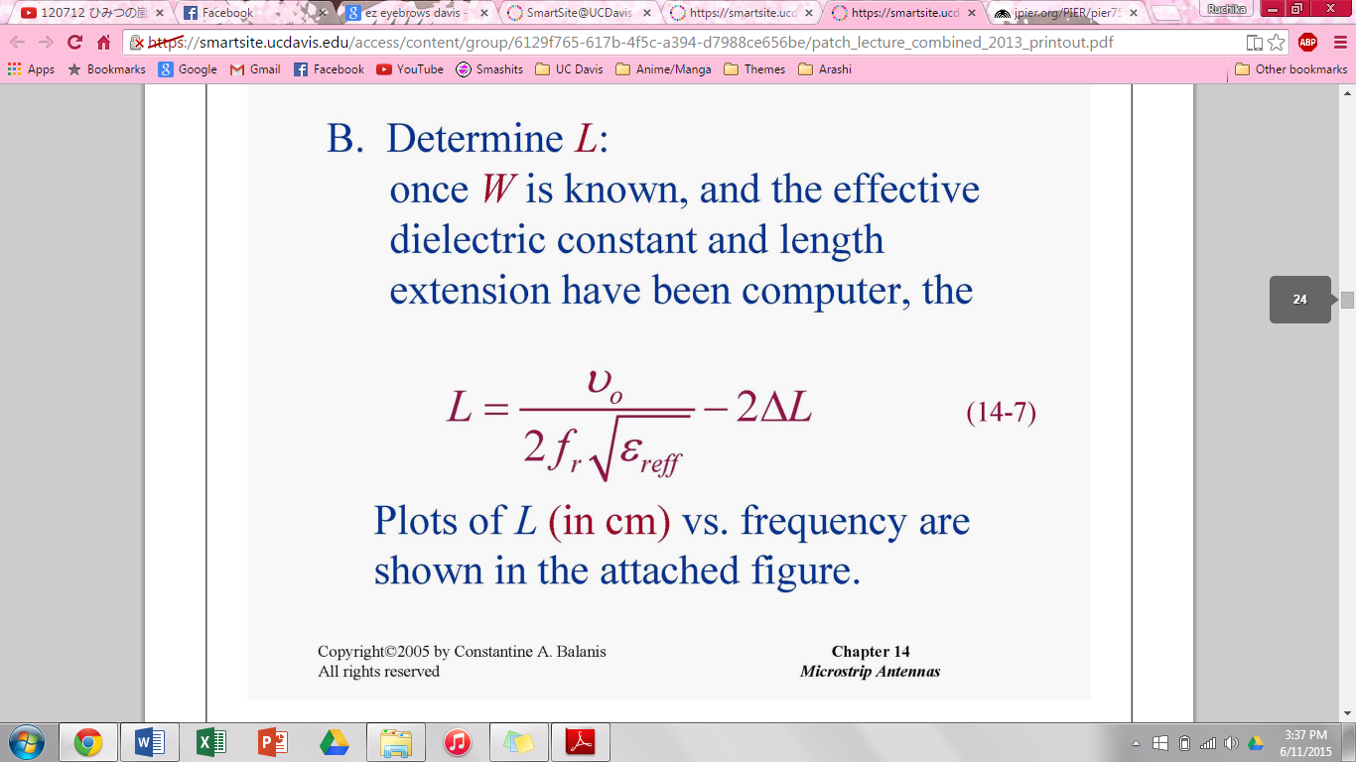

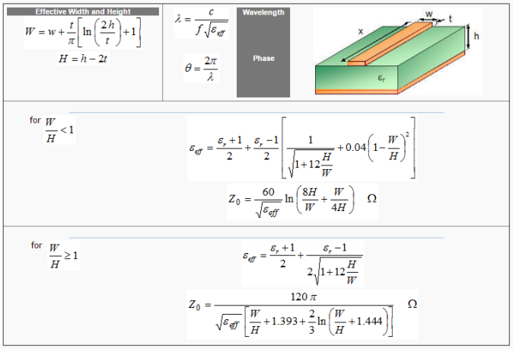

εr is the permittivity constant of the dielectric. W is the effective width of the patch, h is the thickness of the dielectric material, and t is the thickness of the patch. Lis the length of the patch. Note: Make sure to keep the same units for W, h, t, and L. The patch antenna looks like this:

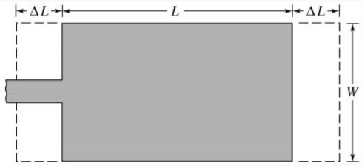

There are two different methods for feeding a patch antenna such as a 50 Ω microstrip line with a quarter-wavelength transition or just a 50 Ω microstrip line.

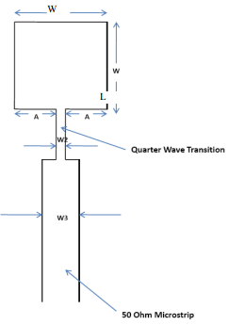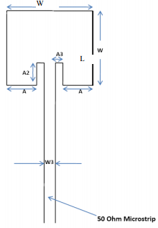

When we first started designing the patch antenna, we went with first method because that was the one we designed in EEC 133. Unfortunately, we couldn’t use that design as it did not fulfill the requirements that were needed in order for our radar to function properly. This design did put out enough power but the bandwidth was very narrow as we needed a bandwidth of 10% around 2.4 GHz. We then researched about different patch antenna designs that gave us a bigger bandwidth and we eventually found one what looks similar to the second type of patch antenna. The one we found was called an E-patch and we found it through this research paper called “A Wideband E-Shaped Microstrip Patch Antenna For 5–6 GHz Wireless Communications” by B. K. Ang and B. K. Chung and it can be found here: <http://jpier.org/PIER/pier75/24.07061909.Chung.A.pdf> . The antenna in this research paper looks like this:

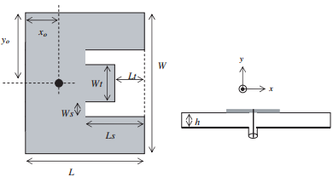

This looks similar to the second method but the feeding method is different. Instead of a 50 Ω line going to the patch, a RF SMA connector’s center lead is fed through the a hole in the patch itself, with the back soldered to the ground plane (make sure to scrape off the ground plane where the outer dielectric of the center lead would touch) and the center lead soldered to the copper patch on top. The antenna will eventually look like this:

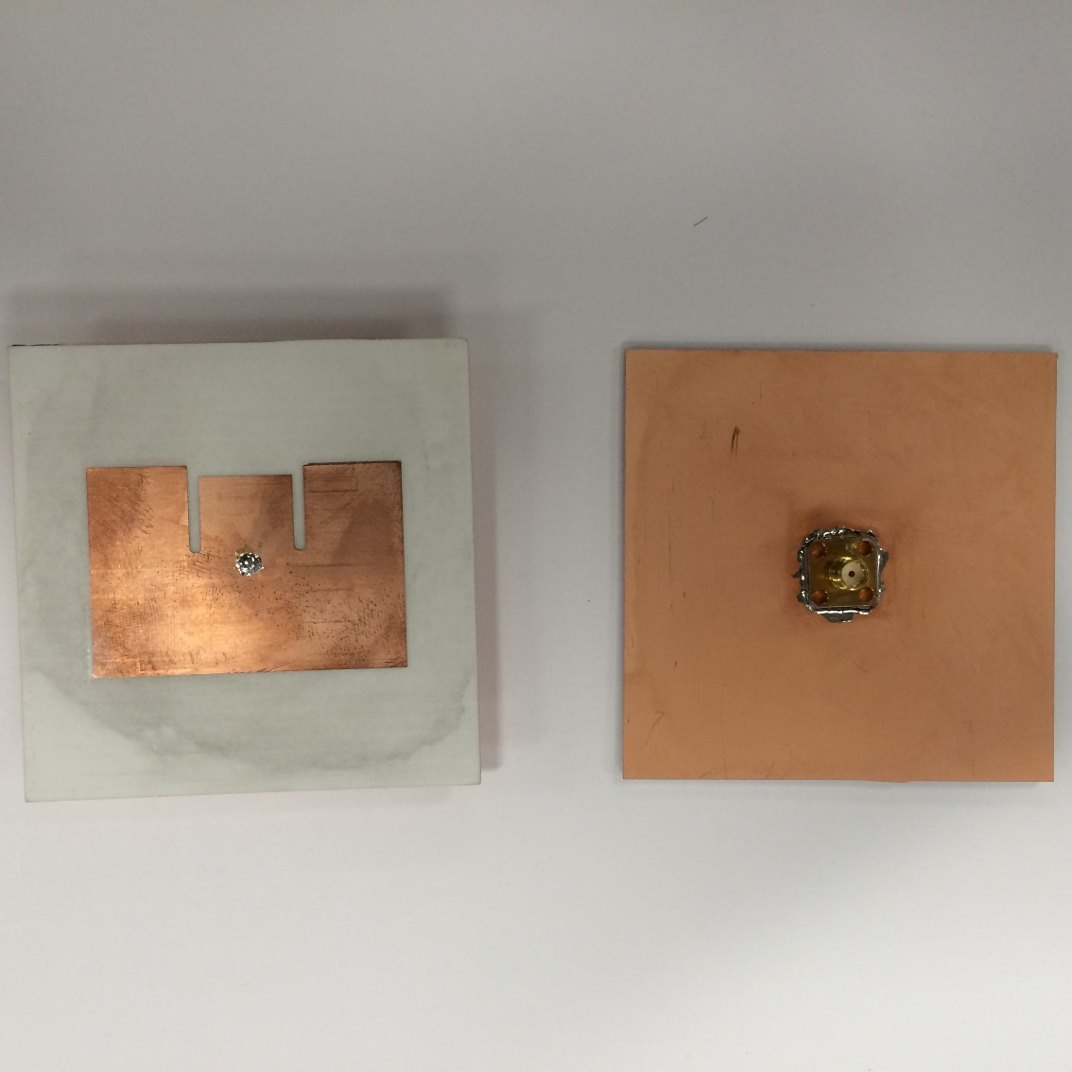

The SMA connector will be connected with a SMA Cable that will connect to the SMA connector that is soldered to the PCB. So the completely assembled radar will look like this when connected to the printed circuit board:

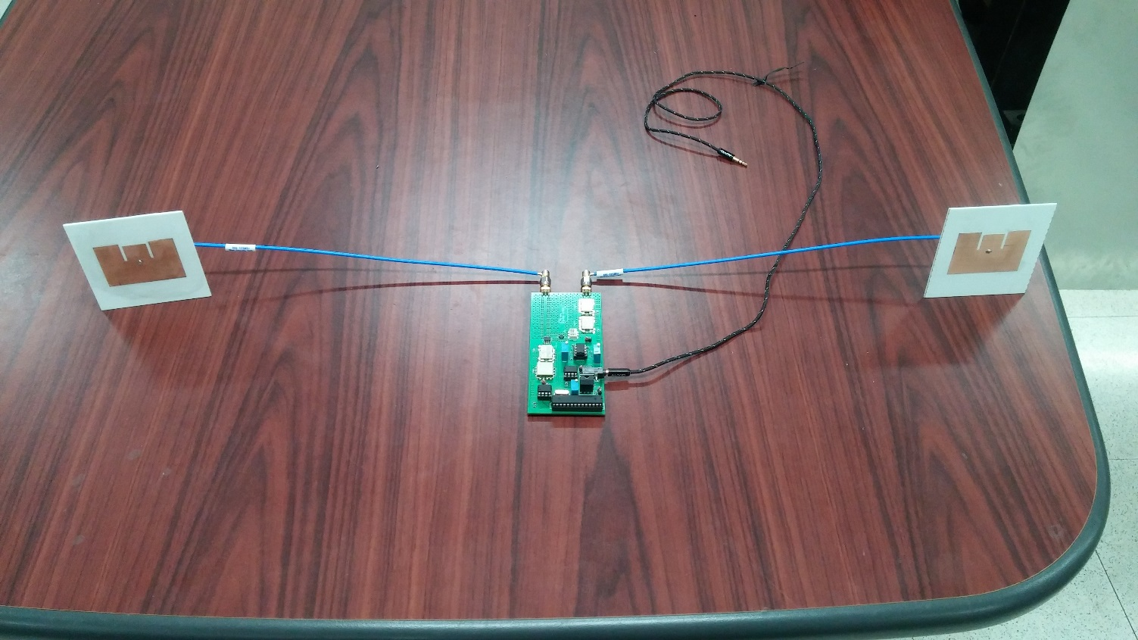

The E-patch antenna design gave us a bandwidth of 10% because of the way it was designed. Since there are now three sections in the patch instead of one, it can create two paths for radiation. One is along the middle section and the other path is along the two sections on each side of the middle section. If you adjust the widths and lengths, the resonant frequency will change. Ws and Ls will change the resonant frequency of the outer sections which forces the signal to travel on a farther path, which will then increase the inductive effect on the frequency response. Wt and Ls will change the resonant frequency of the middle section in the same way as Ws and Ls changed the frequency for the outer sections. This design basically increases the bandwidth by making the resonant frequencies of the outer sections come within a certain frequency difference around the center frequency.

To get a suitable design and results, we would need to consider an appropriate substrate. In the picture above, the substrate we used was the Rogers RO4725JXR substrate which had a dielectric constant, εr, of 2.64 for a frequency range of 1.7 to 5GHz which was perfect for our radar. The substrate had a thickness, h, of 1.542 mm and a copper cladding of 35 µm. Since now we have all of the variables, we can then plug that into the equations from above to get the widths and lengths, where vo is the speed of light and fr is the center resonant frequency. Once we have those values of W and L, we would need to then scale the other widths and lengths given to us from the research paper to the desired center frequency’s lengths and widths. This would be done by scaling Ls, Lt, and xo with respect to L and Ws, and Wt (but leave yo as W/2) with respect to W.

Once we got those down, we can make the model of this design in HFSS. First, we made project variables for each of the different variables so then it would be easier to adjust them. Once we made those, we started creating the model by creating boxes for the ground plane (copper) under the dielectric and for the dielectric (Rogers RO4725JXR). Those two should have the same length and width. We then created a box for the patch (copper) on top of the dielectric, then we start cutting out parts of it to create the three sections. After that we cut out the hole through the ground plane, dielectric, and the patch for the center lead of the SMA. Pick a SMA connector like the one in the pictures as it will be the easiest to solder. The datasheet will tell us outer dielectric’s diameter and the length of the center lead but we will have to find out the radius of the center lead. To do that, we will need to open up Advanced Design System and make sure you have license for it. I recommend getting the 2009 version. Once it’s open, click on new project and name the new project. A new schematic window will pop up and another popup will appear:

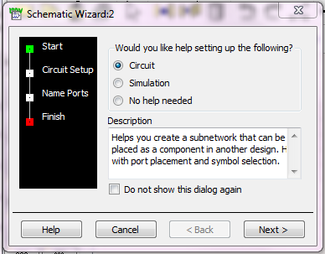

On that window, just click on NO HELP NEEDED and click NEXT 🡪 then on the schematic window, click on TOOLS 🡪 LineCalc 🡪 Start LineCalc. We’ll see this screen next:

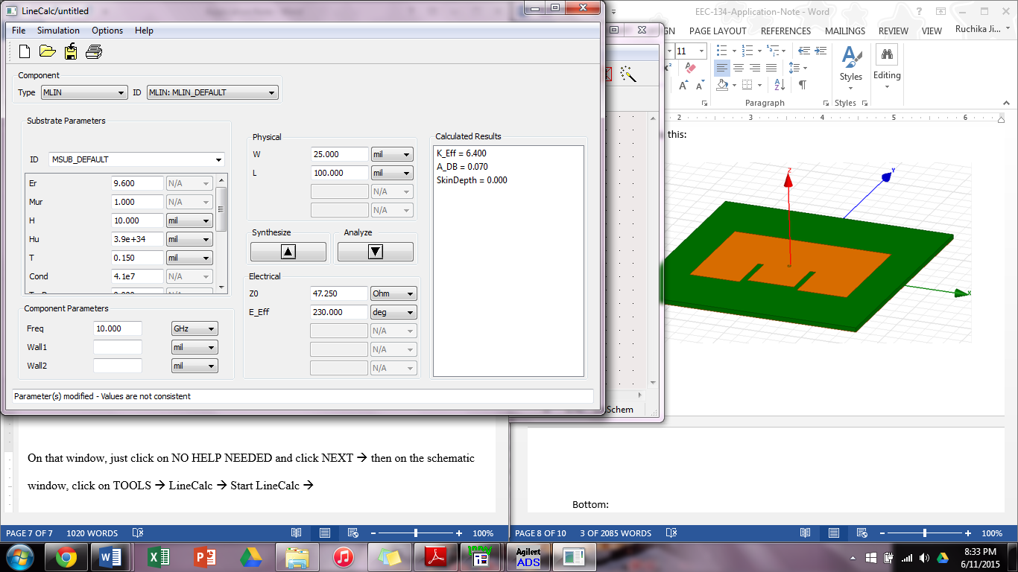

Then under Type, click the drop down menu to COAX, which will give you this screen:

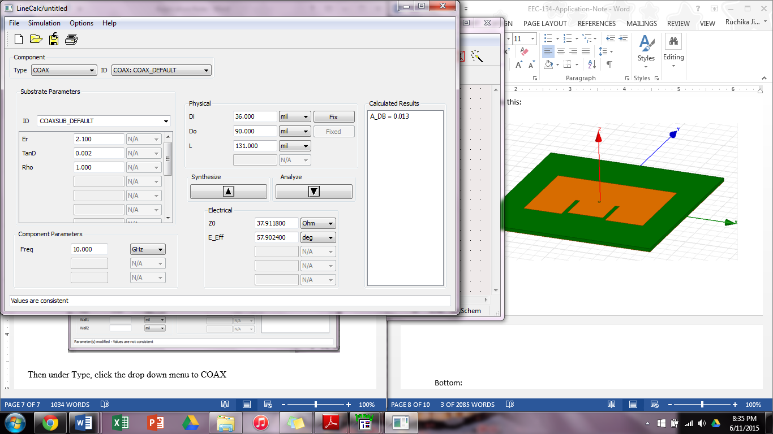

Type in the information from the datasheet for εr, Do, and L. Frequency is the center frequency, Z0 is 50 Ω and Eeff is 90 degree. Fix Do and change all the units to cm and click on SYNTHESIZE to get the value of Di. Use that value to create the hole. This is how it will look in HFSS:

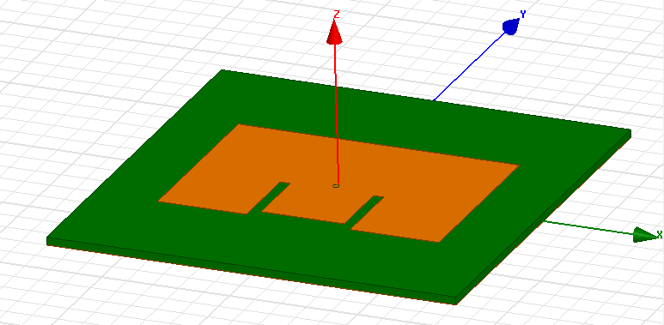

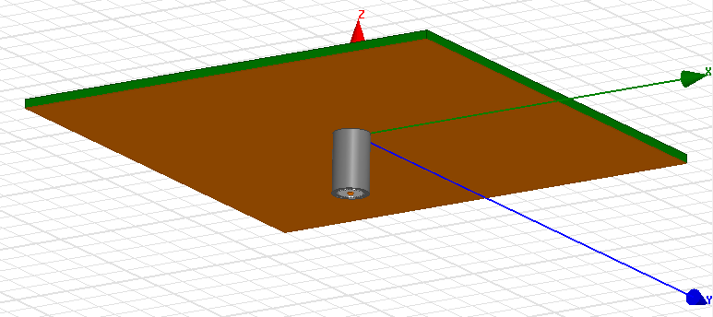

Use Di, L, and W of the back connector to create the back of the connector in HFSS and make sure to not let it touch the ground plane. You can then simulate it by setting it up to analyze at a large range of frequencies around the center frequency and do parametric analyses with the different variables of the E-patch to get the desired S11 plot. At center frequency, S11 should be more than or equal to 10dB and bandwidth should be around 10%. The gain should be around 6 dBm. Once we get the desired measurements of the patch, we can fabricate, solder the SMA connector to it, and test it in an anechoic chamber.

When soldering on the SMA connector, make sure to scrape of the diameter of Do of the ground plane until you see the dielectric. Then place the center lead through the hole until it is seen at the top of the patch. After that, tape the top where the center lead is so that it doesn’t fall out and attach the antenna to a clamp. Then add a lot of flux around the back where the flat part touches the ground plane to get the solder to stick. Then solder it down with solder wire and a solder iron and wait for the solder to cool before turning to the other side and soldering the center lead to the patch.

Just like how we soldered the connector, we can do the same for through-holed components for a PCB. We just stick the leads into the holes, tape the front, attach PCB upside down to clamp, and use solder wire, solder iron, and flux to solder the leads down. It’s pretty easy to solder through-hole but surface mount components use a different method to solder them onto the PCB. Depending on how big the surface mount component is, you might need a microscope. I would recommend getting the largest size that is possible for your design so then you won’t make things harder for you than they already are. Find some solder paste in a syringe that is connected to a pressure box. That box will come a pedal to push down which will add pressure to the syringe bringing a little bit of the solder out. Add that solder to the pads on the PCB for the component that you are soldering and grab a tweezer and the component. Pick up the component with the tweezer, orient it however you need to, and place it on the pads. Once all the surface mount components are on, find a toaster oven/hot plate and set it to the temperature that is required and wait until it heats up. Once it’s heated at the temperature required, put the PCB (without through components) in oven or on the hotplate and wait until the solder is shiny. Once they are shiny, take PCB out of oven/off of hot plate and wait for it to cool down. Once it cools down, solder any through-hole components, and you should be done with soldering. If you have really tiny surface mount components, find a microscope and dentist tool. Put the PCB under the microscope and find the footprint you are looking for. Then grab a dentist tool and solder paste. Use the dentist tool to get tiny amounts of solder (since under the microscope they will look huge) and use that to place it onto the pad. Then grab the component with a tweezer and looking into the microscope, place the component on its pads. Then adjust as you like and put in oven or on hotplate to bake until the solder is shiny. Then solder in the through-hole components and you should be done.