**Wideband E-Shaped Microstrip Patch Antenna for FMCW Radar Application**

By Kristy Yeung

***Abstract* – This paper aims to present an approach to designing a wideband antenna for radar applications. Several different geometries of antennas were attempted and will be described in this paper. However, the E-shaped patch antenna was ultimately fabricated due to its simulated results of high gain and wide bandwidth meeting necessary design specifications for the application. A wideband E-shaped microstrip patch inset feed antenna has been designed for a frequency modulated radar covering the 5.592-6.095 GHz frequency band. The antenna is resonant at 5.8 GHz, with fractional bandwidth of 10.05%, and a gain of 6.0141. The design technique, parameter analysis, real prototype fabrication, and measurement results are compared to the simulation of 5.8 GHz in excellent agreement with the HFSS simulation results.**

1. **Introduction**

The antenna represents one of the most critical hardware components of the radar system, and the radiating element needs to satisfy several constraints in terms of bandwidth and radiation while still being incorporated into a compact configuration. In this particular radar application, to reduce the overall size of the frequency modulated radar, a small and compact antenna has been chosen. The microstrip patch antenna is desired in this application due to its advantages compared to conventional antennas. They are lighter in weight, low cost, low volume, and smaller in dimension [1]. The microstrip antenna consists of a radiating patch on one side of the dielectric substrate with the other side consisting of a ground plane.

Typically, however, microstrip patch antennas are not incorporated in radar systems due to its narrow bandwidth. After an extensive literature search, it was found that incorporating resonant elements on the radiating surface of the antenna will enhance the bandwidth [2]. The E-shape configuration is adopted to produce a wideband response necessary to comply with the radar.

This paper describes the various antenna designs attempted, as well as the fabrication of the E-Shaped path antenna operating at 5.8 GHz. To improve the antenna gain, an inset feed line method is applied. The advantages of this technique include smaller size, higher gain, and its ease of operation in conduction with the radar.

1. **Various Antenna Design Simulations**

Initially the quarter wavelength patch antenna (shown in figure A) was designed at a resonant frequency of 5.8 GHz.

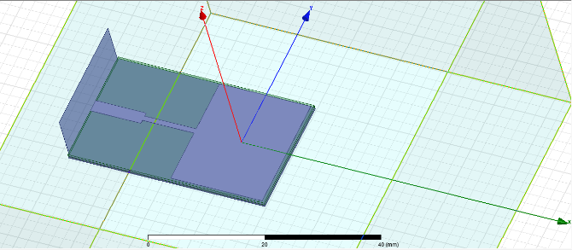Figure A. Quarter Wavelength Patch Antenna

After optimization, the return loss achieved was -16.46 dB and the bandwidth spanned from 5.7975 to 5.85 GHz resulting in a fractional bandwidth of 0.9% (shown in figure B).

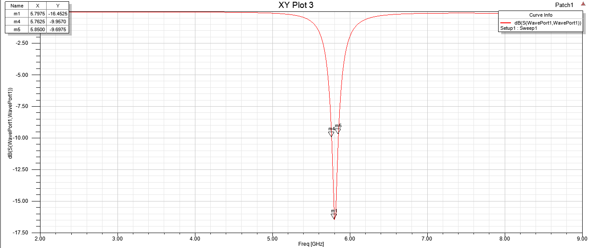

Figure B. Quarter Wavelength Patch Antenna Return Loss

However, the antenna must achieve a bandwidth wide enough for the radar application leading to the exploration of other antenna geometries. After literature search, other antenna geometries were attempted as shown in figure C – F.

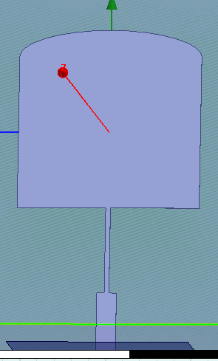 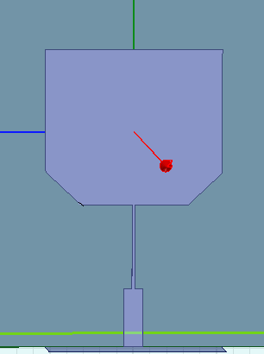Figure C Figure D

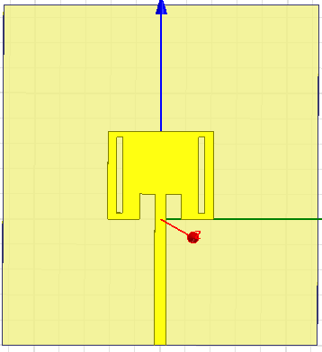 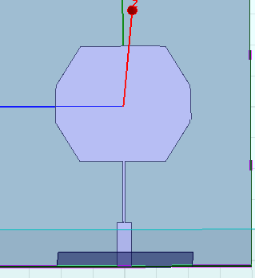Figure E Figure F

Figures A through F however, did not achieve the desired design specifications necessary for the radar application. The bandwidth of designs shown in figure A-F had a fractional bandwidth of less than 1%. Through calculations and analysis of the components used for the radar, a wide bandwidth is needed for the antenna to operate concurrently with the system. The exploration of literature research of different types of antennas led to the findings of the E-shaped microstrip patch antenna which is described in detail in this application note.

1. **E-shaped Patch Antenna Design**

The antenna is a rectangular microstrip patch antenna with two parallel slots incorporated which forms the E-shape. The slots perturb the surface current path introducing an inductive effect that causes the excitation of a second resonant mode [2]. The frequency of the second resonant mode is controlled by the slot width (SW), slot length (SL), and the center arm dimensions (CW and CL). Incorporating the second resonant mode couples the two resonant modes forming a wider bandwidth necessary for the radar application.

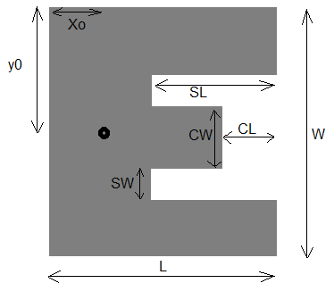

Figure 1. Configuration of the E-shaped Microstrip Antenna.

The E-shaped Microstrip Antenna is chosen to have a coaxial probe feeding method in which the inner conductor of the coaxial is attached to the radiation patch antenna while the outer conductor is attached to the ground plane. The resonant frequency of the second resonant mode can be tuned without affecting fundamental resonant node by locating the feed point at the base rather than the center arm [2]. The inset feed provides a higher gain and perfect impedance matching compared to other feed excitation techniques [3].

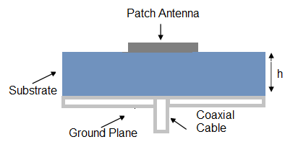Figure 2. Coaxial probe feed

1. **Patch Antenna Configuration**

The E-shape microstrip patch antenna has been designed to operate at 5.8 GHz with input impedance of 50 Ω. Rogers RT/duroid 5880 Laminates has been selected for the substrate with a dielectric constant of 2.2. The height of the substrate is 3.125 mm. Various analytical approximated approaches were used to meet the initial design requirements. In this design, all dimensions of the E-shaped patch antenna are calculated using equations (1) – (5) [4] (text book 466). The width is given by

(1)

where is the resonant frequency of the patch antenna, c is the free-space velocity of light and 𝝴r is the substrate dielectric constant ( The effective dielectric constant is given by

(2)

(3)

The path length due to fringing effects is determined by

(4)

The effective path length of the E-shaped microstrip path antenna after taking into account of the fringing effect is calculated by

(5)

This microstrip patch antenna is fed by the inset feed feeding technique. By varying the location of the feed, it can help determine and control the characteristic impedance of the coaxial feed. To achieve an impedance of 50 Ω, the inset length (y0) can be calculated by

(6)

Where Rin(y=0) is the input impedance at the radiating edge of the patch and Rin (y=0) is the desired input impedance of 50 Ω [5].

After optimization, the improved results of the patch dimensions are shown in Table 1. The width was optimized to 20 mm and the length optimized to 15.45 mm. The inset feed length was optimized to 10 mm.

|  |  |
| --- | --- |
| **Parameter** | **Dimension** |
| Width (W) | 20 mm |
| Length (L) | 15.45 mm |
| Slot Width (SW) | 1 mm |
| Slot Length (SL) | 10 mm |
| Center Arm Width (CW) | 6.2 mm |
| Center Arm Length (CL) | 2.8 mm |
| Inset Feed Point Distance (y0) | 10 mm |
| Microstrip Line Distance | 5.2 mm |

1. **Simulation Results**

Simulations were performed using the software High Frequency Structure Simulator. Ansoft HFSS is a high performance full wave electromagnetic (EM) field simulator [6]. This software was used to calculate parameters such as return loss gain, bandwidth, VSWR, and various other parameters. Figure 3 shows the proposed antenna design in HFSS.

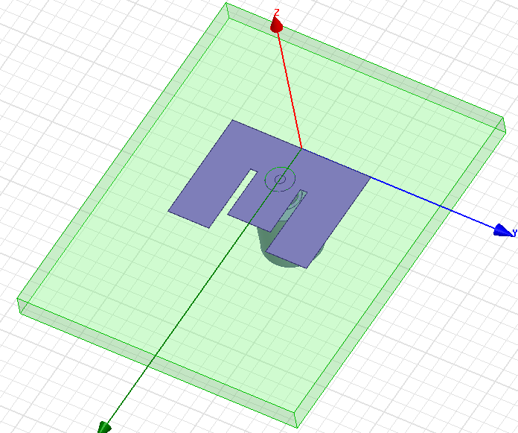

Figure 3 Proposed Antenna Design

Initial simulation was performed using the analytically computed antenna parameters (1)- (5). Guided by initial simulated results, optimization of the antenna parameters were performed to meet satisfactory results necessary for the radar application.

1. **Return Loss**

Return loss indicates the loss of power in the signal returned. More specifically, it measures how well the antenna is matched to its source. A larger return loss indicates higher power radiated by the antenna. Ideally, an antenna is considered matched when the return loss is less than or equal to -10 dB [7]. As shown in figure 4, the obtained input return loss (S11) is -27.1713 dB.

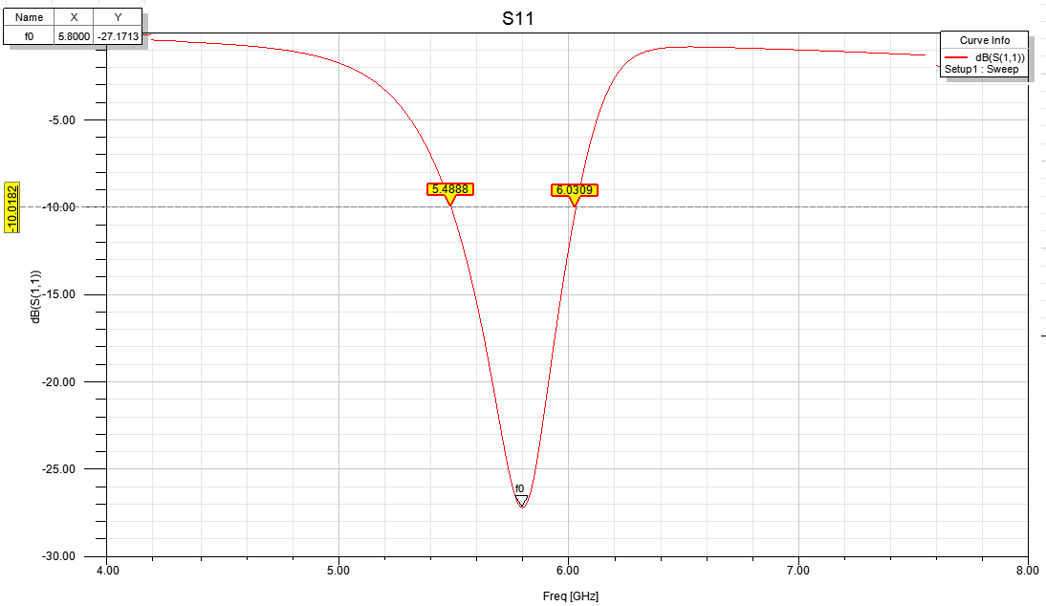

Fig. 4 Return Loss of the E-shaped Patch Antenna

The S11 in figure 4 shows the fractional bandwidth spans from 5.448 GHz to 6.0309 GHz. This results in a fractional bandwidth of 10.05% which is concurrent with the desired radar application.

1. **Gain**

The gain of the antenna describes the performance of the antenna and the capability to concentrate energy through a direction to emulate the radiation performance. It refers to the direction of maximum radiation. Figure 5 shows the simulated gain results of the proposed antenna showing a maximum achievable gain of 6.0141 dB.

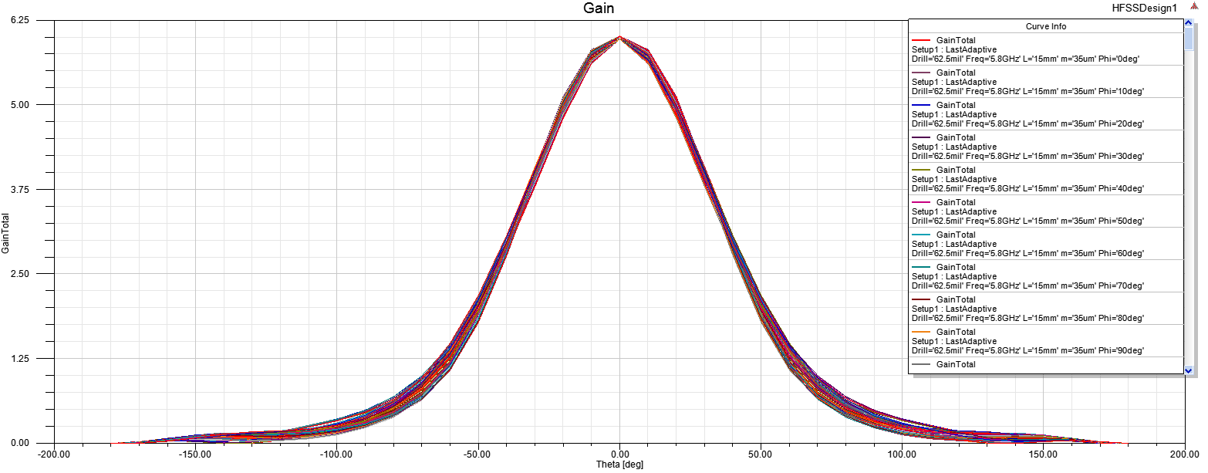

Fig. 5 Gain of the E-shaped Patch Antenna

1. **Radiation Pattern**

The radiation pattern of the E-shaped Microstrip Patch antenna is the power radiated and received by the antenna. The radiation pattern of the proposed antenna is shown in figure 6. The far field radiation pattern is shown in figure 7.

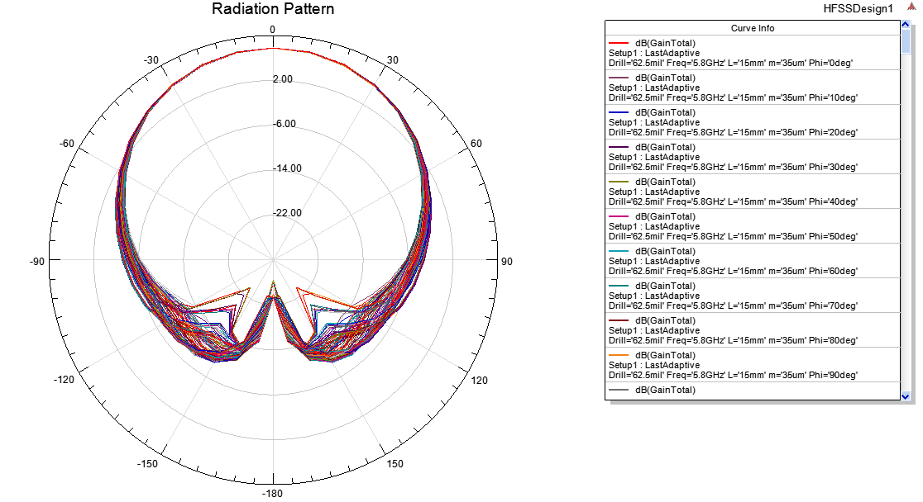

Fig. 6 Radiation Pattern for the E-shaped Patch Antenna

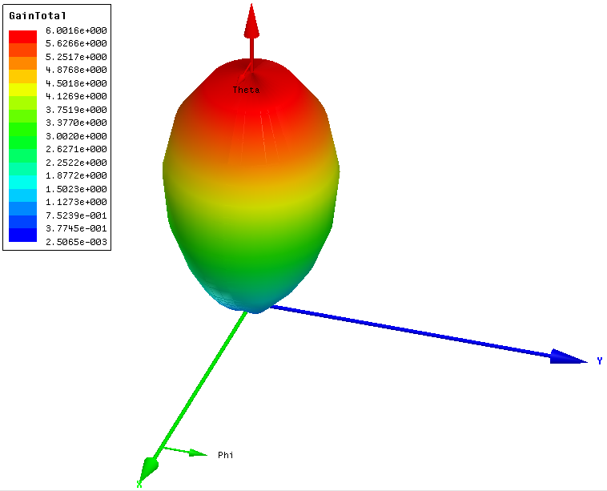

Fig. 7 Far Field Radiation Pattern for the E-shaped Patch Antenna

1. **Input Impedance**

The input impedance of the antenna is shown in figure 8. At the operating frequency the input impedance is 53.212 Ω. Ideally the resistance should be 50 Ω, and the reactance should be 0 Ω. This antenna design has relatively good matching at 5.8 GHz. 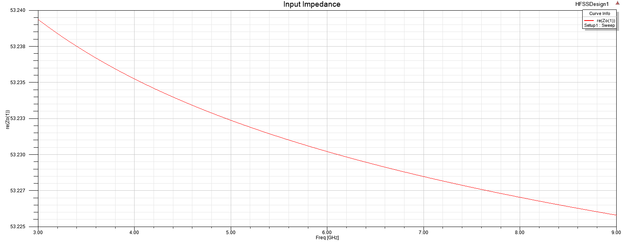

Fig 8. Input Impedance

**E. Voltage Standing Wave Ratio (VSWR)**

The VSWR measures how well an antenna is matched to the impedance where the reflection |Γ| = 0. This represents all power is transmitted to the antenna and there is no reflection. The simulation results of the VSWR is shown in Figure 9. The value obtained for this E-shaped antenna is 1.08.

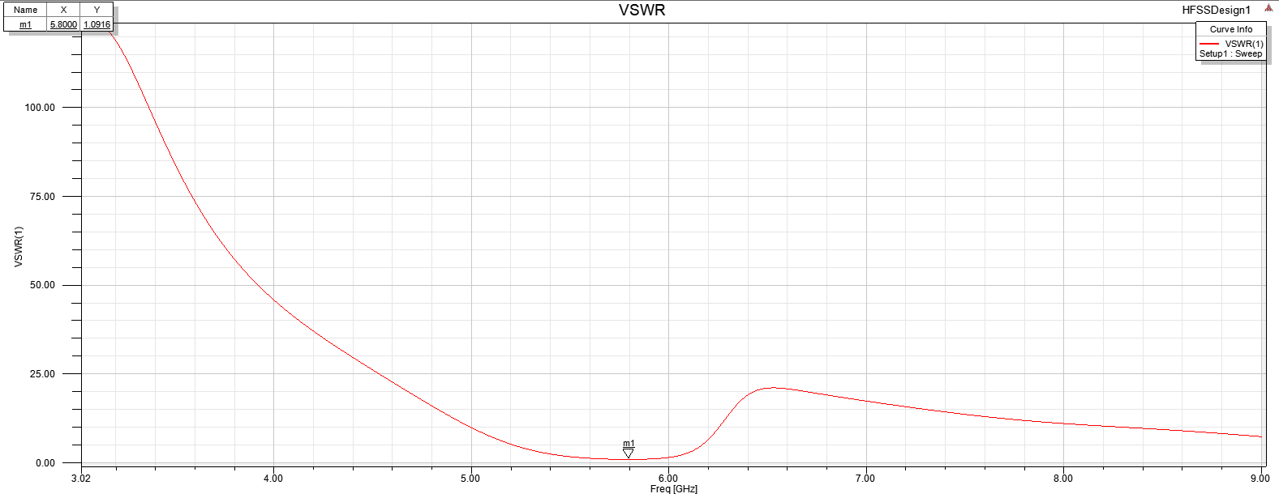

Fig. 9 VSWR Of E-shaped Patch Antenna

1. **Fabrication and Measurement Results**

The E-shaped Patch Antenna was fabricated on the Rogers RT/duroid 5880 as simulated in HFSS. The substrate has a thickness of 3.125 mm and a copper layer of 35 µm. Gerber files were created emulating the original HFSS design for the milling machine. The milling machine uses a milling cutter to remove material from the surface of a work piece. For this particular fabrication, this enabled etching the E-shaped patch dimensions by removing the copper layer. A hole was drilled at the center of the antenna as described in Table 1 allowing the soldering of the SMA connector. Figure 10 shows the designed antenna.

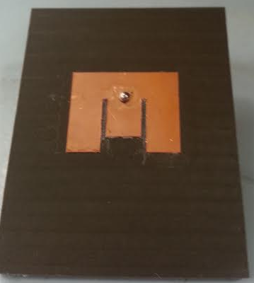

Figure 10. Fabricated E-shaped Patch Antenna

For measurements, the network analyzer was used to test the fabricated antennas. This system is used to calculate the S11 or return loss of the fabricated antennas.

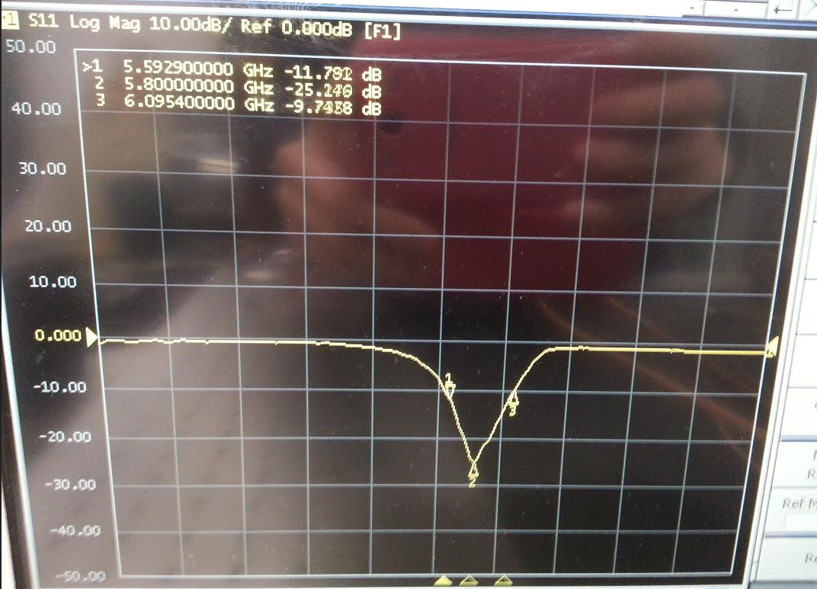

Fig. 11 Measurement of S11 Parameter of Fabricated E-shaped Patch Antenna using the Network Analyzer

Figure 11 shows a return loss of -25.24 dB at the resonant frequency. The simulation on HFSS resulted in a return loss of -27.13 dB which is comparable to the experimental results. The fractional bandwidth of the fabricated antenna spans from 5.59 GHz to 6.0954 GHz which is a fractional bandwidth of 8.713%. Good agreement between the simulation and measurement of the fabricated design was observed. Comparisons in table 2 shows that the resonant frequency is concurrent with the simulated HFSS results.

|  |  |  |
| --- | --- | --- |
|  | **Simulated** | **Measured** |
| **Resonant Frequency** | 5.8 GHz | 5.8 GHz |
| **Fractional Bandwidth** | 10.05% | 8.713% |
| **Return Loss** | -27.17 dB | -25.24 dB |

Table 2: Comparison between Simulated and Measured

1. **Anechoic Chamber Testing**

The E-shaped patch antenna was also tested using the anechoic chamber. The anechoic chamber is lined with electromagnetic wave absorbing material. The chamber results in more precise measurements because there are no external radiation incident on the antenna. The antenna was rotated from 90 degrees to -90 degrees in the anechoic chamber to measure the gain in terms of S21. Figure 11 shows the antenna measurements in the anechoic chamber.

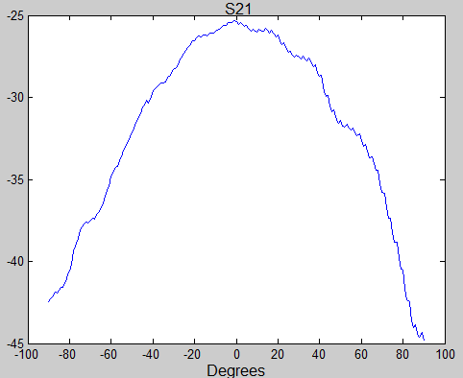

Fig 11. Measurements of S21 using the Anechoic Chamber

Though the gain is at -25 dB during measurement, after some investigation, the calibration was not set properly and resulted in an obscure gain value. To test this theory, the results were compared to a known standard. A horn antenna designed by Hewlett- Packard was tested in the anechoic chamber and the results are shown in Figure 12. The particular horn antenna is designed to have a gain of around 20 dB, however, it resulted in a gain of -10 dB. This shows that there were issues with the anechoic chamber. Never the less, the E-shaped Patch antenna is showing the desired pattern at resonant frequency consistent with the simulated results.

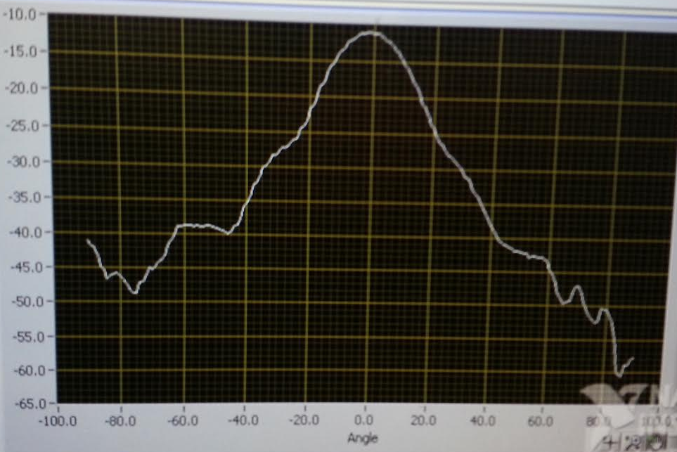

Fig. 12 Horn Antenna Anechoic Chamber Results used as a compared known standard

1. **Conclusion**

The goal of this project was to design a low-cost, light weight, microstrip antenna for a frequency modulated radar application. An inset fed E-shaped microstrip patch antenna was designed and simulated at a resonant frequency of 5.8 GHz. An input return loss of -25.24 dB and a gain of 6.041 dB. An effective bandwidth of 8.713% was obtained (5.59-6.09 GHz). The overall performance of the antenna is more than meeting the demanding design specifications necessary for the radar application.

**References**

[1] Syeda, Rabia Zainab. "Design and Performance Analysis of Switched Beam Series-Fed Patch Antenna Array for 60 GHz WPAN Applications." Thesis. Polytechnic University of Cataluña, 2014. (n.d.): n. pag. Web. 15 Mar. 2015.

[2] Ang, Boon-Khai, and Boon-Kuan Chung. "A Wideband E-Shaped Microstrip Patch Antenna For 5 - 6 Ghz Wireless Communications." *Progress In Electromagnetics Research* 75 (2007): 397-407. Web.

[3] Upadhyay, Priya, and Richa Sharma. "Design and Study of Inset Feed Square Microstrip Patch Antenna for S-Band Application.” *International Journal of Application or Innovation in Engineering & Management*2.1 (2013): n. pag. Web.

[4] Stutzman, Warren L., and Gary A. Thiele. *Antenna Theory and Design*. 3rd ed. New York: Wiley, 1981. Print.

[5] Irfan, Nazish, Mustapha C. E. Yagoub, and Khelifa Hettak. "Design of a Microstrip-Line-Fed Inset Patch Antenna for RFID Applications." *IACSIT International Journal of Engineering and Technology* 4.5 (2012): n. pag. Web.

[6] Balanis C.A., Antenna Theory Analysis and Design, John Wiley & Sons, 2005.

[7] Pozar, D. “Microwave Engineering”, 3rd ed. Wiley, New York, 2005