Jimmy Hua

997227433

EEC 134A/B

**RF System: Baseband Application Note**

**Baseband Design and Implementation:**

The purpose of this app note is to detail the design of the baseband circuit and its PCB implementation on KiCAD PCB design tool. The general purpose of the baseband circuit is to receive the IF signal output from the mixer module that is on the RF circuit board. The expected frequency of the IF signal is at 2.4GHz which will be mixed down to a relatively small frequency through the low pass filters and gain stage similar to the design from Lab 6 manual. The only difference that we included in our revised baseband PCB was an extra gain stage in the case we needed more amplification; however, in the final test run, the second gain stage was removed since it was not necessary to achieve the minimum 50 meter distance mark. We noticed that cascading the second gain stage amplifier with the first gain stage amplifier resulted in an amplification of noise as we recorded the digital signal on Audacity and ran it through our MATLAB to plot the RTI plot. Some general rules to follow are to ground both top and bottom layer of the PCB to help prevent outside interference and make wiring the components more manageable, make sure to build the PCB based on the PCB vendor's minimum criteria; in this case it was Bay Area Circuits, and make sure to have labels on the PCB to help guide the person who will be soldering the components onto the board.

**KiCAD Schematic Capture of Baseband Circuit**

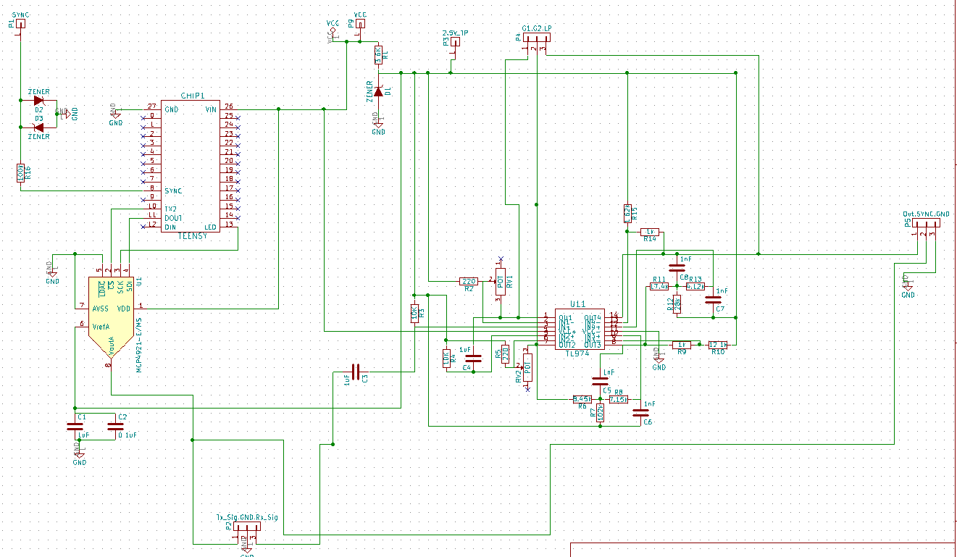

The schematic layout of the baseband circuit is powered by the micro-USB cord that powers the Teensy 3.1 microcontroller. A VCC test point was also included in this design in the case we wanted to use an external power supply to power the baseband circuit board and measure the power consumption by the supply. Test points were also included in this design in order to allow quality tests and probing of the PCB. Illustrated below is the baseband circuit schematic layout of the gain stage and low pass filter stage that will limit the intermittent signal from the mixer output which will be sent into a computer's analog-to-digital converter for further signal processing.

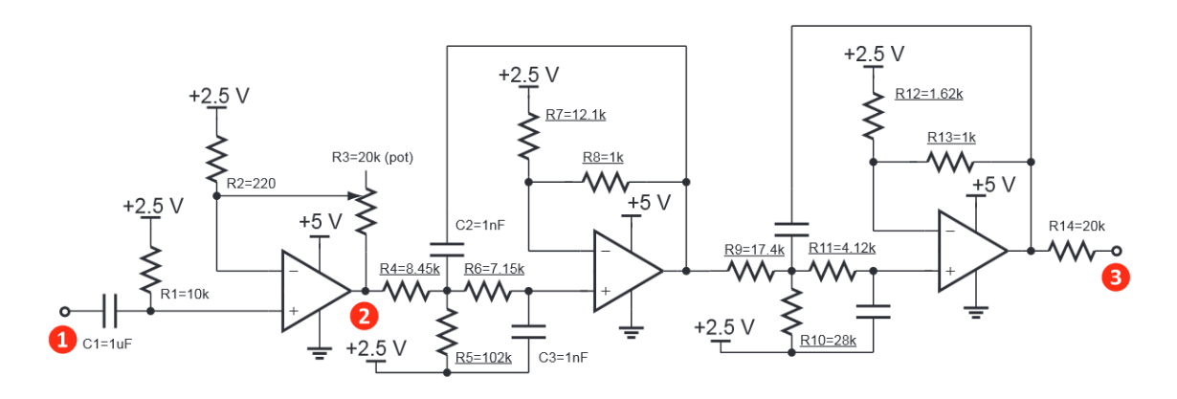

Baseband Circuit Schematic Layout

In **Portion 1**., the circuit layout is similar to that of a non-inverting operational amplifier. The non-inverting op amp results in an output signal that is of the same polarity as the input signal. The purpose of this circuit is to increase the received signal strength as it is expected to have significantly dropped off due to wave propagation and reflection.



|  |  |
| --- | --- |
| In **Portion 2**., the circuit layout depicts two second order active low pass filters cascaded together to create a Sallen-Key fourth order active low pass filter. The purpose of this circuit is to limit the receiving signal to a lower frequency output. The intermittent frequency outputted from the mixer module will have both frequency spectrums. By using this low pass filter, we are able to get a signal that is easy to work with and has relatively low noise interference. | fil82.jpeg |
|  |  |
|  |  |

**Baseband Component Selection:**

After designing the baseband block design, we decided to follow the lab report and use the provided components in Lab 1. These components include:

* 14-DIP TL97IN Op Am IC
* LM317 IC
* 20k potentiometer
* Teensy 3.1
* All other resistors and capacitors are the same as in Lab 1

|  |  |
| --- | --- |
| We also included two Zener diodes in a clipper circuit configuration to limit the output voltage to approximately 0.6V in order to stabilize the signal entering the laptop's DAC and prevent circuit overloading. | clip.PNG |

In order to make debugging the ICs and swapping the pin through components easier, we decided to solder pin and socket strips onto the pcb board. The pin and socket strips are detachable so the strip can be broken into smaller strips to fit the specific IC's pin count. Shown below is the image of the pin and socket strips and the ICs that use the pin and socket strips.

|  |  |  |
| --- | --- | --- |
| MP70S20.jpg | Pinsocks1.png | Pinsock2.png |

**PCB Test Point and Expectations:**

|  |  |
| --- | --- |
| Test point clippers are placed on the baseband pcb board to monitor the voltage and signal integrity to ensure that the right signal is to be expected. We choose to position our test point clippers at a designated area so that we can focus on that part for debugging and testing. In our case, we wanted to use three pinned test clippers to make things easier to debug.  By placing the test points of the gain stages and low pass filter's output in one place, observing the signal's integrity as it travels through each component becomes easier to test and record quantitative data.  The transmitted(Tx) and received(Rx) signals are also grouped together to have easy access when testing .  **Note:** Though we have two gain stage in this baseband system, we decided to use only one op-amp stage because cascading two op-amp stage caused our signal to appear more noisy after the RTI Matlab signal processing. | Test points.png |

**Baseband System PCB Layout:**

|  |
| --- |
| Copy of BaseBand(New).PNG |

|  |
| --- |
| **Test Characteristic and Expectations:**   * The specific test that we did on the baseband PCB was to test if the voltage supply is providing **5V** and **2.5V** respectively to the specific points on the board(**P9** and **P3**). This assures that the op-amp IC is properly powered by a consistent power supply. * Make sure that the audio cable is connected corrected: **black** to **GND**, **green** to **SYNC**, and **red** to **Rx_Sig**. * Under an oscilloscope, expect the signal of the Rx_Sig node to be constant at a low voltage and changing if an object moves away from the front of the radar system. The further the object is the smaller the V_peak; the closer the object the larger the V_peak. |

**Conclusion:**

This application notes provides a comprehensive outline of the design of the baseband system by providing details on the design and testing of the baseband system. The outline details the schematic layout used in KiCAD design tools and the footprints that were individually created to allocate the IC and passive components on the board. The outline also gives suggestions on how to test the board and the expected  characteristic and signal integrity that goes into the audio cable for the laptop to perform the signal processing. The baseband system is an important part in the overall radar system because this determines whether the amplification gain should be higher to provide a stronger input signal to be recorded, or a lower signal so that the power does not damage the internal ADC of the laptop. This application note touches on the key factors of possible test errors and provides a general understanding of the baseband system was successfully built. It is best to follow the KiCAD PCB tutorial document that is provided by Professor Leo because it thoroughly goes over the key concepts that are important in designing in KiCAD. One take home message that should be further emphasized is to always ground the top and bottom layer of the PCB. This way, it prevents the issues of external interference and the off chance that the PCB is accidently tampered with. Doing this will also make it much easier to wire your components using via holes and make the arrangement of the components easier to deal with.