**EEC 134 Application Note for PCB Design**

Gerardo Abrego

912390484

**Introduction:**

For this application note I will discuss the main points on how you can design and fabricate your own PCB using KiCad.

**Schematic Design:**

The first step is to build a schematic for your design. This is the most important part. Here is where you connect your circuit and make sure that everything is grounded and connected correctly. If something goes unnoticed here and you send it in to fabricate it will come back like that and most likely not work. Remember that PCB runs take weeks to receive so attention to detail here is critical in determining your PCB board success. In this application note I will use my baseband board as an example. Below is the schematic I designed for the baseband board.

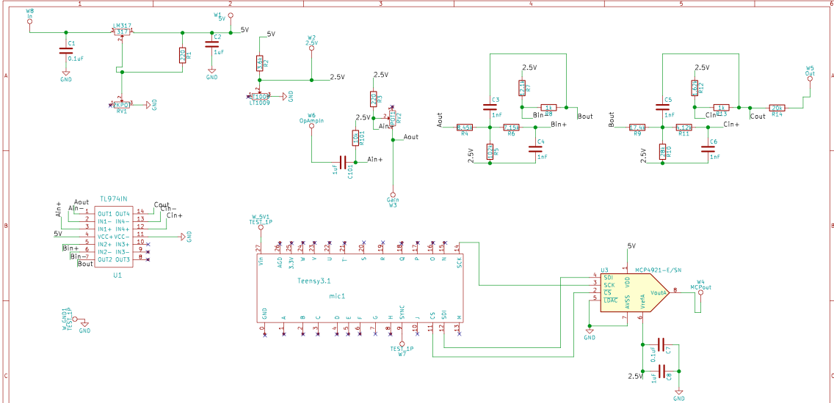

When laying out the schematic the first thing you should do is make sure that your components are in the KiCad library. Resistors, capacitors and inductors are all in here. When I designed the baseband board most of the components my group and I selected were not in the library. Even if your components are in the KiCad library I recommend you design your own footprint for them. This way you ensure that your ordered components really fit and have the correct pins labeled.

**Footprint Editor:**

When designing the footprints for your components the first thing you should do is look at the data sheet. All of them will have a recommended PCB layout that you should follow. The first thing to notice is the orientation of the components. Once you have this down within KiCad you can open the component library editor. I will use the TL974 as an example. Below we can see the pin layout for the TL974 given from the datasheet. The next step is to open the component library from KiCad. Once this is open make sure that you create a new library if not it will get saved within one of the built in ones and can make it difficult to find. In the component editor create a box and place the pin in the same order. After you have done this make sure you label the pins in the same order as the datasheet. This is to ensure that when you mount the actual components the pins are connected correctly. Once you have build the component in the component editor now we need to make the footprint. In the component editor the dimensions didn’t matter this is because we only use this to draw the schematic. In the footprint editor we will now use the correct dimensions. Go back to your component datasheet and look for the dimensions and orientation of your component.

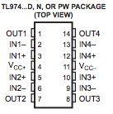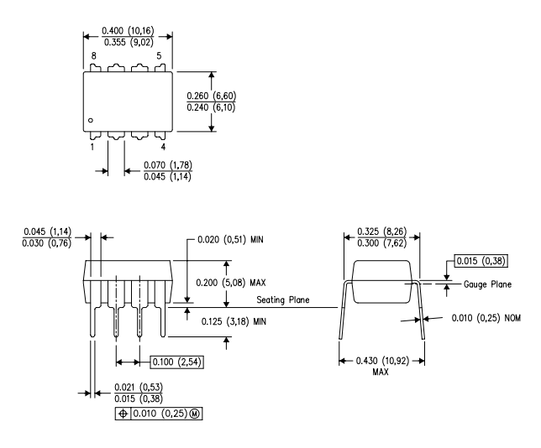

Fig 1: TL974 layout and dimension

Once you have the data sheet now we can make it in the footprint editor. Here we have to be accurate and make sure that we follow the dimensions given to us. There is a tolerance that you can have, but it is really small. One of the tips that I recommend is using the spacebar when you are ready to measure your length or width. This centers your axis to 0,0 and helps in reading your dimensions. Remember to be patient and use a mouse so that you can draw straight lines. It will take some trial and error but you will get it down. I recommend you start with your simpler components first as you build those you will get the practice and be able to make more complicated ones. If you feel uncomfortable have all members of your group make a footprint and then compare. That is what my group did and it worked out great. Once you have done this for all of your components you are ready to go back to the schematic add them to it and review your schematic design.

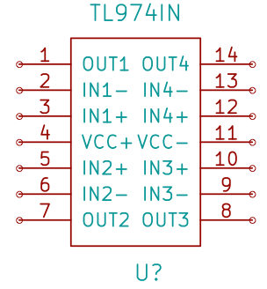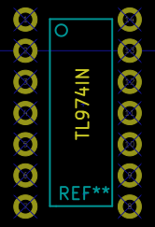

Fig 2: Finished component and footprint of TL974

**Annotation and assigning footprint to components.**

Once your schematic is set and connected correctly you can now assign the footprint you just created to your schematic drawing. Select the annotate button.



Once this is selected you will get a pop up window that looks like Fig 3. Make sure that those options are chosen if not just click the correct ones. Once this is done you are ready to choose your footprints. You will then get a pop up window that looks like Fig 4. Here select your footprint components with the corresponding component on the list. For resistors, inductors and capacitors select hand soldered 603 this is the correct size that we will use for our PCB’s when we solder them. After all of this is done click the save button and close the window. The last step before we can begin our PCB layout is to create the net list file. Just click on the NET button from the top menu and select ok. Now we can move on to the PCB layout.

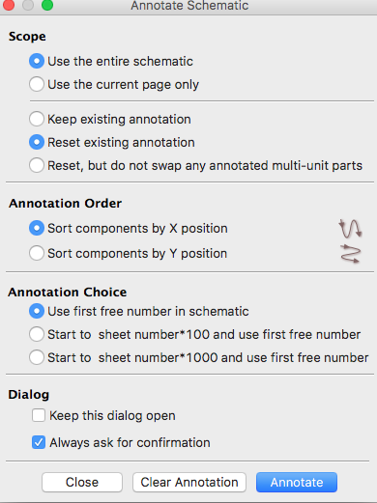

Fig 3: Annotation Window

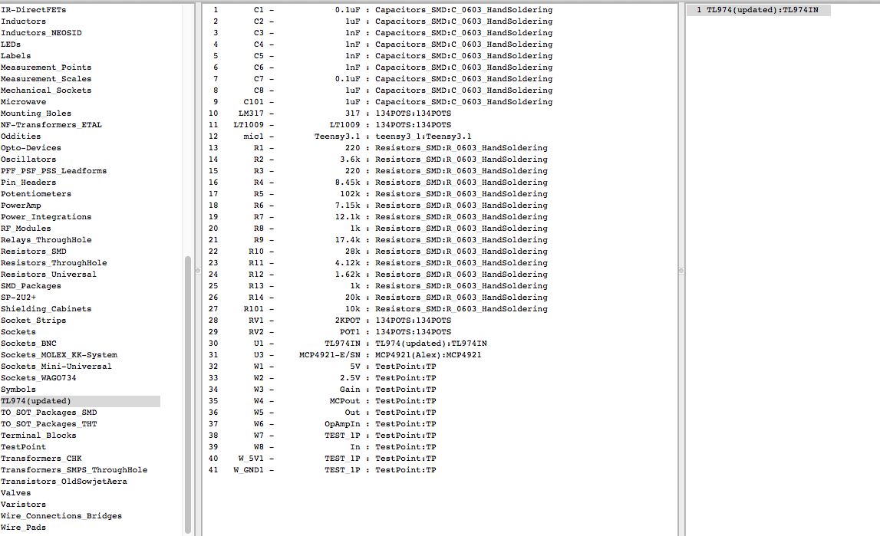

Fig 4: Footprint window

**PCB Design:**

Now that we have made footprints and the schematic it gets a little easier. Here in the PCB layout you should decide how you will lay out your board. When you look at the rat net you will see a bunch of unconnected wires and it may be overwhelming at first. Before we can start to move the components and place them on the board you must make the dimensions of the board. For quarter 1 we had to keep it at 2X2 inches. In quarter 2 you have the freedom of choosing your dimensions. If you want to make your system small and light weight you will need smaller dimensions. Just make sure you don’t cram everything just to save millimeters of space. Once you decide your dimensions you need to make an edge cut which can be made with the tool in Fig 4. Once you have done this you will have a yellow outline. This is your boundaries where you should make sure that your components don’t overlap and later your traces. My advice and Professor Leo will say the same thing is to place your IC chip first on the board. Once you have placed them on the board select the capacitors, resistors and inductors that correspond to the IC. Place these components as close to your IC this way you can ensure that everything works properly and that your traces are short. Once you have done this it’s time to add traces. Traces are wires that connect your components together. With a baseband board, you don’t have restrictions. Its ok to have traces that aren’t completely straight. First connect all the components that are closest to one another. For the baseband board that I used I had 65 connections to make. To me this part was fun sort of like Tetris. Just know that traces on the same layer can’t overlap. You have the top and bottom layers. You can have a combination of top and bottom connections. Another thing to do before you start connecting traces is to make sure you review design criteria with the vendor you will use. For this class, we used bay area circuits. Go to their website and check the trace dimensions. Once you have connected all your components you will have a PCB layout like Fig 6. Now that you have worked hours on making connections everything gets easier. The next step is to add fill zones to your PCB. Remember you have a top and bottom layer. What this does is connect things together. For my PCB, I wanted the top and bottom layers to be grounded. So, I filled both zones with ground. Depending on what you want to connect this can change. To do this is simple first select the add fill zone button you will get a pencil looking cursor. From here select the top corner select what you want the layer to be in my case ground and make your way around your PCB and when you get back to where you started double click. Once this is done right click on the center of your PCB and select fill zone. This will apply a color to your PCB it will look red/green like in Fig 7 below.

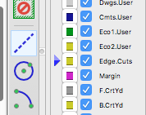

Fig 4: Edge cut window

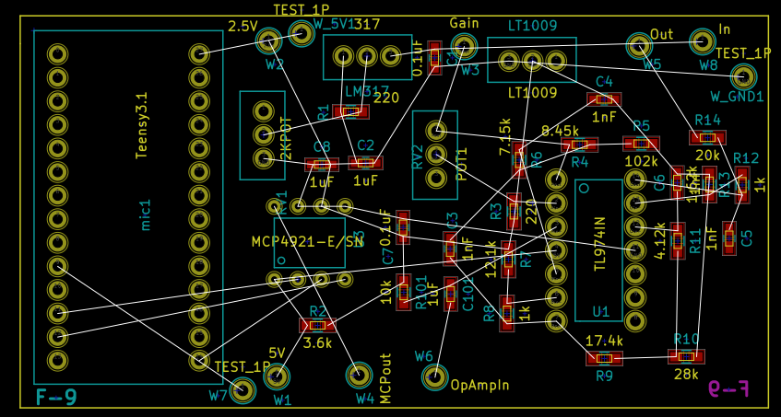

Fig 5: PCB layout with components not connected

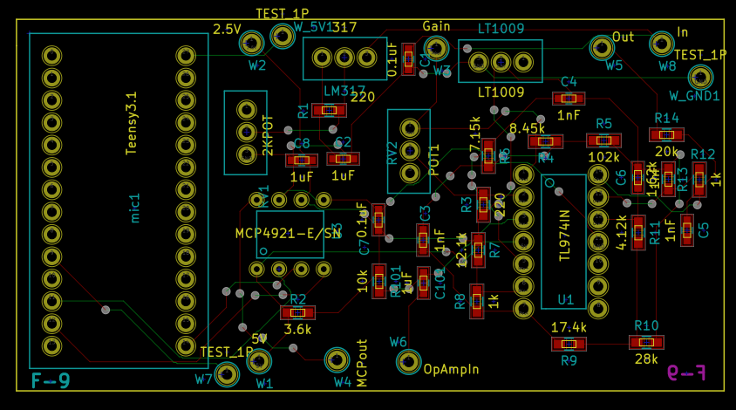

Fig 6: PCB layout with all traces connected

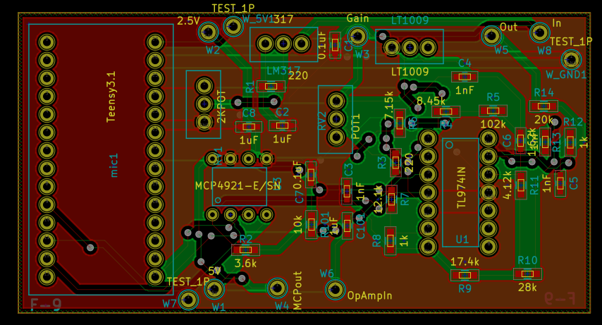

Fig 7: PCB layout with filled zones

Once this is done you can do you the last step which is to plot your files. Here you will get a pop up window like Fig 8. Make sure the same options are included. Here we want the front and back layers of copper selected we also want the silk this shows you your components numbers and helps you when you solder. Make sure to also select edge cuts so the vender knows your dimensions. Before you plot hit the generate drill file make sure that correct folder is selected and change the dimensions to inches or millimeters depending on what dimensions you worked with for my design I used millimeters. Once this is set hit drill files and close the window. You will be back to the first window here select plot and you will have your Gerber files. Gerber files are used by your vendor to print your PCB boards. Once this is done congratulations on designing your first PCB. The last step is to run a DFM report. Bay area circuits allows you to submit a ZIP file of your plots that contains your Gerber files. With the DFM report it tells you if your design can be fabricated. The report will tell you if your traces are the correct width and if everything else passes their fabrication criteria. If it does congrats you can submit your design for fabrication. If not you will need to see the report and locate the exact traces that aren’t passing their criteria.

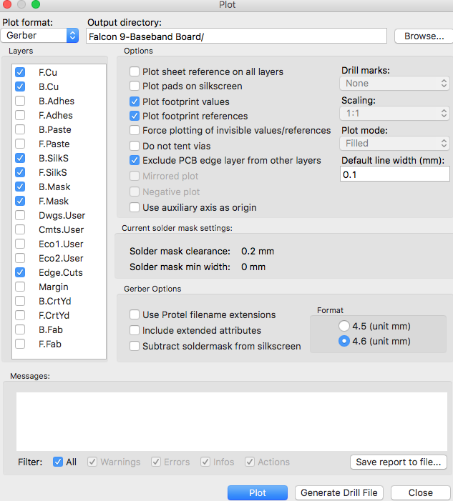

Fig 8: Plot Window

**Soldering your components on PCB:**

After receiving your board, you will have to solder your components on to them. This allows you to test your PCB. For soldering, there are 3 different ways you can solder and will probably use a combination of all 3. The first way is using a solder gun and solder wire. This is good to use for bigger components. Especially if you want to solder pin headers for your IC. The second way is using flux, solder paste and a heating plate. This will probably be your best bet for soldering on your capacitors, inductors, resistors and small IC’s. You can use a magnifier to help you place your components. You must be patient here and make sure that your components contact the pads. When applying solder paste to your pads make sure you cover the whole pad, but don’t place too much. I also suggest you work on one area at a time when you have one area covered place the PCB board on the heating plate on a low temperature. You will see the paste turn metallic and this tells you it is heated. If your components move heat it up again remove the component and try again. It will take a few tries but keep trying. The last way is using the hot air gun. You still apply paste to your PCB but instead of placing it on the heating plate you place a gun over a certain component and just heat that one up. This is perfect for bigger IC’s we used this for our VCO which was a big block.

**Tips for building and soldering a successful PCB:**

The success of your PCB is very important. This contains your circuit that powers whatever it is your working on. If you fabricate a PCB it takes weeks to come back and if you don’t put enough time or effort into it when you receive it and it doesn’t work it will be frustrating and take away weeks from your timeline so please take the time to check your schematic and connections. For my group, we had 2 PCB boards. One was the baseband board and the other was an RF board. I recommend having at least two, but you can also have more boards or at least keep your RF components on a single board. Having multiple boards is also a great way to debug because you know what board doesn’t work. I recommend watching YouTube videos and attending the PCB tutorial workshop that is provided by Professor Leo. Even after attending and viewing videos it will not be enough you must practice and put time into it. Make sure that during quarter 1 you try and work on those PCB’s so that when quarter 2 comes around you feel more comfortable. My last tip is to have other people double check your design and layout. This ensures that when you submit your design for fabrication that it will come back a success.

Soldering is also important in this class. It’s not as hard as designing a PCB, but essential in ensuring that you can test your PCB. Some tips include being patient, doing one area at a time being careful around the equipment, and going to the workshop provided. Remember that everything gets hot so be sure to handle everything carefully. Also keep a clean area if you place your PCB on the table and there is dirt or even paste it can get stuck on the bottom of your board. Next time you place the board on the heating plate it will burn your PCB board. I found out the hard way so just want to warn future students about that.

**What I learned:**

In designing and soldering my groups PCB I learned so much. I learned to manage my time. We had PCB runs twice each quarter. You may think that 4 weeks is a lot of time to design a PCB, but I guarantee you that its stressful if you wait till the last week. Start right away start with your footprints of the components you choose. From here set time aside every week to work on your PCB. I also learned how to make PCB’s which you will also learn. My first PCB didn’t work I will admit that, but learning from those mistakes I was able to make successful ones. I learned how to make schematics and footprints I also learned how to place components. All of this you will learn as you work on your design. Be patient and don’t let frustration get the best of you for many including myself this was my first time doing this, but if you keep at it you will learn and get better at it. Nothing is more satisfying than receiving your PCB, soldering your components, testing and showing that your PCB works. I promise that you will have that feeling of success in PCB design.

**Conclusion:**

In conclusion PCB design is time consuming you will spend many hours on your PCB schematic and layout. It will all be worth it when you receive and test a successful PCB. Be patient and have others look at your design before you submit it. I learned many skills in designing PCBS and you will too. PCB design is important for any engineer it shows that you understand circuits and that you can look at datasheets and understand layouts. If you follow this guide, take advantage of the resources your being offered, put in the time into your design and have others check your work you will be successful in PCB design. Good luck and hope that this guide was helpful.