Jiaming She

990902799

Application Note

Testing Procedure

During this quarter, we have made several testings. In general, there were three testing phases for our project. Through all the testing procedures, we have modified our radar system for several times. We also modified some major components and tried several different forms of the components. We finalized our radar system in Phase 3.

1. Phase 1

Before we got our PCB back, we started the first testing phase with breadboard circuits and metal box RF components. In the first phase of testing, we built a radar system that is similar to the one we built in fall quarter. We modified the system a little bit. We rearranged the circuit for baseband on one breadboard. We tried our best to keep the legs for resistors and capacitors shorter and made each part of the circuit close enough to each other. The baseband circuit became simpler and clearer. This also helped decrease the power loss in the circuit and make the circuit more accurate. We also took off the attenuator and added one more LNA at the receiving end. We replaced both can antennas with two patch antennas.

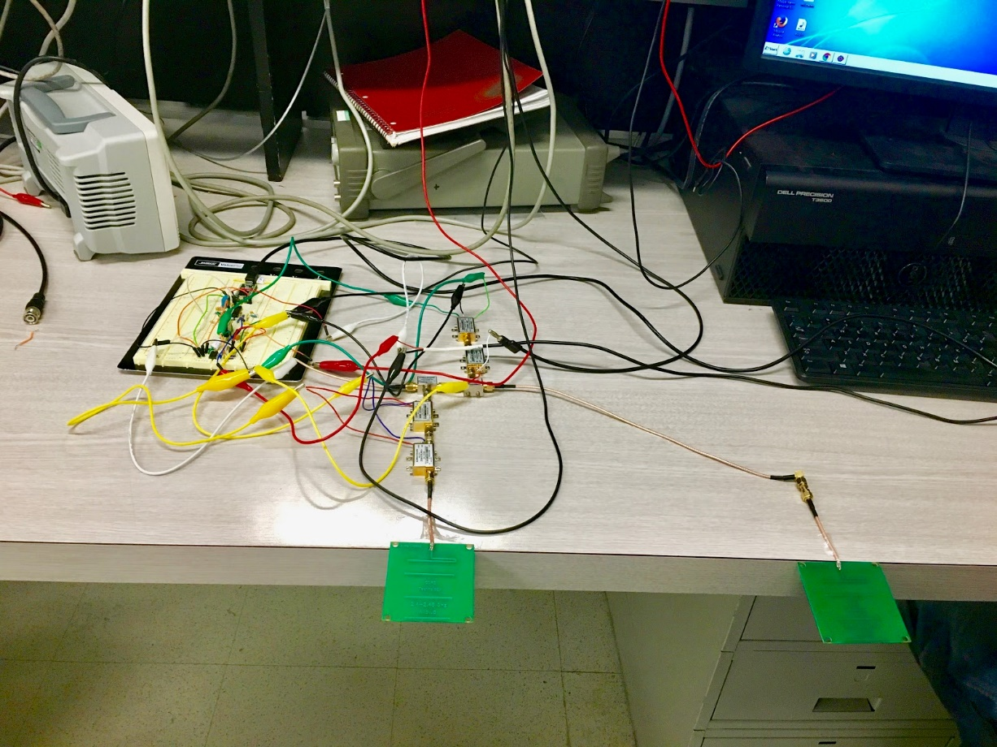

Fig 17. Phase 1 Radar System

We used the software Audacity in the computer in our lab room to test the whole system as instructed in lab 6 from fall quarter. Then we used the python code given in fall quarter to analyzed the audio data we collected.

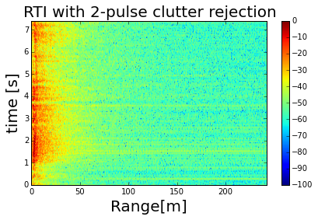

Fig 18. Phase 1 test result

Fig 18 shows the plot generated by the python code. The plot was not clear enough to tell the position of the objects. Since there were so many objects in the lab room, too much reflections from those objects could be a possible reason that resulted the plot we got. It was also possible that the signal that received by the receiving antenna was too weak. We made modifications and improvements to our radar system in the second testing phase.

1. Phase 2

When we received our PCBs, we started built the radar system with our PCBs. We replaced all the three LNAs with PCBs, but then a problem happend with the circuit. When we turned on the power supply, the power supply showed that there was overload happening in the circuit. But when we disconnected the LNAs from the circuit, there were no overloading happening. We thought the LNA PCBs may have too much gain.

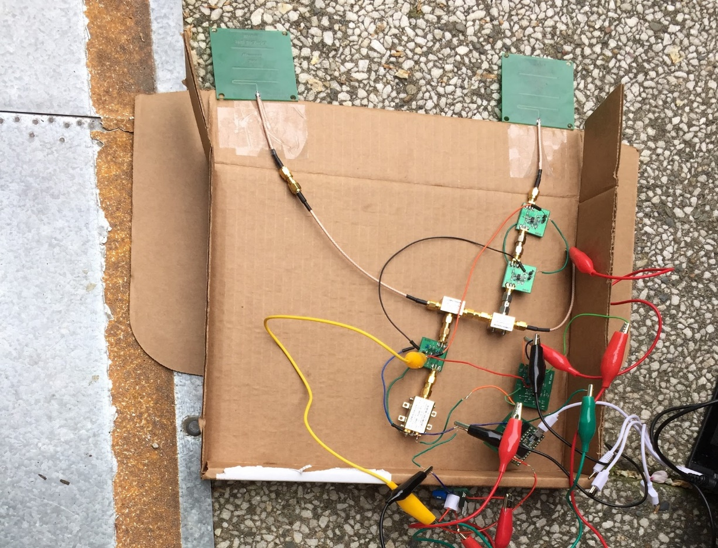

Fig 19. Phase 2 system with LNAs in PCB

Then we modified the system and replaced two of the LNAs with metal box circuits. The overloading problem was solved. We also replaced the transmitting antenna with can antenna, because we found out that the can antenna has more gain than the patch antenna due to our measurement. We performed test again. We first tested inside the lab room and got the following result.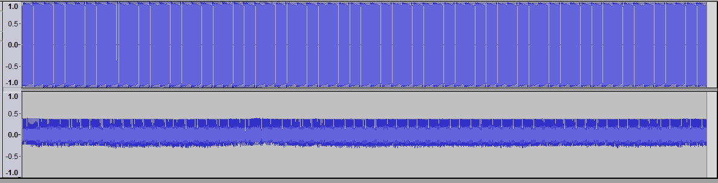

Fig 20. In-room test audio file

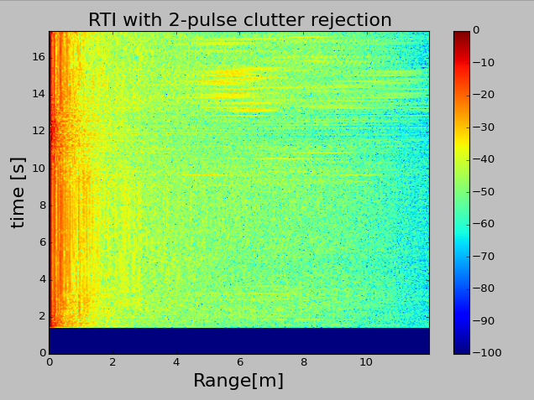

Fig 21. Phase 2 system in-room test result

However, we found out that the resulting plot generated by the python code was still not too clear. By taking a detailed look with the audio file, we discovered that the audio plot was constant, which suggested that the radar system did not work properly. Suggested by TA and Professor Liu,  we decided to check the transmitting side and receiving side of our system separately. We tested our PCBs again but found no problems. Then we performed the labs from last quarter again to test each RF components but found no problems. Finally we decided to ask one of the TAs, Daniel, for help. With the help from Daniel, we found out that there was some problem with the PCBs we designed for low-noise amplifier. The LNA took in too much signal instead only one desired signal. Thus, we had to use the metal box circuits for all the LNAs in our radar system. This became the final version of our system.

1. Phase 3

In the third phase of testing, we finalized our radar system.

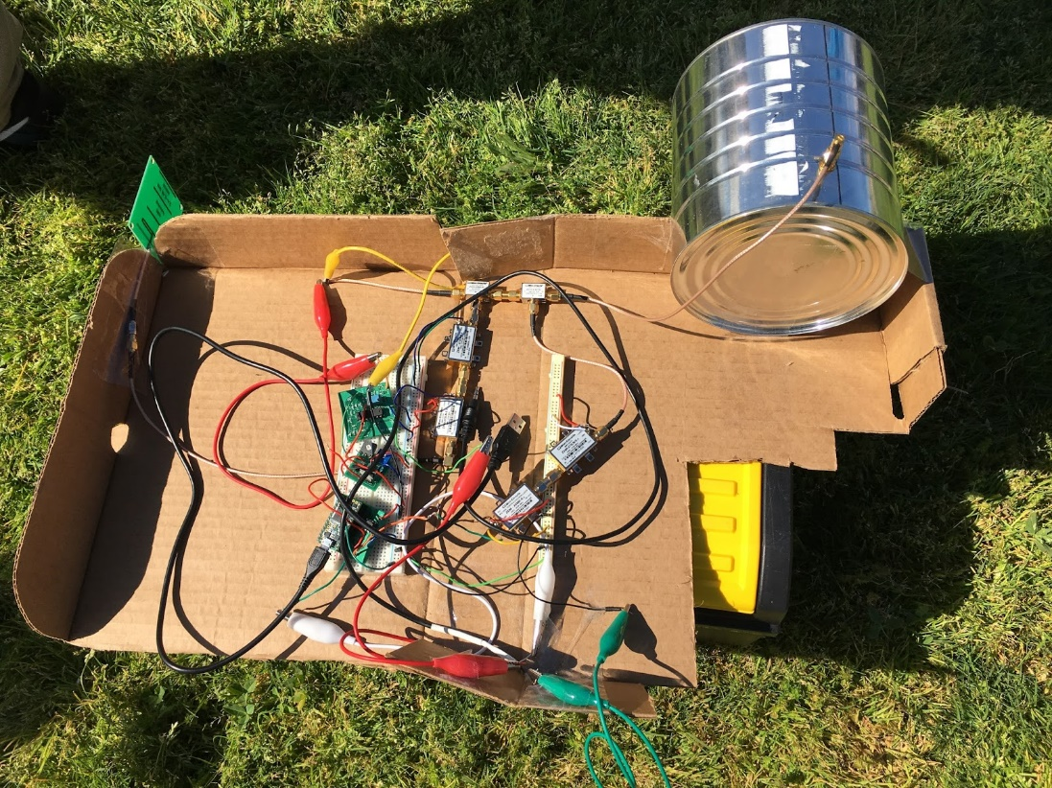

Fig 22. Final Radar System

We first tested the system in the lab room. We got a very clear plot this time. As shown in the following plot, we could see a clear path shown one of our group member walking away from the radar and then walked back.

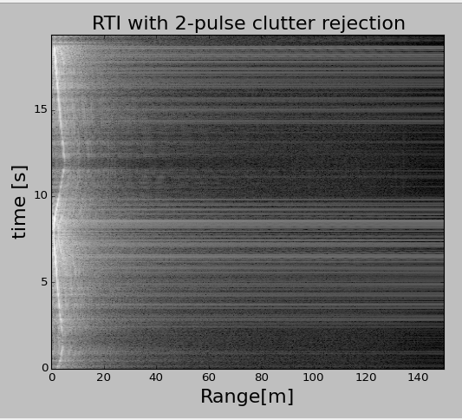

Fig 23. Final Radar System In-room Testing Result

In the final test competition, we used this final radar system and got the following results for each test.

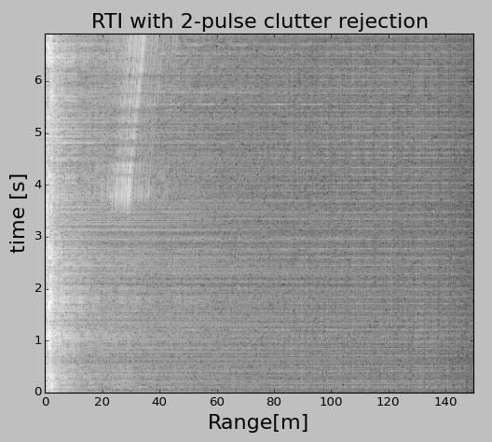

Fig 24. Final Test 1

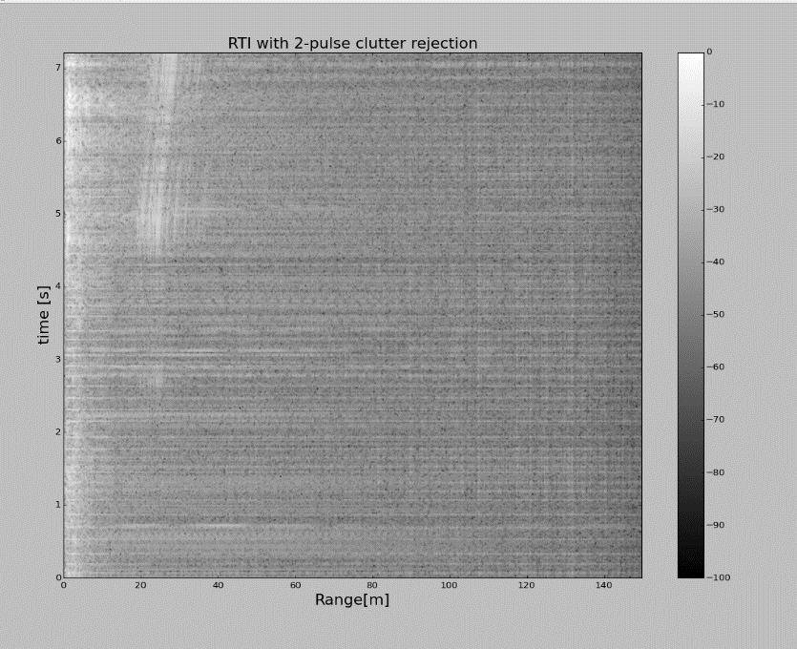

Fig 25. Final Test 2

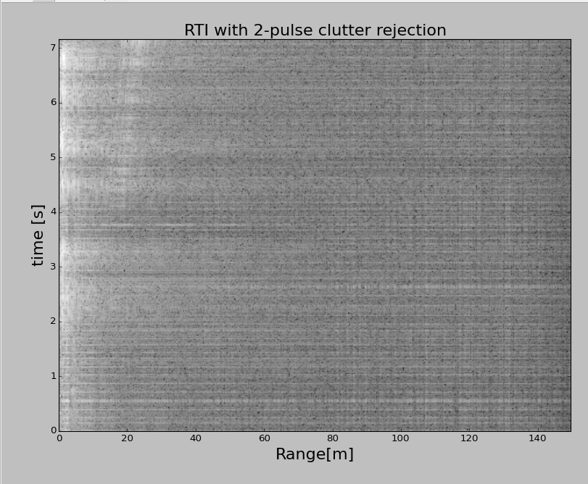

Fig 26. Final Test 3

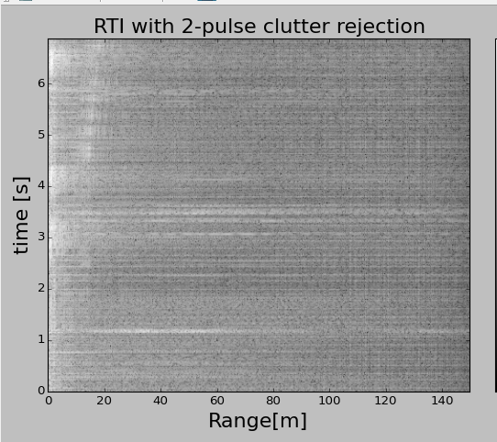

Fig 27. Final Test 4

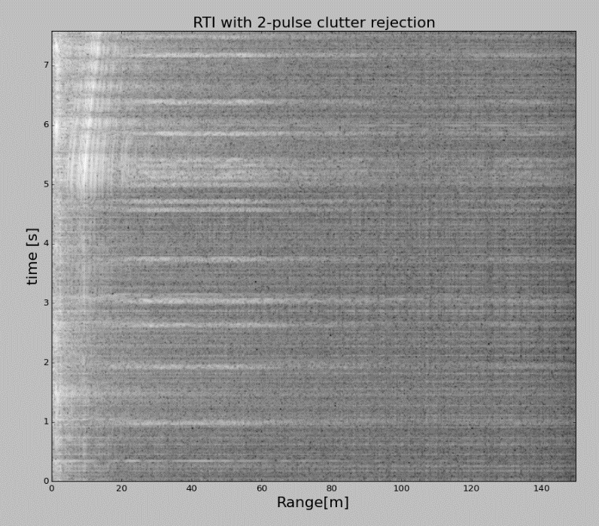

Fig 28. Final Test 5

As shown in the all five figures above, our radar system can detect the metal plate as far as 50 meters. From all those five figures, we can clearly know that TA were walking from nearly 50m toward to us. The results we got are showing in the below figure.

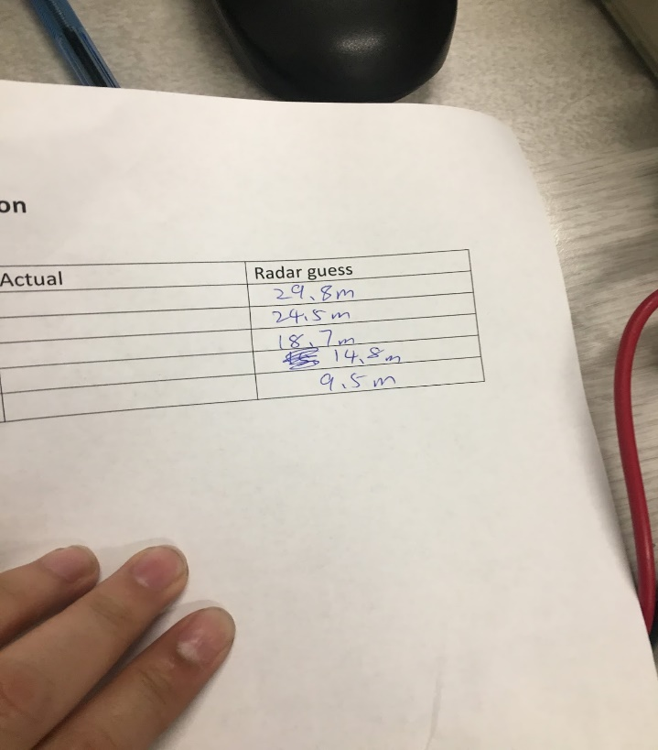

Fig 29. Final Test Guessing Results