Vladislav Vakulchik

ID 998107581

EEC 134

Professor Liu

UC Davis Winter 2017

Application Note: RF PCB Design

The first step in designing a PCB is to know that the circuit has no flaws and will perform as desired. To test this, one may simulate the circuit on a solder-less breadboard and confirm the design properly functions. However, this is not possible at RF, so the recommendation would be to find a circuit simulator able to test at higher frequencies. For example, ADS (Advanced Design System) can be an appropriate option for an RF circuit testing software.

Once there is confirmation that the circuit works, we can now build that circuit in the schematic portion of the PCB design software. In our case, the chosen software was KiCad. KiCad is a viable option because it is compatible with Bay Area Circuits requirements. Certain schematic components that are needed may not be in the KiCad library. This is when a custom component should be created. Note: Each component may have its own circuit so plan accordingly as to how complex you desire the system to be.

**Make sure to know when wires are nodes and when they are not. I made the mistake of thinking there was not a junction between two wires. This caused the LNA in our system to not work.**

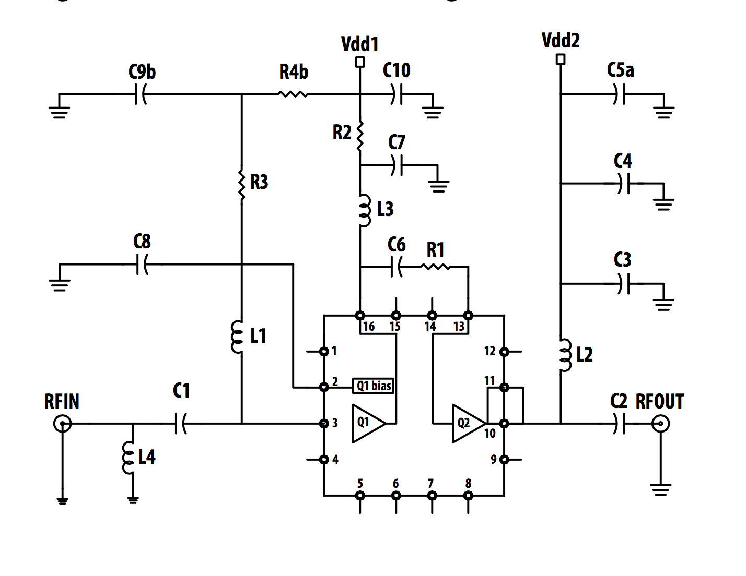

**Luckily, the node was related to biasing and not matching. This allowed our group to solder jumper wires in the necessary areas.**

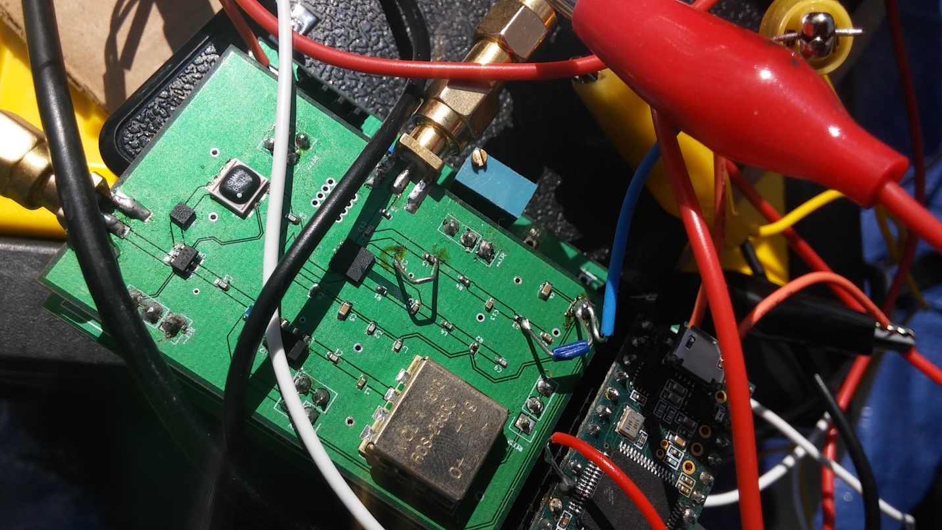We were lucky and had we not been so lucky, would have had the receiver portion of the RF PCB poorly working. Once the circuit is double checked and wired in KiCad, it is recommended to run for errors and warnings. Errors should be fixed while typically warnings may be left alone.

The next step is to make the custom footprints. Since the KiCad library may not have the needed footprints, a custom footprint should be created.

The footprint dimensions are in the component’s data sheet. Make sure to follow the PCB land pattern (footprint dimensions) exactly as stated in the data sheet. I made them slightly larger to give more space when soldering. In hindsight, that step was not necessary since the extra calculations wasted time. Make certain of the orientation as there are times that the data sheet shows a component from the bottom. Once the custom footprints are created, double check all the dimensions. This may seem like a hassle, but it can potentially prevent from future complications. The footprints are extremely vital because if incorrectly made, the component may not properly fit on the PCB leading to either poor performance or a broken system.

The next step is to associate the components in the schematic to the component footprints that will physically be on the PCB. This is done by clicking CvPcb on the schematic toolbar which will open a dialogue box with three sections. Click on a component in the middle dialogue box and double click the desired footprint in the rightwards dialogue box. Do this for each component, then save.

Before laying out the PCB, we need to find the widths of the transmission lines for matching.

I recommend using Coplanar Waveguide (CPWG). You can use “http://chemandy.com/calculators/coplanar-waveguide-with-ground-calculator.htm” to calculate the necessary parameters.

The RF PCB can now be layed out. You should make the transmission lines as straight as possible. If a straight connection cannot be achieved, you can connect at 45 degree angles. However, avoid 90 degree connections.

If, as in our case, the pads of some components are much smaller than the width of the trace, it may be necessary to connect a thinner trace to the wider trace. When you do the copper fill and change the layout, make sure you remove fill and re-fill again.

Our group used a distance of 2 mm between connecting components so that space will be conserved. This allows for the board to be smaller and soldering still manageable.

General Tips:

Aim for a simple design as ambition often leads to a non-functioning system.

Try different variation of antenna configurations. We believed that having the Yagi antenna as a receive would degrade results. However, this configuration with a Cantenna as the transmit and the Yagi as the receive gave us the best results.

Make sure you are certain of orientation when you solder the components onto the board. If possible, place some flux on the pads to preventing the contacts from shorting.

To test RF board, cut a Coaxial Cable, connect to spectrum analyzer, and probe near the RF trace.

Always buy back up components. I repeat, Always buy backups, often multiple sets.

Do many tests in different environments and remember to calibrate.

Don’t be afraid to spend money. It is there to help you gather all the resources to have a successful and fun senior design project.