**RF PCB Technical Notes**

Josue Herrera

EEC 134

Professor Liu

26 March 2017

Having worked on PCB desgin and fabrication this qurter, there are lessons that I have learned that I strongly believe will be helpul in future projects and that could be useful for students taking this course in the future.

Because our first RF PCB worked as intended and after taking into consideration the PCB and MiniCircuts shipping times, and the time needed to build and test the RF PCB, as a group we decided to use our first PCB in the final project; nonetheless by no means does this mean that our PCB was perfect, and had we had the time, we I have implemented the following changes.

The major problem with out PCB was the lack of test points for the bias voltages and the RF signal. As can be observed in figure 1, the only inputs and outputs for the PCB are the bias inputs, the transmitter output, the receiver input and the IF signal output.

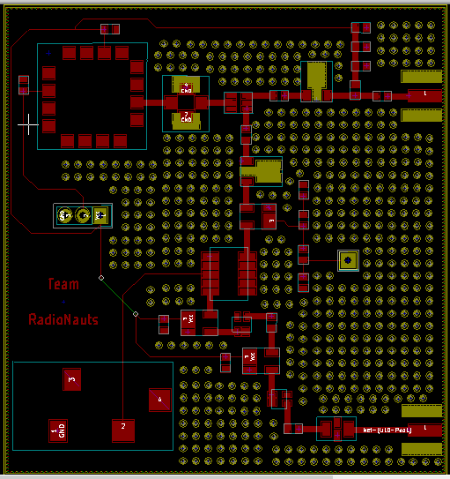

Figure 1: RF PCB

While there were sevel points troughout the PCB with exposed metal where each component was soldered that one could easily reach with the probe that was made from an SMA cable, this was an innacurate and unreliable method for testign and dubbugging the RF PCB. The method was unreliable because, using at best one was able to measure the gain or loss across the RF components and often those reading were unreliable, which lead great uncertainty about the possible problem in the PCB. At times, the only solution was to desolder the component to test it separetely or remove a component in order to isolate a computnt that was left in the PCB. As a result, my plan was to add test points through out the PCB. Before decideing that keep our first PCB, I had plan to include test points as the ones shown in figure 2.

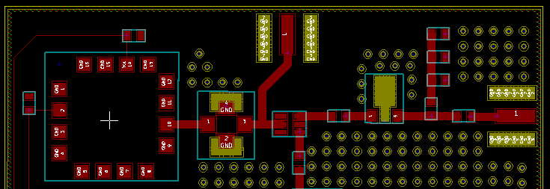

Figure 2: RF PCB with test points

The problem with tis kind of test points is that it violated one of the design rules stated in the RF PCB tutorial given given in class, which stated that the tranmission lines should be kept as short as possible in order to prevent losses in the system. The second idea was the to add test points that could be used if they were needed, but unused when they were not required. The idea was then to include test points as the ones shown in figure 3.

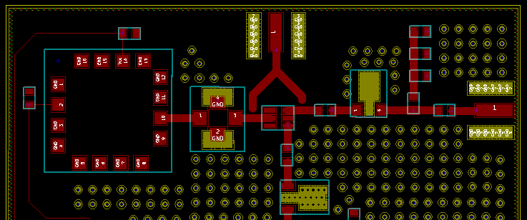

Fiugre 3: Usoldered Test points

Unline the test poitns in figure 2, the test poits in figure 3 will not cause any losses, reflections or interferences to the system when they are not connected to the main tranmission line traces. Althogh these test lines would require some work to integrate into the system by needing to be connected using copper tape, they would serve their intended function of serving as test points and if after running the necessary steps and debugging, the PCB was found to be useful then it could be used withot compromising the performance of the system. One must note from this figure 3, that this was only an example of how to use test lines would look, but in order to implete this test points, the end of the tranmission lines leading to the SMA connector must be exposed footprint leads so that copper tape can be soldered to it. This also applies to the points where the test point traces will connect to.

When designgin the RF PCB, the focus and priority shoud be the RF components and traces. The RF traces should have priority over any bias trace, and because the there will be RF traces running to the test point SMA’s, this means that there will be no possible path for the bias traces; this is not only fine but also something needed for the RF board. In order to test the active components in the RF board, one may also test the power consumed by each component and this can only be done if the bias of each active compnent can be isolated, which can only be done by braking the bias braces carrying the voltage and current to the active component as shown in figure 4.

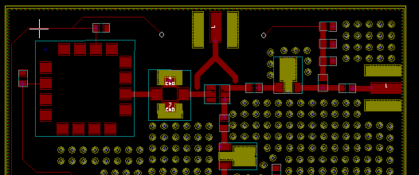

Figure 4: Bias test points

As can be observed in figure 3, the bias is provied to the power amplifier by connecting a wire betwee the header pins located at the edges of the RF test poin SAM. In comparison to figure 1, if one wanted to test the current drawn by the power amplifier, one could simply disconnect the wire carrying the bias to the power amplifier and connected in series to a multimeter, which would allow one to determine the current and voltage being drawn by the power amplifier. After calculating the power consumption of the component, one could compare this value to that provided on the datasheet.

A few final notes for RF PCB’s comes from the fabrication process. When fabricating the PCB, one should first solder and test the small components, for after soldering the large components, it becomes unpractical and time consumming to correct any short circits resulting from improper soldering. While designing the PCB, the components should not be too close together, for if one needs to desolder a component, the heat will likely melt the solder in the adjecent components, which may fall or move out of place. In cases, such as when using the heat gun to desolder a component, it will not be possible to direct the heat only at the inteded cmponent, but one can limit the heat reaching the surrounding components by shilding them using the metal tweezers used to to handle small components. Continuing with this topic, when designing the PCB, it may be difficult to estimate the distance beteen components based on the footprints, however, by becoming familiar with the smd capacitors used in class ( 0603 imperial), one can gain an intutuion on the PCB design tool of the space between components by placing a 0603 component nest to it.