
How to Model Your Favorite Biological Network with Netflux
Jeff Saucerman (U. Virginia)
UC Davis, December 10, 2026, 3:00 to 5:00 PM, followed by a reception · GBSF Auditorium

Bring your laptop with WiFi and a cartoon image of a signaling pathway you’d like to model
- More info at: https://tinyurl.com/davisnetflux
Goal: To develop your own predictive computational model of a small biological network
Feel free to email Jeff Saucerman (jsaucerman@virginia.edu) or submit issues on GitHub
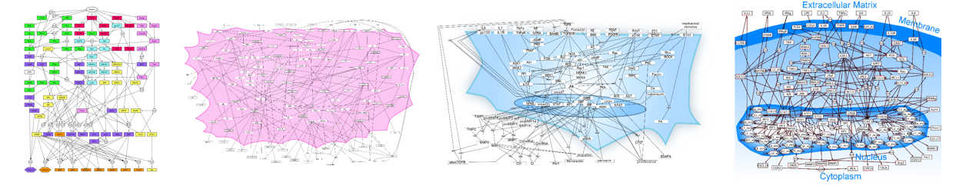


Resources
Primary Resources | URL
Netflux Workshop Notes (this document) | https://virginia.box.com/s/bh3y8wypzeitvddsj50etvqvc2zgkuux  https://tinyurl.com/davisnetflux
Netflux Web App | https://netflux.pythonanywhere.com
Netflux tutorial  Clark et al PLOS Comp Biol 2025 | https://pubmed.ncbi.nlm.nih.gov/40184419
Netflux Workshop slides
Supplementary Resources | URL
Netflux video tutorial | https://www.youtube.com/watch?v=tU2gU8d5hvQ
Netflux source code - MATLAB | https://github.com/saucermanlab/Netflux
Netflux source code - Python | https://github.com/saucermanlab/Netflux2
Papers using Netflux or Logic-Based Differential Equations | https://virginia.box.com/s/adyouty5x4jakr6lcr2il45708eiqmb4
FAQ about Logic-Based Differential Equations and Netflux (advanced) | https://virginia.app.box.com/file/1958177298069

Agenda
Introduction (10 min)
Hands-on introduction to using Netflux using exampleNet (10 min)
Share and discuss your network schematic (10 min)
Time to work on your network model, in pairs (25 min)
Share initial progress with your model, reflection and questions on modeling biological networks
Wrap-up

Share your name and example network schematic
Jeff Saucerman
Wnt signaling in myocardial infarction. Fu et al Acta Pharmacologica Sinica (2019)
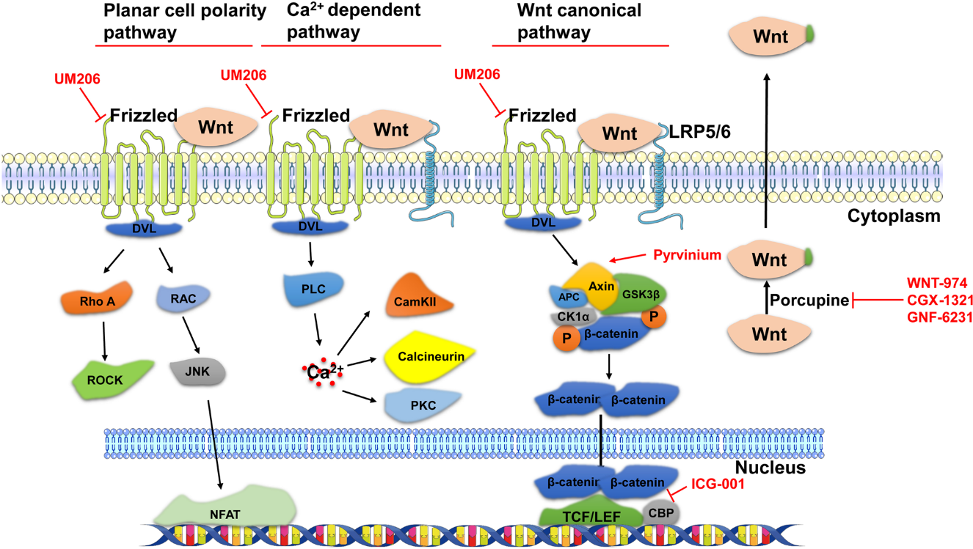

Share your name and example network schematic

