Quarto Vignette Example
library(ettbc)

1 Introduction
This vignette demonstrates how to use Quarto (.qmd) files as vignettes in R packages. Quarto is the next-generation version of R Markdown, offering enhanced features and better integration with multiple programming languages.

2 Why Use Quarto?
Quarto offers several advantages over traditional R Markdown:
- Enhanced features: Better support for cross-references, callouts, and other advanced formatting
- Multiple engines: Works with R, Python, Julia, and Observable
- Modern syntax: Cleaner YAML and chunk options using #| syntax
- Better publishing: Improved website and book publishing capabilities

3 Basic Example
Here’s a basic example using the package:
# Create some sample data
sample_data <- c(1, 2, 3, 4, 5, 10, 15, 20)
# Use the example function
result <- example_function(sample_data)
result
#> [1] 4.5

4 Quarto Features

4.1 Callouts
 Note
This is a callout block that highlights important information.

 Tip
Quarto supports multiple types of callouts: note, tip, warning, important, and caution.

4.2 Code Chunks with Modern Syntax
You can use the modern #| syntax for chunk options:
# Create a simple plot
plot(sample_data,
main = "Sample Data",
xlab = "Index",
ylab = "Value",
pch = 19,
col = "steelblue")
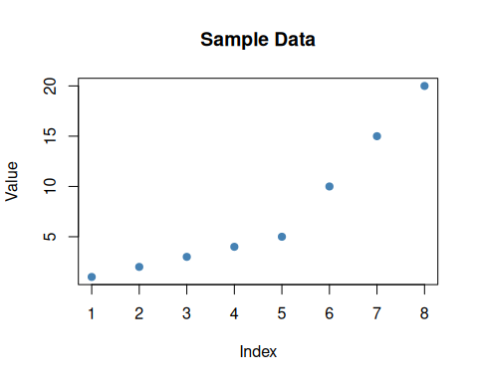
Figure 1: Example plot showing data distribution

5 Equations
Quarto has excellent support for mathematical equations using LaTeX syntax:
Inline equation: $E=mc^{2}$
Display equation:
$$\overset{‾}{x}=\frac{1}{n}\sum_{i=1}^{n}{x_{i}}$$

6 Tables
Table 1: Comparison of R Markdown and Quarto
Feature | R Markdown | Quarto
YAML | Standard | Enhanced
Chunks | {r, option=value} | #| option: value
Publishing | Good | Excellent
Cross-refs | Limited | Native

7 Summary
Quarto vignettes provide a modern, feature-rich way to document R packages. They integrate seamlessly with documentation systems and offer enhanced capabilities for technical documentation.

8 References
For more information, see:
- Quarto Documentation
- Using Quarto with R
- R Core Team (2024)
- Morrison (2024)
Morrison, Douglas Ezra. 2024. Ettbc: Emulating a Target Trial for Breast Cancer Screening. https://github.com/ucdavis/ettbc.
R Core Team. 2024. R: A Language and Environment for Statistical Computing. R Foundation for Statistical Computing. https://www.R-project.org/.

