Innovation Lab for assets and Market access

**Introduction:** Many of the world’s poor live in rural areas and rely on agriculture for a living. Increasing food production not only creates more to eat – but also allows for more to sell. Growth in the agriculture sector is one of the best ways to spur economic development to reduce poverty and leave no one behind.

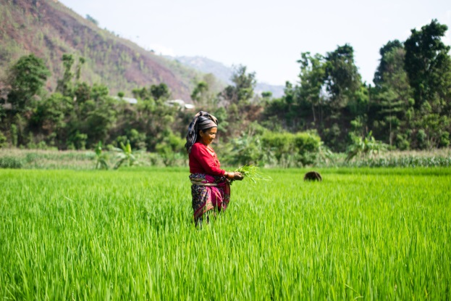**The Labs:** The FTF Innovation Lab for Assets and Market Access is one of 24 Feed the Future Innovation Labs that leverage U.S. university research to advance agricultural science and reduce poverty in developing countries. Each university-hosted Feed the Future Innovation Lab, with collaborative research partnerships in developing countries, works solve some of the world’s most pressing agricultural challenges.

**Impact:** Since 2009, the AMA Innovation Lab has been identifying and supporting agricultural economic research and promoting those projects that empower the vulnerable to rise up out of poverty. Our broad portfolio of projects has shown that index-based insurance packages, flexible savings and credit programs, and temporary input subsidies are all adding significant value to the lives of smallholder farmers and pastoralists.

*In Nepal, as well as in many other developing countries, the AMA Innovation Lab is working on ground-breaking agriculture economic research structure to understand the role risk plays in keeping people poor, and how to mitigate that risk.*

Photo: Nick Magnan

**Why Assets and Market Access?**

A projected 702 million people still live in extreme poverty. Climate or market shocks can further drive them into a downward spiral; making their often dire circumstances even worse. By pioneering approaches to reduce risk, protect assets, and create new avenues for farmers to reach markets, the AMA Innovation Lab has been creating stability and opportunity in impoverished regions all around the world.

**Collaborating across borders to strengthen small-scale farmer access to markets & assets**

**Director:** Michael Carter

**Contact:** mrcarter@ucdavis.edu

**Focus countries:** Bangladesh, Burkina Faso, Dominican Republic, Ethiopia, Ghana, Haiti, Kenya, Malawi, Mozambique, Mexico, Nepal, Tanzania, Senegal, Uganda

**Award:** 40 million over 10 years

**Led by UC Davis since:** 2012

**Focus Activities**:

Through a pioneering toolbox of financial, behavioral, and informational innovations, our lab strives to better understand the roadblocks that stop farmers from adopting new technologies and works to design interventions to close yield gaps, increase productivity and secure more sustainable livelihoods. The AMA Innovation Lab’s policy-relevant research on how market function and access can promote (or hinder) asset accumulation and the competitiveness and the capacity of smallholder farmers and the rural poor to manage economic and climate-related shocks is making real-world impact.

* Please visit our website, basis.ucdavis.edu to read more about the impact of our projects such as Index-based Livestock Insurance in Kenya and Ethiopia and our work on Temporary Input Subsides in Mozambique.