Feed the Future Innovation Lab for climate resilient chickpea

**Introduction:** The Climate Resilient Chickpea Innovation Lab emphasizes the crop-based traits of climate resilience and nutrition, focusing genetic improvement on the needs of smallholder farmers in Ethiopia and India. In both countries chickpea is key to food security, providing a vital source of protein nutrition and income. Year-to-year climatic variation is a key factor limiting yields.

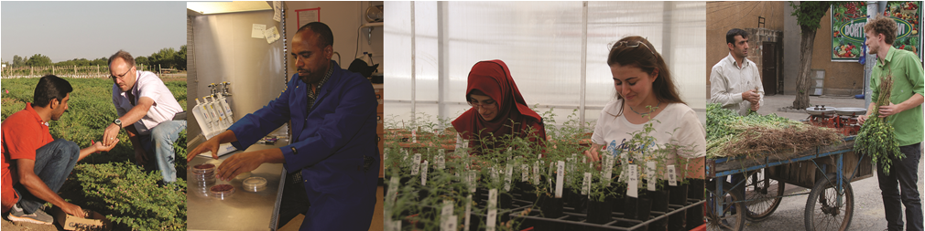

**Background:** Policy and investment since the 1960’s have favored Green Revolution cereal crops, which were planted on the best agricultural land and received the lion’s share of investment. Legumes were often relegated to marginal lands where elevated temperatures, rain fed cropping systems, short growing seasons and poor soils conspired to limit yield potential. Enhancing climate resilience – including resilience to variable climate, marginal soils, and climate-driven plant disease – is a primary challenge to chickpea production.

**Collaborating across borders to enhance Chickpea**

**Director:** Professor Douglas Cook

**Contact:** drcook@ucdavis.edu

**Focus countries:** Ethiopia & India

**Award:** $6 million over 5 years

**Launched at UC Davis in:** 2014

**Project:** Chickpea has exceedingly narrow genetic and phenotypic diversity, which has consequences for breeding because much of the capacity to tolerate environmental extremes has been lost through domestication. Breeding for climate resilience as well as other high value traits will be greatly accelerated if we can expand the range of adaptations accessible to breeders. Towards this end, the Chickpea Innovation Lab is characterizing wild chickpea from a representative range of environments; introducing wild diversity so that it is amenable for trait assessment and breeding; characterizing the material by systematic phenotyping; developing a digital information network that identifies and quantifies the contributions of useful alleles; and developing improved chickpea varieties using an international consortium of chickpea breeders. The project fosters breeding of high-yielding, climate-resilient chickpea within the context of user-preferred traits.

***"Our efforts harness the potential of wild species to increase genetic diversity and elevate crop production and farmer prosperity in the developing world." – Douglas Cook, Director***

**Impact:** Since 2014, the Chickpea Innovation Lab has expanded its partnerships and funding by ~3-fold, now involving 25 laboratories in 8 countries. We are training numerous graduate students and postdocs through partnerships with international institutions. Our international colleagues along with U.S. collaborators are discovering and delivering genetic solutions for drought and heat stress, disease and pest resistance, plant architecture, and nitrogen fixation**.**