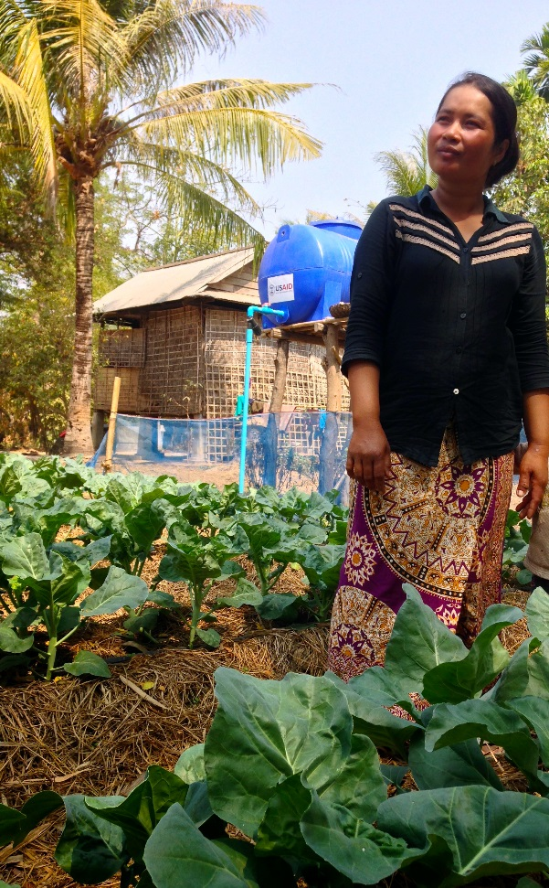Horticulture Innovation Lab

**Introduction.** Many of the world’s poor live in rural areas and rely on agriculture for a living. Increasing their prospects for food production not only creates more food to eat – but it can also have a serious impact on people’s income and pull them out of poverty. Growth in the agriculture sector is one of the best ways to spur the kind of economic growth that reduces poverty and leaves no one behind.

Replace with  
optional photo (3” W)

*In Cambodia, the Horticulture Innovation Lab helps farmers use conservation practices to grow vegetables and earn higher prices with market connections.*

**Feed the Future Innovation Labs.** The Horticulture Innovation Lab is one of 24 Feed the Future Innovation Labs that leverage U.S. university research to advance agricultural science and reduce poverty in developing countries. Each Feed the Future Innovation Lab is led by a university, with collaborative research partnerships in developing countries to solve some of the world’s most pressing agricultural challenges.

**Impact.** Since 2009, the Horticulture Innovation Lab has invested $37 million in agricultural research – training more than 38,000 individuals in 30 countries, including more than 14,000 farmers who improved their farming practices.

**Why horticulture? Improving diets and incomes**

Horticulture – growing fruits and vegetables – provides critical nutrients for a balanced diet. Diets low in fruits and vegetables contribute to some of the most widespread, debilitating nutrient-related disorders. Increasing access to diversified, nutrient-rich diets is a major goal of the Horticulture Innovation Lab.

**Collaborating across borders to strengthen horticultural value chains**

**Director:** Elizabeth Mitcham

**Contact:** horticulture@ucdavis.edu

**Focus countries:** Guatemala, Honduras, Kenya, Rwanda, Uganda, Zambia, Bangladesh, Cambodia, Nepal

**Award:** $37 million over 10 years

**Led by UC Davis since:** 2009

Farmers who grow high-value horticultural crops such as fruits, vegetables, flowers or herbs consistently earn more than those who grow other commodities. Horticulture can increase their profits and be an engine for agricultural and economic diversification.

**Focal Activities.** To support horticultural development, the Horticulture Innovation Lab focuses on research across the value chain – seed systems, vegetable production, irrigation innovations, conservation practices, pest management, reducing postharvest losses, market access and extending agricultural information. Improving gender equity, advancing technological innovation, improving access to information and building research capacity are central to the Horticulture Innovation Lab’s work.