Feed the Future Innovation Lab for Sustainable Intensification

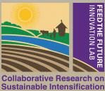 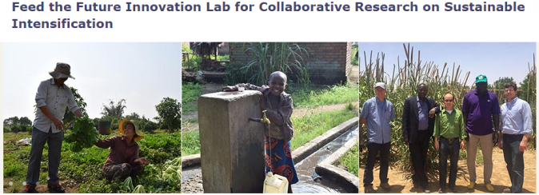

**Lead University of Kansas**

**Focus.** Feed the Future Innovation Lab for Sustainable Intensification Lead University: Kansas State University This Innovation Lab focuses on integrated farming systems research and technologies to sustainably increase agricultural productivity and income that provide food security and nutrition to smallholder farmers.

**Focus Countries**: Bangladesh, Burkina Faso, Burma, Ethiopia, Ghana, Senegal, Tanzania

**Website**: [www.k-state.edu/siil](http://www.k-state.edu/siil)

**Director**: Vara Prasad, [vara@ksu.edu](mailto:vara@ksu.edu)

**UC Davis component - Geospatial and Farming Systems Research Consortium (GFSRC)**

**Focus**. Support SIIL by providing spatially-explicit data and analysis to identify 1) current patterns of agricultural intensification, 2) opportunities for sustainable intensification, 3) strategies for increasing adoption and diffusion of technologies, 4) Organize these materials into an interdisciplinary university-level course on the topic

**Website**: <https://www.k-state.edu/siil/whatwedo/consortiums/geospatial/index.html>

**Lead.** Robert Hijmans

