Feed the Future Innovation Lab for climate resilient millet

**Introduction** Many of the world’s poor live in rural areas and rely on agriculture for a living. Increasing their prospects for food production not only creates more food to eat – but it can also have a major impact on people’s income and pull them out of poverty. Growth in the agriculture sector is one of the best ways to spur the kind of economic growth that reduces poverty and leaves no one behind

**Collaborating across borders to enhance Millet**

**Director:** Eduardo Blumwald

**Contact.** [eblumwald@ucdavis.edu](mailto:eblumwald@ucdavis.edu)

**Collaborators:** Vincent Vadez**,** ICRISAT, India.

**Focus countries:** India, Mali, Nigeria

**Award:** $1,800,000 over 4 years

**Led by UC Davis since:** 2012

**The Labs.** The FTF Innovation Lab for Climate Resilient Millet is one of 24 Feed the Future Innovation Labs that leverage U.S. university research to advance agricultural science and reduce poverty in developing countries. Each Feed the Future Innovation Lab is led by a university, with collaborative research partnerships in developing countries to solve some of the world’s most pressing agricultural challenges.

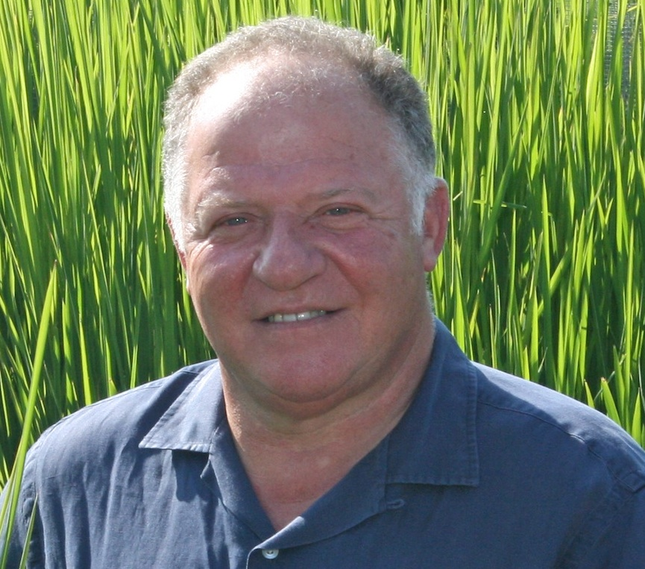**Impact.** Since 2012, the Climate resilient Millet Lab developed methods for the genetic transformation of elite pearl millet varieties, mapped drought tolerant QTLs and screened water-use-efficient millet germplasm.

**Why Millet.** Millet is a staple food particularly among the poorest rural households and among the poorest countries. It has grown in importance in Africa where the area planted doubled in the last 20 years. Millet’s growing value in the food and feed industry offers opportunities for income generation and this economic value is evident in the growth in production in both Africa and Asia. Millet is grown almost entirely in hot, drought-prone arid and semi-arid regions and seasonal variations in rainfall and extreme high temperatures are the most important factors limiting millet yields, making millet production increasingly perilous for these families. There is a great need to protect the staple diets of these poor families by providing varieties that can better tolerate drought and heat stress.

**Focal Activities.** This Innovation Lab is harnessing genomic and advanced molecular tools and proprietary technologies for climate resilience from U.S.-based (Arcadia Biosciences) and India-based (Krishidhan Seeds) companies to develop heat- and drought tolerant millet varieties for smallholder farmers.

**Website:** <http://www.arcadiabio.com/news/press-release/indo-us-consortium-develop-drought-tolerant-pearl-millet-asia-and-africa>