Feed the Future Innovation Lab for genomics to improve poultry

**Introduction** Many of the world’s poor live in rural areas and rely on agriculture for a living. Increasing their prospects for food production not only creates more food to eat – but it can also have a major impact on people’s income and pull them out of poverty. Growth in the agriculture sector is one of the best ways to spur the kind of economic growth that reduces poverty and leaves no one behind.

**Collaborating across borders to enhance smallholder poultry production**

**Director:** Huaijun Zhou

**Contact:** [hzhou@ucdavis.edu](mailto:hzhou@ucdavis.edu)

**Focus countries:** Ghana, Tanzania

**Award:** $6 million over 5 years

**Led by UC Davis since 2013**

**The Labs.** The FTF Innovation Lab for Genomics to Improve Poultry is one of 24 Feed the Future Innovation Labs that leverage U.S. university research to advance agricultural science and reduce poverty in developing countries. Each Feed the Future Innovation Lab is led by a university, with collaborative research partnerships in developing countries to solve some of the world’s most pressing agricultural challenges.

**Impact.** Since 2013, the Genomics to Improve Poultry Innovation Lab has renovated facilities at universities in Tanzania and Ghana for poultry breeding and for conducting experimental trials. The Innovation Lab has also trained African graduate students, staff, and faculty in poultry biosecurity, animal experimental trials, and laboratory assays.

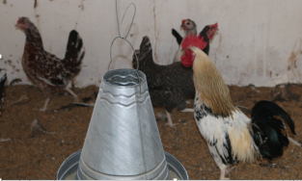

**Building Human and Institutional Capacity**

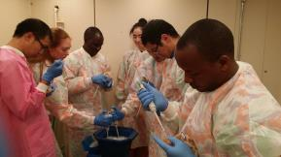

**Why Poultry?**

The majority of poor rural families in less developed countries typically have one or more chickens running around their home gardens. These animals represent a major opportunity to improve incomes and nutrition through greater meat and egg production with minimal inputs. However, to achieve this, major challenges exist. Chicken populations in villages struggle to thrive; being regularly decimated by diseases – especially Newcastle disease - the most problematic and virulent. In addition, high temperatures affect both bird growth rate and egg production.

**Focus activities.** This Innovation Lab is working to reduce limitations to poultry production by applying advanced genetics and genomic approaches to enhance innate resistance to Newcastle disease and tolerance to heat stress in chickens in places where Newcastle disease and hot climates are prevalent.