Data Quality Report (DQR)
Dataset: ppr-group-25208508-train.csv
Module: COMP47350 Group Project - Part (1) DQR
Scope: Data understanding, quality diagnosis, and action recommendations for downstream cleaning and modeling.

1. Executive Summary
This report presents a structured data quality assessment for the training dataset used in the residential property price prediction task. The objective is to identify quality risks that can affect statistical analysis and model robustness, then define practical actions for the next stage (Data Quality Plan, DQP).
The dataset contains 54,000 rows and 9 columns. At a high level, the data is usable but requires targeted handling in four critical areas:
- High missingness in location/size-related fields (Eircode, Property Size Description).
- High-cardinality text features (Address, Eircode) that are not directly model-friendly.
- Price outliers and heavy right skew, which may destabilize model training.
- 4. Small number of exact duplicates that should be removed for consistency.
Core recommendation: preserve business signal while simplifying fragile raw fields through controlled feature engineering, robust target handling, and transparent step logging in DQP.

2. Dataset Overview

2.1 Shape and Features
- Rows: 54,000
- Columns: 9
- Features:

  - Date of Sale (dd/mm/yyyy)
  - Address
  - County
  - Eircode
  - Price (€)
  - Not Full Market Price
  - VAT Exclusive
  - Description of Property
  - Property Size Description

2.2 Time Coverage
Date of Sale is fully populated and valid for all records. Transactions span 2016 to 2024, with near-even annual counts in this grouped sample.

3. Data Quality Findings

3.1 Missingness
The missingness profile is concentrated in two columns.
Feature | Missing Count | Missing Rate
Property Size Description | 51,164 | 94.75%
Eircode | 37,108 | 68.72%
Other columns | 0 | 0%
Interpretation: - Property Size Description has very limited usable coverage and cannot reliably support size-based modeling decisions in its current form. - Eircode is heavily missing and inconsistent as a direct location key.

3.2 Duplicates and Constants
- Exact duplicate rows: 9 (0.017% of all rows)
- No meaningful fully constant analytical column after preprocessing checks.
Interpretation: - Duplicate count is small but should still be removed to avoid duplicated training signal and metric distortion.

3.3 Cardinality and Feature Usability
High-cardinality fields:
- - Address: 53,261 unique values
- - Eircode: 16,823 unique values
Moderate/low-cardinality fields:
- - County: 26
- - Description of Property: 3
- - Not Full Market Price: 2
- - VAT Exclusive: 2
Interpretation: - Raw Address and Eircode should not be directly one-hot encoded. - Structured, low-dimensional derived location features are preferred.

3.4 Price Quality and Distribution
Parsed numeric Price (€) summary:
- Mean: 340,639 - Median: 250,000 - Std: 1,662,132 - Min: 5,250
- 5th percentile: 60,000 - 95th percentile: 703,000 - Max: 225,000,000
Interpretation: - Distribution is strongly right-skewed. - Extreme values (especially very high-end records) can dominate model loss and coefficient estimation. - Robust transformation/clamping should be applied in DQP.

3.5 Category Balance (Key Fields)

County

- Dublin: 16,592 (~30.7%)
- Cork: 5,975
- Kildare: 2,926
- Others with smaller shares

Description of Property
- Second-Hand Dwelling house /Apartment: 44,332
- New Dwelling house /Apartment: 9,665
- Minor residual category: 3

VAT and Full-Market Indicators
- VAT Exclusive: Yes = 9,514, No = 44,486
- Not Full Market Price: Yes = 2,850, No = 51,150
Interpretation: - Category imbalance is manageable but must be acknowledged in interpretation and model evaluation. - VAT Exclusive carries business-rule implications for target standardization.

4. Visual-Analytical Interpretation (from notebook figures)
The notebook visuals support four consistent conclusions:
- Price distribution is heavy-tailed, and raw boxplots show long upper whiskers and extreme outliers.
- County-level heterogeneity is significant, especially for Dublin/Wicklow compared with many other counties. 3. Time signal exists (year-level trend stronger than month-level variation). 4. High-cardinality location raw fields are not directly suitable for robust modeling and should be transformed.
These observations justify moving from raw text location fields to engineered location features and from raw price to standardized robust target variants in DQP.

5. Recommended Actions for DQP

5.1 Feature-Level Plan
Feature | DQR Issue | Recommended DQP Action
Price (€) | Heavy skew + extreme outliers | Parse to numeric, apply business-rule standardization and robust clamping
VAT Exclusive + Description of Property | Price definition inconsistency risk | Rule-based VAT adjustment for qualifying new dwellings
Address | Very high cardinality, noisy free text | Extract compact interpretable features, then drop raw address
Eircode | High missingness + high cardinality | Drop or convert only if stable transformed signal exists
Property Size Description | 94.75% missing | Drop in final cleaned training set
Date of Sale | Raw date not model-ready | Derive Sale Year and Sale Month
Duplicates | Exact duplicates present | Remove duplicate rows

5.2 Modeling-Safety Principles
- Keep preprocessing deterministic and auditable.
- Avoid leakage from target-derived transformations in predictors.
- Prefer robust target formulation for stable evaluation.
- Ensure no missing values remain in the final DQP output dataset.

6. Risk Assessment
If DQP actions are not applied, expected risks include: 1. Unstable model coefficients due to target outliers. 2. Overfitting and sparse matrices from raw high-cardinality text encoding. 3. Reduced reproducibility from ad-hoc preprocessing. 4. Weaker generalization due to unresolved price-definition inconsistency.

7. Conclusion
The training dataset is adequate for predictive modeling after targeted cleaning and transformation. The DQR confirms that the highest-impact interventions should focus on: - robust price handling, - location feature engineering, - explicit missingness strategy, - duplicate removal, - and feature-type finalization.
These decisions form the technical bridge from descriptive quality assessment (DQR) to executable cleaning policy (DQP), and they are expected to materially improve model stability and interpretability in later project stages.

8. Detailed DQR Procedure Alignment with project.ipynb
This section adds the detailed DQR procedural items present in organize/project.ipynb and requested for alignment.

8.1 Data Type Conversion (Raw -> Converted)
Feature | Raw Type | Converted Type | Notes
Date of Sale (dd/mm/yyyy) | string/object | datetime64 | Parsed with dayfirst=True; invalid values coerced to NaT
Price (€) | string/object | float64 | Currency symbol/comma removed, then numeric parse
County | string/object | category | Low-cardinality categorical feature
Not Full Market Price | string/object | category | Binary categorical feature
VAT Exclusive | string/object | category | Binary categorical feature
Description of Property | string/object | category | Low-cardinality categorical feature
Property Size Description | string/object | category | Sparse but standardized before final drop decision
Address | string/object | string (kept raw in DQR stage) | High-cardinality field; transformed in DQP
Eircode | string/object | string (kept raw in DQR stage) | High-missing/high-cardinality field
Sale Year | N/A | Int64 (derived) | Derived from parsed sale date
Sale Month | N/A | Int64 (derived) | Derived from parsed sale date

8.2 Save Interim Cleaned Dataset (Intermediate Artifact)
After core DQR preprocessing (type parsing and duplicate handling), an interim cleaned version is saved for traceability and downstream checks before DQP rule execution.
- Purpose: reproducibility and stage-to-stage audit trail.
- Scope: still a DQR-stage artifact (not final DQP output).

8.3 Table Structure (Standalone)
To match the notebook structure, descriptive statistics are presented in three separate blocks:
- Numeric Features Summary Table
- count, mean, std, min, quartiles, max for numeric variables.
- Categorical Features Summary Table
- non-null count, unique count, top category, top frequency.
- High-Cardinality String Features
- explicit cardinality report for raw string features (notably Address, Eircode) and model-usability commentary.

8.4 VAT Consistency Check (Process Detail)
A rule-consistency check is performed at DQR stage before DQP adjustment:
- Build cross-tab between VAT Exclusive and Description of Property.
- Verify that VAT-related positive cases are concentrated in New Dwelling house /Apartment.
- Flag potential inconsistencies for DQP handling.
This provides the direct rationale for the DQP rule: - for qualifying new dwellings with VAT Exclusive = Yes, create VAT-adjusted price representation.

8.5 Export DQR Summary Tables (Action + Filenames)
The DQR summary exports are explicitly produced as CSV files.
From project.ipynb: - DQR-NumericFeatures.csv - DQR-CategoricalFeatures.csv
From standalone DQR.ipynb workflow (naming variant):

train-cleaned.csv

DQR-NumericFeatures.csv

DQR-CategoricalFeatures.csv8.6 Structured Findings (Subsection Form)
To mirror notebook structure, DQR findings are grouped as:
- Missing Value Issues: concentrated high missing (Property Size Description, Eircode).
- Structural Issues: duplicates and field usability constraints.
- Distribution & Outlier Issues: heavy right tail in price and extreme values.
- Logical Consistency Issues: VAT-related business-rule consistency.
- Feature Usability Summary: keep/transform/drop guidance for DQP.

Appendix A: DQR Code-Generated Figures and Tables (from organize/project.ipynb)
This appendix lists outputs generated by DQR code cells, with section mapping and brief descriptions.

A.1 Figures

Figure A1: Output from cell 28 (1.7 Missing Value Visualisation)
- Section mapping: 1.7 Missing Value Visualisation
- Basic description: Plot generated during DQR exploratory checks to support data quality interpretation.
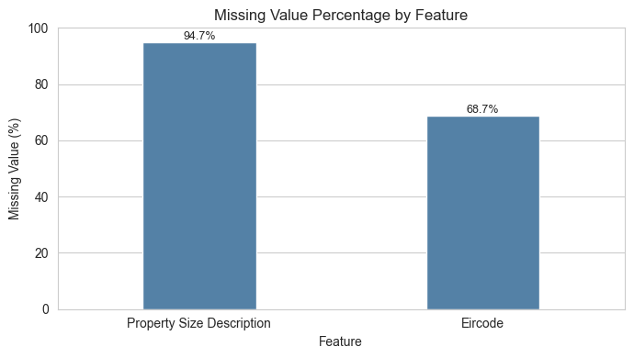

Figure A2: Output from cell 31 (1.8 Categorical Feature Distributions)
- Section mapping: 1.8 Categorical Feature Distributions
- Basic description: Plot generated during DQR exploratory checks to support data quality interpretation.
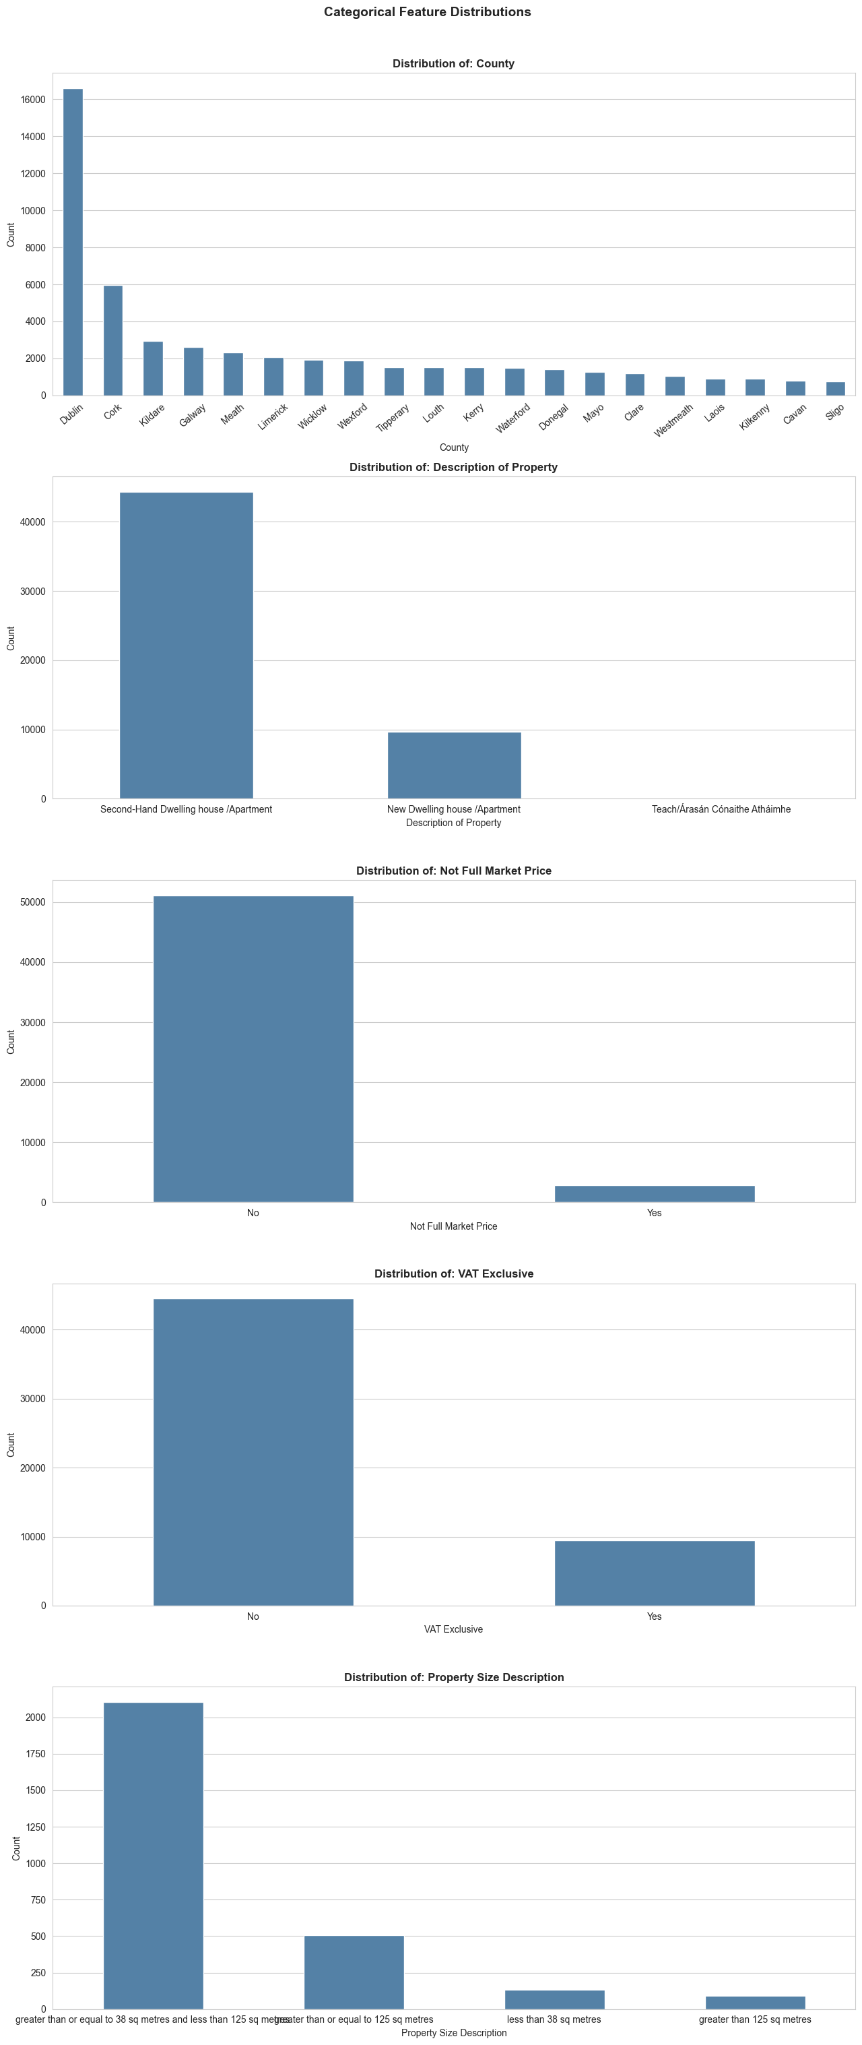

Figure A3: Output from cell 35 (1.9 Price Distribution Analysis)
- Section mapping: 1.9 Price Distribution Analysis
- Basic description: Plot generated during DQR exploratory checks to support data quality interpretation.
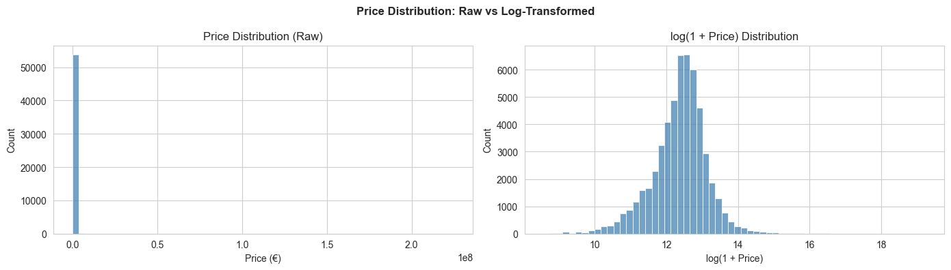

Figure A4: Output from cell 35 (1.9 Price Distribution Analysis)
- Section mapping: 1.9 Price Distribution Analysis
- Basic description: Plot generated during DQR exploratory checks to support data quality interpretation.
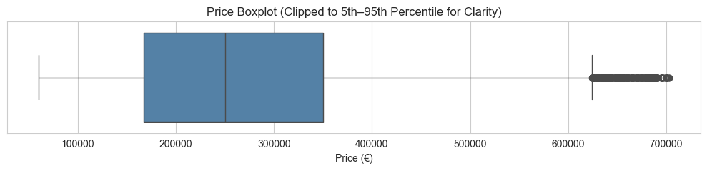

A.2 Tables (Analysis Outputs Only)

Table A1: Initial Data Structure Check (cell 6)
- Section mapping: 1.2 Initial Data Structure Check
- Basic description: Missingness and structure diagnostics (e.g., display(missing_df)).

Table A2: Initial Data Structure Check (cell 6)
- Section mapping: 1.2 Initial Data Structure Check
- Basic description: Complementary structure summary table from the same step.

Table A3: Data Type Conversion Summary (cell 9)
- Section mapping: 1.3 Data Type Conversion
- Basic description: Field-level raw-to-converted dtype summary.

Table A4: Numeric Features Summary (cell 19)
- Section mapping: 1.6.1 Numeric Features Summary Table
- Basic description: Descriptive statistics for numeric features.

Table A5: Categorical Features Summary (cell 22)
- Section mapping: 1.6.2 Categorical Features Summary Table
- Basic description: Cardinality/top-frequency summary for categorical features.

Table A6: High-Cardinality Feature Summary (cell 25)
- Section mapping: 1.6.3 High-Cardinality String Features
- Basic description: High-cardinality diagnostics for string features.

Table A7: Price Outlier Investigation Table (cell 38)
- Section mapping: 1.10 Price Outlier Investigation
- Basic description: Percentile/boundary-based outlier summary.

Table A8: VAT Consistency Check Table (cell 42)
- Section mapping: 1.13 VAT Consistency Check
- Basic description: VAT vs property-type consistency cross-check.

Table A9: VAT Consistency Check Supplement (cell 42)
- Section mapping: 1.13 VAT Consistency Check
- Basic description: Additional table output from VAT rule diagnostics.

A.3 DQR CSV Exports from project DQR section
- organize/train-cleaned.csv
- organize/DQR-NumericFeatures.csv
- organize/DQR-CategoricalFeatures.csv

