4. Machine Learning Model
This chapter describes the machine-learning component of the Dublin Bikes project, whose purpose is to predict the number of available bikes at any given station for every weather-forecast entry currently cached in the database. In the current implementation, only forecast rows up to 48 hours ahead of the current UTC hour are stored. The complete training and evaluation code is version-controlled in the main repository under flask-app/machine_learning/ml.ipynb, together with the exported artefacts bike_availability_model.pkl and model_features.pkl.

4.1 Problem Definition and Target Variable
The business objective is to help users decide when and where to pick up a bike by forecasting future availability. Consequently, the problem is framed as a supervised regression task:
- Target variable: num_bikes_available – the number of bikes that can be rented from a station at a specific point in time.
- Inputs: A vector of temporal, spatial, and meteorological features that are known in advance or can be observed at prediction time.
Predictions are produced in bulk for every forecast entry stored in the weather_forecast table whose forecast_time is at or after the current hour, and the results are exposed to the frontend via the GET /api/stations/<number>/prediction endpoint.

4.2 Dataset and Data-Cleaning Process

4.2.1 Raw Data
The raw training set is the file final_merged_data.csv. It contains 298,946 rows and 78 columns, built by joining historical station-availability snapshots with historical weather readings provided by Met Éireann. Each row represents the state of one specific station at one specific hour.
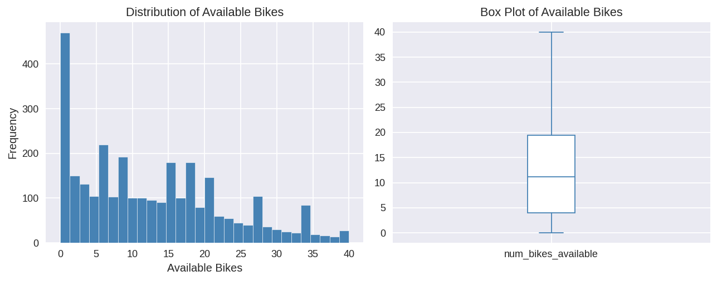

4.2.2 Data-Cleaning and Feature-Selection Rationale
Category of removed columns | Reason
All *_quality_indicator columns | Metadata flags with no meteorological signal.
All *_std_deviation columns | Redundant once corresponding min/max or mean values are retained.
Soil / grass / earth temperature columns | Low correlation with urban bike-usage patterns.
Text columns (name, address, last_reported) | Not numerical; location identity encoded by station_id, lat, and lon.
Near-constant booleans | Almost 100% True; providing no discriminative power.

4.2.3 Feature Engineering
Five derived features were created to capture periodic and meteorological patterns:
- day_of_week, is_weekend, avg_temperature, avg_humidity, avg_pressure.
Additionally, the columns month and year were removed during the correlation analysis phase because the training data covers only December 2024, meaning both columns carry a single constant value (zero variance) and provide no discriminative signal to the model. The final feature set used for model training consists of eleven features: station_id, capacity, lat, lon, hour, day, day_of_week, is_weekend, avg_temperature, avg_humidity, avg_pressure.
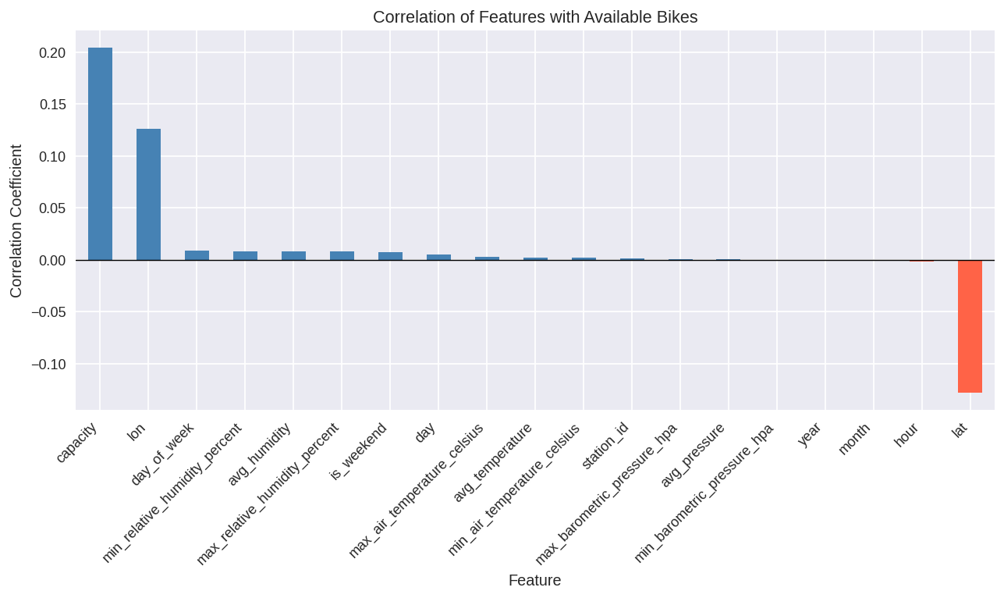

4.3 Training and Testing Process
The dataset was split using a 70% training / 30% testing ratio (random_state=42). Four candidates were evaluated: Linear Regression, Decision Tree Regressor, Random Forest Regressor, and Gradient Boosting Regressor. The Decision Tree was trained with default scikit-learn parameters (no maximum depth constraint, no minimum sample restrictions), allowing the tree to grow fully. The Random Forest was trained with n_estimators=100, max_depth=15, and min_samples_leaf=10 to limit tree depth and reduce variance. Both the Gradient Boosting and Linear Regression models were trained with their respective default parameters.

4.4 Results

4.4.1 Model Comparison
Model | MAE | RMSE | R²
Linear Regression | 7.829 | 9.366 | 0.075
Decision Tree | 0.970 | 2.376 | 0.941
Random Forest | 2.325 | 3.393 | 0.879
Gradient Boosting | 6.120 | 7.537 | 0.401

Based on the superior performance metrics, the Decision Tree was selected as the final model for production deployment.
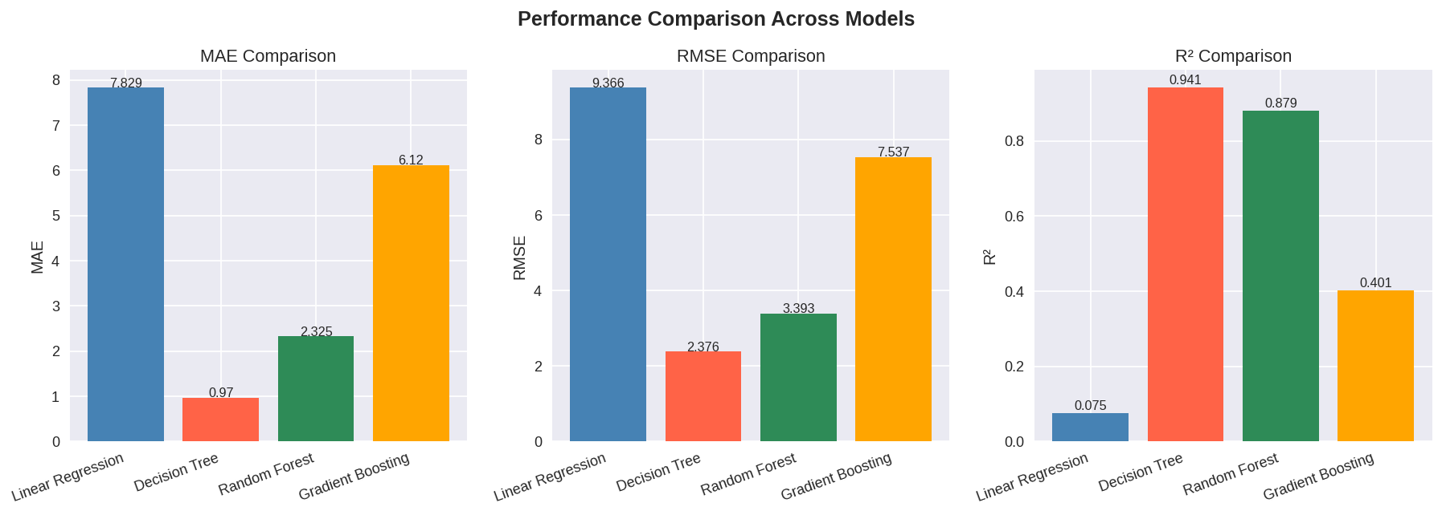

4.4.2 Feature Importance Analysis
The selected Decision Tree model was used to inspect feature importance, identifying which features contribute most to predicting bike availability. Geographic features (lat, lon) and temporal features (day, hour) ranked highest, followed by avg_pressure, station_id, and capacity. Weather-derived averages (avg_temperature, avg_humidity) and is_weekend contributed the least.
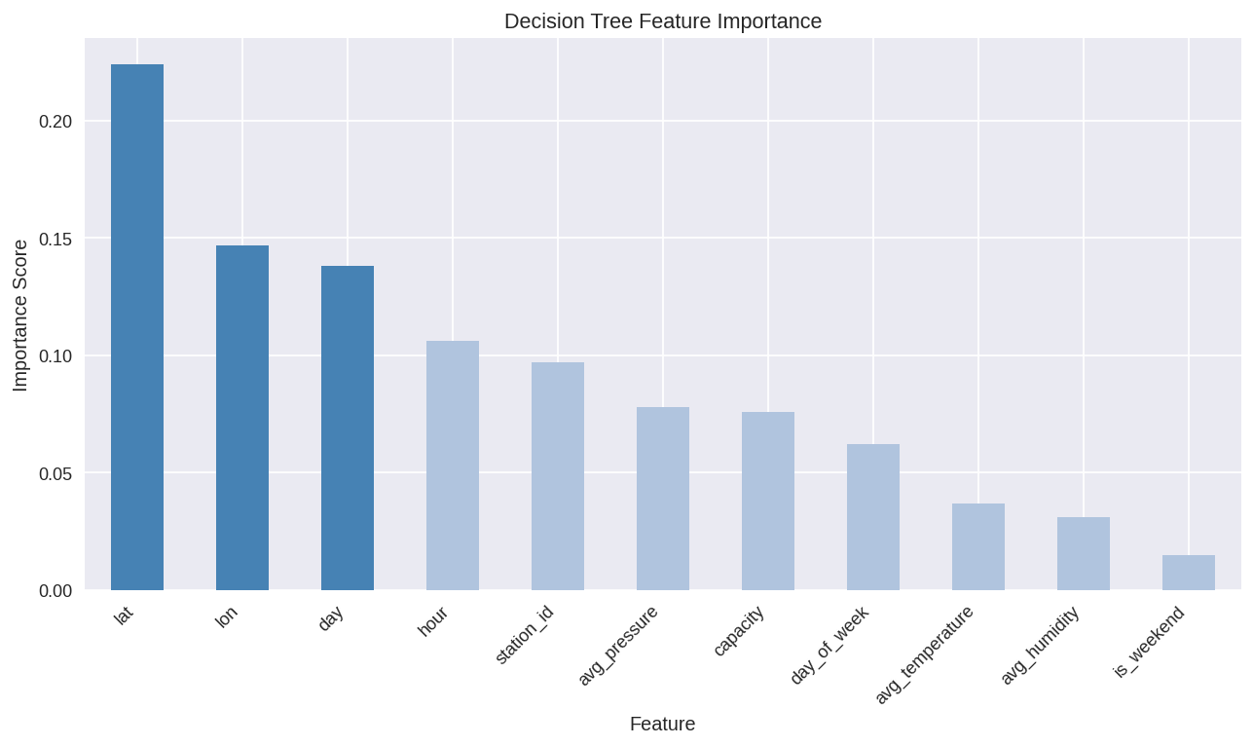

4.5 Reflection and Future Work

4.5.1 Strengths
- Straightforward Pipeline: No missing-value imputation is needed, and the feature set is compact, leading to fast retraining.
- Actionable Predictions: The output is a direct bike count, making it user-friendly for the frontend.
- Decoupled Architecture: The REST endpoint allows independent updates to the model and the UI.

4.5.2 Limitations
- Temporal Scope: Training data covers only December 2024. Seasonal variations are not captured, potentially reducing accuracy in other months.
- Weather-source Mismatch: Difference between Met Éireann daily aggregates (training) and OpenWeatherMap hourly forecasts (inference) introduces distributional shift.
- Overfitting Risk: While the Decision Tree achieves exceptional metrics (MAE 0.970, R² 0.941), it is inherently prone to overfitting. Performance on unseen data might be less stable without further regularization.

4.5.3 Future Improvements
- Data Expansion: Incorporate multiple seasons to improve generalization.
- Lag Features: Add historical availability (e.g., t-1 hour) to exploit temporal autocorrelation.
- Hyperparameter Optimization: Perform systematic grid search or Bayesian optimization on the Decision Tree (e.g., tuning max_depth, min_samples_leaf) to prevent overfitting.
- Uncertainty Communication: Introduce prediction confidence intervals for users.

