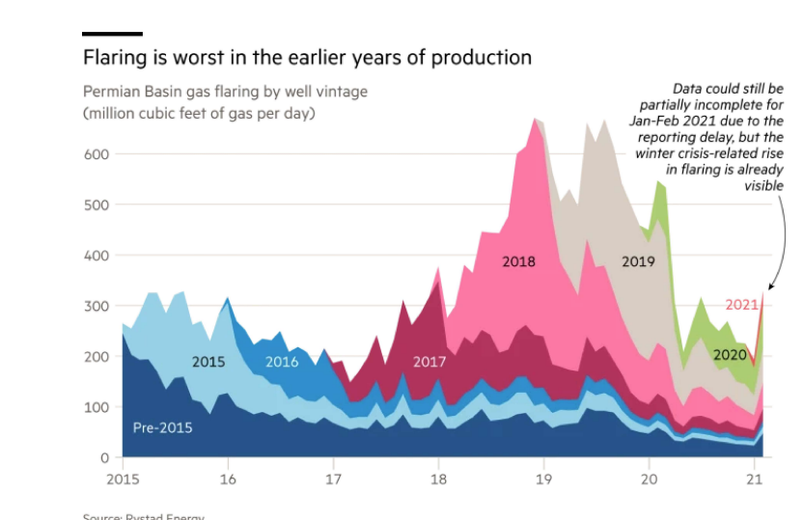

1. Flaring pattern(flaring power trend) - clustering ---based on filter dataset
2. Wellpads life cycle vs flaring energy/power - probability of flaring power peak in specific cycle range --- based on life cycle for the 8 selected wellpad
3. diff of total and peak flaring energy/ power between new well and old well - using spud date as indicator ---based on filter dataset
4. clean burn/dirt burn/ no burn in a good/bad way -- classification but without label is needed, standard/definition for each term is needed , third party data(co2, other gas detection data needed)

issue:

sjoin nearest

missing data before 2012

only 8 selected wellpads can be used for life cycle

-- Data synthesis?

third party data:

Form Colorado school of mines—VIIRS night fire or VIIRS nighttime light?

From google earth—need to research more about that