Assignment 2- Case Study

Stage 3 Lab Activities

SmartCare Domain Modelling
The intended order between files isn’t entirely clear, changing by the week. Additionally, some questions are repeated across the files, and a few appear without any accompanying prompt or are simply left blank, so apologies if some answers are missed or repeated slightly.

A - Requirements Review
Highlight nouns, verbs and business rules in SmartCare v0.2.
Nouns – Patient, Practitioner, Appointment, Status, History, & Staff.
Verbs – Register, Search, Create, Cancel, Update, View, Modify, & Prevent.
Business Rules – No two active appointments may conflict for the same practitioner FR-05, Cancelled appointments are retained and not deleted FR-07, & Relevant data must persist between sessions FR-08.

B - Candidate Classes
Record candidate concepts, supporting requirements, state and behaviour.
Candidate | Class? | Supporting Requirements | State/Behaviour
Patient | Yes | FR-01, FR-02, FR-09 | Holds name and contact details, can be created, searched for, and edited.
Practitioner | Yes | FR-03, FR-05, FR-11 | Holds name, tracks own appointments, checks for scheduling conflicts.
Appointment | Yes | FR-04, FR-05, FR-06, FR-07, FR-08, FR-10, FR-12 | Links one Patient, one Practitioner, a time, holds status of active/cancelled, and can be cancelled or modified.
Name | No | N/A | Attribute only, no behaviour of its own.
Clinic | No | N/A | No confirmed requirement gives it state or behaviour.
Database | No | FR-08 (Indirectly) | Infrastructure concern, not a domain class.
Cancellation | No | FR-06, FR-07 | Represented as a status change on Appointment, not its own class.
Status | No | FR-05, FR-06, FR-07 | Attribute of Appointment, not a class.

C - CRC Cards
Create CRC cards for Patient, Practitioner and Appointment.

Patient
Responsibilities | Collaborators
Provide own details when linked to an appointment | Appointment
Store and maintain own identifying and contact details | N/A

Practitioner
Responsibilities | Collaborators
Check own active appointments for conflicts before accepting a new one | Appointment
Store own identifying information | N/A

Appointment
Responsibilities | Collaborators
Link exactly one Patient and one Practitioner at a specific time | Patient, Practitioner
Track and change its own status (active -> cancelled) | N/A

D - UML Model
Draw classes, attributes, operations, associations and multiplicities.
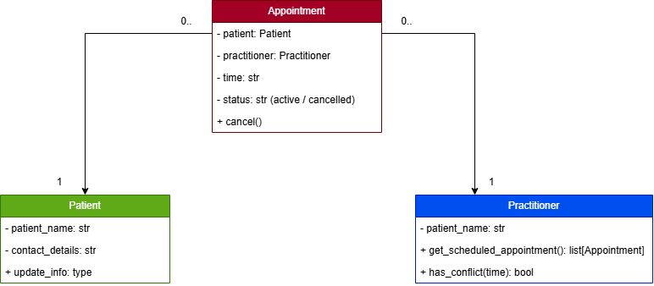

E - AI Design Review
Ask AI to suggest classes and relationships using only confirmed requirements; require supporting requirement IDs.
AI suggestion | Evidence | Decision | Reason | Model change
Add a status field to appointment (active/cancelled) | FR-06 & FR-07 | Accepted | Directly required, cancellation must change status without deleting the record. So, Appointment needs a status attribute to support this. | Appointment class gains a status attribute.
Add PatientManager, PractitionerManager, AppointmentManager | None | Rejected | No Functional Requirement separates manger classes, this also risks duplicating responsibility that Patient/Practitioner/Appointment already hold. | None
Add NotificationManager for reminders | None | Rejected | SMS reminders are still provisional, this has not been confirmed as a requirement by the client. | None
Add ScheduleEngine for conflict/schedule logic | FR-05, FR-11 | Modified | Evidence exists for the behaviour, but not for needing a separate class. Practitioner and Appointment can already do this together, revisit only if the logic grows more complex. | None at this stage
Add ClinicController | None | Rejected | No Functional Requirement gives a Clinic level coordinating responsibility. | None
Make Appointment inherit from Patient | None | Rejected | Appointment is not a type of Patient, its an association. | None

F - Compare and Decide
Record at least one accepted, modified and rejected AI suggestion.
As per above table, showing an accepted, modified, and rejected suggestion from the AI.

G - Python Skeletons
Create simple Patient, Practitioner and Appointment class skeletons.
This has been created and is in week 6 folder under the file titled – Python_Class_Skeleton_Week6.py

H - Consistency Check
Check model-code consistency; do not implement full behaviour yet.
The skeletons match the CRC cards. Patient only handles its own data, Practitioner owns conflict checks against its own appointments matching with FR-05, and Appointments owns its status transition matching with FR-06 and FR-07. No booking, persistence, or validation logic has been implemented, as this stage is structure only, keeping consistency with not implementing full behaviour yet.

Reflection
What modelling decision was hardest? Where did AI over-design? What evidence supported your final choices?
The hardest modelling decision was resisting the separation of manager classes, it seems tempting to add them because they look like proper software architecture, however nothing in the confirmed requirements actually requires for that extra layer. AI over-designed by suggesting a NotificationManager and ClinicController, both of which reach beyond the current scope of features and structure that the client has asked for. The core evidence that shaped the final model was the Functional Requirement list, only classes whose responsibilities could be traced to specific Functional Requirement (Patient, Practitioner, Appointment) were kept, and subsequently everything else was ignored and treated as unverified, rather than adding it on the assumption that it could be needed later down the line.

