SmartCare v0.3 - Domain Model Workbook

Requirement-to-Concept Trace
Requirement | Concept | State/behaviour | Decision
FR-01: The system shall allow staff to register a patient. | Patient | At registration, create a new Patient object, validate name is not empty before it is created. | Confirmed
FR-02: The system shall allow staff to search for a patient. | Patient | At search time, compare input against stored patient names/details, return a match or “not found”. | Confirmed
FR-03: The system shall allow staff to register a practitioner. | Practitioner | At registration, create a new Practitioner object, validate name is not empty. | Confirmed
FR-04: The system shall allow staff to create an appointment. | Appointment | At creation, build a new Appointment linking one Patient, one Practitioner, and a time, the status will default to “active”. | Confirmed
FR-05: The system shall prevent conflicting active appointments for the same practitioner. | Appointment/ Practitioner | At creation before FR-04 completes, check the Practitioner’s existing active appointments for matching time. If found, block creation and return an error message. | Confirmed
FR-06: The system shall allow staff to cancel appointments in appointment history. | Appointment | At cancellation, change the existing Appointment’s status field from “active” to “cancelled”. The object is never deleted. | Confirmed
FR-07: The system shall retain cancelled appointments in appointment history. | Appointment | Ongoing after cancellation, the cancelled object remains in the appointments list with status “cancelled” so it’s still viewable. | Confirmed
FR-08: The system shall preserve relevant patient, practitioner and appointment data between sessions. | Patient/Practitioner/ Appointment | At the start and end of program, read from and write to persistent storage so that data survives between uses. Not yet implemented. | Confirmed
FR-09: The system shall allow staff to update patient information. | Patient | At edit time, locate an existing Patient via FR-02 search, then overwrite one or more of its attribute values. | Confirmed
FR-10: The system shall allow staff to view existing appointments. | Appointment | At display time, loop through all stored Appointment objects and print/return them. | Confirmed
FR-11: The system shall allow staff to view a practitioner’s scheduled appointments. | Practitioner/Appointment | At display time, filter the Appointment list down to only those linked to a specific Practitioner. | Confirmed
FR-12: The system shall allow staff to modify the practitioner or time of an existing appointment. | Appointment | At edit time, change an existing Appointment’s practitioner or time field. This must re-run the FR-05 conflict check before the change is to be accepted. | Confirmed

CRC Cards

Patient
Responsibilities | Collaborators
Provide own details when linked to an appointment | Appointment
Store and maintain own identifying and contact details | N/A

Practitioner
Responsibilities | Collaborators
Check own active appointments for conflicts before accepting a new one | Appointment
Store own identifying information | N/A

Appointment
Responsibilities | Collaborators
Link exactly one Patient and one Practitioner at a specific time | Patient, Practitioner
Track and change its own status (active -> cancelled) | N/A

Optional class
Responsibilities | Collaborators

UML Class Diagram
Insert/draw UML here. Include defensible relationships and multiplicities.
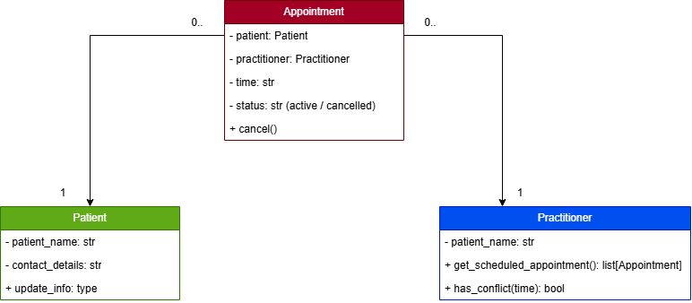
Multiplicities – One Patient can be linked to zero or many Appointments, subsequently one Practitioner can be linked to zero or many Appointments.

Design Rationale
Explain class selection, responsibility allocation and key relationships.
Patient, Practitioner, and Appointment were chosen because each has distinct data and behaviour tied directly to the confirmed Functional Requirements, additionally they are the only three concepts that appear consistently as nouns performing actions across the requirements. Attributes and simple checks such as, name, contact info, status, conflict detection were kept on the classes that own the relevant date, instead of separating them into manager classes.

AI Design Review Record
AI suggestion | Evidence | Decision | Reason | Model change
Add a status field to appointment (active/cancelled) | FR-06 & FR-07 | Accepted | Directly required, cancellation must change status without deleting the record. So, Appointment needs a status attribute to support this. | Appointment class gains a status attribute.
Add PatientManager, PractitionerManager, AppointmentManager | None | Rejected | No Functional Requirement separates manger classes, this also risks duplicating responsibility that Patient/Practitioner/Appointment already hold. | None
Add NotificationManager for reminders | None | Rejected | SMS reminders are still provisional, this has not been confirmed as a requirement by the client. | None
Add ScheduleEngine for conflict/schedule logic | FR-05, FR-11 | Modified | Evidence exists for the behaviour, but not for needing a separate class. Practitioner and Appointment can already do this together, revisit only if the logic grows more complex. | None at this stage
Add ClinicController | None | Rejected | No Functional Requirement gives a Clinic level coordinating responsibility. | None
Make Appointment inherit from Patient | None | Rejected | Appointment is not a type of Patient, its an association. | None

