ACE-II Evaluation

Descriptive Summary Statistics
Provider survey (n = 93 health workers) and attendance extraction (n = 752 worker-month records). Survey tables are stratified by facility category; extraction tables by study period. Categorical variables are summarised as n (%); continuous variables as mean (SD) and median [Q1, Q3]. 95% confidence intervals are shown for the key continuous outcomes.

Part 1. Provider survey

S1. Respondent and facility profile
S1. Respondent and facility profile
Characteristic | Overall  N = 93¹ | Control  N = 54¹ | Intervention  N = 39¹
Local Government Area
Enugu North | 25 (27%) | 12 (22%) | 13 (33%)
Igbo Etiti | 11 (12%) | 6 (11%) | 5 (13%)
Nkanu West | 31 (33%) | 22 (41%) | 9 (23%)
Nsukka | 26 (28%) | 14 (26%) | 12 (31%)
Gender of health worker
Female | 90 (97%) | 53 (98%) | 37 (95%)
Male | 3 (3.2%) | 1 (1.9%) | 2 (5.1%)
Location of facility
Rural | 29 (31%) | 12 (22%) | 17 (44%)
Semi-urban | 15 (16%) | 7 (13%) | 8 (21%)
Urban | 49 (53%) | 35 (65%) | 14 (36%)
Cadre of respondent
Ad-hoc | 3 (3.2%) | 1 (1.9%) | 2 (5.1%)
CHEW | 49 (53%) | 27 (50%) | 22 (56%)
JCHEW | 6 (6.5%) | 3 (5.6%) | 3 (7.7%)
Nurse/Midwife | 6 (6.5%) | 4 (7.4%) | 2 (5.1%)
Other | 13 (14%) | 8 (15%) | 5 (13%)
Physician | 1 (1.1%) | 0 (0%) | 1 (2.6%)
Volunteer | 15 (16%) | 11 (20%) | 4 (10%)
Number of children under 12 under care
0 | 42 (45%) | 23 (43%) | 19 (49%)
1 | 16 (17%) | 11 (20%) | 5 (13%)
2 | 16 (17%) | 10 (19%) | 6 (15%)
3 | 11 (12%) | 7 (13%) | 4 (10%)
4 | 7 (7.5%) | 3 (5.6%) | 4 (10%)
6 | 1 (1.1%) | 0 (0%) | 1 (2.6%)
Number of adult dependents under care
0 | 46 (49%) | 26 (48%) | 20 (51%)
1 | 21 (23%) | 12 (22%) | 9 (23%)
2 | 13 (14%) | 8 (15%) | 5 (13%)
3 | 7 (7.5%) | 6 (11%) | 1 (2.6%)
4 | 5 (5.4%) | 1 (1.9%) | 4 (10%)
5 | 1 (1.1%) | 1 (1.9%) | 0 (0%)
Lives within walking distance of facility | 22 (24%) | 13 (24%) | 9 (23%)
¹n (%)

S2. Attendance register and monitoring
S2. Attendance register and monitoring
Characteristic | Overall  N = 93¹ | Control  N = 54¹ | Intervention  N = 39¹
Facility keeps an attendance register (Q11) | 88 (95%) | 49 (91%) | 39 (100%)
OIC checks/cross-signs the register (Q12)
Daily | 47 (51%) | 20 (37%) | 27 (69%)
Monthly | 2 (2.2%) | 0 (0%) | 2 (5.1%)
Never | 9 (9.7%) | 9 (17%) | 0 (0%)
Not every day but several times each week | 18 (19%) | 12 (22%) | 6 (15%)
Not sure | 3 (3.2%) | 0 (0%) | 3 (7.7%)
Once a week | 11 (12%) | 11 (20%) | 0 (0%)
Once in a while | 3 (3.2%) | 2 (3.7%) | 1 (2.6%)
Enumerator verified register exists (Q13)
No | 7 (7.5%) | 7 (13%) | 0 (0%)
Not sure | 2 (2.2%) | 0 (0%) | 2 (5.1%)
Yes | 84 (90%) | 47 (87%) | 37 (95%)
WDC/HFC monitors absenteeism (Q29)
No | 51 (55%) | 46 (85%) | 5 (13%)
Not sure | 3 (3.2%) | 3 (5.6%) | 0 (0%)
Yes | 39 (42%) | 5 (9.3%) | 34 (87%)
Direct observation of local monitoring (Q30)
No | 57 (61%) | 46 (85%) | 11 (28%)
Not sure | 7 (7.5%) | 4 (7.4%) | 3 (7.7%)
Yes | 29 (31%) | 4 (7.4%) | 25 (64%)
Maintained register before July 2025 (Q56)
No | 5 (13%) | 0 (NA%) | 5 (13%)
Not sure | 1 (2.6%) | 0 (NA%) | 1 (2.6%)
Yes | 33 (85%) | 0 (NA%) | 33 (85%)
(Missing) | 54 | 54 | 0
Frequency records reviewed by supervisor (Q57)
Monthly | 19 (49%) | 0 (NA%) | 19 (49%)
Occasionally | 6 (15%) | 0 (NA%) | 6 (15%)
other | 3 (7.7%) | 0 (NA%) | 3 (7.7%)
Weekly | 11 (28%) | 0 (NA%) | 11 (28%)
(Missing) | 54 | 54 | 0
Documentation system exists (Q58)
No | 4 (10%) | 0 (NA%) | 4 (10%)
Not sure | 5 (13%) | 0 (NA%) | 5 (13%)
Yes | 30 (77%) | 0 (NA%) | 30 (77%)
(Missing) | 54 | 54 | 0
Records used for management decisions (Q59)
No | 1 (2.6%) | 0 (NA%) | 1 (2.6%)
Not sure | 2 (5.1%) | 0 (NA%) | 2 (5.1%)
Yes | 36 (92%) | 0 (NA%) | 36 (92%)
(Missing) | 54 | 54 | 0
¹n (%)

S3. Staffing on interview day
S3. Staffing on interview day
Characteristic | Overall  N = 93¹ | Control  N = 54¹ | Intervention  N = 39¹
Health workers expected present today (Q20)
2 | 12 (13%) | 4 (7.4%) | 8 (21%)
3 | 9 (9.7%) | 3 (5.6%) | 6 (15%)
4 | 3 (3.2%) | 2 (3.7%) | 1 (2.6%)
5 | 7 (7.5%) | 6 (11%) | 1 (2.6%)
7 | 10 (11%) | 7 (13%) | 3 (7.7%)
8 | 13 (14%) | 1 (1.9%) | 12 (31%)
9 | 14 (15%) | 6 (11%) | 8 (21%)
10 | 5 (5.4%) | 5 (9.3%) | 0 (0%)
12 | 20 (22%) | 20 (37%) | 0 (0%)
Expected but absent today (Q21)
0 | 30 (32%) | 12 (22%) | 18 (46%)
1 | 8 (8.6%) | 4 (7.4%) | 4 (10%)
2 | 26 (28%) | 11 (20%) | 15 (38%)
3 | 20 (22%) | 20 (37%) | 0 (0%)
4 | 2 (2.2%) | 1 (1.9%) | 1 (2.6%)
5 | 1 (1.1%) | 0 (0%) | 1 (2.6%)
7 | 6 (6.5%) | 6 (11%) | 0 (0%)
Scheduled on duty – Physicians | 14 (15%) | 11 (20%) | 3 (7.7%)
Scheduled on duty – Nurses
0 | 23 (25%) | 14 (26%) | 9 (23%)
1 | 52 (56%) | 30 (56%) | 22 (56%)
2 | 18 (19%) | 10 (19%) | 8 (21%)
Scheduled on duty – CHEW
0 | 7 (7.5%) | 1 (1.9%) | 6 (15%)
1 | 17 (18%) | 7 (13%) | 10 (26%)
2 | 22 (24%) | 11 (20%) | 11 (28%)
3 | 30 (32%) | 23 (43%) | 7 (18%)
4 | 7 (7.5%) | 2 (3.7%) | 5 (13%)
6 | 10 (11%) | 10 (19%) | 0 (0%)
Scheduled on duty – JCHEW
0 | 56 (60%) | 40 (74%) | 16 (41%)
1 | 35 (38%) | 12 (22%) | 23 (59%)
2 | 1 (1.1%) | 1 (1.9%) | 0 (0%)
3 | 1 (1.1%) | 1 (1.9%) | 0 (0%)
Scheduled on duty – Volunteers
0 | 24 (26%) | 9 (17%) | 15 (38%)
1 | 26 (28%) | 20 (37%) | 6 (15%)
2 | 6 (6.5%) | 2 (3.7%) | 4 (10%)
3 | 19 (20%) | 5 (9.3%) | 14 (36%)
4 | 10 (11%) | 10 (19%) | 0 (0%)
5 | 8 (8.6%) | 8 (15%) | 0 (0%)
Scheduled on duty – Ad-hoc
0 | 68 (73%) | 36 (67%) | 32 (82%)
1 | 15 (16%) | 8 (15%) | 7 (18%)
2 | 10 (11%) | 10 (19%) | 0 (0%)
Scheduled on duty – Others
0 | 49 (53%) | 26 (48%) | 23 (59%)
1 | 27 (29%) | 19 (35%) | 8 (21%)
2 | 5 (5.4%) | 5 (9.3%) | 0 (0%)
3 | 12 (13%) | 4 (7.4%) | 8 (21%)
Actually present – Physicians | 3 (3.2%) | 1 (1.9%) | 2 (5.1%)
Actually present – Nurses
0 | 38 (41%) | 29 (54%) | 9 (23%)
1 | 41 (44%) | 19 (35%) | 22 (56%)
2 | 14 (15%) | 6 (11%) | 8 (21%)
Actually present – CHEW
0 | 7 (7.5%) | 1 (1.9%) | 6 (15%)
1 | 44 (47%) | 19 (35%) | 25 (64%)
2 | 10 (11%) | 4 (7.4%) | 6 (15%)
3 | 20 (22%) | 20 (37%) | 0 (0%)
4 | 2 (2.2%) | 0 (0%) | 2 (5.1%)
5 | 10 (11%) | 10 (19%) | 0 (0%)
Actually present – JCHEW
0 | 56 (60%) | 40 (74%) | 16 (41%)
1 | 36 (39%) | 14 (26%) | 22 (56%)
2 | 1 (1.1%) | 0 (0%) | 1 (2.6%)
Actually present – Volunteers
0 | 25 (27%) | 9 (17%) | 16 (41%)
1 | 26 (28%) | 20 (37%) | 6 (15%)
2 | 14 (15%) | 3 (5.6%) | 11 (28%)
3 | 18 (19%) | 12 (22%) | 6 (15%)
4 | 10 (11%) | 10 (19%) | 0 (0%)
Actually present – Ad-hoc
0 | 68 (73%) | 36 (67%) | 32 (82%)
1 | 15 (16%) | 8 (15%) | 7 (18%)
2 | 10 (11%) | 10 (19%) | 0 (0%)
Actually present – Others
0 | 48 (52%) | 25 (46%) | 23 (59%)
1 | 35 (38%) | 20 (37%) | 15 (38%)
2 | 10 (11%) | 9 (17%) | 1 (2.6%)
¹n (%)

S4. Types of absenteeism observed
S4. Types of absenteeism observed
Characteristic | Overall  N = 93¹ | Control  N = 54¹ | Intervention  N = 39¹
Coming late observed (Q18a) | 93 (100%) | 54 (100%) | 39 (100%)
Leaving before shift ends observed (Q18b) | 32 (34%) | 26 (48%) | 6 (15%)
Full-day absence observed (Q18c) | 26 (28%) | 20 (37%) | 6 (15%)
Most common type of absenteeism (Q19)
Coming late to work | 92 (99%) | 53 (98%) | 39 (100%)
Leaving before shift ends | 1 (1.1%) | 1 (1.9%) | 0 (0%)
¹n (%)

S5. Sanctions for absenteeism
S5. Sanctions for absenteeism
Characteristic | Overall  N = 93¹ | Control  N = 54¹ | Intervention  N = 39¹
Sanction exists for lateness (Q23a) | 88 (95%) | 51 (94%) | 37 (95%)
Sanction exists for leaving early (Q23b) | 38 (41%) | 21 (39%) | 17 (44%)
Sanction exists for full-day absence (Q23c) | 44 (47%) | 24 (44%) | 20 (51%)
Sanctions used in past 6 months (Q25)
No | 58 (62%) | 31 (57%) | 27 (69%)
Not sure | 13 (14%) | 9 (17%) | 4 (10%)
Yes | 22 (24%) | 14 (26%) | 8 (21%)
¹n (%)

S6. Incentives for punctual staff
S6. Incentives for punctual staff
Characteristic | Overall  N = 93¹ | Control  N = 54¹ | Intervention  N = 39¹
Money incentive (Q26) | 16 (17%) | 8 (15%) | 8 (21%)
Food incentive (Q26) | 5 (5.4%) | 3 (5.6%) | 2 (5.1%)
Promotion incentive (Q26) | 0 (0%) | 0 (0%) | 0 (0%)
Recognition incentive (Q26) | 4 (4.3%) | 3 (5.6%) | 1 (2.6%)
How often incentives come (Q28)
No | 21 (23%) | 20 (37%) | 1 (2.6%)
Not sure | 4 (4.3%) | 3 (5.6%) | 1 (2.6%)
Yes | 68 (73%) | 31 (57%) | 37 (95%)
¹n (%)

S7. Local structures and community support
S7. Local structures and community support
Characteristic | Overall  N = 93¹ | Control  N = 54¹ | Intervention  N = 39¹
Village Development Association (Q17) | 4 (4.3%) | 2 (3.7%) | 2 (5.1%)
Town Union (Q17) | 12 (13%) | 5 (9.3%) | 7 (18%)
Local Traditional Leadership (Q17) | 7 (7.5%) | 4 (7.4%) | 3 (7.7%)
Ward Development Committee (Q17) | 91 (98%) | 52 (96%) | 39 (100%)
Health Facility Committee (Q17) | 23 (25%) | 18 (33%) | 5 (13%)
Community provides support (Q31)
Cash support | 1 (1.1%) | 0 (0%) | 1 (2.6%)
Cleaning the premises | 1 (1.1%) | 1 (1.9%) | 0 (0%)
No | 77 (83%) | 51 (94%) | 26 (67%)
Security | 5 (5.4%) | 1 (1.9%) | 4 (10%)
Security Cleaning the premises | 1 (1.1%) | 1 (1.9%) | 0 (0%)
Security other | 2 (2.2%) | 0 (0%) | 2 (5.1%)
Security Staff housing | 1 (1.1%) | 0 (0%) | 1 (2.6%)
Security Staff housing other | 1 (1.1%) | 0 (0%) | 1 (2.6%)
Supply of essential materials needed in the health facility other | 4 (4.3%) | 0 (0%) | 4 (10%)
Support: security (Q32) | 2 (2.2%) | 0 (0%) | 2 (5.1%)
Support: staff housing (Q32) | 1 (1.1%) | 0 (0%) | 1 (2.6%)
Support: cash (Q32) | 2 (2.2%) | 2 (3.7%) | 0 (0%)
Support: cleaning premises (Q32) | 4 (4.3%) | 0 (0%) | 4 (10%)
Support: essential materials (Q32) | 84 (90%) | 51 (94%) | 33 (85%)
¹n (%)

S8. Transport allowance
S8. Transport allowance
Characteristic | Overall  N = 93¹ | Control  N = 54¹ | Intervention  N = 39¹
Transport allowance disbursed (Q34)
Yes | 39 (100%) | 0 (NA%) | 39 (100%)
(Missing) | 54 | 54 | 0
Frequency of disbursement (Q35)
Monthly | 39 (100%) | 0 (NA%) | 39 (100%)
(Missing) | 54 | 54 | 0
Reduced absenteeism (Q37)
Yes | 39 (100%) | 0 (NA%) | 39 (100%)
(Missing) | 54 | 54 | 0
Improved punctuality (Q38)
Yes | 39 (100%) | 0 (NA%) | 39 (100%)
(Missing) | 54 | 54 | 0
¹n (%)

S9. Peer support network
S9. Peer support network
Characteristic | Overall  N = 93¹ | Control  N = 54¹ | Intervention  N = 39¹
Peer support network established (Q40)
Yes | 39 (100%) | 0 (NA%) | 39 (100%)
(Missing) | 54 | 54 | 0
Frequency of peer meetings (Q41)
Monthly | 35 (90%) | 0 (NA%) | 35 (90%)
Weekly | 4 (10%) | 0 (NA%) | 4 (10%)
(Missing) | 54 | 54 | 0
Improved teamwork (Q43)
Yes | 39 (100%) | 0 (NA%) | 39 (100%)
(Missing) | 54 | 54 | 0
Reduced absenteeism (Q44)
Yes | 39 (100%) | 0 (NA%) | 39 (100%)
(Missing) | 54 | 54 | 0
¹n (%)

S10. CMSC monitoring
S10. CMSC monitoring
Characteristic | Overall  N = 93¹ | Control  N = 54¹ | Intervention  N = 39¹
CMSC established/strengthened (Q46)
Yes | 39 (100%) | 0 (NA%) | 39 (100%)
(Missing) | 54 | 54 | 0
CMSC actively monitors attendance (Q47)
Yes | 39 (100%) | 0 (NA%) | 39 (100%)
(Missing) | 54 | 54 | 0
Frequency CMSC engages facility (Q48)
Occasionally | 2 (5.1%) | 0 (NA%) | 2 (5.1%)
other | 1 (2.6%) | 0 (NA%) | 1 (2.6%)
Weekly | 36 (92%) | 0 (NA%) | 36 (92%)
(Missing) | 54 | 54 | 0
CMSC reduced absenteeism (Q49)
Yes | 39 (100%) | 0 (NA%) | 39 (100%)
(Missing) | 54 | 54 | 0
¹n (%)

S11. Sanction authority and consistency
S11. Sanction authority and consistency
Characteristic | Overall  N = 93¹ | Control  N = 54¹ | Intervention  N = 39¹
Who has authority to sanction (Q51)
LGA Health Authority | 4 (10%) | 0 (NA%) | 4 (10%)
Officer-in-Charge | 33 (85%) | 0 (NA%) | 33 (85%)
other | 1 (2.6%) | 0 (NA%) | 1 (2.6%)
SMOH | 1 (2.6%) | 0 (NA%) | 1 (2.6%)
(Missing) | 54 | 54 | 0
Facility has formal authority (Q52)
No | 1 (2.6%) | 0 (NA%) | 1 (2.6%)
Not sure | 2 (5.1%) | 0 (NA%) | 2 (5.1%)
Yes | 36 (92%) | 0 (NA%) | 36 (92%)
(Missing) | 54 | 54 | 0
Consistency sanctions applied (Q53)
Monthly | 1 (2.6%) | 0 (NA%) | 1 (2.6%)
Not active | 3 (7.7%) | 0 (NA%) | 3 (7.7%)
Not applied | 11 (28%) | 0 (NA%) | 11 (28%)
Occasionally | 15 (38%) | 0 (NA%) | 15 (38%)
other | 2 (5.1%) | 0 (NA%) | 2 (5.1%)
Weekly | 7 (18%) | 0 (NA%) | 7 (18%)
(Missing) | 54 | 54 | 0
Influence of CMSC on attendance (Q54)
Highly influential | 36 (92%) | 0 (NA%) | 36 (92%)
Moderately influential | 3 (7.7%) | 0 (NA%) | 3 (7.7%)
(Missing) | 54 | 54 | 0
Importance of peer support (Q55)
Highly influential | 37 (95%) | 0 (NA%) | 37 (95%)
Moderately influential | 2 (5.1%) | 0 (NA%) | 2 (5.1%)
(Missing) | 54 | 54 | 0
¹n (%)

S12. Systems and sustainability capacity
S12. Systems and sustainability capacity
Characteristic | Overall  N = 93¹ | Control  N = 54¹ | Intervention  N = 39¹
Sufficient staff for coverage (Q60)
No | 12 (31%) | 0 (NA%) | 12 (31%)
Not sure | 2 (5.1%) | 0 (NA%) | 2 (5.1%)
Yes | 25 (64%) | 0 (NA%) | 25 (64%)
(Missing) | 54 | 54 | 0
Capacity to sustain after Feb 2026 (Q61)
Fully capable | 18 (46%) | 0 (NA%) | 18 (46%)
Not capable | 4 (10%) | 0 (NA%) | 4 (10%)
Not sure | 6 (15%) | 0 (NA%) | 6 (15%)
Partially capable | 11 (28%) | 0 (NA%) | 11 (28%)
(Missing) | 54 | 54 | 0
¹n (%)

S13. PCI perceptions
S13. PCI perceptions
Characteristic | Overall  N = 93¹ | Control  N = 54¹ | Intervention  N = 39¹
Importance of reducing absenteeism, pre (Q62)
Moderately important | 3 (7.7%) | 0 (NA%) | 3 (7.7%)
Not important | 4 (10%) | 0 (NA%) | 4 (10%)
Not sure | 3 (7.7%) | 0 (NA%) | 3 (7.7%)
Slightly important | 6 (15%) | 0 (NA%) | 6 (15%)
Very important | 23 (59%) | 0 (NA%) | 23 (59%)
(Missing) | 54 | 54 | 0
Staff commitment to reducing absenteeism, pre (Q63)
Moderately committed | 12 (31%) | 0 (NA%) | 12 (31%)
Not committed | 4 (10%) | 0 (NA%) | 4 (10%)
Not sure | 1 (2.6%) | 0 (NA%) | 1 (2.6%)
Slightly committed | 8 (21%) | 0 (NA%) | 8 (21%)
Very committed | 14 (36%) | 0 (NA%) | 14 (36%)
(Missing) | 54 | 54 | 0
Leadership commitment to enforcement (Q64)
Moderately committed | 2 (5.1%) | 0 (NA%) | 2 (5.1%)
Slightly committed | 2 (5.1%) | 0 (NA%) | 2 (5.1%)
Very committed | 35 (90%) | 0 (NA%) | 35 (90%)
(Missing) | 54 | 54 | 0
Community supportiveness (Q65)
Moderately supportive | 2 (5.1%) | 0 (NA%) | 2 (5.1%)
Not supportive | 4 (10%) | 0 (NA%) | 4 (10%)
Slightly supportive | 1 (2.6%) | 0 (NA%) | 1 (2.6%)
Very supportive | 32 (82%) | 0 (NA%) | 32 (82%)
(Missing) | 54 | 54 | 0
Leadership interest in continuing (Q66)
Moderately interested | 1 (2.6%) | 0 (NA%) | 1 (2.6%)
Not sure | 4 (10%) | 0 (NA%) | 4 (10%)
Slightly interested | 1 (2.6%) | 0 (NA%) | 1 (2.6%)
Very interested | 33 (85%) | 0 (NA%) | 33 (85%)
(Missing) | 54 | 54 | 0
¹n (%)

S14. RE-AIM – Reach, Effectiveness, Adoption
S14. RE-AIM – Reach, Effectiveness, Adoption
Characteristic | Overall  N = 93¹ | Control  N = 54¹ | Intervention  N = 39¹
Proportion of staff benefited (Q67)
25–49% | 1 (2.6%) | 0 (NA%) | 1 (2.6%)
50–74% | 1 (2.6%) | 0 (NA%) | 1 (2.6%)
75–100% | 37 (95%) | 0 (NA%) | 37 (95%)
(Missing) | 54 | 54 | 0
Extent absenteeism reduced (Q68)
Moderate reduction | 3 (7.7%) | 0 (NA%) | 3 (7.7%)
Significant reduction | 36 (92%) | 0 (NA%) | 36 (92%)
(Missing) | 54 | 54 | 0
Punctuality improved (Q69)
No | 2 (5.1%) | 0 (NA%) | 2 (5.1%)
Not sure | 2 (5.1%) | 0 (NA%) | 2 (5.1%)
Yes | 35 (90%) | 0 (NA%) | 35 (90%)
(Missing) | 54 | 54 | 0
Leaving early reduced (Q70)
Not sure | 1 (2.6%) | 0 (NA%) | 1 (2.6%)
Yes | 38 (97%) | 0 (NA%) | 38 (97%)
(Missing) | 54 | 54 | 0
Unintended negative consequences (Q71)
No | 37 (95%) | 0 (NA%) | 37 (95%)
Not sure | 1 (2.6%) | 0 (NA%) | 1 (2.6%)
Yes | 1 (2.6%) | 0 (NA%) | 1 (2.6%)
(Missing) | 54 | 54 | 0
Service delivery improved (Q72)
Yes, significantly | 39 (100%) | 0 (NA%) | 39 (100%)
(Missing) | 54 | 54 | 0
Staff commitment improved (Q73)
No | 1 (2.6%) | 0 (NA%) | 1 (2.6%)
Not sure | 2 (5.1%) | 0 (NA%) | 2 (5.1%)
Yes | 36 (92%) | 0 (NA%) | 36 (92%)
(Missing) | 54 | 54 | 0
Leadership approved interventions (Q74)
No | 1 (2.6%) | 0 (NA%) | 1 (2.6%)
Not sure | 3 (7.7%) | 0 (NA%) | 3 (7.7%)
Yes | 35 (90%) | 0 (NA%) | 35 (90%)
(Missing) | 54 | 54 | 0
Staff willingness at start (Q75)
Reluctant | 2 (5.1%) | 0 (NA%) | 2 (5.1%)
Somewhat willing | 7 (18%) | 0 (NA%) | 7 (18%)
Very willing | 30 (77%) | 0 (NA%) | 30 (77%)
(Missing) | 54 | 54 | 0
¹n (%)

S15. RE-AIM – Implementation, Maintenance
S15. RE-AIM – Implementation, Maintenance
Characteristic | Overall  N = 93¹ | Control  N = 54¹ | Intervention  N = 39¹
Transport disbursed on schedule (Q76)
Always on schedule | 37 (95%) | 0 (NA%) | 37 (95%)
Sometimes delayed | 2 (5.1%) | 0 (NA%) | 2 (5.1%)
(Missing) | 54 | 54 | 0
Peer meetings as planned (Q77)
All planned meetings held | 37 (95%) | 0 (NA%) | 37 (95%)
Most meetings held | 2 (5.1%) | 0 (NA%) | 2 (5.1%)
(Missing) | 54 | 54 | 0
CMSC visits as scheduled (Q78)
Fully as scheduled | 37 (95%) | 0 (NA%) | 37 (95%)
Partially as scheduled | 2 (5.1%) | 0 (NA%) | 2 (5.1%)
(Missing) | 54 | 54 | 0
Overall adherence to design (Q79)
Fully adhered | 35 (90%) | 0 (NA%) | 35 (90%)
Mostly adhered | 4 (10%) | 0 (NA%) | 4 (10%)
(Missing) | 54 | 54 | 0
Interventions still ongoing (Q80)
No | 4 (10%) | 0 (NA%) | 4 (10%)
Not sure | 5 (13%) | 0 (NA%) | 5 (13%)
Yes | 30 (77%) | 0 (NA%) | 30 (77%)
(Missing) | 54 | 54 | 0
Integrated into routine ops (Q81)
Fully integrated | 21 (54%) | 0 (NA%) | 21 (54%)
Not integrated | 9 (23%) | 0 (NA%) | 9 (23%)
Partially integrated | 9 (23%) | 0 (NA%) | 9 (23%)
(Missing) | 54 | 54 | 0
Likely active in 12 months (Q82)
Not sure | 1 (2.6%) | 0 (NA%) | 1 (2.6%)
Somewhat likely | 14 (36%) | 0 (NA%) | 14 (36%)
Unlikely | 2 (5.1%) | 0 (NA%) | 2 (5.1%)
Very likely | 21 (54%) | 0 (NA%) | 21 (54%)
Very unlikely | 1 (2.6%) | 0 (NA%) | 1 (2.6%)
(Missing) | 54 | 54 | 0
¹n (%)

Part 2. Attendance extraction

E1. Extraction coverage
E1. Extraction coverage
Characteristic | Overall  N = 752¹ | Pre-intervention  N = 308¹ | Intervention  N = 444¹
Local Government Area
Enugu North | 190 (25%) | 77 (25%) | 113 (25%)
Igbo Etiti | 208 (28%) | 95 (31%) | 113 (25%)
Nkanu West | 266 (35%) | 125 (41%) | 141 (32%)
Nsukka | 88 (12%) | 11 (3.6%) | 77 (17%)
Designation / Cadre
Admin/Other support | 54 (7.3%) | 24 (7.9%) | 30 (6.8%)
CHEW | 441 (59%) | 186 (61%) | 255 (58%)
Health Attendant | 83 (11%) | 33 (11%) | 50 (11%)
JCHEW | 73 (9.8%) | 24 (7.9%) | 49 (11%)
Lab/Tech | 41 (5.5%) | 19 (6.3%) | 22 (5.0%)
Nurse/Midwife | 33 (4.4%) | 10 (3.3%) | 23 (5.2%)
Other | 3 (0.4%) | 3 (1.0%) | 0 (0%)
Physician | 6 (0.8%) | 2 (0.7%) | 4 (0.9%)
Volunteer | 9 (1.2%) | 3 (1.0%) | 6 (1.4%)
(Missing) | 9 | 4 | 5
¹n (%)

E2. Attendance metrics
E2. Attendance metrics
Characteristic | Overall  N = 752 | Pre-intervention  N = 308 | Intervention  N = 444
Number of scheduled duty days
Mean (SD) | 19.8 (8.7) | 21.2 (8.9) | 18.8 (8.4)
Median [Q1, Q3] | 22.0 [16.0, 25.0] | 22.5 [20.0, 26.0] | 21.0 [10.0, 25.0]
(Missing) | 2 | 0 | 2
Number of days present
Mean (SD) | 15.0 (8.6) | 15.8 (9.9) | 14.4 (7.6)
Median [Q1, Q3] | 16.0 [8.0, 21.0] | 17.0 [8.0, 21.0] | 15.0 [9.0, 20.0]
(Missing) | 15 | 6 | 9
Number of days absent (scheduled – present)
Mean (SD) | 5.5 (7.1) | 6.2 (7.8) | 5.0 (6.6)
Median [Q1, Q3] | 3.0 [0.0, 8.0] | 3.0 [0.0, 9.0] | 2.0 [0.0, 7.0]
(Missing) | 15 | 6 | 9
Absenteeism rate (%)
Mean (SD) | 24.1 (30.3) | 26.8 (32.8) | 22.2 (28.3)
Median [Q1, Q3] | 13.0 [0.0, 36.4] | 16.0 [0.0, 37.0] | 11.9 [0.0, 33.3]
(Missing) | 31 | 15 | 16
Attendance rate (%)
Mean (SD) | 84.7 (53.9) | 80.1 (55.9) | 87.9 (52.3)
Median [Q1, Q3] | 87.0 [63.6, 100.0] | 84.0 [63.0, 100.0] | 88.1 [66.7, 100.0]
(Missing) | 31 | 15 | 16
Days late recorded in register
Mean (SD) | 3.2 (13.7) | 1.9 (3.8) | 4.0 (17.4)
Median [Q1, Q3] | 0.0 [0.0, 4.0] | 0.0 [0.0, 2.0] | 1.0 [0.0, 5.0]
(Missing) | 37 | 20 | 17
Total minutes late
Mean (SD) | 99.7 (239.9) | 79.9 (253.2) | 113.1 (229.8)
Median [Q1, Q3] | 7.0 [0.0, 73.0] | 0.0 [0.0, 40.0] | 30.0 [0.0, 94.0]
(Missing) | 37 | 20 | 17
Average minutes late per incident
Mean (SD) | 16.3 (25.0) | 12.2 (23.1) | 19.1 (25.8)
Median [Q1, Q3] | 4.1 [0.0, 23.2] | 0.0 [0.0, 15.0] | 10.0 [0.0, 30.0]
(Missing) | 40 | 22 | 18

E3. Service volume
E3. Service volume
Characteristic | Overall  N = 752 | Pre-intervention  N = 308 | Intervention  N = 444
Total patients seen per month (ANC + Immunisation)
Mean (SD) | 242.1 (170.8) | 235.6 (152.9) | 246.6 (182.2)
Median [Q1, Q3] | 164.0 [113.0, 415.0] | 164.0 [115.0, 377.0] | 163.0 [98.0, 421.0]

Part 3. Distributions and relationships (figures)

Figure 1. Distribution of worker-month absenteeism rate
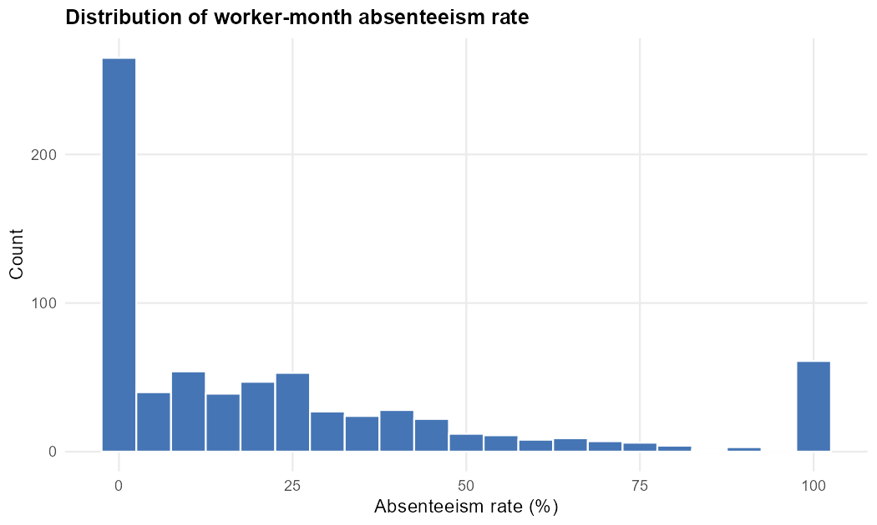

Figure 2. Distribution of monthly patient volume
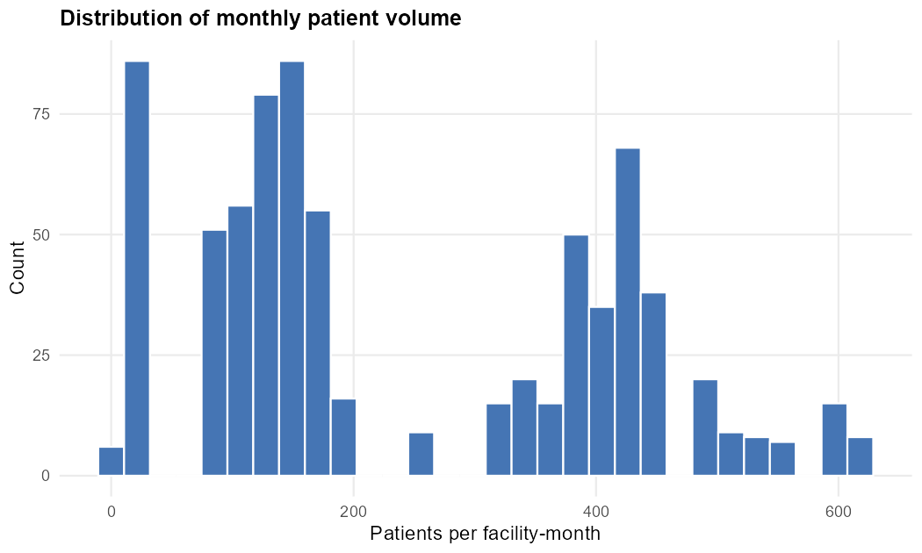

Figure 3. Absenteeism rate by period
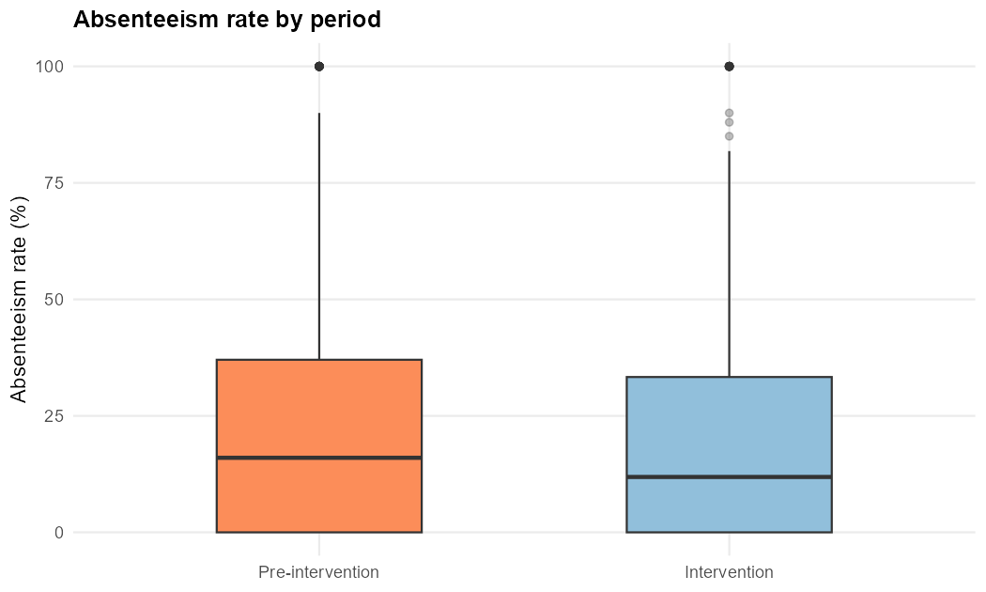

Figure 4. Total minutes late by period
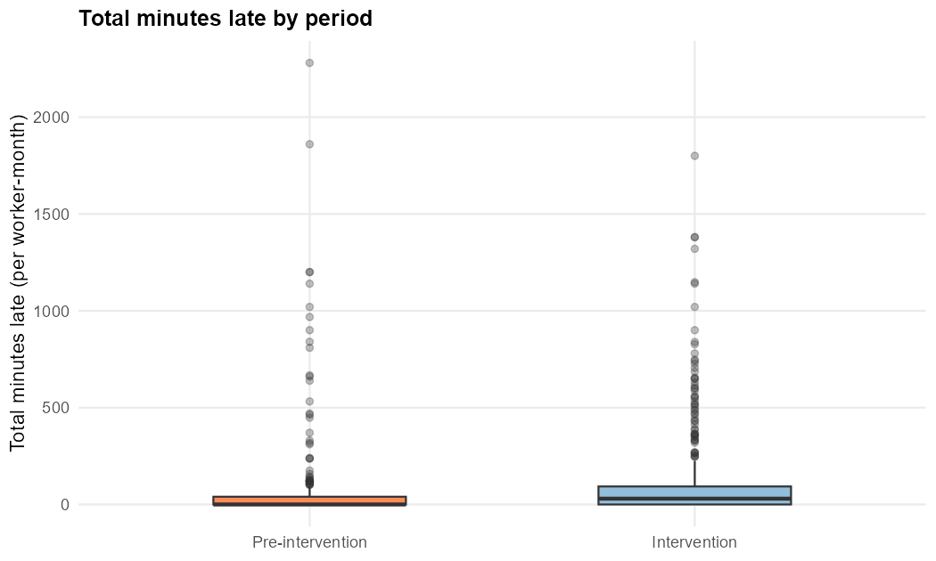

Figure 5. Absenteeism rate by cadre
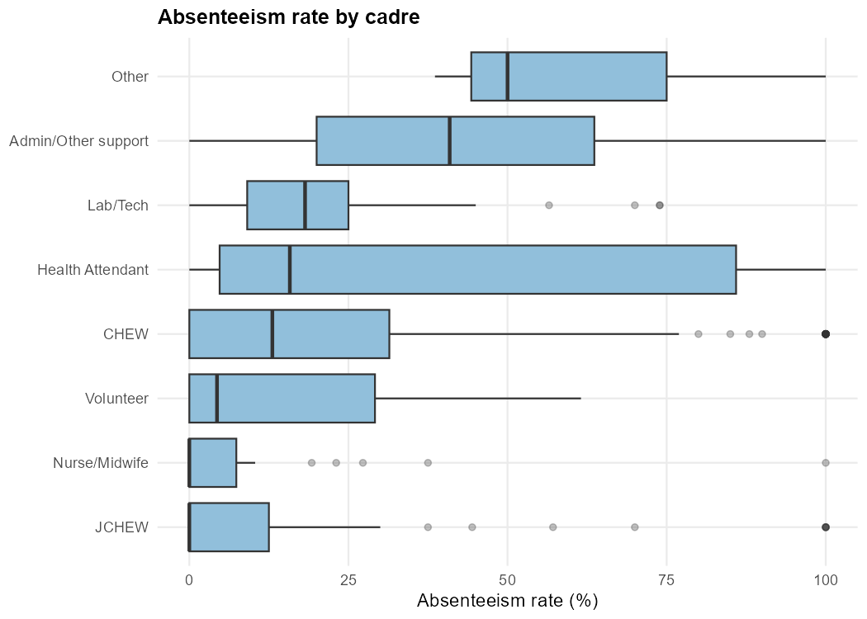

Figure 6. Patient volume vs absenteeism rate
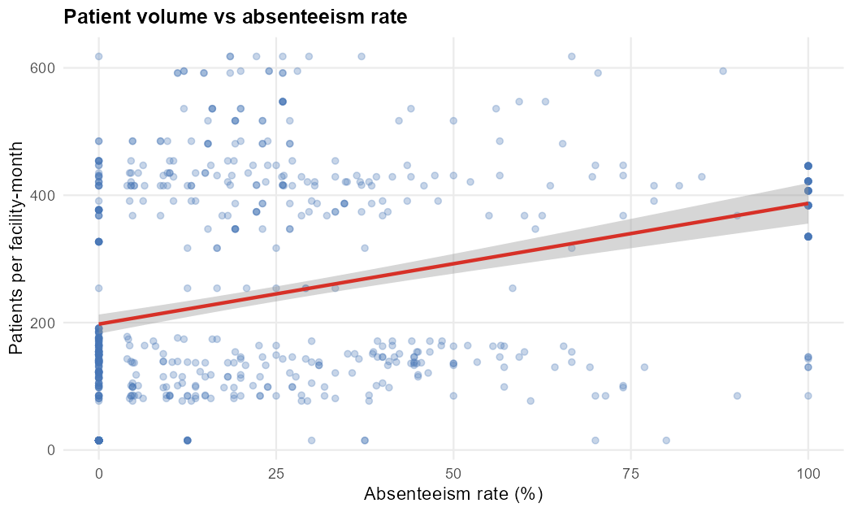

Figure 7. Total minutes late vs days present
