CTO Exploratory Data Analysis

Uche Ezema

2023-02-28

## CTO Logistics Data

This is an exploratory data analysis of the CTO Logistics Questionnaire. Only a descriptive analysis of charts and tables are covered to provide insight for further inferential analysis. The report has been built with **R Markdown.**

### 1.1 Logistics Supply Chain System (LSCS) components that facilities have.

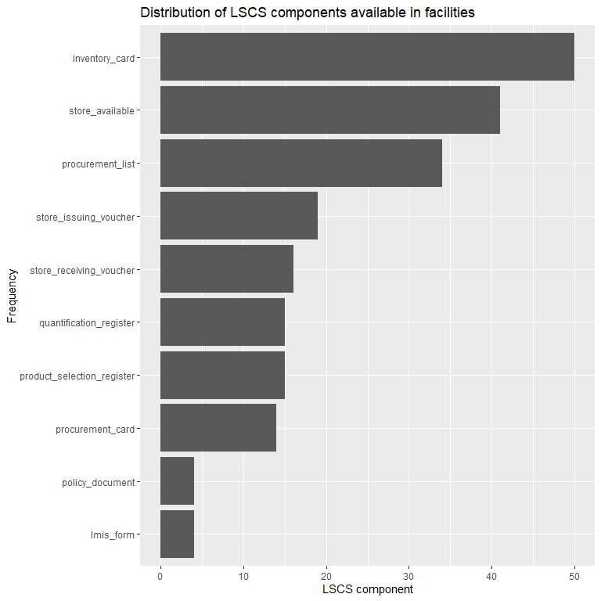

### 1.2 Training status of respondents

Respondents that have ever received logistics training:

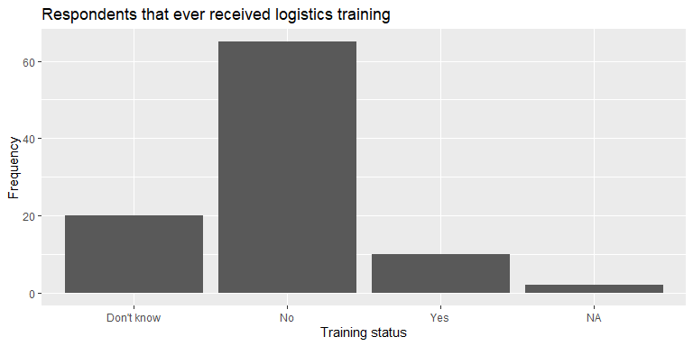

### 1.3 Different methods used by health facility respondents for selecting commodities:

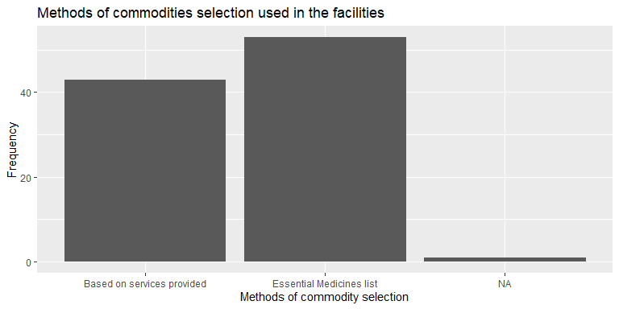

### 1.4 Respondents opinion about what effective logistics system can achieve:

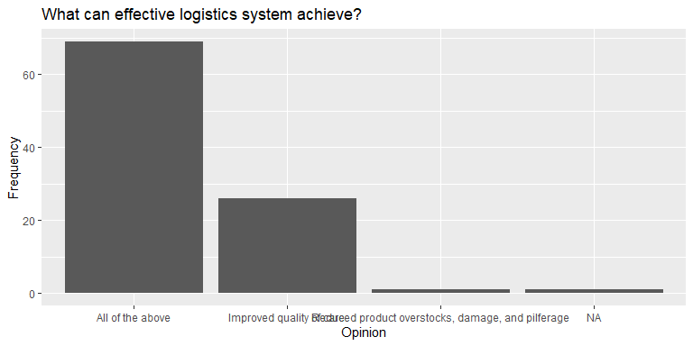

### 1.5 Including Plots

Respondents that have ever received logistics training:



## 1.6 Including Plots

Respondents that have ever received logistics training:



## 1.7 Including Plots

Respondents that have ever received logistics training:



## 1.8 Including Plots

Respondents that have ever received logistics training:



## 1.9 Including Plots

Respondents that have ever received logistics training:



## 1.10 Including Plots

Respondents that have ever received logistics training:

