# At h=5m, test various rho values

At a termination depth of 29.99 m:

* Using rho=0.02, Vs30_SD=0.06-0.07
* Using rho=0.10, Vs30_SD=0.06
* Using rho=0.05, Vs30_SD=0.06
* Using rho=0.02, Vs30_SD=0.05
* Using rho=0.002, Vs30_SD=0.04

At a termination depth of 20.05m:

* Using rho=0.02 gives a SD of 0.14-0.16
* Using rho=0.002 gives a SD of 0.09-0.12

At a termination depth of 15.66m:

* Using rho=0.02 gives a SD of 0.25-0.30
* Using rho=0.002 gives a SD of 0.20-0.23

At a termination depth of 10.52m:

* Using rho=0.20, Vs30_SD=0.52-0.57
* Using rho=0.10, Vs30_SD=0.49-0.51
* Using rho=0.05, Vs30_SD=0.44-0.45
* Using rho=0.02, Vs30_SD=0.39-0.40
* Using rho=0.002, Vs30_SD=0.33-0.35

The standard deviation of Vs30 varies as a result of randomly generated samples. The accuracy depends on sample size. The number of samples used here is 500, and 50 in the Christchurch Vs30 summary file.

**Observation**:

Small rho value corresponds to a smaller vertical correlation, hence a smaller standard deviation. The difference of using 2% or 20% of rho values at 5m is noticeable but not significant. The variation decreases as termination depth increases.

# Variogram

Have attempted multiple times to generate a variogram for the general Canterbury soil. The difference (of Vs) square is plotted against the lag distance. However, the exponential model failed to converge. In Thompson (2009) paper, they used slowness instead of Vs.

Since the variogram is used to verify the correlation (rho), which only affects the standard deviation, and the effects are not significant. To keep the complexity consistent, I have stopped further developing the variogram. The scripts and plots are kept in case required in the future.

# One to one plot (categorised by termination depth)

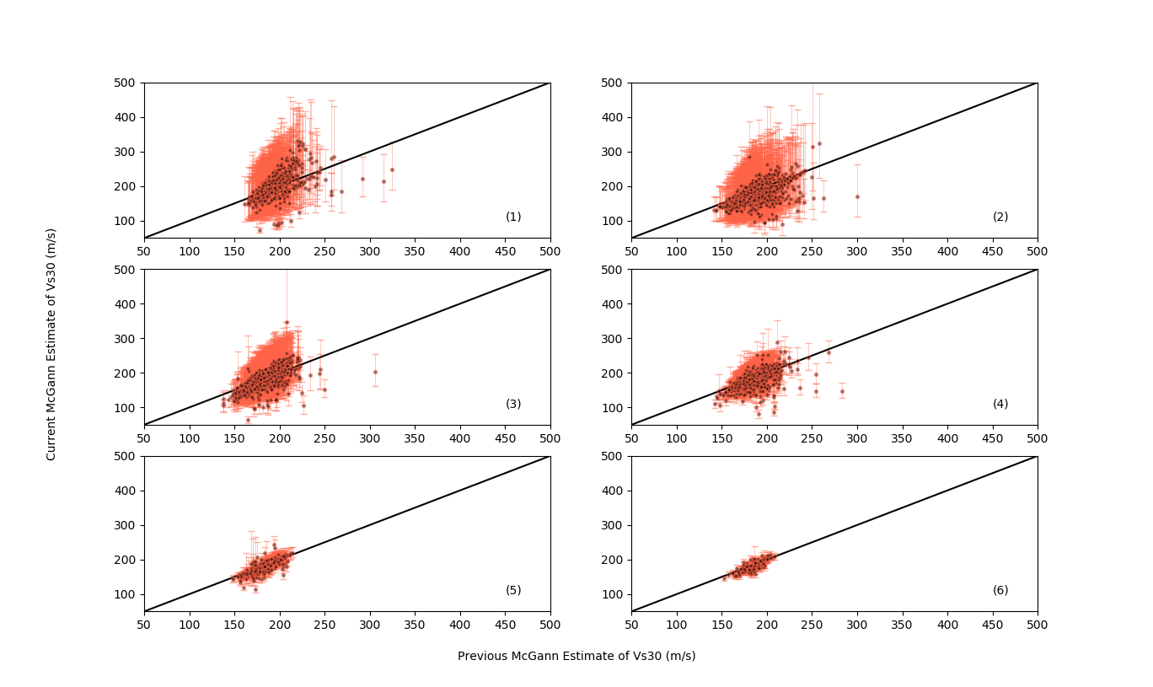

Figure 1. Comparison between all Vs30 estimations.

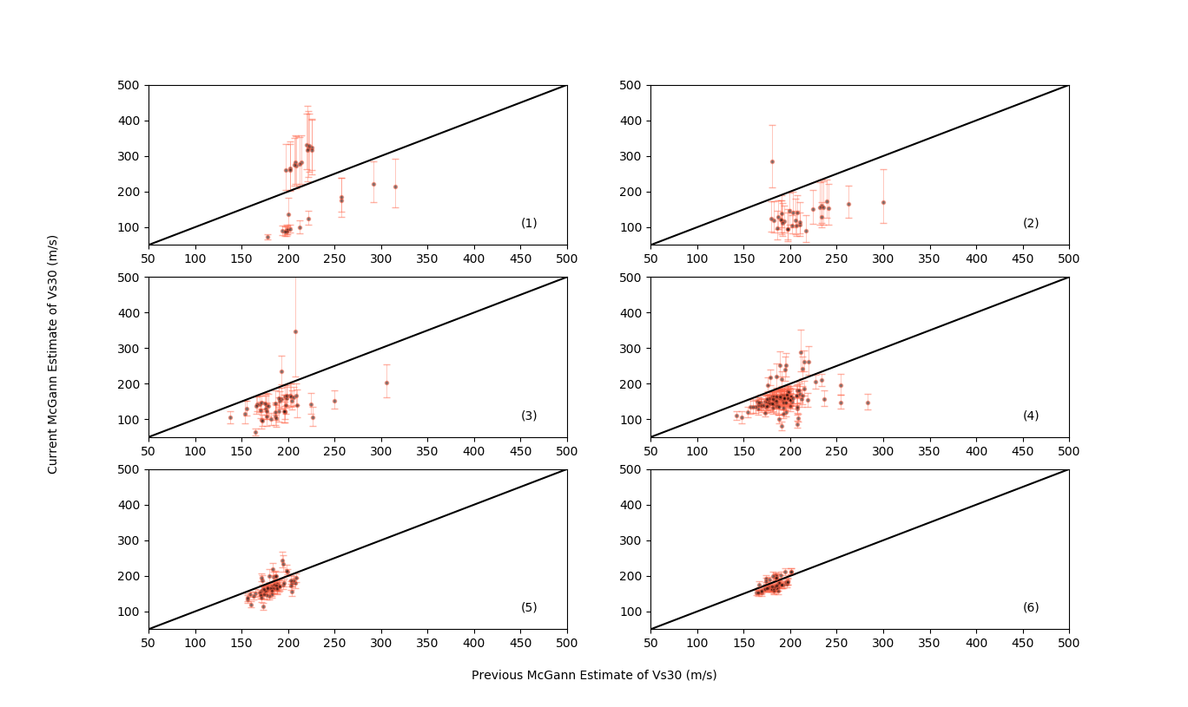

Figure 2. The points where the error bars do not cover 1:1 line.

In Figure 1a-1c, the error bars are large due to shallow determination depth, which explains why there are less points that do not cover 1:1 line. It does not mean the estimation is more accurate, only means that we know there is a large uncertainty.

In Figure 1d-1f, as the termination depth increases, the uncertainties reduce, which explains why there are more points that do not cover 1:1 line.

The points below 1:1 line (underpredicting) are more accurate in the previous McGann’s model, because it accounts for the gravel level.

# Correlations in Wellington Region

Using the Vs measurements from DesignSafe to verify the estimation of Vs correlations. However, due to lack of data, the cpt measurements can be up to 50 meters away from the Vs measurements.

**Aotea Quay (AQ1)**

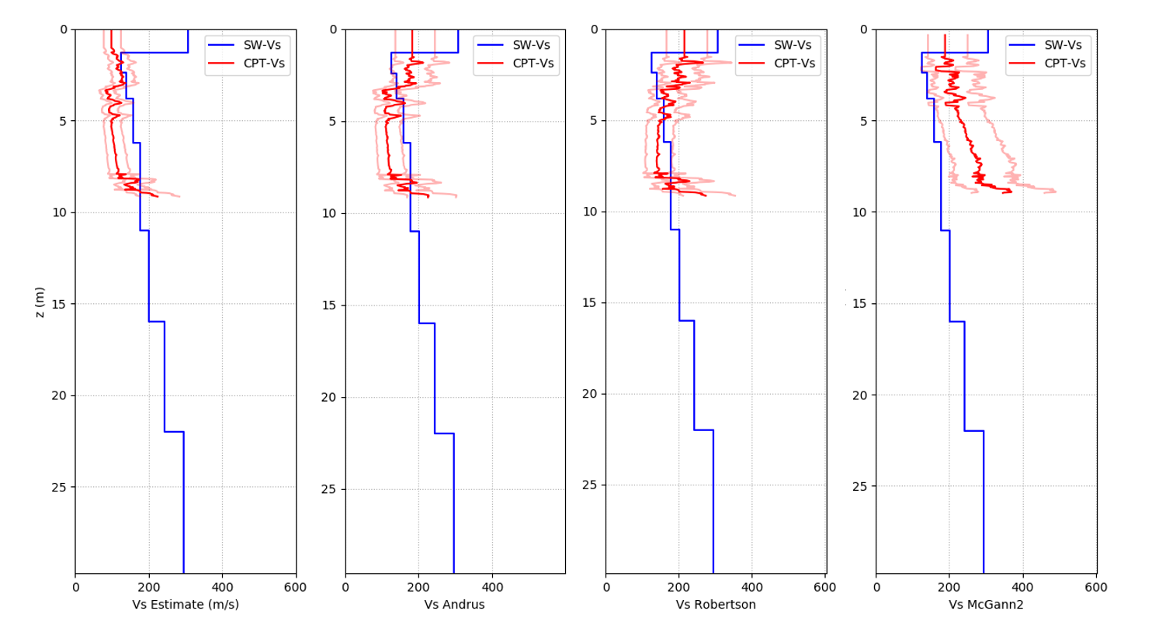

**BSRV1, BSRV3**

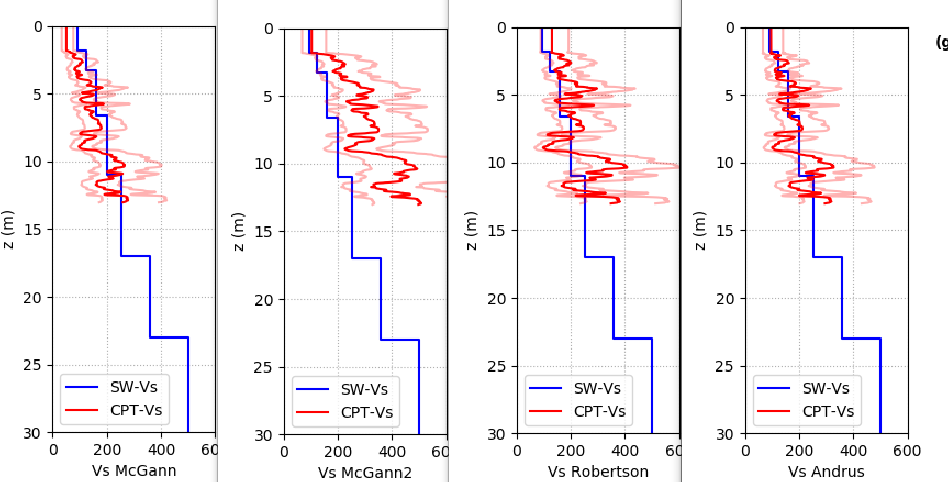

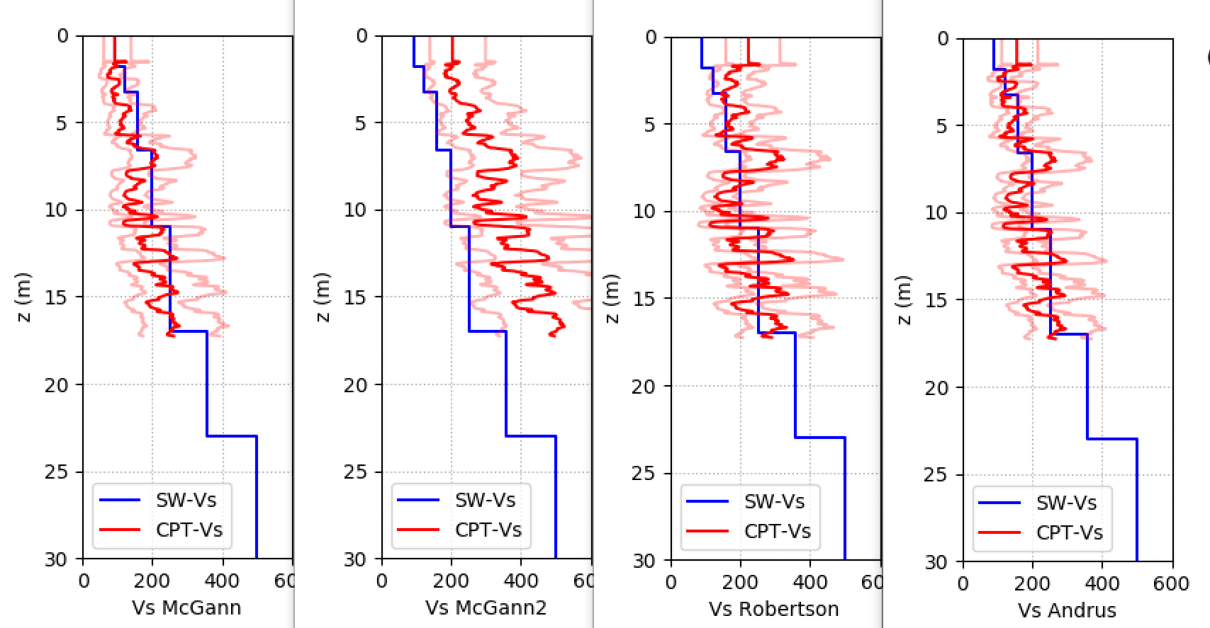

**BNZ1, BNZ2, BNZ4**

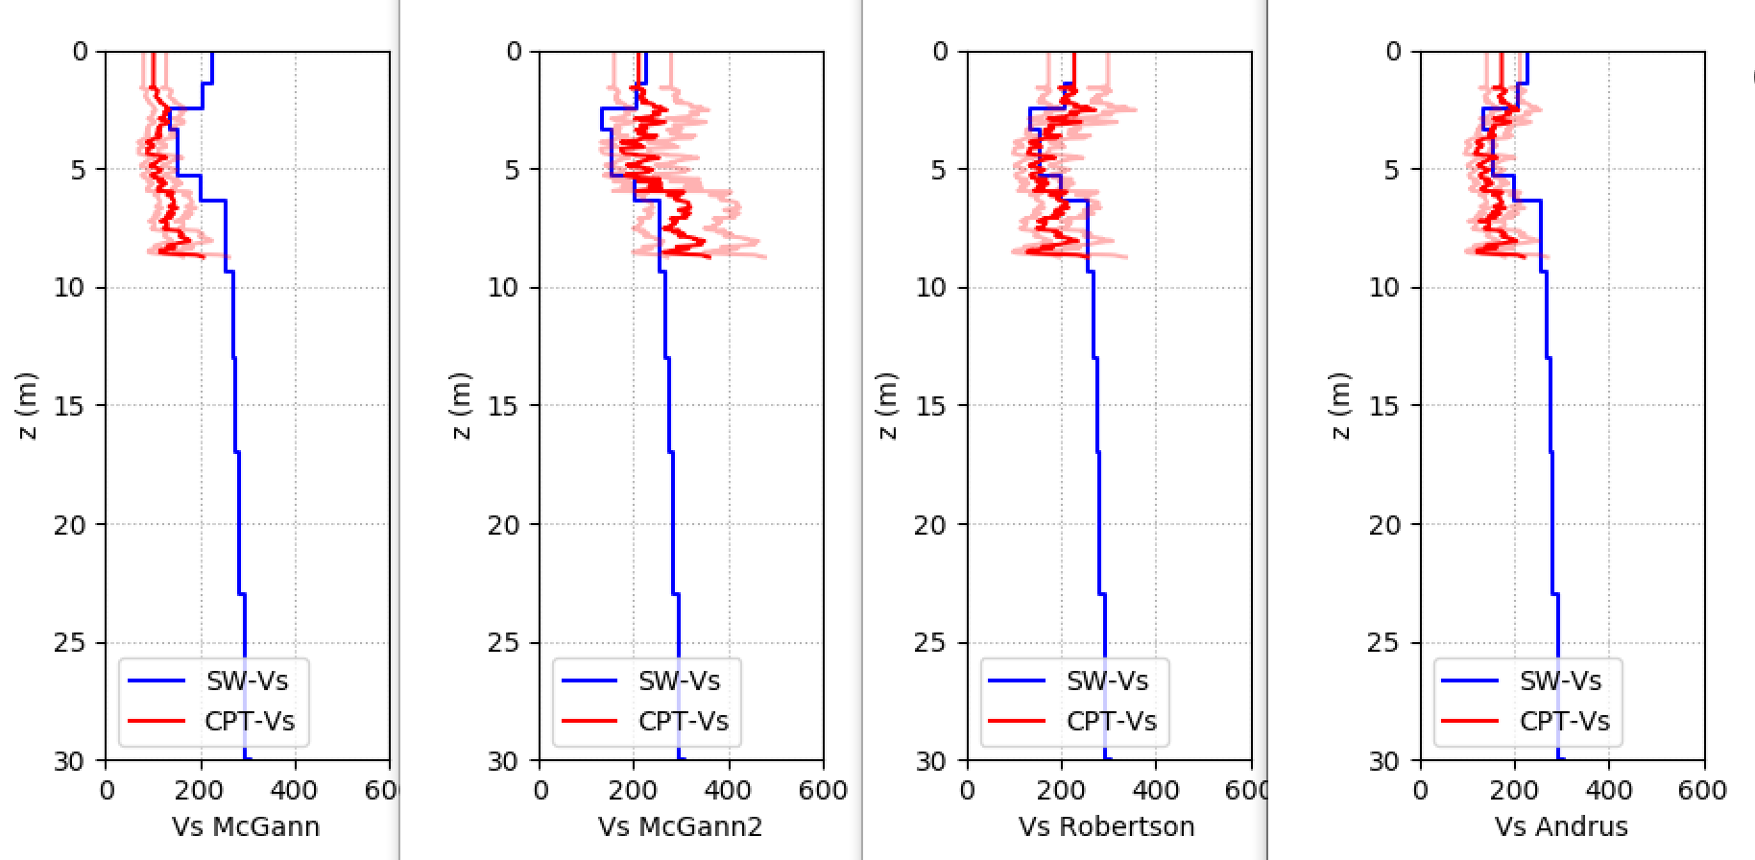

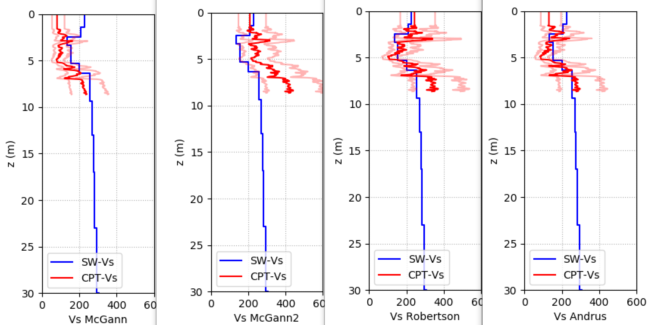

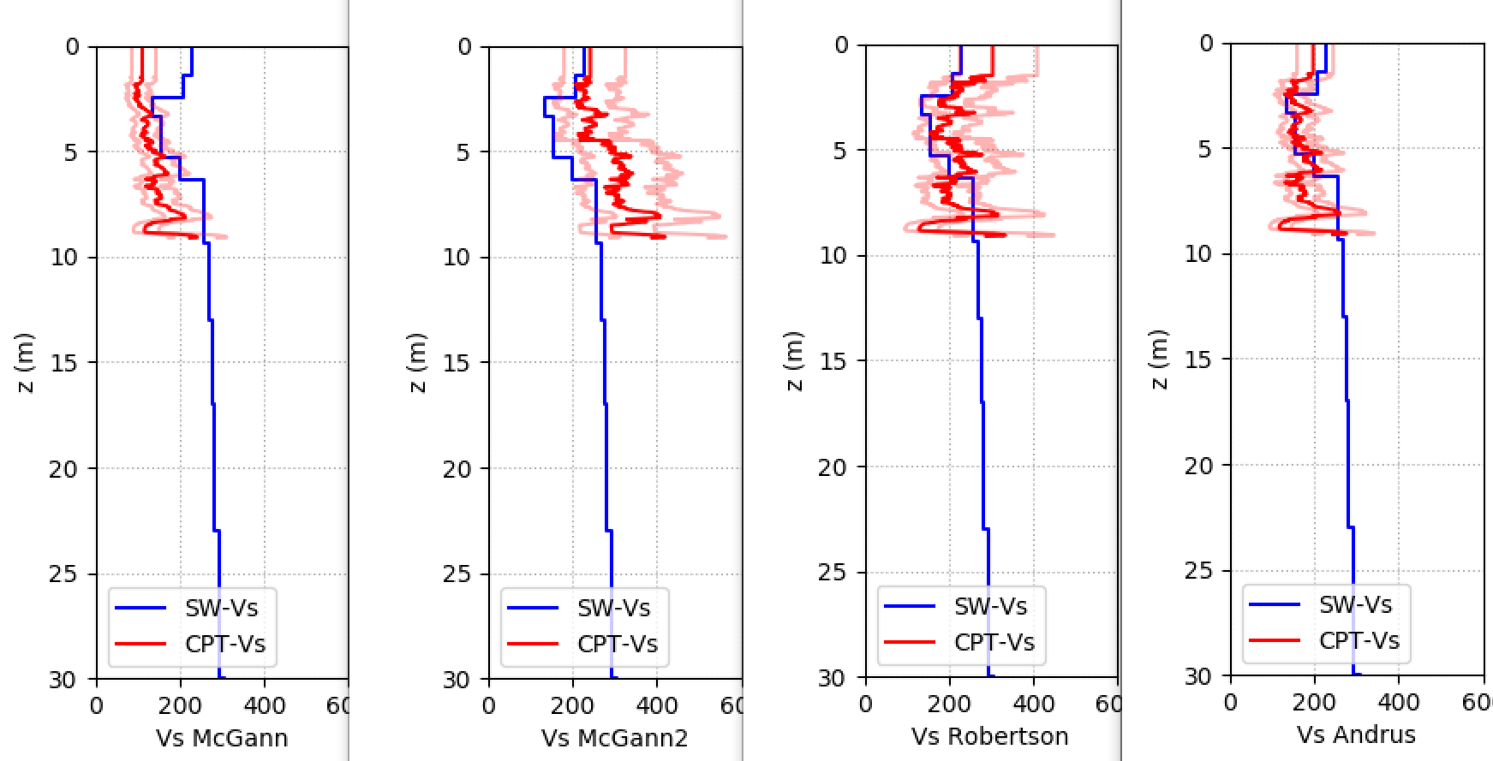

**MO1, MO2, MO4**

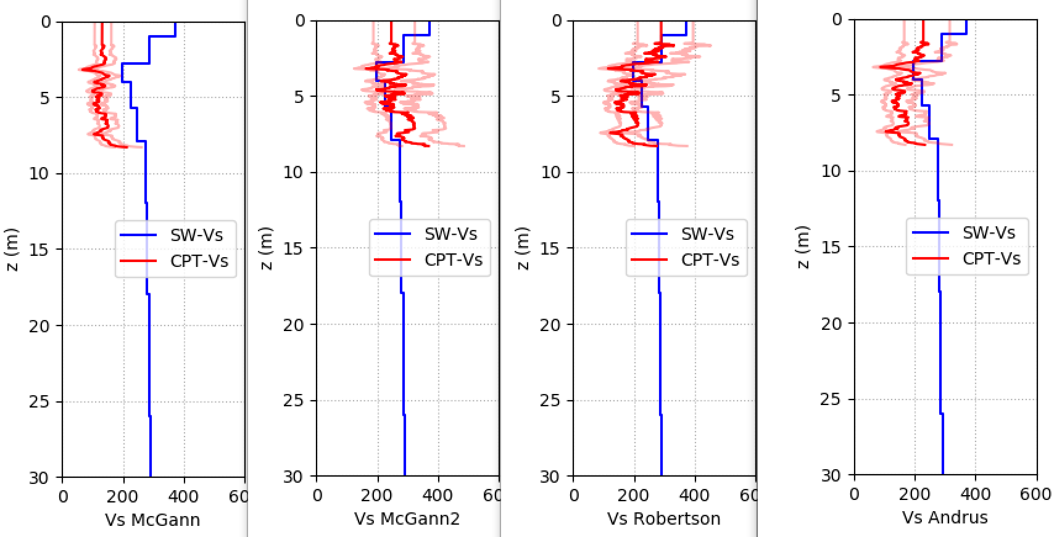

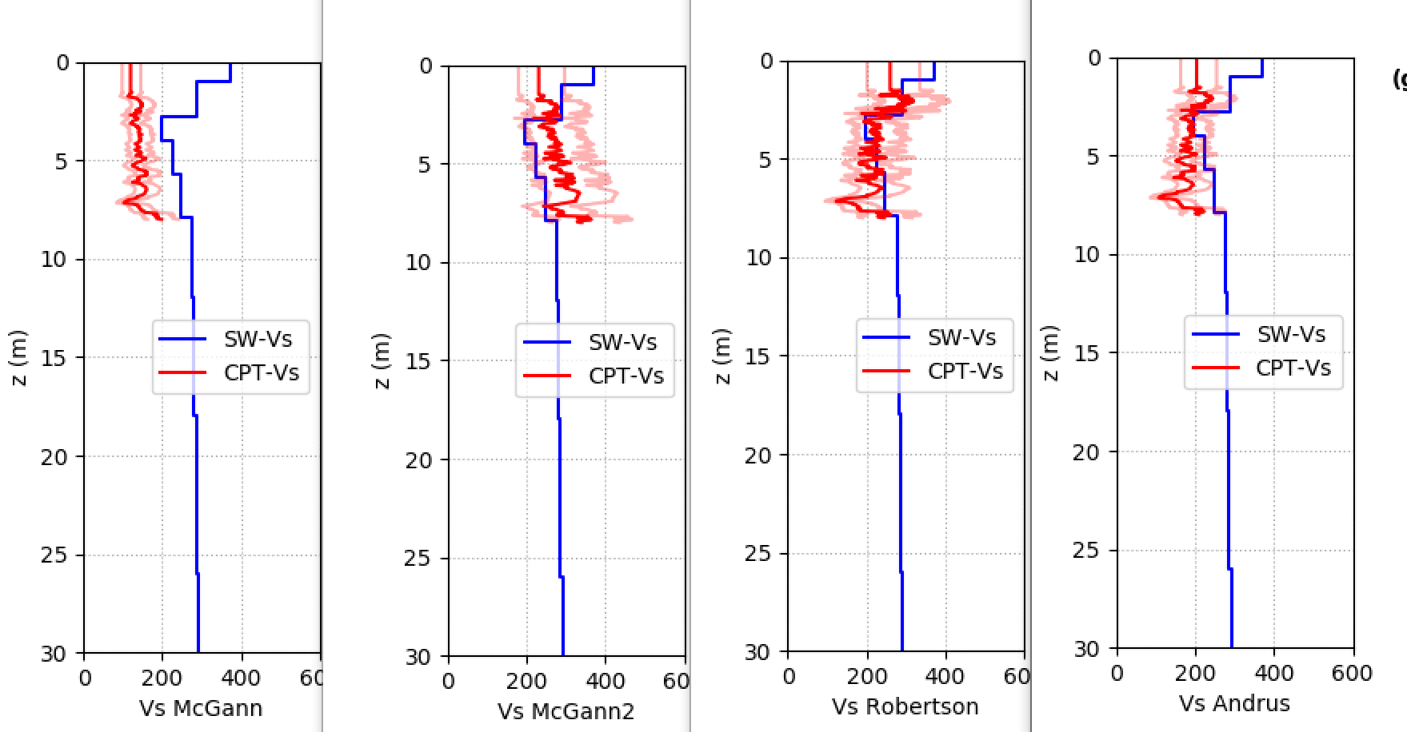

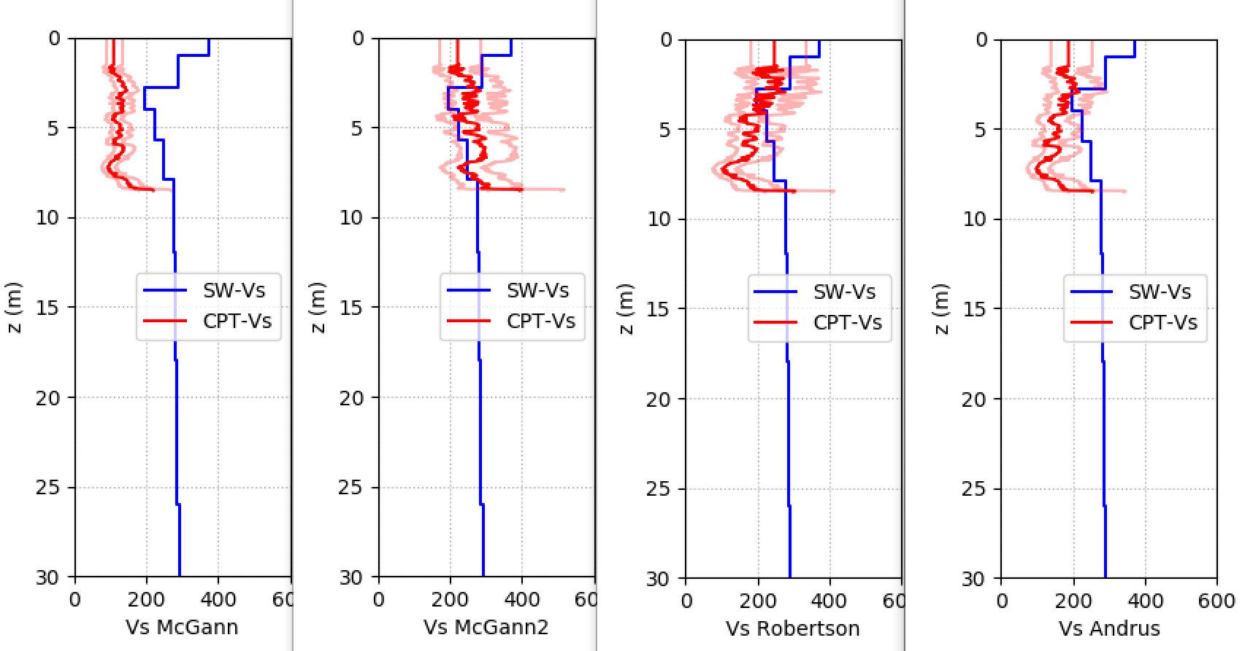

**Observation**:

Based on comparison, the general correlation from Roberston works the best in the Wellington region. The surficial geology at these locations are mianly Alluvium deposits and Reclaimed fill (the map from GNS is not very clear). It may be worth verifying that if the correlation can be applied based on surficial geology to imporve accuracy.