**Comparison of Vs profiles and its standard deviation (+-1): (left – Chris; right – Claire)**

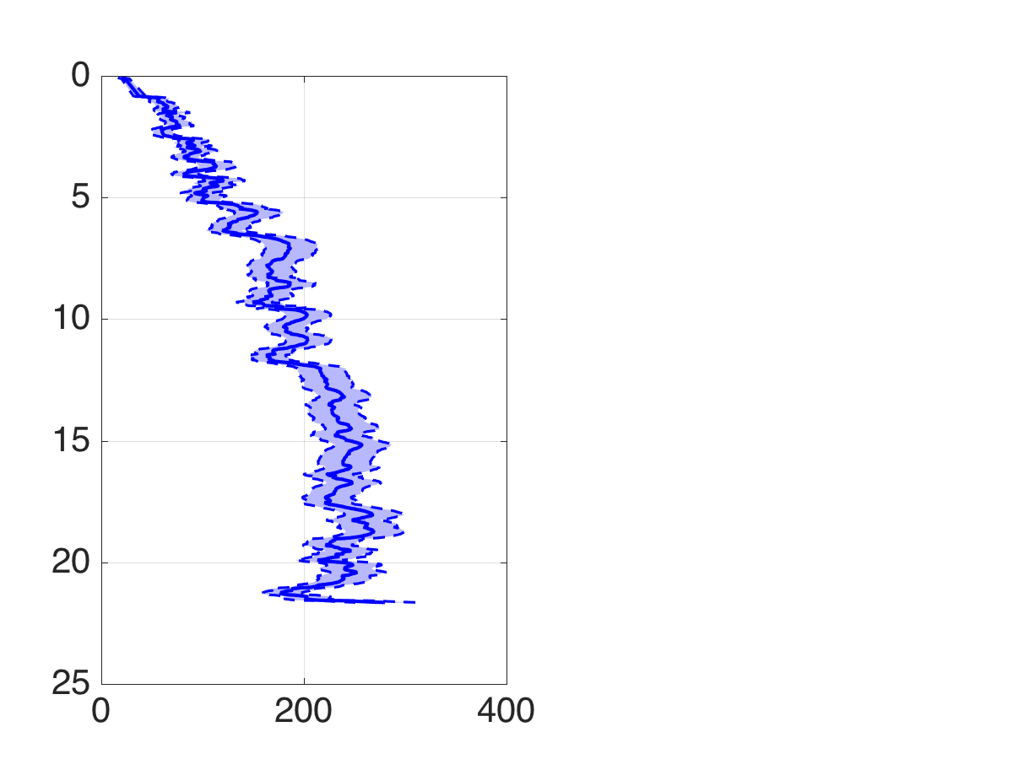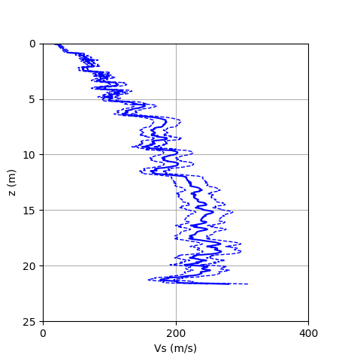

Vsz:

* Chris got Vsz = 134.8 m/s at 21m, I got Vsz = 135.11 m/s. Both using the sum of the incremental depths for depths <= 21m.
* Using mid-point velocity at each layer, which leads to a slightly lower estimation-131.88 m/s.
* Vsz range: 117-155 (Chris); 121-151 (using bottom point velocity); 118-147 (using mid-point velocity)
* Data is trimmed by deleting rows where Vs = 0

**Checking Vsz:**

A simple linear Vs profile is created with Z from 0-20 m, and Vs from 100-300 m/s, plot as shown below. Solve total travel time by integrating $t=\int_{0}^{20}{\frac{1}{Vs(z)}dz}=0.109861 s$; and Vsz is found to be $Vsz=\frac{20}{0.109861}=182.047 m/s$. The answer matches with what I got from my code, where a snapping shot is shown below.

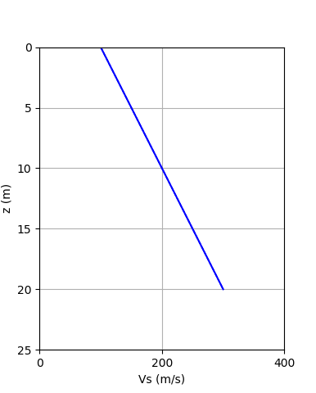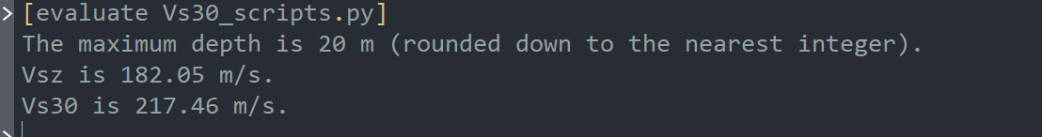

**Checking Vs30:**

It is hard to reproduce the figure in Boore’s paper, because he uses more than a hundred sets of data. The verification is done by plotting Vs30 at each depth z against Vsz, as shown in the figures below. Where Figure a is the dataset used in the previous section; and figure b is another set of data that has a max depth greater than 30 m. All 25 coefficients from 5-29m are covered in these plots. Few observations made: (1) There is no spike or any outliers. (2) Vs30 estimated using different depths are similar, all approximately lying on a horizontal straight line. (3) As depth increases, Vs30 approaches to the diagonal line. These three observations suggest that the code is working.

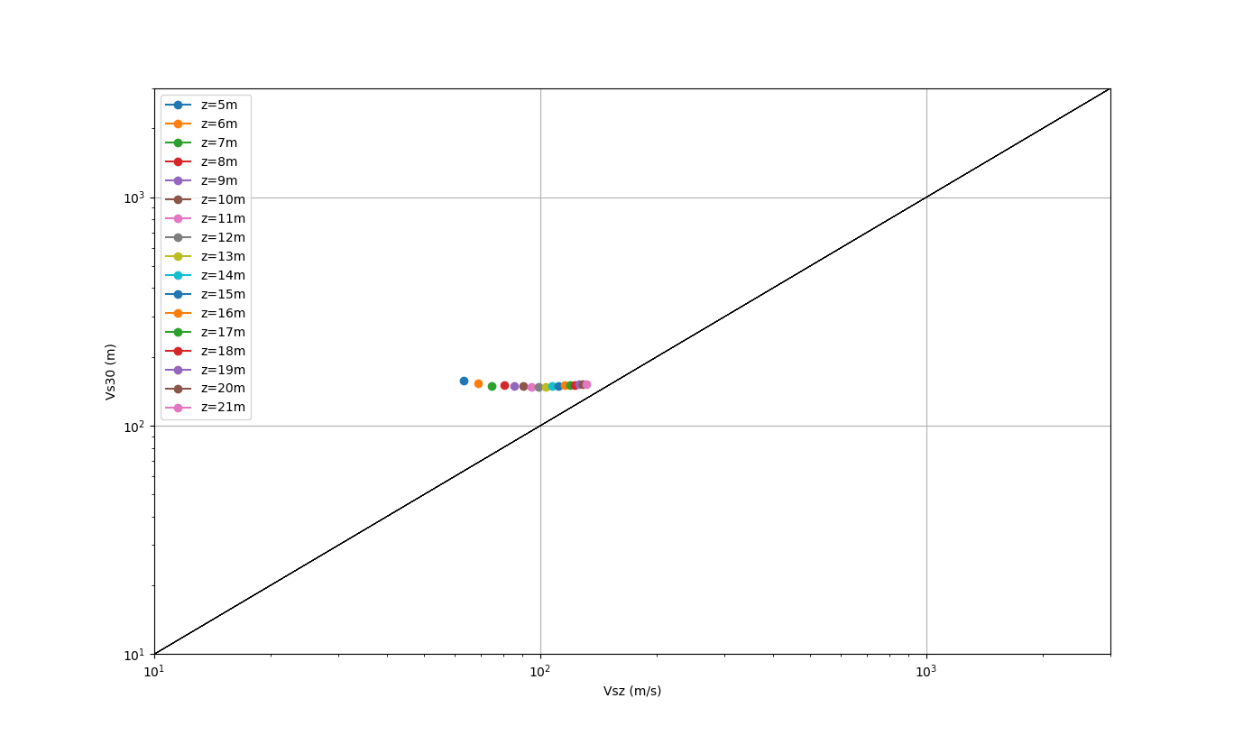

CPT – 782

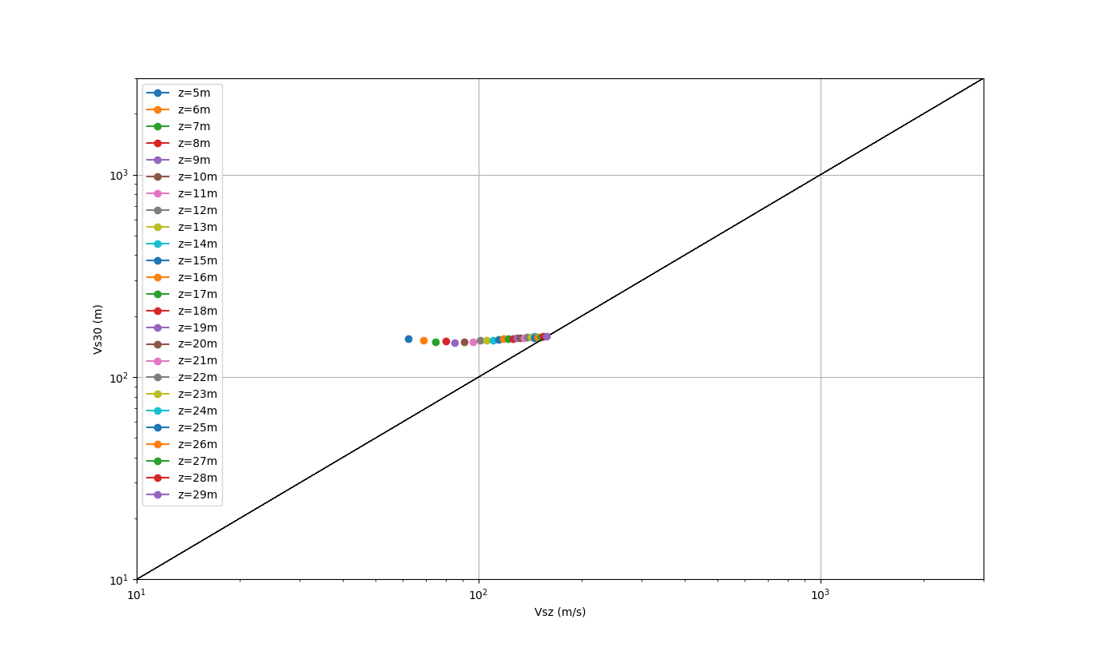

CPT – 917

A simple plot to compare the predicted Vs (green), mean Vs from random selected samples (blue), and measured Vs (orange). Note here the correlation flag is 0.

