

Spring 2020

CSE482 Project Proposal

**Section: 03**

**Group: 05**

Submitted to:

Ms. Zarin Hoque

Group Members:

1. **Shafayet Jamil Zim - 1620346042**
2. **Md. Nahid Hasan - 1620847042**
3. **Uchchwas Das - 1620016042**

Introduction:

Internet shopping now is really popular for days. One that saves time in our busy life. It's a very strong selling and buying site for goods. A web-based e-commerce platform provides users with the ability to easily visit the website and pick the product and place a delivery order. Shopkeepers get the details on the order, collect all the items and deliver to the address given. Very simple, quick and efficient.

Problem Statement:

In our modern-day life, we are very busy with different works. Sometimes we don’t have enough time to go to the bazar and do shopping. Sometimes we stuck to a situation and we are in a hurry that never let us go to the bazar. Because it kills much time and energy. Though many super shops have online delivery system they take much time for delivery. That’s why e-shopping will be a solution for this type of condition.

Proposed Solution:

This web application connects to a variety of mega stores. When a user enters the website, he / she will show the website belongs to all the surrounding shops. Then you can select the shop and choose the items he / she wants. Users will see information relevant to all the items such as, brand price etc. The users can also scan for their product of choice. The delivery will be issued in a very short time after order confirmation.

What is new?

It will remove the problem about delivery time because our system will ensure the fastest delivery. This application will perform as a medium. Every super shop has their own website for online delivery but our application will merge them into single platform. All the order information will be handed over to the shopkeepers and their own delivery man will deliver the products as soon as possible. Shopkeepers will ensure the security issue for their delivery man and product quality will be ensured.

Business Idea:

We will get our profit from the super shop monthly based on how much they get profit through our application. If they don’t get any order, they don’t have to pay anything.

Technology Platform:

Front-end:

* Bootstrap.

* HTML.

* CSS.

* Java Script.

* We also use Template.

Back-end:

* PHP.

* PDO ( PHP data objects ).

* SQL.

We decide to use PDO in back-end part to create CMS. There's tutorial about CMS that we're trying to implement using PDO. And, we have to do mass modification.

Features:

* Sign-up and Sign-in (Both customer and shopkeepers).

Users and Shopkeepers must have to sign up and then sign in to access the system. Then, they can do what they want.

=> Customer portal:

* Order History.

User can go and see what they ordered and their previous order history.

* Profile

They can see every information that was provided by them.

=> Shopkeeper portal:

* Entry new product.

Shopkeepers can add new products.

* Entry new category.

Shopkeepers can add new category.

* Customize Entry.

Shopkeepers can customize entry.

* Delete entry.

Shopkeepers can delete products.

* Profile.

Shopkeepers can see their shop related information.

* Order History.

Shopkeepers can see what customers ordered.

Name of this online platform : AjkerBazar

### Relational Database Schema :

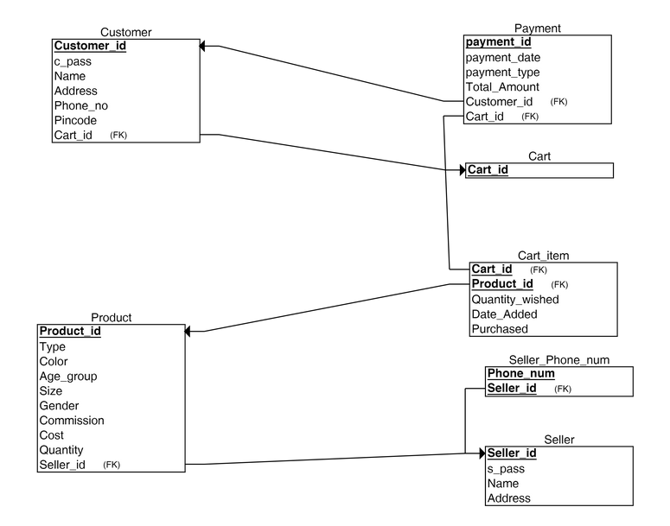

UI Design:

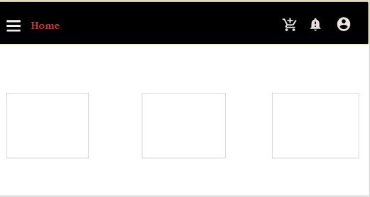

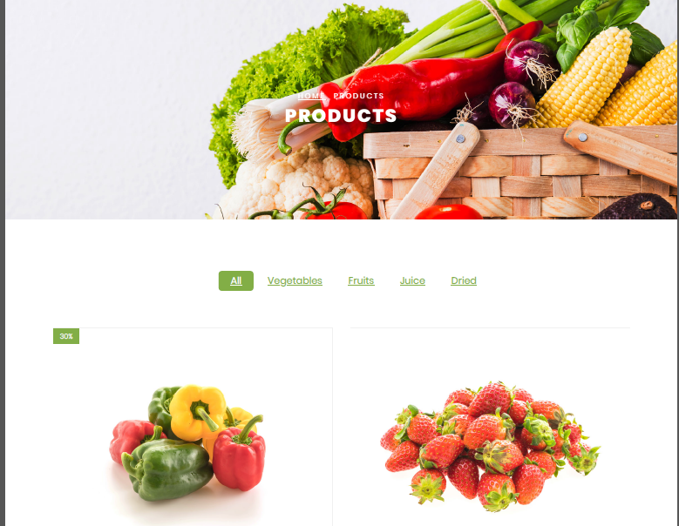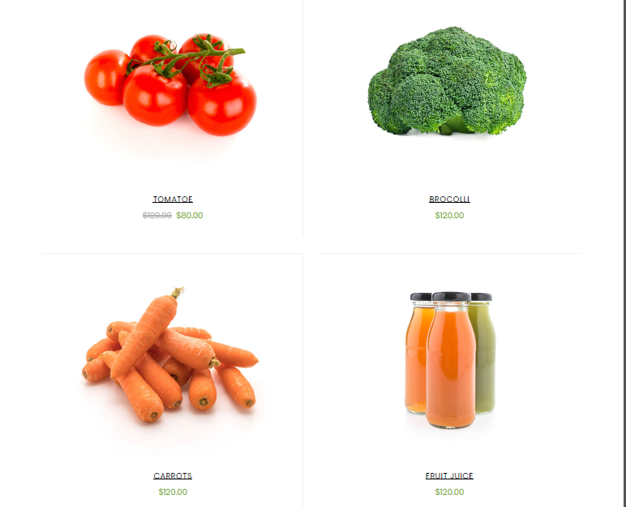

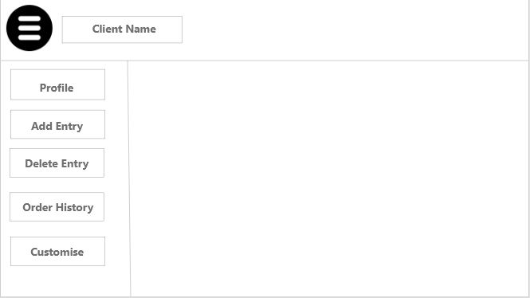

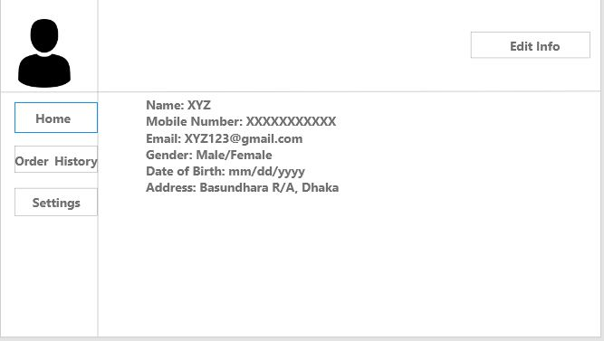

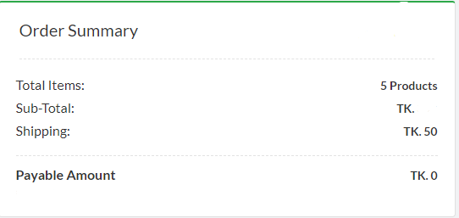

Project track by :

Github: https://github.com/uchchwas1/ajkerbazar

Trello: https://trello.com/b/8a8ulGC0/ajkerbazar