Slide 1 — Cover / Opening
🥇 Tanara AI
An Intelligent Public Health Early-Warning System for ASEAN
Tagline:
Predict Earlier. Act Faster. Protect Lives.
Include:
- Team name
- SDG 3 logo
- Healthcare + AI visual

Slide 2 — The Human Story (Inspiration)
Title:
Behind Every Health Statistic Is a Human Life
Content:
Our journey started from a personal experience. A member of our team lost his father to tuberculosis — a reminder that many health challenges become tragedies not only because solutions do not exist, but because risks are often detected too late.
Transition:
We asked ourselves: What if health systems could see tomorrow’s risks to
Slide 3 — The Problem
Title:
Healthcare Systems Are Still Fighting Yesterday’s Battles
Show:
660M+ ASEAN Population
Problem points:
- Health progress is uneven across countries
- Critical health indicators remain fragmented
- Decision-makers lack early-warning intelligence
- Resources often arrive after risks become crises
End with:
Public health needs prediction, not just reaction.

Slide 4 — Our Solution
Title:
Introducing 🥇 Tanara AI
One diagram:
Health Data
↓
Risk Intelligence Engine
↓
AI Prediction Model
↓
Priority Classification
↓
Action Recommendations
Text:
🥇 Tanara AI transforms health indicators into predictive intelligence that helps governments identify risks early and act before crises escalate.

Slide 5 — How 🥇 Tanara AI Works (Framework)
Title:
From Data to Life-Saving Decisions
Three pillars:
1. Health Risk Index
Measures vulnerability
Uses:
- Mortality indicators
- Disease burden
- Nutrition

2. Readiness Intelligence
Measures capacity
Uses:
- Immunization
- Healthcare workforce
- Health investment

3. AI Early Warning
Predicts future risk and recommends action

Slide 6 — Data & Methodology
Title:
Built on Real Public Health Indicators
Dataset:
- ASEAN countries
- 2004–2025
- Provided Data + World Bank Development Indicators
Pipeline:
Data Collection
↓
Cleaning & Integration
↓
Feature Engineering
↓
ML Training
↓
Deployment
Mention:
Current-year indicators predict following-year health risk.
Example:
2024 indicators → 2025 risk

Slide 7 — Key Insights (EDA)
Title:
What the Data Revealed
Show your best visuals:
- Health risk scores across ASEAN (2025)
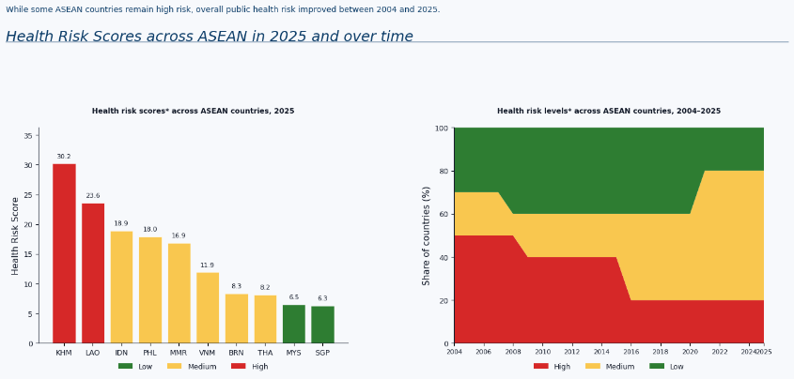

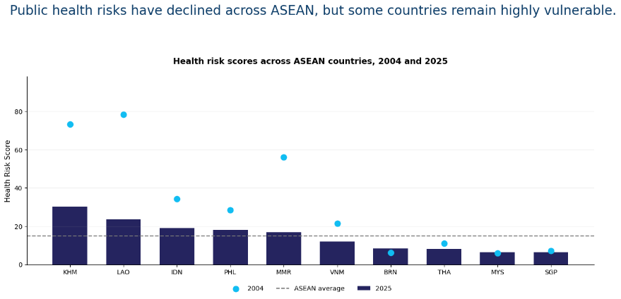

- Risk evolution 2004–2025
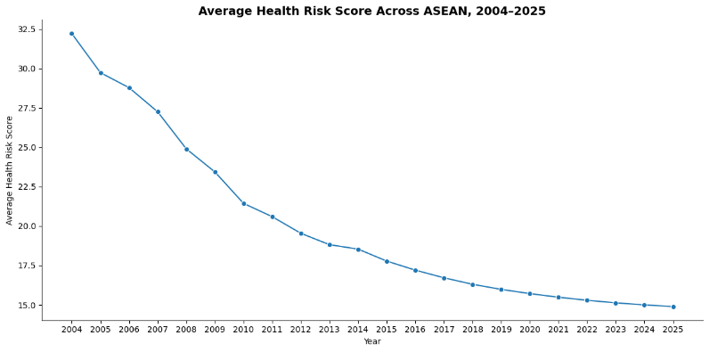
- Risk vs Readiness Matrix
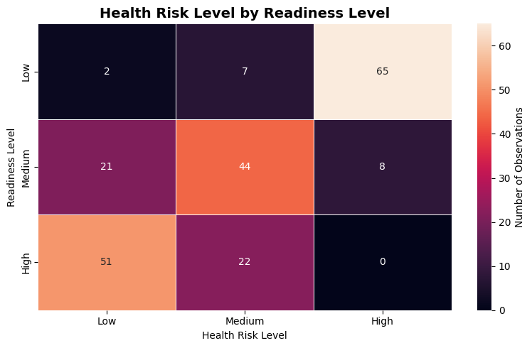

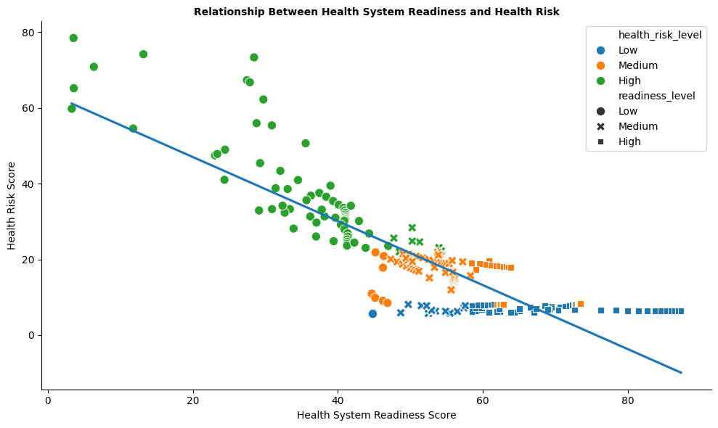

Main insight:
Countries with similar risks often have different capacities to respond — making readiness as important as risk detection.
If the correlation between readiness score and health risk score is negative, it suggests that countries with stronger health system capacity tend to have lower public health risk.
The cross-tabulation between readiness level and health risk level helps validate the Risk–Readiness Matrix by showing whether low-readiness countries are more likely to appear in medium or high-risk categories.

Slide 8 — Machine Learning Model
Title:
Teaching AI to Detect Tomorrow’s Health Risks
Show:
Models tested:
- Logistic Regression
- Random Forest
Evaluation:
- Time-based validation
- Prioritized High-risk detection
Important line:
In public health, missing a high-risk country is more costly than raising an early warning.
Add metrics:
Accuracy
F1-score
High-risk recall

Slide 9 — Product Demo
Title:
Turning Predictions Into Action
Show Streamlit screenshots:
Pages:
- Executive Dashboard
- Risk Intelligence
- AI Copilot
- Country Deep Dive
Highlight:
Input:
Cambodia 2025 health indicators
Output:
2026 predicted risk + recommended interventions
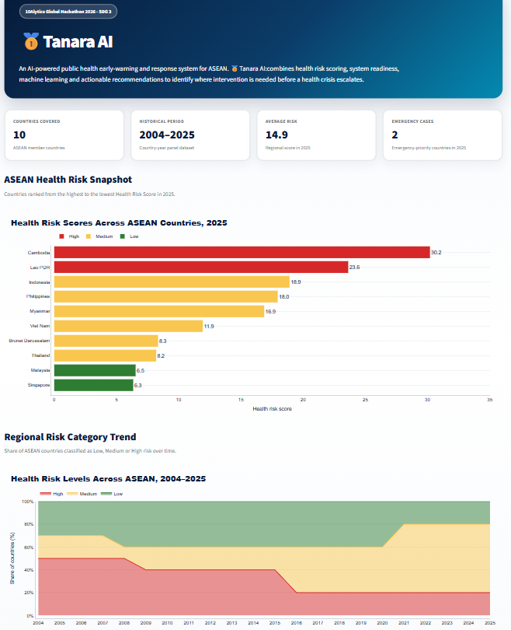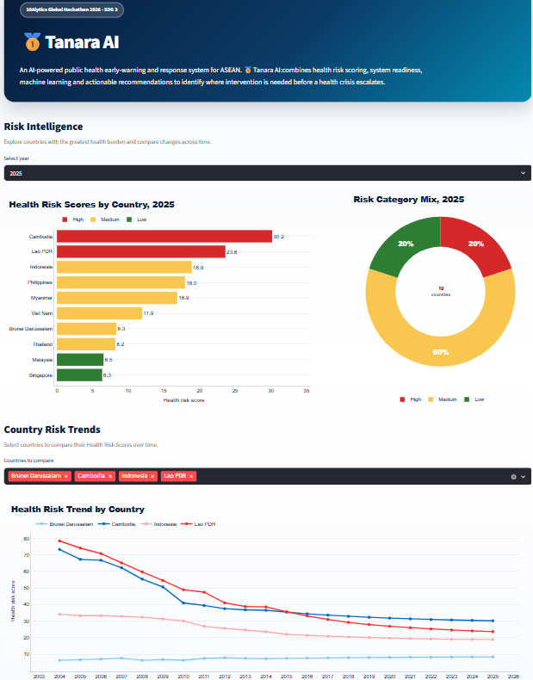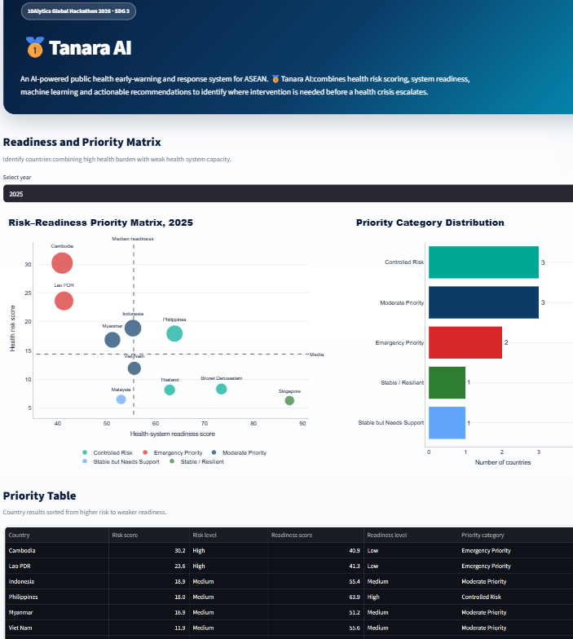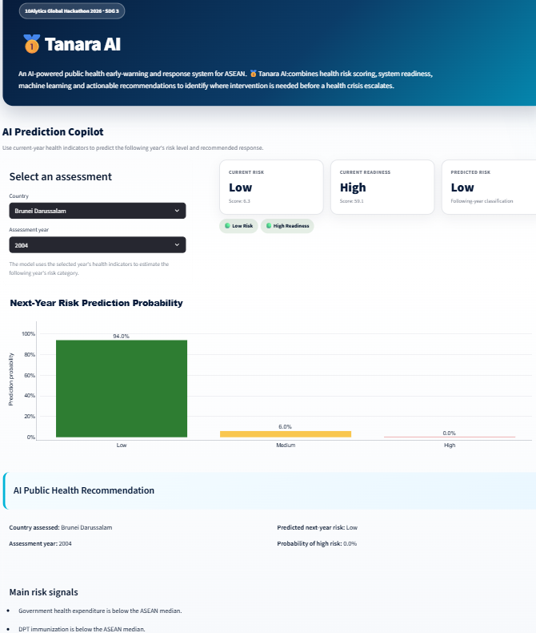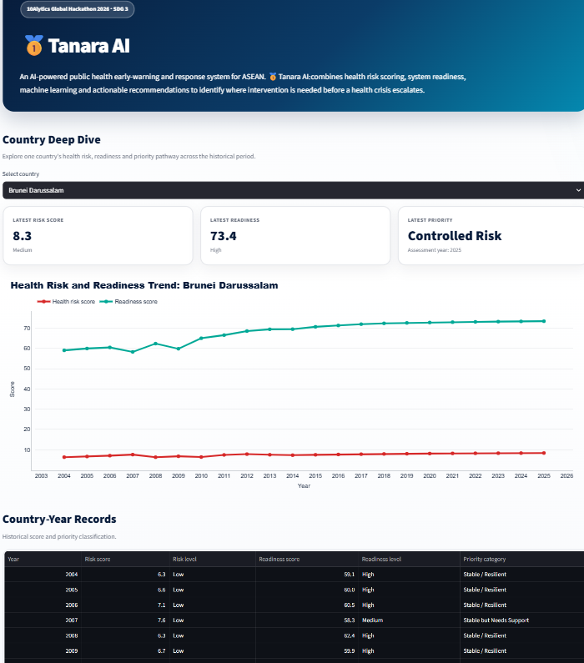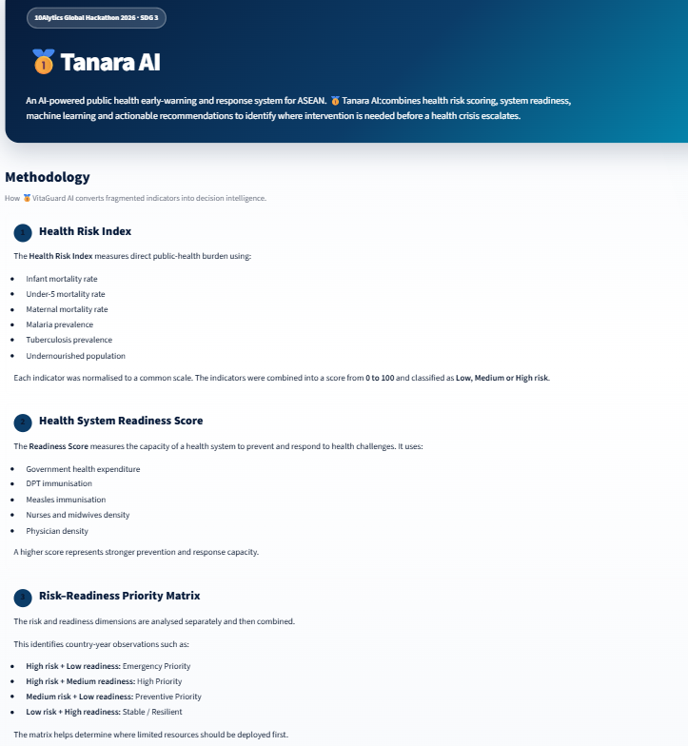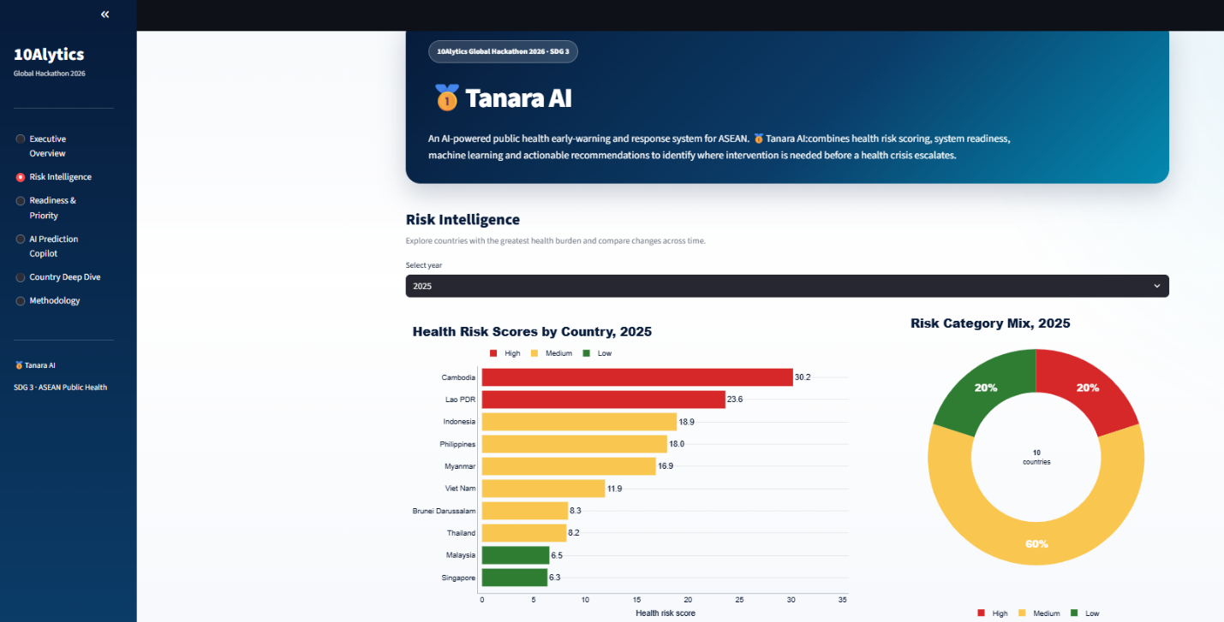

Slide 10 — What Makes 🥇 Tanara AI Different?
Title:
Beyond Prediction — Decision Intelligence
Comparison:
Traditional Approach | 🥇 Tanara AI
React after crisis | Predict before crisis
Monitor indicators | Understand risk
Separate datasets | Unified intelligence
Reports | Action recommendations

Slide 11 — Scalability & Future Vision
Title:
Built for ASEAN. Designed for the World.
Future:
- Real-time WHO health feeds
- Climate-risk indicators
- Disease outbreak signals
- Subnational predictions
- Government decision platform
Key message:
The framework can scale beyond ASEAN to any region.

Slide 12 — Closing / Impact
Title:
The Future of Healthcare Is Preventive
End with:
🥇 Tanara AI helps decision-makers stop asking:
“What went wrong?”
and start asking:
“What can we prevent next?”
Big tagline:
Predict Earlier. Act Faster. Protect Lives.
For a hackathon, I would keep it 10–12 slides maximum. Your biggest weapons are:
- The TB personal story
- The risk + readiness framework
- The AI prediction
- The recommendation engine

