CSE 847: Homework 5

Ikechukwu Uchendu

https://github.com/uchendui/CSE847/tree/master/Homework/Homework5

1. Clustering: K-Means
   1. It is certainly possible for k-means and spectral relaxation of k-means to arrive at the same solution. Consider the example matrix we used in class. The matrix had a form such that the regular k-means and spectral k-means had the same solution.
   2. The spectral relaxation technique seems to make the clusters more compact. The points have also been rotated due to the spectral transformation.

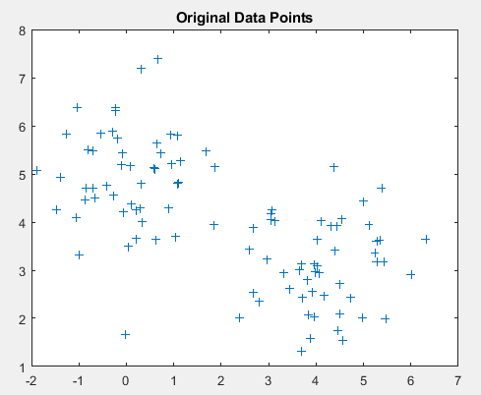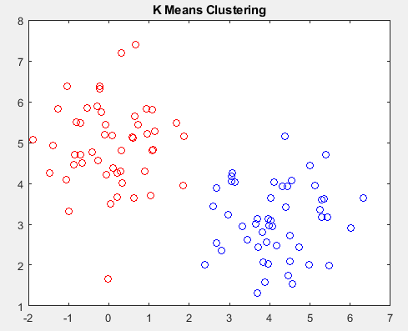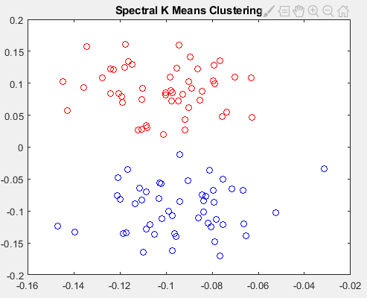

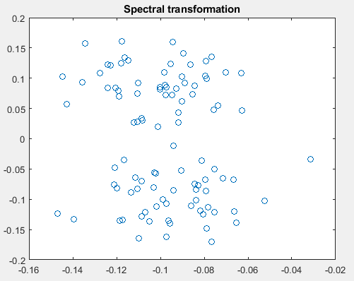

1. Principle Component Analysis
   1. The first principle component will be the vector in the direction of (-1,2). This is because all of the data points are on the same line. The second principle component will be a vector in the direction of (2,1). This is the direction perpendicular to the second principle component.

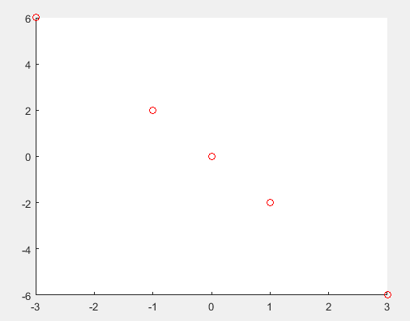





Error: 0.51648

Error: 0.26372



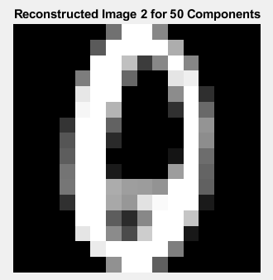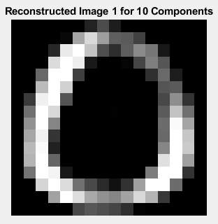

Error: 1.1528

Error: 4.1957

Error: 4.3131

Error: 2.1114

Error: 1.642

Error: 1.1515