title: “Advanced Bioinformatics 2019 assessment” author: “Candidate number 8941” date: “15/06/2019” output: html_document

## Task 1

sum(5:55)

## [1] 1530

## Task 2

n=10  
sumfun<- sum(5:n)  
sumfun

## [1] 45

n=20  
sumfun<- sum(5:n)  
sumfun

## [1] 200

n=100  
sumfun<- sum(5:n)  
sumfun

## [1] 5040

## Task 3

Fibonacci <- numeric(12)  
Fibonacci[1] <- Fibonacci[2] <- 1  
for (i in 3:12) Fibonacci[i] <- Fibonacci[i-2] + Fibonacci[i-1]  
print(Fibonacci)

## [1] 1 1 2 3 5 8 13 21 34 55 89 144

## Task 4

library(ggplot2)  
str(mtcars)

## 'data.frame': 32 obs. of 11 variables:  
## $ mpg : num 21 21 22.8 21.4 18.7 18.1 14.3 24.4 22.8 19.2 ...  
## $ cyl : num 6 6 4 6 8 6 8 4 4 6 ...  
## $ disp: num 160 160 108 258 360 ...  
## $ hp : num 110 110 93 110 175 105 245 62 95 123 ...  
## $ drat: num 3.9 3.9 3.85 3.08 3.15 2.76 3.21 3.69 3.92 3.92 ...  
## $ wt : num 2.62 2.88 2.32 3.21 3.44 ...  
## $ qsec: num 16.5 17 18.6 19.4 17 ...  
## $ vs : num 0 0 1 1 0 1 0 1 1 1 ...  
## $ am : num 1 1 1 0 0 0 0 0 0 0 ...  
## $ gear: num 4 4 4 3 3 3 3 4 4 4 ...  
## $ carb: num 4 4 1 1 2 1 4 2 2 4 ...

ggplot(mtcars, aes(x = as.factor(gear), y = mpg, fill = gear))+  
 geom_point()+  
 geom_boxplot()+  
 labs(x='number of gears', y='miles per gallon', title='mtcars box plot')

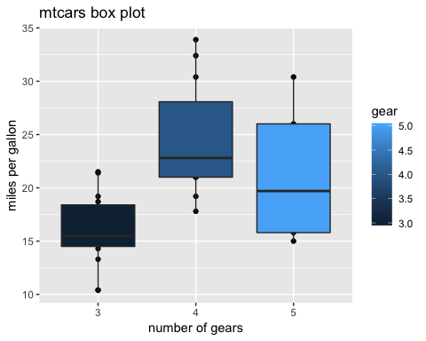

#with a small amount of random variation added to the points because of small dataset  
library(ggplot2)  
ggplot(mtcars, aes(x = as.factor(gear), y = mpg, fill = gear))+  
 geom_point()+  
 geom_boxplot()+  
 geom_jitter()+  
 labs(x='number of gears', y='miles per gallon', title='mtcars box plot (some random variation to points added)')

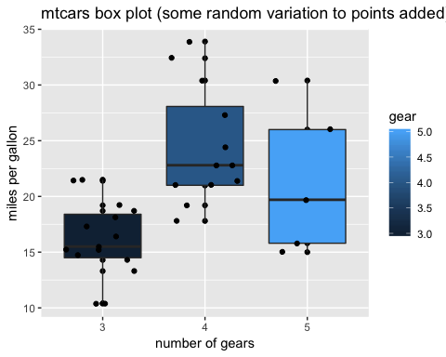

## Task 5

str(cars)

## 'data.frame': 50 obs. of 2 variables:  
## $ speed: num 4 4 7 7 8 9 10 10 10 11 ...  
## $ dist : num 2 10 4 22 16 10 18 26 34 17 ...

summary(cars)

## speed dist   
## Min. : 4.0 Min. : 2.00   
## 1st Qu.:12.0 1st Qu.: 26.00   
## Median :15.0 Median : 36.00   
## Mean :15.4 Mean : 42.98   
## 3rd Qu.:19.0 3rd Qu.: 56.00   
## Max. :25.0 Max. :120.00

# Model1  
#variable speed centered around its mean to avoid nonesense negative values  
set.seed(1)  
speed.c = scale(cars$speed, center = TRUE, scale = FALSE)  
model1 = lm(formula = dist~speed.c, data = cars)  
summary(model1)

##   
## Call:  
## lm(formula = dist ~ speed.c, data = cars)  
##   
## Residuals:  
## Min 1Q Median 3Q Max   
## -29.069 -9.525 -2.272 9.215 43.201   
##   
## Coefficients:  
## Estimate Std. Error t value Pr(>|t|)   
## (Intercept) 42.9800 2.1750 19.761 < 2e-16 ***  
## speed.c 3.9324 0.4155 9.464 1.49e-12 ***  
## ---  
## Signif. codes: 0 '***' 0.001 '**' 0.01 '*' 0.05 '.' 0.1 ' ' 1  
##   
## Residual standard error: 15.38 on 48 degrees of freedom  
## Multiple R-squared: 0.6511, Adjusted R-squared: 0.6438   
## F-statistic: 89.57 on 1 and 48 DF, p-value: 1.49e-12

##### fitted slope in Model1 is 3.932 feet with standard deviation of 0.415

##### intercept of the line is 42.98 feet with standard deviation of 2.175

# Model2   
#optimisation with log transformation of variable distance  
#variable speed centered around its mean to avoid nonesense negative values  
set.seed(1)  
speed.c = scale(cars$speed, center = TRUE, scale = FALSE)  
model2 = lm(formular = log(dist)~speed.c, data = cars)

## Warning: In lm.fit(x, y, offset = offset, singular.ok = singular.ok, ...) :  
## extra argument 'formular' will be disregarded

summary(model2)

##   
## Call:  
## lm(data = cars, formular = log(dist) ~ speed.c)  
##   
## Residuals:  
## Min 1Q Median 3Q Max   
## -7.5293 -2.1550 0.3615 2.4377 6.4179   
##   
## Coefficients:  
## Estimate Std. Error t value Pr(>|t|)   
## (Intercept) 8.28391 0.87438 9.474 1.44e-12 ***  
## dist 0.16557 0.01749 9.464 1.49e-12 ***  
## ---  
## Signif. codes: 0 '***' 0.001 '**' 0.01 '*' 0.05 '.' 0.1 ' ' 1  
##   
## Residual standard error: 3.156 on 48 degrees of freedom  
## Multiple R-squared: 0.6511, Adjusted R-squared: 0.6438   
## F-statistic: 89.57 on 1 and 48 DF, p-value: 1.49e-12

##### fitted slope in Model2 is 0.1656 with standard deviation of 0.0175

##### intercept of the line is 8.28 with standard deviation of 0.874

## Task 6

# Model1 plot  
library(ggplot2)  
ggplot(cars, aes(x = speed, y = dist))+  
 geom_point()+  
 labs(x='Speed in miles per hour', y='Stopping distance in feet', title='Plot of Model1 linear fit')+  
 stat_smooth(method = lm, se = FALSE)

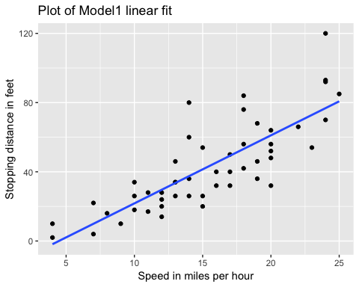

# Model2 plot  
library(ggplot2)  
ggplot(cars, aes(x = speed, y = log(dist)) )+  
 geom_point()+  
 labs(x='Speed in miles per hour', y='Log of stopping distance in feet', title='Plot of Model2 linear fit')+  
 stat_smooth(method = lm, se = FALSE)

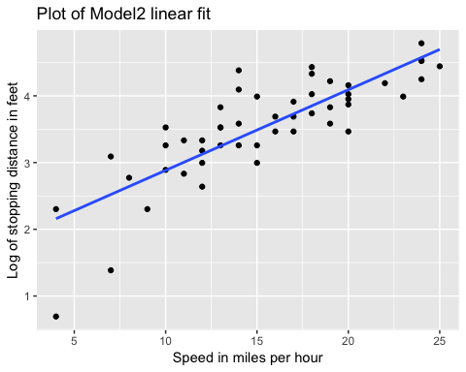

Task 7

library(dplyr)

##   
## Attaching package: 'dplyr'

## The following objects are masked from 'package:stats':  
##   
## filter, lag

## The following objects are masked from 'package:base':  
##   
## intersect, setdiff, setequal, union

#manipulating data in cars to create new columns with speed in miles per second and stopping distance in miles  
carsM <- mutate (cars, speedM = speed/3600, distM = dist/5280)  
str(carsM)

## 'data.frame': 50 obs. of 4 variables:  
## $ speed : num 4 4 7 7 8 9 10 10 10 11 ...  
## $ dist : num 2 10 4 22 16 10 18 26 34 17 ...  
## $ speedM: num 0.00111 0.00111 0.00194 0.00194 0.00222 ...  
## $ distM : num 0.000379 0.001894 0.000758 0.004167 0.00303 ...

#now doing linear regression with new data to relate stopping distance to square of speed  
set.seed(1)  
model3 = lm(formula = distM~I(speedM^2), data = carsM)  
summary(model3)

##   
## Call:  
## lm(formula = distM ~ I(speedM^2), data = carsM)  
##   
## Residuals:  
## Min 1Q Median 3Q Max   
## -0.0053878 -0.0017445 -0.0006807 0.0009614 0.0086860   
##   
## Coefficients:  
## Estimate Std. Error t value Pr(>|t|)   
## (Intercept) 1.678e-03 7.739e-04 2.168 0.0351 *   
## I(speedM^2) 3.166e+02 3.236e+01 9.781 5.2e-13 ***  
## ---  
## Signif. codes: 0 '***' 0.001 '**' 0.01 '*' 0.05 '.' 0.1 ' ' 1  
##   
## Residual standard error: 0.00285 on 48 degrees of freedom  
## Multiple R-squared: 0.6659, Adjusted R-squared: 0.6589   
## F-statistic: 95.67 on 1 and 48 DF, p-value: 5.2e-13

#ggplot of data points and fitted reltionship is model3 plot  
library(ggplot2)  
ggplot(carsM, aes(x = speedM^2, y = distM))+  
 geom_point()+  
 labs(x='Speed in miles per second squared', y='Stopping distance in miles', title='Plot of Model3 linear fit')+  
 stat_smooth(method = lm, se = FALSE)

