Hello ROS!
In this short tutorial we will validate our ROS installations and begin to explore how the system works.
Step 1. Run TurtleSim using rosrun
- ROS2 should be installed in /opt/ros/jazzy. You must set up each terminal to find ros by either typing the following every time you open a terminal
source /opt/ros/jazzy/setup.bash
or
Edit your bashrc file so setup.bash is automatically called every time you open a terminal by typinh once:
echo "source /opt/ros/jazzy/setup.bash" >> ~/.bashrc

You can check you have edited your bashrc correctly by running
source ~/.bashrc
Explanation of these steps can be found here: https://docs.ros.org/en/jazzy/Tutorials/Beginner-CLI-Tools/Configuring-ROS2-Environment.html
- In a terminal run:
ros2 run turtlesim turtlesim_node
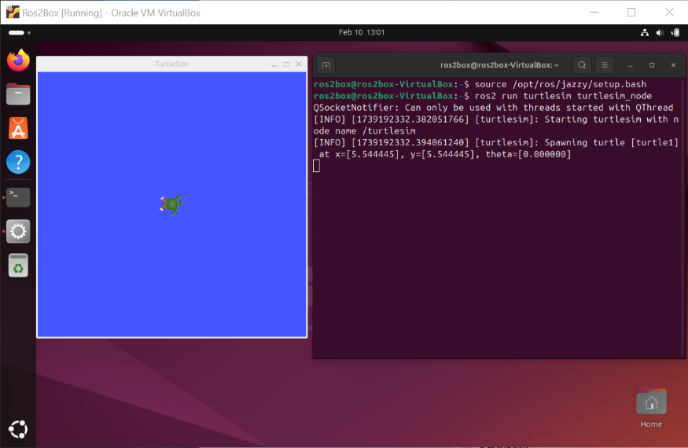
You should now see your TurtleSim window with your two terminals

- In a new terminal run
Ros2 run turtlesim turtle_teleop_key
You should now be able to control your turtle through keyboard control, see below for how your screen should appear.
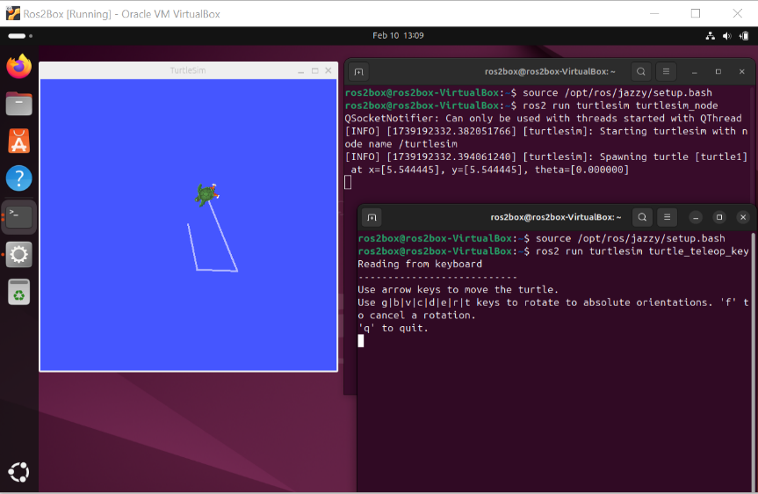
Step 2. Run TurtleSim using roslaunch
As you can see in Step 1, using ros2 run can quickly cascade into many windows each running a process, which can become unmanageable. A launch file can help us run many nodes in a set configuration, making complex combinations of packages much easier to manage.
To use a launch file we first must create a workspace. You can follow instructions here, please skip Step 3 (cloning a repository) and 4 (resolving dependencies) as these are not appropriate for us: https://docs.ros.org/en/jazzy/Tutorials/Beginner-Client-Libraries/Creating-A-Workspace/Creating-A-Workspace.html
You can then create a new package following instructions here: https://docs.ros.org/en/jazzy/How-To-Guides/Developing-a-ROS-2-Package.html. Note the following instructions are assuming you create a package my_turtle_sim. Going forward we will be creating packages with other names.
Create a turtlesim.launch file in your my_turtle_sim package. Tutorial can be found here:
https://docs.ros.org/en/jazzy/Tutorials/Beginner-CLI-Tools/Introducing-Turtlesim/Introducing-Turtlesim.html
and here
https://docs.ros.org/en/jazzy/Tutorials/Intermediate/Launch/Creating-Launch-Files.html
In a terminal you can create the folder and launch file using to following
cd ~/ros2_ws/src/my_turtle_sim
mkdir ./launch
cd ./launch
touch turtlesim.launch
To open the newly created file you can use
gedit turtlesim.launch
Create your nodes in your launch file as shown below (in this instance creating two turtle nodes.)
from launch import LaunchDescription
from launch_ros.actions import Node

def generate_launch_description():
return LaunchDescription([
Node(
package='turtlesim',
namespace='turtlesim1',
executable='turtlesim_node',
name='sim',
arguments=['--ros-args', '--log-level', 'info']
),
Node(
package='turtlesim',
namespace='turtlesim2',
executable='turtlesim_node',
name='sim',
ros_arguments=['--log-level', 'warn']
),
Node(
package='turtlesim',
executable='mimic',
name='mimic',
remappings=[
('/input/pose', '/turtlesim1/turtle1/pose'),
('/output/cmd_vel', '/turtlesim2/turtle1/cmd_vel'),
]
)
])

You must also modify your local setup.py found in <your workspace>/src/<your package name> as show below.
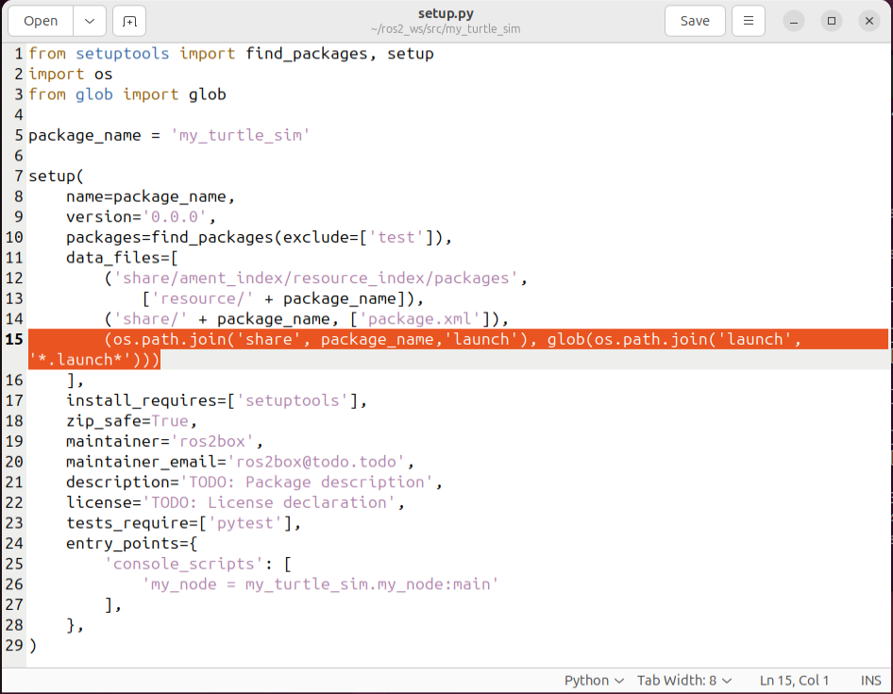
You must then rerun colcon build and source your setup file to load the launch file.
You can now call (replace turtlesim.launch with your file name)
ros2 launch my_turtle_sim turtlesim.launch
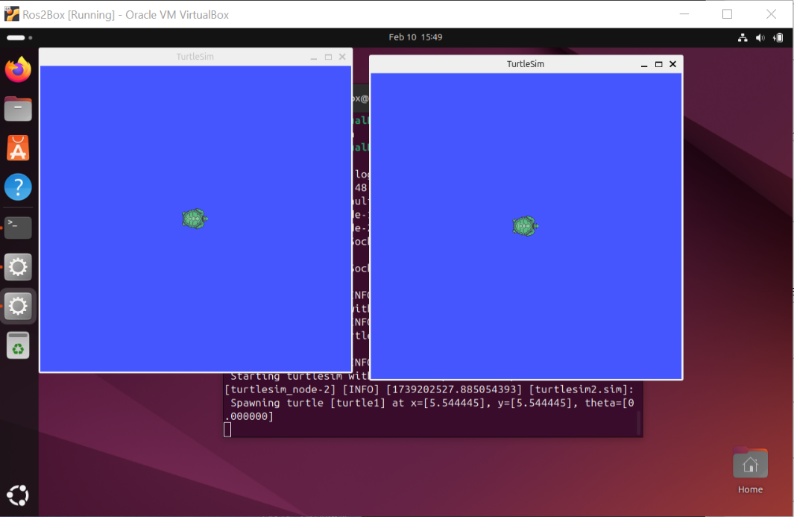
As before you must run turlesim_teleop_key from the terminal to manipulate turtles with the arrows on your keyboard. If you see [ERROR] text, like below, this is a sign that your launch file is poorly formed. Refer to the line indicated by the error in your launch file and check for errors.
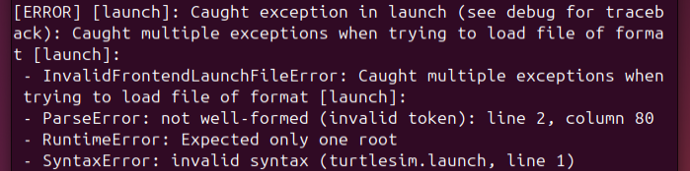

Step 3. Beyond the basics
- Understand how to look at the ros2 console and graph from this tutorial: https://docs.ros.org/en/jazzy/Tutorials/Beginner-CLI-Tools/Introducing-Turtlesim/Introducing-Turtlesim.html
- Get your turtle to move by publishing a topic: https://docs.ros.org/en/jazzy/Tutorials/Beginner-CLI-Tools/Understanding-ROS2-Topics/Understanding-ROS2-Topics.html
- Create your own subscriber node to report on a TurtleSim’s location. A starting place can be found here: https://docs.ros.org/en/jazzy/Tutorials/Beginner-Client-Libraries/Writing-A-Simple-Py-Publisher-And-Subscriber.html (note not a TurtleSim tutorial but a good starting point). Validate this system by moving TurtleSim and demonstrating the location updates appropriately.

