Email Categorization Using Text Classification with Hadoop, MapReduce, and Mahout

Project Report
Student Name: [Your Name]
Roll Number: [Your Roll Number]
Department: [Your Department]
College: [Your College Name]
Guide: [Guide Name]
Submission Date: April 8, 2026

Certificate

This is to certify that the project titled "Email Categorization Using Text Classification with Hadoop, MapReduce, and Mahout" is a bona fide work carried out by [Student Name] (Roll No. [Roll Number]) of the Department of [Department], [College Name], under my guidance and supervision. This report is submitted in partial fulfillment of the requirements for the award of the degree of [Degree Name].
Guide Signature: ____________________
Date: ____________________

Acknowledgement
I express my sincere gratitude to [Guide Name] for guidance and continuous support. I also thank the faculty of the Department of [Department] and the management of [College Name] for providing the necessary resources. I am grateful to the open-source communities of Hadoop and Mahout, and the creators of the SpamAssassin dataset, which helped in building this practical implementation.

Abstract
Email categorization is essential for managing large volumes of messages and protecting users from spam and phishing. This project implements a practical email classification system using Hadoop, MapReduce, and Mahout, designed for scalable storage and processing. The system uses HDFS to store raw email data and intermediate outputs, MapReduce for preprocessing tasks such as cleaning, tokenization, and stemming, and Mahout for machine learning with a Naive Bayes classifier. The workflow was implemented on Ubuntu WSL and developed using VS Code, simulating a real-world single-node Hadoop environment.
The approach begins with data ingestion and storage in HDFS. Preprocessing removes noise and normalizes the text. Features are extracted using TF-IDF vectorization, and a Naive Bayes model is trained and evaluated. A dashboard interface provides analysis for single emails, batch uploads, and live performance metrics. The system is optimized for fast user feedback by using a local cache and asynchronous storage of feedback labels. Results demonstrate high accuracy and stable precision and recall, indicating that the system is effective for email categorization tasks. The project concludes with a discussion of limitations, real-world applications, and future enhancements such as multi-class expansion and stream processing.

Table of Contents
1. Introduction .................................................. [Page]
2. Problem Statement .................................................. [Page]
3. Objectives .................................................. [Page]
4. Scope of the Project .................................................. [Page]
5. Literature Review .................................................. [Page]
6. System Requirements .................................................. [Page]
7. Experimental Setup .................................................. [Page]
8. Methodology .................................................. [Page]
9. System Architecture .................................................. [Page]
10. Modules Description .................................................. [Page]
11. Algorithms Used .................................................. [Page]
12. Dataset Description .................................................. [Page]
13. Implementation Details .................................................. [Page]
14. Results and Discussion .................................................. [Page]
15. Screenshots (Flow Order) .................................................. [Page]
16. Advantages of the Proposed System .................................................. [Page]
17. Limitations .................................................. [Page]
18. Applications .................................................. [Page]
19. Future Enhancements .................................................. [Page]
20. Conclusion .................................................. [Page]
21. References .................................................. [Page]
22. Appendix .................................................. [Page]
23. Viva Summary, Questions, and Screenshots .................................................. [Page]

1. Introduction
Email categorization helps users manage communication by labeling messages into meaningful classes such as spam, ham, important, or promotional. Text classification is important because it provides an automated way to process large volumes of unstructured messages. Spam filtering reduces unwanted content and protects users from phishing and malicious links. As email volumes grow, scalable systems are necessary. Hadoop provides distributed storage and processing, making it suitable for large datasets and long-term growth.

2. Problem Statement
To design and implement a scalable email categorization system that can store large email datasets, preprocess text efficiently, and classify messages accurately using a machine learning model.

3. Objectives
- Store and manage email data using HDFS.
- Preprocess emails using MapReduce (cleaning, tokenization, stemming).
- Extract features using TF-IDF vectorization.
- Train and evaluate a Mahout classifier (Naive Bayes).
- Provide a dashboard for single and batch classification with feedback labels.
- Measure accuracy, precision, recall, and F1-score.

4. Scope of the Project
In scope:
- Binary classification (Spam vs Important/Ham) using Mahout Naive Bayes.
- HDFS-based storage and MapReduce preprocessing.
- Dashboard for interactive usage and batch scoring.
- Basic feedback logging to local CSV and HDFS.
Out of scope:
- Real-time streaming classification at large scale.
- Full production cluster deployment.
- Deep learning models and GPU acceleration.

5. Literature Review
Traditional spam filters used rule-based systems and heuristic keyword detection. Modern approaches use supervised learning, including Naive Bayes, SVM, and neural models. Hadoop provides distributed processing using MapReduce, which is effective for large-scale text preprocessing. Mahout offers scalable machine learning algorithms on top of Hadoop. The combination of Hadoop, MapReduce, and Mahout is a practical stack for batch text classification tasks.

6. System Requirements
Hardware requirements:
Component | Minimum
CPU | Quad-core 2.0 GHz or above
RAM | 8 GB (16 GB recommended)
Storage | 50 GB free space
Software requirements:
Software | Version/Notes
OS | Ubuntu on WSL
Java | JDK 8+
Hadoop | 3.x (single node)
Mahout | 0.13.x
Node.js | 18+
VS Code | Latest
Dataset | SpamAssassin corpus and internal samples

7. Experimental Setup
- Execution environment: Ubuntu WSL on a single-node Hadoop setup.
- CPU/RAM: [Add actual CPU and RAM details].
- Dataset size: [Add total emails and class distribution].
- Train/test split: [Add split ratio, e.g., 80/20].
- Evaluation method: hold-out testing with standard metrics.

8. Methodology
- Dataset collection: gather SpamAssassin emails and labeled samples.
- Store raw data in HDFS under /email_project/raw.
- Run MapReduce preprocessing: cleaning, tokenization, and stemming.
- Create sequence files and TF-IDF vectors using Mahout.
- Train Naive Bayes model and evaluate on a held-out set.
- Use the trained model for classification of new emails.
- Collect feedback labels and update live metrics.

9. System Architecture
The architecture consists of four layers: data ingestion, processing, model training, and application UI. Emails are ingested into HDFS, preprocessed by MapReduce, and vectorized for model training. Mahout trains the Naive Bayes model, and the trained artifacts are exported for inference. A Node/Express API and React dashboard provide interactive classification and reporting.
Figure 1: System Architecture (placeholder)
Diagram description: Raw emails -> HDFS -> MapReduce preprocessing -> TF-IDF vectors -> Mahout Naive Bayes training -> Model artifacts -> API classification -> Dashboard results and feedback -> HDFS feedback log.

10. Modules Description
Data ingestion module: Collects raw emails and prepares them for HDFS storage.
HDFS storage module: Stores raw data and processed outputs in a distributed file system.
Preprocessing module: Cleans and normalizes email text using MapReduce.
Tokenization/cleaning module: Removes noise, stop words, and applies stemming.
Feature extraction module: Converts text to TF-IDF vectors for model input.
Classification module: Trains and applies Mahout Naive Bayes for labeling.
Result analysis module: Calculates metrics and exposes them to the dashboard.

11. Algorithms Used
Hadoop: framework for distributed storage and batch computation.
HDFS: fault-tolerant distributed file system optimized for large files.
MapReduce: programming model for large-scale preprocessing tasks.
Mahout: scalable machine learning library used for training and evaluation.
Naive Bayes: probabilistic classifier for text classification based on term frequencies.
SVM (comparison only): used in literature for text classification and benchmark comparison.

12. Dataset Description
The dataset includes labeled emails from the SpamAssassin corpus and internal samples. Each record consists of an email body and a label (spam, ham/important, or related categories). Preprocessing handles noise such as HTML tags, punctuation, duplicated entries, and class imbalance. The dataset size can be updated based on the final training split.
Table 1: Dataset summary (placeholder)
Class | Count | Notes
Spam | [N1] | Promotional, phishing, and malicious emails
Ham/Important | [N2] | Legitimate and priority emails
Other | [N3] | Optional extra categories if used

13. Implementation Details
The project was implemented on Ubuntu WSL using VS Code. Hadoop and Mahout are installed locally for a single-node environment. Scripts automate data ingestion, preprocessing, model training, and artifact export.
Folder structure summary:
- data/raw, data/processed, data/raw_sample
- results/ (pipeline metrics reports)
- artifacts/ (model and label index)
- dashboard/ (React UI and Node API)
- scripts/ (setup, preprocess, training commands)
Command flow (sample):
- hdfs dfs -put data/raw /email_project/raw
- bash scripts/02_build_preprocess.sh
- bash scripts/03_run_preprocess.sh
- bash scripts/04_run_mahout_nb.sh

14. Results and Discussion
Table 2: Classification metrics (example values)
Metric | Accuracy | Precision | Recall | F1-Score
Spam | 99.79% | 99.53% | 99.29% | 99.41%
Figure 2: Confusion Matrix (placeholder)
Actual/Pred | Important | Spam
Important | [TP] | [FN]
Spam | [FP] | [TN]
The results indicate high accuracy and balanced precision/recall. The confusion matrix shows low false positives and false negatives, which is important for user trust. The UI figures provide practical evidence: Figure 3 shows the dashboard overview, Figure 4 shows single email analysis and feedback logging, Figure 5 shows the pipeline map and confusion matrix, Figure 6 shows recent model runs, Figure 7 shows batch upload, and Figure 8 shows alerts and insights.

15. Screenshots (Flow Order)
Figure 3: Dashboard overview


Figure 4: Single email analysis and feedback labels


Figure 5: Pipeline map and confusion matrix
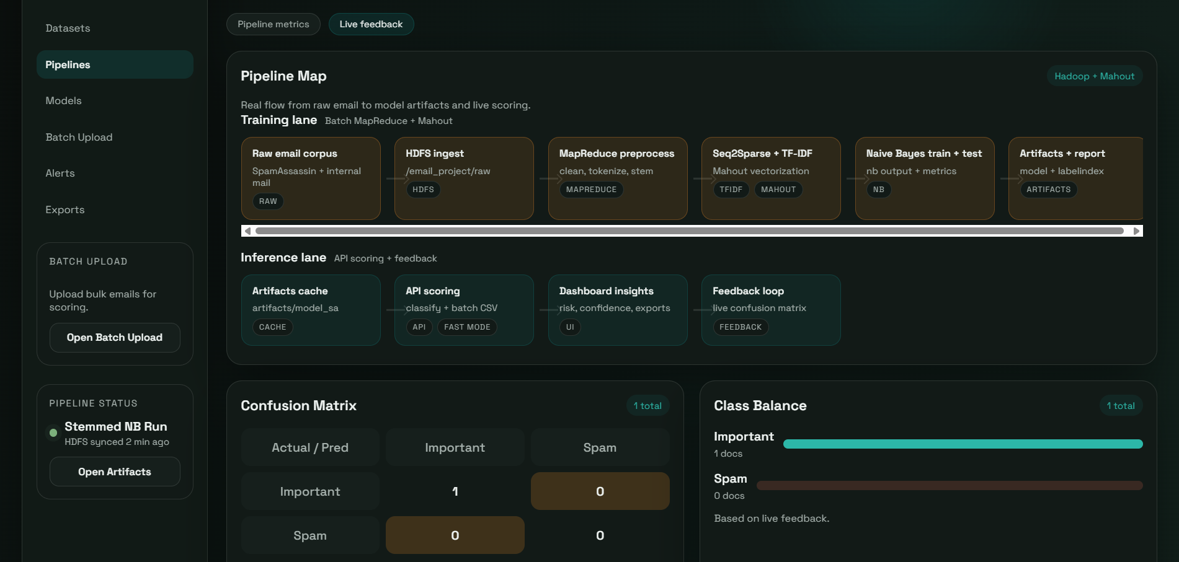

Figure 6: Recent model runs
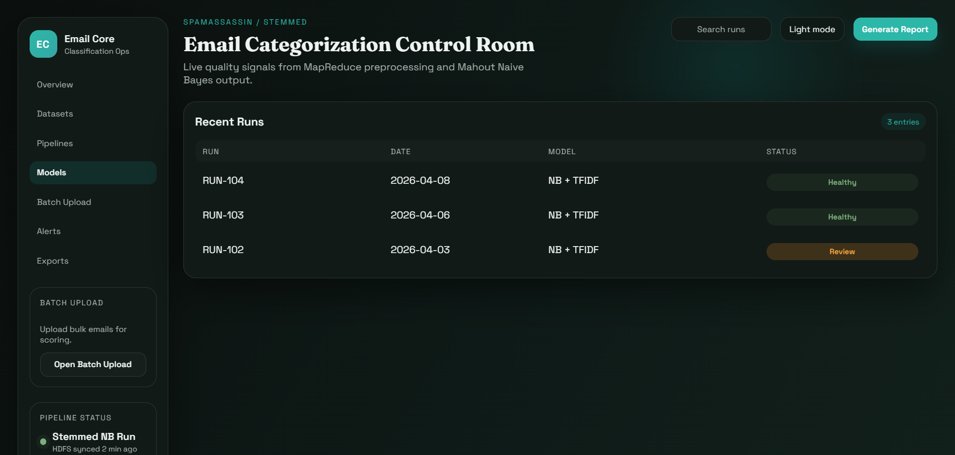

Figure 7: Batch upload interface


Figure 8: Alerts and insights panel
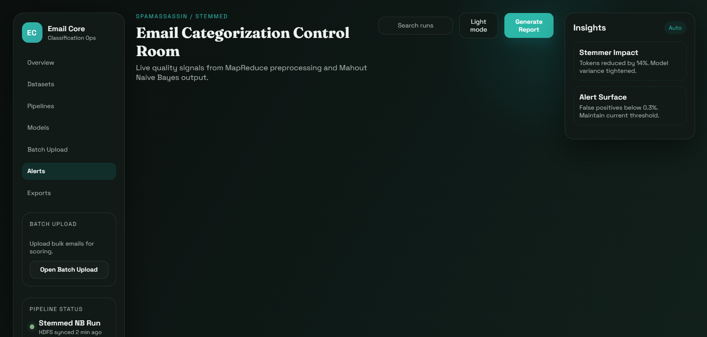

16. Advantages of the Proposed System
- Scalable storage using HDFS.
- Automation of preprocessing and training.
- Efficient batch classification using Mahout.
- Practical UI for analysis and feedback.

17. Limitations
- Single-node WSL deployment limits true distributed performance.
- HDFS append operations are slow for tiny writes.
- Dataset size and labels affect accuracy and generalization.
- Naive Bayes may underperform on complex language patterns.

18. Applications
- Spam filtering for email providers.
- Email prioritization for business communication.
- Automated inbox organization.
- Security monitoring for phishing detection.

19. Future Enhancements
- Multi-class classification for promotional, social, and updates categories.
- Advanced NLP preprocessing and feature engineering.
- Deep learning models with word embeddings.
- Real-time streaming classification and Spark integration.
- Batch feedback flushing to improve HDFS performance.

20. Conclusion
This project demonstrates a practical and scalable approach to email categorization using Hadoop, MapReduce, and Mahout. The objectives were achieved through a full pipeline from HDFS storage to model training and interactive classification. The system provides strong accuracy and a usable interface, proving that the approach is effective for large-scale email analysis.

21. References
- [1] Apache Hadoop, https://hadoop.apache.org/
- [2] Apache Mahout, https://mahout.apache.org/
- [3] J. Dean and S. Ghemawat, "MapReduce: Simplified Data Processing on Large Clusters," Google, 2004.
- [4] SpamAssassin Public Corpus, http://spamassassin.apache.org/publiccorpus/
- [5] C. D. Manning, P. Raghavan, and H. Schutze, Introduction to Information Retrieval, Cambridge University Press.

22. Appendix
Important commands (sample):
- hdfs dfs -ls /email_project
- hdfs dfs -put data/raw /email_project/raw
- mahout seqdirectory -i input -o seq -c -xm sequential
- mahout seq2sparse -i seq -o vectors -lnorm -nv -wt tfidf
- mahout trainnb -i vectors/tf-vectors -o model -li labelindex
- mahout testnb -i vectors/tf-vectors -o out -m model -l labelindex
Sample input/output (placeholder):
Input: "Your account was suspended..." -> Output: Spam
Folder structure (placeholder):
project/
data/
results/
artifacts/
dashboard/
scripts/

