Chhattisgarh e-Procurement Chatbot
Module
Procurement Policy Query and Guidance System
Team Members
- [Information to be provided]
Problem Statement
Procurement personnel need timely and consistent guidance on rules, procedures, approvals, and document requirements. Relevant information is distributed across policy documents, circulars, manuals, and departmental references. Searching these sources manually is time-consuming and can lead to incomplete or inconsistent responses. The issue affects officials who require clear guidance while preparing procurement requests, processing purchases, and responding to routine procedural questions. A single question may require reviewing multiple documents, which increases the effort needed for day-to-day work. The system is intended to improve access to approved procurement information while retaining the original source material as the basis for responses.
Solution Proposed
The Chhattisgarh e-Procurement Chatbot has been developed as a question-answering system for procurement-policy guidance. It receives a user query, identifies the relevant procurement context, retrieves supporting content from the approved knowledge base, and presents a clear response through a web interface. The system supports natural-language questions and is designed to provide concise guidance for common procurement processes. It maintains separation between source retrieval, response generation, and the user interface so that each component can be maintained independently. The expected outcome is faster access to procurement guidance, reduced manual search effort, and more consistent handling of routine questions by procurement personnel.
Approach
- Input: The user submits a procurement-related question through the web interface.
- Processing: The system identifies the query context and searches relevant approved content.
- Data Storage: Source documents, processed text, and retrieval data are maintained separately.
- AI/ML Processing: Retrieval-augmented generation prepares a response using relevant source content.
- Output: The chatbot returns a clear procurement-policy response to the user.
Technology Used
Component | Technology
Frontend | HTML5, CSS3, JavaScript, Node.js and Express.js
Backend | Python 3.11, Flask 3 and Waitress WSGI server
Database | Qdrant vector database with local persistent storage
AI/ML | BGE-M3 embeddings, BGE reranker, Ollama, llama3.2 and llama3:8b
APIs | Flask REST JSON APIs and Server-Sent Events on POST /api/stream
Frameworks | Qdrant Client, FlagEmbedding, SentenceTransformers and Transformers
Deployment | Windows environment with Node.js proxy and local Python backend
Other Tools | PyMuPDF, OpenCV, Pillow, python-docx, Git and VS Code
Relevant Screenshots
Screenshot 1 - Portal Home Page
Purpose: Shows the public Chhattisgarh e-Procurement portal and chatbot entry point.
Description
- Government of Chhattisgarh header
- e-Procurement system title
- Procurement service categories
- Ask E-proc AI entry button
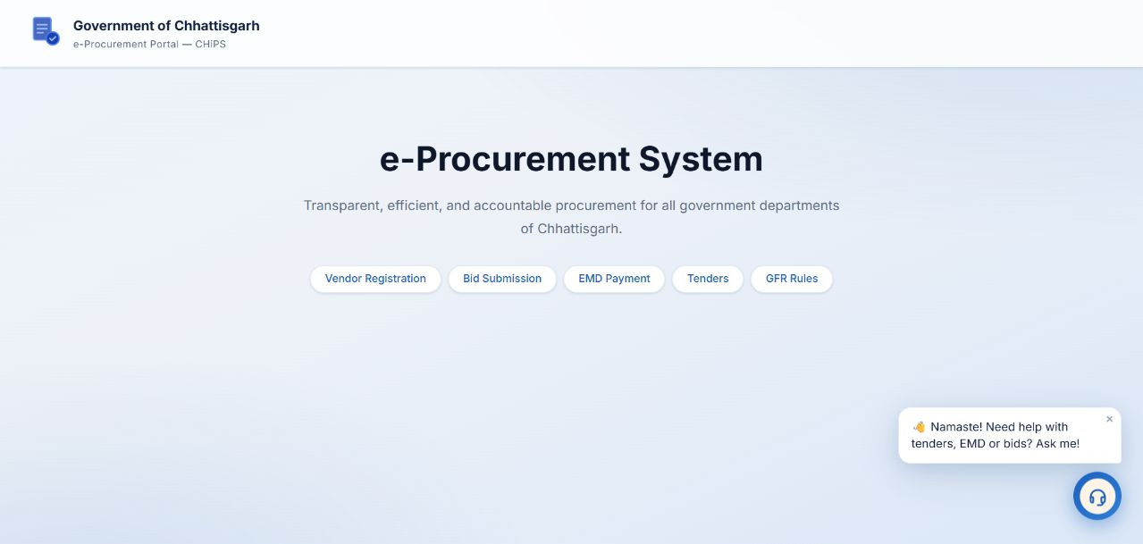
Figure 1 - Portal Home Page
Screenshot 2 - Assistant Welcome Interface
Purpose: Shows the assistant opening panel and available procurement guidance topics.
Description
- Assistant welcome message
- User role starting points
- Suggested procurement questions
- Question input field
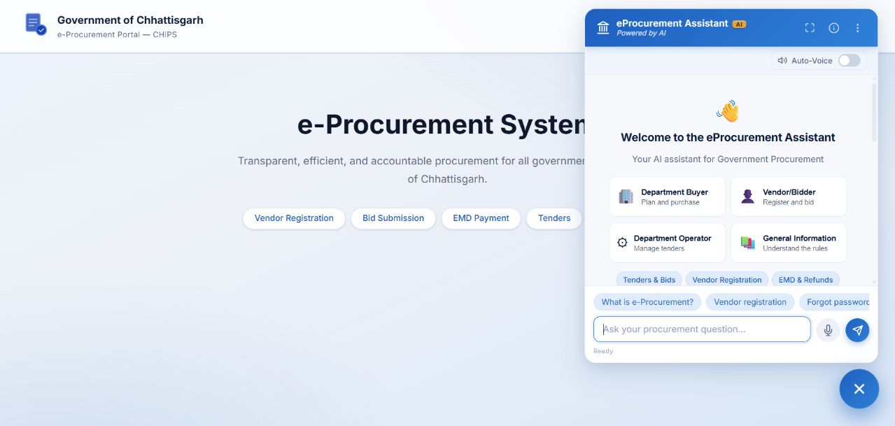
Figure 2 - Assistant Welcome Interface
Screenshot 3 - Source-Backed Chatbot Response
Purpose: Shows a chatbot response with the supporting source reference.
Description
- User procurement question
- Generated answer
- CHiPS FAQ source reference
- Official-document verification notice
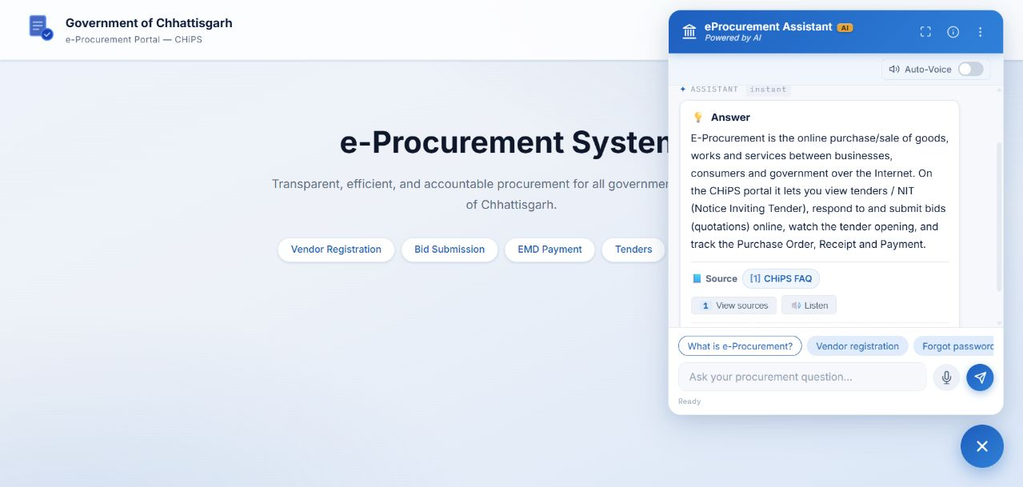
Figure 3 - Source-Backed Chatbot Response

