CHiPS e-Procurement AI Chatbot
Project Report
Prepared on 24 July 2026
Project Name | CHiPS e-Procurement AI Chatbot
Domain | Government e-Procurement assistance, document-grounded query answering, and multilingual support
Supported Languages | English, Hindi, and Hinglish
Current Stage | Validated prototype with web UI, source-grounded answers, voice support, and benchmark workflow

1. Project Goal and Key Features
The CHiPS e-Procurement AI Chatbot is designed to help users understand procurement rules, portal workflows, and document-based procedures through a conversational interface. Its main objective is to provide fast, source-grounded guidance for tenders, bids, EMD, vendor registration, auctions, and procurement rules without forcing users to manually search through large manuals.
• Multilingual question answering in English, Hindi, and Hinglish.
• Document-grounded responses using a Retrieval-Augmented Generation workflow.
• Support for procurement topics such as tender methods, bid submission, vendor registration, EMD, and GFR / Store Purchase rules.
• Web-based chatbot widget integrated into a government-style portal interface.
• Source viewing support so users can connect responses back to the original manuals and reference material.
• Voice-oriented interaction support including Auto-Voice and speech-flow enhancements.

1.1 Chatbot Interface Snapshots
The screenshots below show the current chatbot presentation layer, including the portal landing view, the opened assistant widget, and a sample answer state.
Portal landing page with chatbot entry point
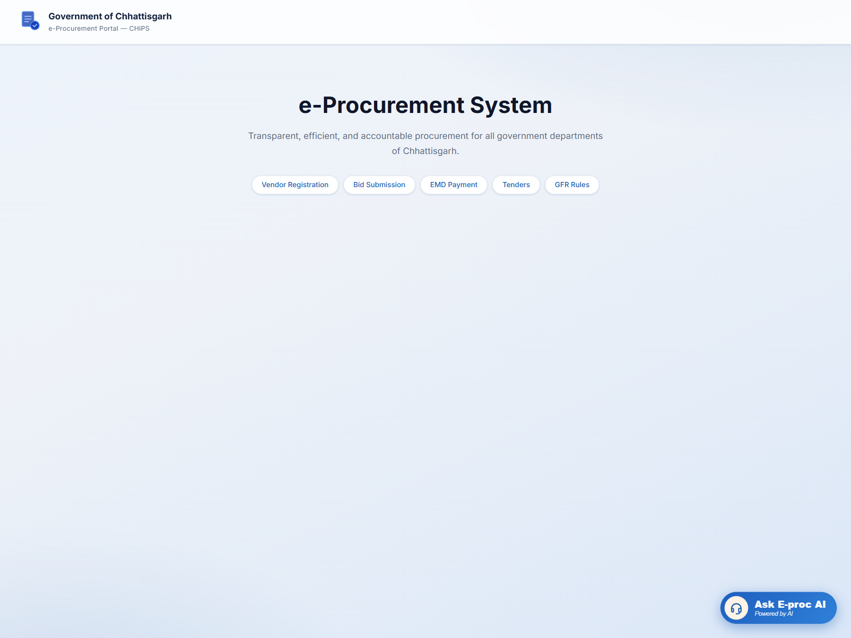
chatbot_home.png
Opened chatbot widget for user interaction
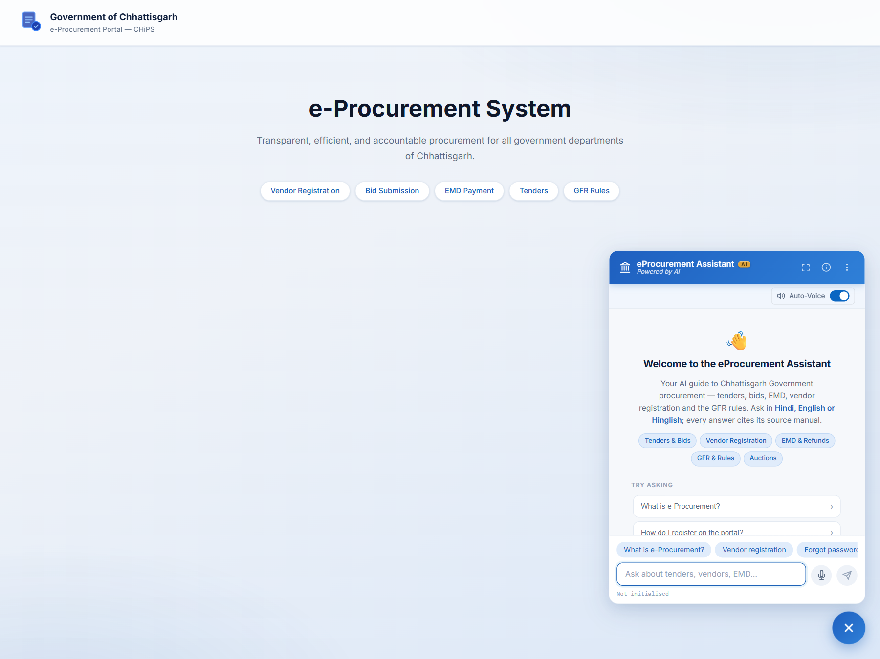
chatbot_widget_open.png
Sample chatbot response with answer and source
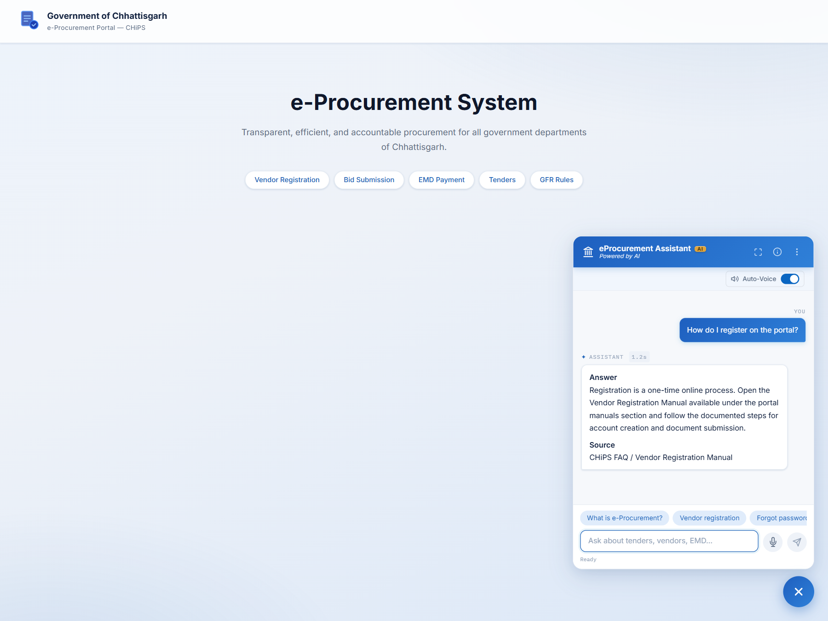
chatbot_sample_answer.png

2. System Design and Technology Stack
The system follows a layered architecture where documents are processed into searchable knowledge assets, retrieved context is ranked and selected, and the final answer is generated and displayed in a browser-based interface.
Layer | Technology | Purpose
Frontend UI | HTML, CSS, JavaScript, Node.js / Express | Provides the chatbot widget, portal-like interface, quick prompts, and UI-level interactions.
Backend API | Python 3.11, Flask | Handles query processing, streaming responses, routing, and answer orchestration.
Retrieval Layer | Qdrant, BGE-M3 embeddings, bge-reranker-v2-m3 | Stores and ranks relevant document chunks for source-grounded answers.
LLM Layer | Ollama-hosted local models | Generates conversational answers using retrieved procurement context.
Source Corpus | Tender manuals, GFR, IT Act, vendor and bid manuals | Acts as the factual base for procurement guidance and portal instructions.
Voice Support | Browser-side voice interaction and Auto-Voice flow | Improves accessibility and ease of use for spoken interaction.

3. Week-by-Week Progress
Week | Progress Achieved
Week 1 | Stabilized the project structure, aligned documentation layout, and maintained the core chatbot codebase for easier development and review.
Week 2 | Enhanced the UI with improved chatbot presentation, quick prompts, cleaner answer rendering, and Auto-Voice controls.
Week 3 | Improved actor routing, fine-intent handling, context diagnostics, and language enforcement to make answers more focused and source-bound.
Week 4 | Ran exact-answer validation, UAT answer-quality audit, and production benchmark checks; documented issues, fixes, and current performance status.

4. Overall Summary
This reporting period strengthened both the technical quality and the presentation quality of the CHiPS e-Procurement AI Chatbot. The project now has a more polished web interface, stronger answer controls for sensitive procurement topics, improved multilingual handling, and a clearer validation workflow through regression tests, live checks, and benchmark reporting. The chatbot is better positioned for demonstrations, further evaluation, and the next cycle of production-oriented refinement.

5. Planned Work for the Next Period
• Further improve answer quality for fallback-heavy and partially answered procurement queries.
• Extend UAT validation with stricter semantic acceptance checks for multilingual questions.
• Continue frontend verification in live conditions and refine the source-viewing and answer-presentation experience.
• Prepare the chatbot stack and documentation for broader stakeholder review and deployment-readiness discussion.

