- docker –version
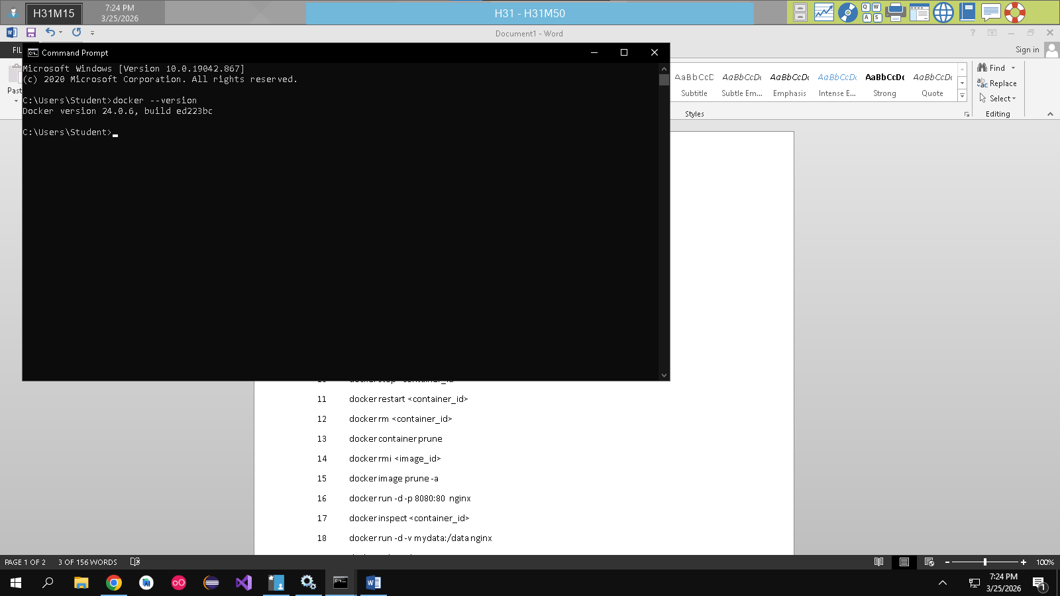
- docker run hello-world
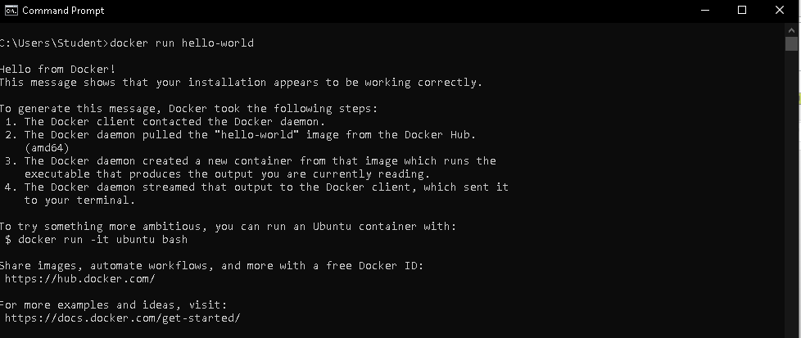
- docker pull nginx
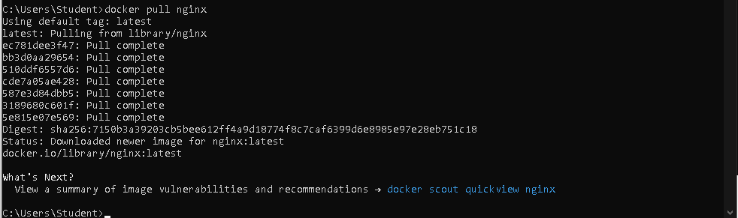
- docker images
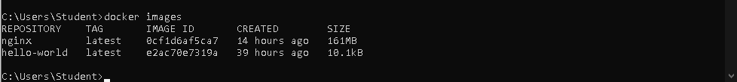
- docker run -d nginx
- docker ps
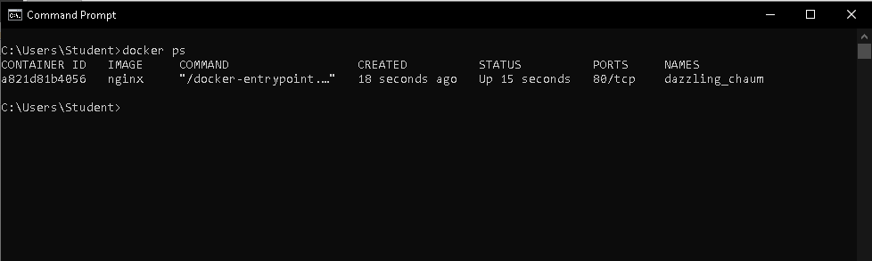
- docker ps –a
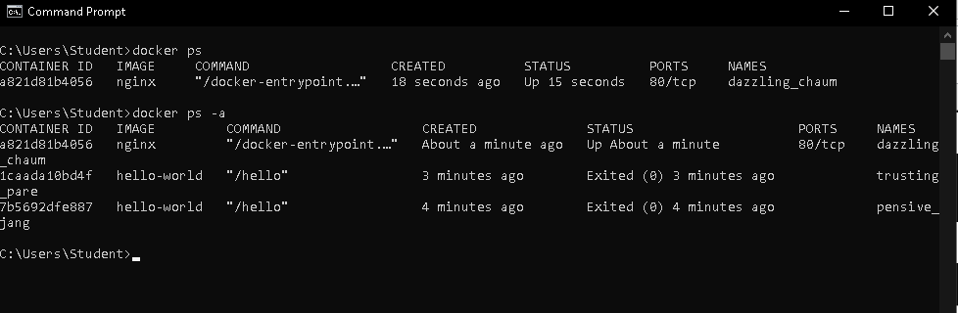
- docker logs <container_id>
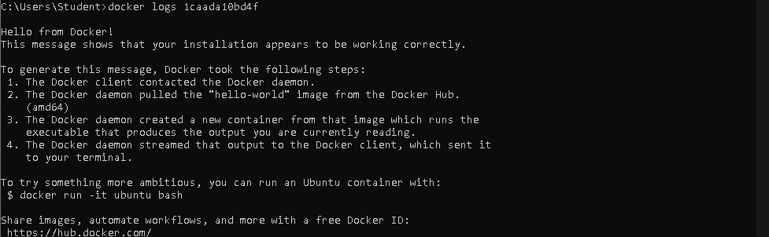
9 docker exec -it <container_id> /bin/sh
10 docker stop <container_id>
11 docker restart <container_id>
12 docker rm <container_id>
13 docker container prune
14 docker rmi <image_id>
15 docker image prune -a
16 docker run -d -p 8080:80 nginx
17 docker inspect <container_id>
18 docker run -d -v mydata:/data nginx
19 docker volume ls
20 docker volume prune
21 docker run -d --name my_nginx nginx
22 docker stats
23 docker network ls
24 docker network create my_network
25 docker run -d --network my_network --name my_container nginx
26 docker network connect my_network my_nginx
27 docker run -d -e MY_ENV=hello_world nginx
28 docker logs -f my_nginx
29 FROM nginx
COPY index.html /usr/share/nginx/html/index.html
30 docker build -t my_nginx_image .
31 docker run -d -p 8080:80 my_nginx_image

