

Adaptive Multi-Stage Behavioural Progression Architecture For Early Detection Of SIP Toll Fraud

K.M.U.P. Kosgoda
(Reg. No.: MS24913188)

A THESIS
SUBMITTED TO
SRI LANKA INSTITUTE OF INFORMATION TECHNOLOGY
IN PARTIAL FULFILMENT OF THE REQUIREMENTS
FOR THE DEGREE OF
MASTER OF SCIENCE IN INFORMATION SYSTEMS

Dec 2026
I certify that I have read this thesis and that in my opinion it is fully adequate, in scope and in quality, as a thesis for the degree of Master of Science.

Dr. Nimal Rathnayaka
Approved for MSc. Research Project:

MSc in Information Systems Programme Co-ordinator, SLIIT
Approved for MSc:

Head of Graduate Studies, FoC, SLIIT

DECLARATION
This is to certify that the work is entirely my own and not of any other person, unless explicitly acknowledged (including citation of published and unpublished sources). The work has not previously been submitted in any form to the Sri Lanka Institute of Information Technology or to any other institution for assessment for any other purpose.
Sign: ........................................................
K.M.U.P. Kosgoda
Date: ……………………………………..

ABSTRACT
Adaptive Multi-Stage Behavioural Progression Architecture For Early Detection Of SIP Toll Fraud
K.M.U.P. Kosgoda
MSc. in Information Systems
Supervisor: Dr. Nimal Rathnayaka
Dec 2026
This thesis develops and evaluates a SIP behavioural progression prototype using an Asterisk PBX and a separate SIPp generator. The detector evolved from request counts to confirmed authentication failures and linked registration and call events. V6 flagged six simulated attack cases and one benign control in a twelve-case development set. A frozen causal logistic model did not distinguish matched authorized and simulated-unauthorized roles. A later native and external deployment pilot verified seven cases and twenty-one isolated calls across five online stage categories. The final extension predefined account, destination and recovery permissions before twelve fresh experiments. All cases passed independent packet, authentication-log, CDR and cleanup checks, including nine answered calls. V6 produced TP=5, FP=2, TN=4 and FN=1. Contextual review produced TP=5, FP=1, TN=5 and FN=1, increasing balanced accuracy from 75.0% to 83.3% on this small controlled set. However, pre-call warnings decreased from four of five simulated-role call cases to two of five. A five-failure simple baseline warned earlier than V6. Four separate REGISTER-only controls also verified. The contribution is auditable progression and permission-conditioned review with an explicit ambiguity boundary. Allowed-policy abuse remains indistinguishable in a matched case, and false-alert reduction can reduce warning coverage. These results do not establish operational fraud accuracy, autonomous adaptation, causal overhead or production readiness.
Keywords: SIP security, VoIP fraud detection, toll fraud, behavioural progression, early detection, CDR analytics, risk scoring.

ACKNOWLEDGEMENT
I would like to express my sincere gratitude to my supervisor, Dr. Nimal Rathnayaka, for his guidance, constructive feedback, and support throughout this research. I also acknowledge the academic staff of the Sri Lanka Institute of Information Technology for the knowledge and resources provided during the MSc programme. I am grateful to my colleagues, friends, and family for their encouragement and patience while I designed the experimental environment, conducted repeated tests, and prepared this thesis. Any remaining errors or limitations in this work are my own.

Contents
Chapter 1 Introduction 1
1.1 Background 1
1.2 Research Problem 1
1.3 Research Gap 2
1.4 Research Aim 2
1.5 Research Objectives 2
1.6 Research Questions and Hypotheses 3
1.7 Scope of the Study 4
1.8 Significance and Expected Contributions 4
1.9 Thesis Organization 5
Chapter 2 Literature Review 6
2.1 Introduction 6
2.2 SIP and VoIP Security Foundations 6
2.3 SIP Toll Fraud and Behavioural Progression 6
2.4 Real-Time Fraud Detection 7
2.5 Stateful and Protocol-Aware SIP Detection 7
2.6 CDR and Telecom Behavioural Analytics 7
2.7 Machine Learning for SIP Attack Detection 7
2.8 Comparison of Selected Related Work 8
2.9 Research Gap and Positioning 8
2.10 Conceptual Framework 9
2.11 Chapter Summary 9
Chapter 3 Research Methodology 10
3.1 Laboratory and Migration 10
3.2 Sampling Units and Evidence Families 11
3.3 Independent Ground Truth and Acceptance Gates 12
3.4 Causal Features and Model Separation 13
3.5 Distinct Timing Measures 14
3.6 Classification and Operational Evaluation 14
3.7 Validity and Ethics 14
3.8 Predeclared Permission Context and Common Evaluation 15
Chapter 4 System Design and Implementation 16
4.1 Detector Evolution and Rationale 16
4.2 Confirmed Authentication and Reconnaissance 16
4.3 Recovery and Linked Call Progression 17
4.4 Lightweight Review Priority 18
4.5 Internal and External Realizations 18
4.6 Reproducibility and Implementation Boundaries 19
4.7 Permission Layer and Causal Replay Implementation 19
Chapter 5 Results and Discussion 21
5.1 Earlier Loopback Baseline and Boundary Findings 21
5.2 Registered Scenario Coverage 21
5.3 Common Onset Archived Timing 22
5.4 Frozen Causal Model Evaluation 23
5.5 Live Integration and Shared Authentication Delivery 24
5.6 Call Setup and Resource Pilot 25
5.7 Research Questions and Hypotheses 26
5.8 Limitations and Exploratory Extensions 27
5.9 Later Five Stage Deployment Pilot 27
5.10 Fresh Permission Context Comparison 28
5.11 Fresh REGISTER Controls and Reproducibility 31
Chapter 6 Conclusion and Future Work 32
6.1 Conclusions 32
6.2 Objective Coverage 32
6.3 Future Work 33
References 34
Appendices 36
A Progression Logic and Causal Scoring 36
B Frozen Model Configuration 36
C Evidence and Source Index 36
D Reproducibility Checksums 37

List of Figures
Figure 2.1 Conceptual detection architecture 9
Figure 3.1 Laboratory evidence and early scoring pipeline 11
Figure 3.2 Scenario generation validation and frozen evaluation 13
Figure 4.1 Confirmed authentication failure and recovery logic 17
Figure 4.2 Recovery call attempts and independent completion evidence 18
Figure 4.3 Shared authentication deployment paths and observation endpoints 19
Figure 4.4 Frozen stage logic and independent context in the common evaluator 20
Figure 5.1 Frozen model scores on five matched profiles 23
Figure 5.2 Individual call setup times and per case medians 25
Figure 5.3 False alerts and missed assigned roles in twelve fresh cases 29
Figure 5.4 Pre call coverage with missed and at attempt cases retained 30

List of Tables
Table 1.1 Research objectives and evaluation focus 3
Table 2.1 Comparison of selected related work 8
Table 3.1 Later two Pi laboratory 10
Table 3.2 Evidence families and permitted interpretation 11
Table 3.3 Features available at the scoring event 13
Table 3.4 Timing endpoints used in the evaluation 14
Table 3.5 Independent laboratory permission matrix 15
Table 4.1 Research detector evolution 16
Table 5.1 Historical loopback scenario timing 21
Table 5.2 Historical loopback event metrics 21
Table 5.3 F-series scenario confusion counts and metrics 22
Table 5.4 Archived seconds to first alert from a common onset 22
Table 5.5 Opposite role scores from the frozen causal model 23
Table 5.6 Shared authentication observed alert availability 24
Table 5.7 Accepted call setup cases 25
Table 5.8 Within block setup differences relative to OFF 26
Table 5.9 Process observations during accepted call traffic 26
Table 5.10 Evidence based answers and remaining scope 26
Table 5.11 Later native and external stage decision medians 27
Table 5.12 Fresh case confusion counts and balanced accuracy 28
Table 5.13 Fresh case decisions from the common evaluator 29
Table 5.14 Early warning coverage on five simulated role call cases 30
Table 5.15 Four new bounded REGISTER controls 31
Table 6.1 Coverage of the Section 3 proposal objectives 32
Table A.1 Frozen logistic feature scaling and coefficients 36
Table A.2 Canonical evidence directories 37

Introduction

Background
Voice over IP (VoIP) has become a core communication technology across enterprise, carrier, and service-provider environments because it offers flexibility, scalability, and cost efficiency. Session Initiation Protocol (SIP) is widely used at the signalling layer to establish, modify, and terminate communication sessions [1]. In operational PBX environments, SIP exchanges produce behavioural evidence through messages such as REGISTER, OPTIONS, INVITE, ACK, and BYE, together with response codes, transaction identifiers, dialog state, and timing information. Asterisk also exposes programmatic interfaces and reporting facilities that can support monitoring, event collection, and call-level analysis [2]-[4].
The same openness that makes SIP flexible also creates an attack surface. Toll fraud is particularly important because an attacker who gains access to a SIP account or calling route can generate unauthorized calls to international, premium-rate, or other costly destinations. Such abuse may not begin with fraudulent calling immediately. It can progress through endpoint discovery, repeated registration or authentication attempts, credential compromise, and finally abnormal outbound call activity. Prior work has demonstrated the value of real-time fraud monitoring [5], stateful SIP inspection [6], behavioural call-record analysis [7], and machine-learning-based SIP attack detection [8], but these approaches are commonly evaluated as separate problem classes rather than as one toll-fraud progression.
This research investigates whether SIP signalling evidence can be organized into an interpretable progression model that identifies suspicious evolution before a burst of calls. The prototype was refined using controlled experiments, causal machine-learning features and independent SIP and CDR checks. The resulting alerts represent observable suspicion; experimenter-assigned authorization cannot be inferred reliably from an identical SIP sequence.

Research Problem
The central research problem is the absence of a practical early-detection model for SIP toll fraud that captures behavioural progression across multiple protocol stages while remaining lightweight enough for real PBX operation. Static rules and post-event CDR review can identify obvious abuse, but they may fail to connect early indicators such as repeated REGISTER failures, suspicious 401/403/404 response patterns, rapid probing of multiple targets, unusual destination diversity, and sudden outbound calling bursts into one evolving fraud lifecycle.
An early warning system must accumulate meaningful evidence while limiting unnecessary alerts. The experiments expose two difficulties: short count windows miss slow patterns, and benign credential recovery can resemble simulated unauthorized use. The refinement therefore tests protocol semantics, longer histories and review priority while preserving these ambiguities in the evaluation.

Research Gap
The literature provides strong individual building blocks for this problem: real-time event processing [5], stateful SIP analysis [6], protocol-state modelling [9], CDR-based behavioural profiling [7], graph-based telecom fraud detection [10], [11], and machine-learning-based SIP attack detection [8], [12]. However, there is limited integration of these elements into a single architecture explicitly focused on the progression from reconnaissance through authentication abuse and compromise to toll-fraud calling. The gap addressed by this thesis is therefore the design and experimental evaluation of a lightweight progression-aware detector that combines protocol semantics, temporal behaviour, and operational context while preserving interpretability.

Research Aim
The main aim of this research is to design, build, and evaluate an adaptive multi-stage behavioural progression architecture for early detection of SIP toll fraud in practical VoIP environments.

Research Objectives
1. Identify and formalize SIP-level and entity-level behavioural indicators that reveal progression from reconnaissance to authentication abuse, compromise, and fraudulent outbound calling.
2. Develop a stage-aware progression engine that reconstructs SIP behaviour and tracks evolving fraud risk for monitored entities such as IP addresses, extensions, trunks, or destination groups.
3. Implement the proposed detection approach in a controlled Asterisk-based environment and examine practical integration paths for an external detector and an in-process PBX realization.
4. Evaluate whether lightweight machine-learning refinement and CDR-assisted behavioural context improve discrimination between benign anomalies and true fraud progression.
5. Assess technical and operational effectiveness using detection accuracy, false-alert behaviour, time-to-detect, runtime overhead, and mitigation responsiveness under realistic benign and attack scenarios.
Table 1.1 Research objectives and evaluation focus
Objective | Operational focus | Main evaluation indicators
O1 - Behavioural indicators | Identify SIP- and entity-level indicators that distinguish benign activity from early fraud progression. | Feature relevance, separability, response-code/timing patterns
O2 - Progression engine | Track evolving risk and stage transitions per monitored entity. | Correct stage assignment, early escalation, interpretability
O3 - Practical implementation | Implement and compare external and in-process realization paths. | Latency, integration feasibility, maintainability
O4 - ML refinement | Assess whether lightweight ML and CDR context improve rule-based decisions. | Precision, recall, F1-score, false-alert reduction
O5 - Evaluation | Assess technical and operational suitability under benign and attack scenarios. | Time-to-detect, robustness, CPU/memory/processing overhead

Research Questions and Hypotheses
Primary research question: How can an adaptive multi-stage behavioural progression architecture, driven by SIP dialog semantics and behavioural feature analysis, detect SIP toll fraud early in operational VoIP environments while remaining practical for real-world deployment?
RQ1. Which SIP signalling patterns and behavioural indicators are most reliable for distinguishing normal activity from early-stage toll fraud progression?
RQ2. How effectively does a stage-aware progression model detect suspicious entities earlier than threshold-based or single-event detection approaches?
RQ3. To what extent does lightweight machine-learning refinement improve precision, false-alert control, and overall risk scoring when combined with rule-based progression tracking?
RQ4. How do the two deployment options, namely in-process PBX integration and external service integration, compare in terms of detection latency, runtime overhead, maintainability, and operational practicality?
The corresponding hypotheses retained from the approved proposal are:
H1. The proposed multi-stage framework will detect SIP toll fraud earlier than basic baseline methods.
H2. Adding lightweight machine-learning refinement will reduce false alerts and improve overall detection quality compared with a rule-only stage engine.
H3. The in-process deployment option will provide lower detection latency, while the external deployment option will be easier to maintain and still provide acceptable overhead.
The hypotheses are evaluated on matched scenarios using coverage and explicitly defined timing endpoints. H2 is assessed using frozen causal scores on fresh whole scenarios. H3 is examined through shared-authentication alert availability, process resources and call setup; full-stage parity and maintainability are not treated as measured merely because two deployment paths exist.

Scope of the Study
The study is limited to defensive observation in an authorized laboratory. Later experiments use two Raspberry Pis, accounts 1001 and 1002, and a temporary route to a SIPp user agent server. No stolen credentials, provider calls, billed destinations or customer traffic are used. SIPp labels describe assigned experimental roles. CDRs corroborate completed lab calls; they do not establish fraud intent or a production calling baseline. Automatic blocking, throttling and account locking remain proposed capabilities rather than implemented mitigation.

Significance and Expected Contributions
The expected contribution is both academic and practical. Conceptually, the study treats toll fraud as a progression rather than a single isolated anomaly. Methodologically, it combines protocol-aware SIP evidence with behavioural context and a lightweight refinement layer. Technically, it produces a reproducible prototype and experiment pipeline. The evaluation contribution is the use of scenario-level detection, event-level classification, false-alert analysis, time-to-detect, and operational overhead rather than relying on accuracy alone. Practically, the study aims to provide guidance on how such a detector could be integrated with PBX environments without excessive complexity.

Thesis Organization
Chapters 2 and 3 review prior work and define the laboratory methods. Chapter 4 describes implementation, and Chapter 5 reports measured results. Chapter 6 evaluates the hypotheses and remaining limitations.

Literature Review

Introduction
This chapter reviews research streams directly relevant to early detection of SIP toll fraud. The review is organized around SIP/VoIP security foundations, real-time fraud monitoring, stateful and protocol-aware anomaly detection, CDR-based behavioural analytics, machine-learning-based SIP attack detection, and the specific gap addressed by the proposed progression architecture.

SIP and VoIP Security Foundations
SIP is an application-layer signalling protocol used to create and manage multimedia sessions [1]. Because the protocol is transaction- and dialog-oriented, security monitoring can use relationships among requests, responses, dialog identifiers, authentication challenges, and timing rather than relying only on message counts. Protocol-state-machine research has shown the value of modelling interacting SIP/VoIP states [13], while survey work documents the broad exposure of SIP-based VoIP systems to signalling attacks and flooding behaviour [14]. These characteristics support stateful detection, but they also mean that exposed SIP services can be scanned, enumerated, subjected to repeated authentication attempts, and misused for fraudulent calls once valid access is obtained.
A toll-fraud detector therefore benefits from observing several evidence layers. Signalling records reveal early probing and authentication activity, while CDRs and call-routing records provide information about completed calls, duration, destinations, trunk use, and changes from normal calling behaviour. The research problem is not simply to classify an individual packet as malicious, but to determine whether multiple weak signals form a meaningful progression.

SIP Toll Fraud and Behavioural Progression
Real-world SIP abuse can involve reconnaissance, account discovery, authentication attacks, credential compromise, and subsequent fraudulent calling. Aziz [15] emphasizes that toll-fraud attacks should be interrupted as early as possible, before an attacker learns enough information or generates high-cost traffic. A distributed SIP attack-monitoring infrastructure has also shown the value of correlating observations across security sensors [16]. These works support the thesis premise that defence should reason across stages rather than wait for a final billing anomaly.

Real-Time Fraud Detection
Manunza et al. proposed Kerberos, a real-time fraud detection architecture for IMS-enabled VoIP networks that processes charging and call-evolution events using complex event processing [5]. Its main relevance to this thesis is the demonstration that fraud detection and remediation can occur while communication activity is still in progress rather than only through post-event billing review. Application-aware flow monitoring has likewise been investigated for SIP fraud detection [17]. These approaches support online monitoring, although they do not directly implement the progression model evaluated in this thesis.

Stateful and Protocol-Aware SIP Detection
Seo et al. introduced SIPAD, which uses a stateful rule tree for SIP anomaly detection [6]. Golait and Hubballi similarly model anomalous VoIP behaviour as a discrete event system [9]. Both lines of work are important because they demonstrate that protocol state and sequence provide information that is lost in simple stateless counters. The present thesis extends this reasoning by organizing stateful evidence around a toll-fraud progression and measuring the time required for the detector to move from a normal state to a risk-bearing stage.

CDR and Telecom Behavioural Analytics
CDR-based research provides a complementary view of fraud. Chiappetta et al. analyze anomalies in the social behaviour of VoIP users using call records [7], showing that user-level behavioural context can reveal suspicious patterns that may not be obvious from one protocol event. User-profiling approaches have also been applied to VoIP scam and fraud detection [18]. More recent telecom fraud work uses graph-learning and dynamic graph models to exploit relationships among users, destinations, and time [10], [11]. These approaches are powerful for behavioural profiling but are often oriented around completed call activity. In this thesis, CDR evidence is therefore treated as contextual reinforcement for the faster SIP-signalling detector rather than as the only source of early warning.

Machine Learning for SIP Attack Detection
Machine-learning research has shown that temporal and protocol-specific features can improve the detection of SIP flooding and related attacks. Younes proposes a hybrid deep-learning model for SIP-based DDoS detection [8], while Dassouki et al. use temporal and structural fingerprints to protect cloud-based SIP environments [12]. Survey evidence also shows that SIP DoS/DDoS defence depends strongly on protocol-aware traffic characteristics [14]. These studies motivate the use of timing, rate, diversity, and response-code features. The present work intentionally targets a lightweight model rather than a deep architecture so that risk refinement remains interpretable and deployable near a PBX.

Comparison of Selected Related Work
Table 2.1 Comparison of selected related work
Study | Primary data/method | Strength relevant to this thesis | Remaining gap
Manunza et al. [5] | Charging/service events with CEP | Real-time fraud monitoring and remediation | Limited SIP dialog progression
Seo et al. [6] | Stateful SIP rule tree | Protocol-aware stateful detection | Not specifically a toll-fraud lifecycle
Chiappetta et al. [7] | CDR behavioural profiling | Normal-behaviour context | Primarily post-call / CDR oriented
Golait and Hubballi [9] | Discrete-event VoIP modelling | State and sequence representation | General VoIP anomaly focus
Younes [8] | ML for SIP flooding | Protocol/timing features and intelligent classification | Flooding focus rather than toll-fraud progression
Hu et al. [10]; Ren et al. [11] | Graph-based telecom fraud analytics | Entity relationships and temporal behaviour | Requires richer call-history data; not PBX signalling-time detection
Aziz [15] | Real-time SIP toll-fraud mitigation | Direct relevance to multi-stage toll fraud | Opportunity remains for adaptive progression scoring plus lightweight ML

Research Gap and Positioning
The study evaluates an interpretable progression architecture using controlled SIP signalling, completed-call evidence, a lightweight refinement layer and bounded deployment pilots. The evaluation also tests the limit of signalling-only intent classification. Improved staging and implementation feasibility are assessed separately from a claim of verified toll fraud.

Conceptual Framework
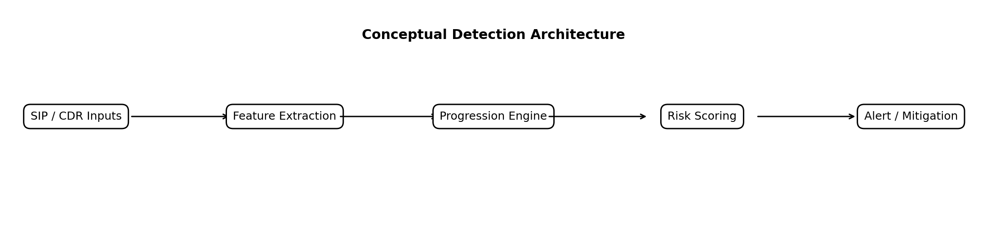
Figure 2.1 Conceptual detection architecture
The conceptual framework links SIP evidence, behavioural state and review decisions. The implemented V6 path now emits suspected compromise after repeated confirmed failures and a valid registration, followed by linked lab call attempts. Completed calls are corroborated using SIP and CDR evidence. The conceptual diagram includes mitigation options; the prototype is observation-only and does not execute call blocking, throttling or account isolation.

Chapter Summary
Existing research strongly supports stateful SIP analysis, behavioural profiling, and real-time fraud monitoring, but these areas are not commonly combined into one lightweight progression model for early SIP toll-fraud detection. The next chapter translates the identified gap into a controlled design-science methodology and an experimental evaluation plan.

Research Methodology
The study uses design science and controlled experiments to build and evaluate a SIP progression artefact. Development, retrospective audit and fresh evaluation are reported separately. Evidence is checked independently of detector predictions, and assigned attack roles are distinguished from confirmed protocol behaviour.

Laboratory and Migration
The original Azure environment used Asterisk and labelled Python-generated traffic. After cloud credits were exhausted, the lab moved to a Raspberry Pi PBX and a separate SIPp generator. Earlier loopback benchmarks remain historical baselines; their event-level metrics are not pooled with later scenario-level SIPp results.
Table 3.1 Later two Pi laboratory
Component | Implementation | Role
PBX Pi | Astrix-lab; Asterisk 20.6.0; 172.16.200.81 | SIP responses, security events and CDRs
Generator Pi | SIPp; 172.16.200.68 | Controlled registration and isolated calls
Lab accounts | 1001 and 1002 | Known valid and wrong-password scenarios
Call destination | Temporary 88001 or 88002 route to SIPp UAS on port 5090 | No provider or billed destination
Evidence | tcpdump, tshark, auth logs and CDR snapshots | Independent packet and call verification
As shown in Figure 3.1, packets supply event-time evidence while authentication logs and CDRs supply independent checks. CDRs become available after call activity, so they are not inputs to the early REGISTER-success ML score.
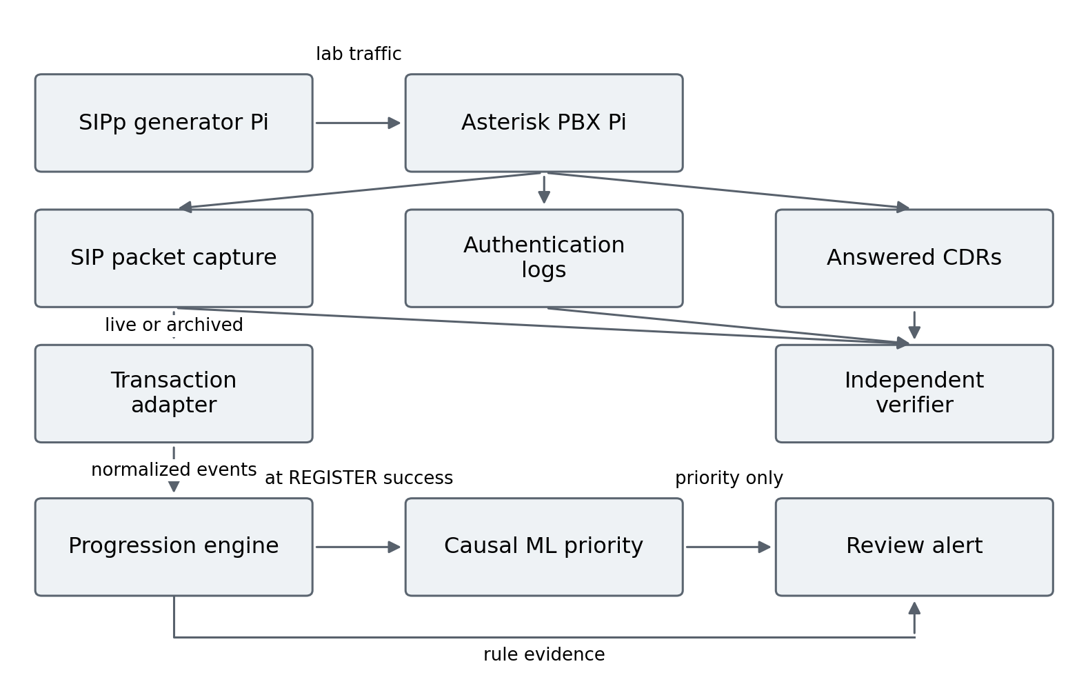
Figure 3.1 Laboratory evidence and early scoring pipeline

Sampling Units and Evidence Families
A scenario or recovery episode is the evaluation unit. Packets inside one scenario are not independent samples. Opposite assigned roles deliberately share observable traffic profiles to test whether the available signals can distinguish intent. All simulated use remains authorized laboratory activity.
Table 3.2 Evidence families and permitted interpretation
Family | Size or identifiers | Purpose
Earlier loopback baseline | 11 repeated runs; fixed scenario structure | Repeatability and event metrics
Earlier boundary experiment | 12 scenarios; 68 labelled events | Short-window failure modes
Registered F-series | F01 to F12; 6 benign and 6 simulated attack cases | Development comparison of V3, V5 and V6
Archived progression audit | 24 D cases and 10 previously inspected H cases | 34-run stage-order replay, not fresh ML testing
Causal ML development | 10 eligible recovery episodes | Train and freeze the early score
Fresh causal evaluation | B006 to B015; 5 matched role pairs | One-time priority evaluation; 30 completed calls
Auth deployment pilot | T001 to T006; no calls | Shared-stage alert availability
Call setup pilot | 6 accepted cases; 18 calls; 1 failed case retained | Shared-authentication process and setup observations
Later full-stage deployment | B030 to B036; 7 cases, 21 calls | Five-stage pilot; 18 primary calls
Fresh independent-context comparison | C001 to C012; 12 cases, 9 calls | Four frozen same-event methods; roles and policy separated
Fresh REGISTER controls | P101 to P104; 24 unauthenticated requests | Known/unknown identity and target diversity controls

Independent Ground Truth and Acceptance Gates
A manifest records the case ID, account, assigned role, authentication count, timing and destination before traffic. The verifier checks distinct generator Call-IDs, successful INVITE responses, ACK and BYE evidence, added answered CDRs, expected authentication logs, packet hashes, zero active calls and route removal. CDRs corroborate an aggregate controlled call count; the experiments do not establish a general exact mapping from SIP Call-ID to CDR unique ID.
Figure 3.2 shows the stop-on-failure procedure. Failed captures are retained with their reasons. A replacement requires a new declaration and case IDs; it does not convert the original failed run into a pass.
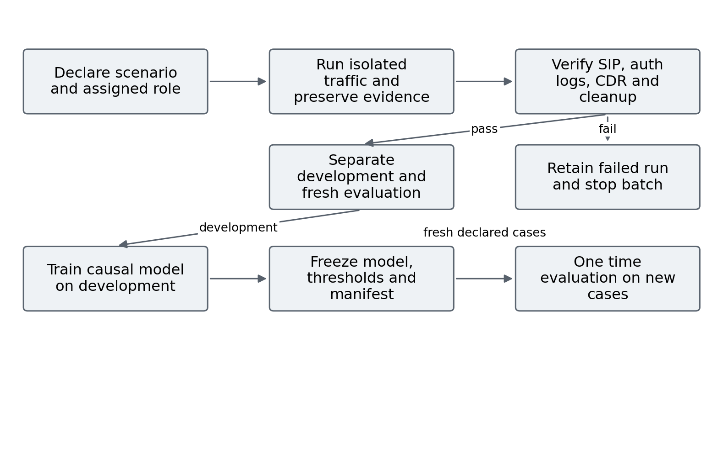
Figure 3.2 Scenario generation validation and frozen evaluation

Causal Features and Model Separation
Table 3.3 Features available at the scoring event
Feature | Definition
failures_120s | Confirmed failures in the previous 120 seconds
peak_failures_10s | Largest failure count in a 10-second interval within the available history
failure_span_s | Time between first and last available failure
first_failure_to_success_s | Time from first available failure to the current REGISTER success
The causal score is evaluated at the first successful REGISTER after at least five confirmed failures within 120 seconds. Later INVITEs, future call durations, answered CDRs, scenario labels and detector predictions are excluded from its feature vector. An earlier whole-scenario tree was exploratory because its post-call information was unavailable at this decision point.
A logistic model was trained on ten development episodes. The feature means, scales, coefficients and thresholds were frozen before B006 to B015. Whole episodes and matched profiles were kept together during development validation. No threshold or coefficient was changed after inspection of the new evaluation cases. The ten earlier H cases were already inspected and are not reused as a fresh holdout.

Distinct Timing Measures
Table 3.4 Timing endpoints used in the evaluation
Measure | Start | End | Interpretation
Archived stage delay | First captured request | Timestamp of qualifying stage event | Policy evidence accumulation
Pre-call review lead | Review event | First linked generator INVITE | Available suspicion before calling
Live alert availability | Captured successful authenticated REGISTER request | Observed native log or external reply | Delivery path included
Service handling | Service receives event | Service decision timestamp | Capture and decoder excluded
Call setup | First generator INVITE | First PBX INVITE 200 on same Call-ID | INVITE auth exchange included
These endpoints answer different questions and are not pooled. The proposal defines early detection using a high-risk alert; a pre-call REVIEW is reported as a review lead, not silently substituted for a high-risk detection endpoint. Earlier first alerts can also arise from an incorrect interpretation of normal authentication challenges.

Classification and Operational Evaluation
Scenario confusion counts report true positives, false positives, true negatives and false negatives against the assigned experiment labels. Precision, recall, F1-score and false-positive rate are reported with denominators. The small development set does not provide population accuracy. Rule alert presence and ML review priority are separate outcomes; lowering priority does not suppress a rule alert.
The early pilots use OFF, INTERNAL and EXTERNAL configurations in two counterbalanced blocks. The native module observes only authentication; the external rule-only comparison forwards the same authentication event family. Process CPU counters and RSS are sampled every 0.25 seconds. Samples around the traffic interval exclude preparation and offline extraction. Short-lived tails and shared memory limit these process observations.

Validity and Ethics
Internal checks preserve PCAPs, timestamps, source hashes, manifests and independent verification. External validity is limited by one generator, one PBX, constructed workloads, WLAN variation and small episode counts. Matched labels indicate assigned experimental roles, not independently observed criminal authorization. No production CDR baseline, real financial loss or autonomous mitigation result is claimed.

Predeclared Permission Context and Common Evaluation
The final controlled extension freezes policy before collecting new traffic. The policy is a laboratory administrator record, independent of scenario intent labels. Table 3.5 states the account and destination permissions. A single time-bounded recovery permission covers account 1001 from the generator source, with at most eight confirmed failures. It contains no case ID or BENIGN/SIMULATED_ABUSE label. Account 1002 has no observed recovery permission, although it is configured for registration and normal calls. The same permissions apply to benign and simulated-role cases, including matched pairs C003/C011 and C004/C012.
Table 3.5 Independent laboratory permission matrix
Account | Allowed source | Allowed destination | Recovery permission
1001 | 172.16.200.68 | 88001 | Predeclared two-hour window; up to 8 failures
1002 | 172.16.200.68 | 88002 | No recovery permission observed
The matrix is an emulated business policy rather than PBX route enforcement. Forbidden destinations are routed only to the isolated SIPp UAS for validation. No provider route or financial charge is involved. Unknown identity or missing permission remains unknown; a configured account does not prove who operated it.
The primary comparator counts ten transaction-confirmed failures within sixty seconds per source/account. A five-failure comparator is also frozen as a sensitivity check. Frozen V6 and V6 plus context receive exactly the same causally ordered SIP events. The common adapter exposes only packets at or before each event, preventing future INVITE identity or CDR outcome from entering a prediction. All raw V6 stages remain available even when contextual review changes an actionable-alert disposition.
Twelve new cases are predeclared: six BENIGN and six SIMULATED_ABUSE. Each method predicts before its assigned role is attached. Evaluation uses complete cases. Early warning means an alert strictly before the first generator INVITE; at-attempt alerts have zero lead and missed call cases remain in the denominator. Delays use causal replay event time, excluding live delivery latency. Models and thresholds remain frozen after traffic.

System Design and Implementation
The implemented system combines a protocol adapter, entity histories, an interpretable progression engine and optional causal review priority. V2 to V6 are research iterations, not released product versions. The frozen V5 and V6 scripts remain intact; later online and burst extensions use separate files.

Detector Evolution and Rationale
Table 4.1 Research detector evolution
Iteration | Change | Reason or boundary
V2 | Early SIP extraction and staged prototype | Establish request and response visibility
V3 | Windowed request and response counts | Interpretable rapid-traffic baseline
V4 evaluation | Explicit scenario IDs and boundary analysis | Avoid merging adjacent scenarios; expose slow and sub-threshold misses
V5 | Transaction-matched confirmed digest rejection and longer auth window | Normal 401 challenges are not rejected credentials
V6 | Link source and account across failure, recovery and lab call evidence | Represent progression while preserving suspicion semantics
Separate online extension | Normalized events, rule service, causal priority and distinct-call burst | Observe live decisions without rewriting frozen replay artefacts

Confirmed Authentication and Reconnaissance
V5 matches requests and responses using Call-ID, CSeq, method and reversed addresses. A normal initial challenge does not count as a failed password. An authenticated rejection is confirmed after a one-second retry grace; stale challenges and successful retries are excluded. Figure 4.1 shows why raw response counts can overstate attempted credential failures.
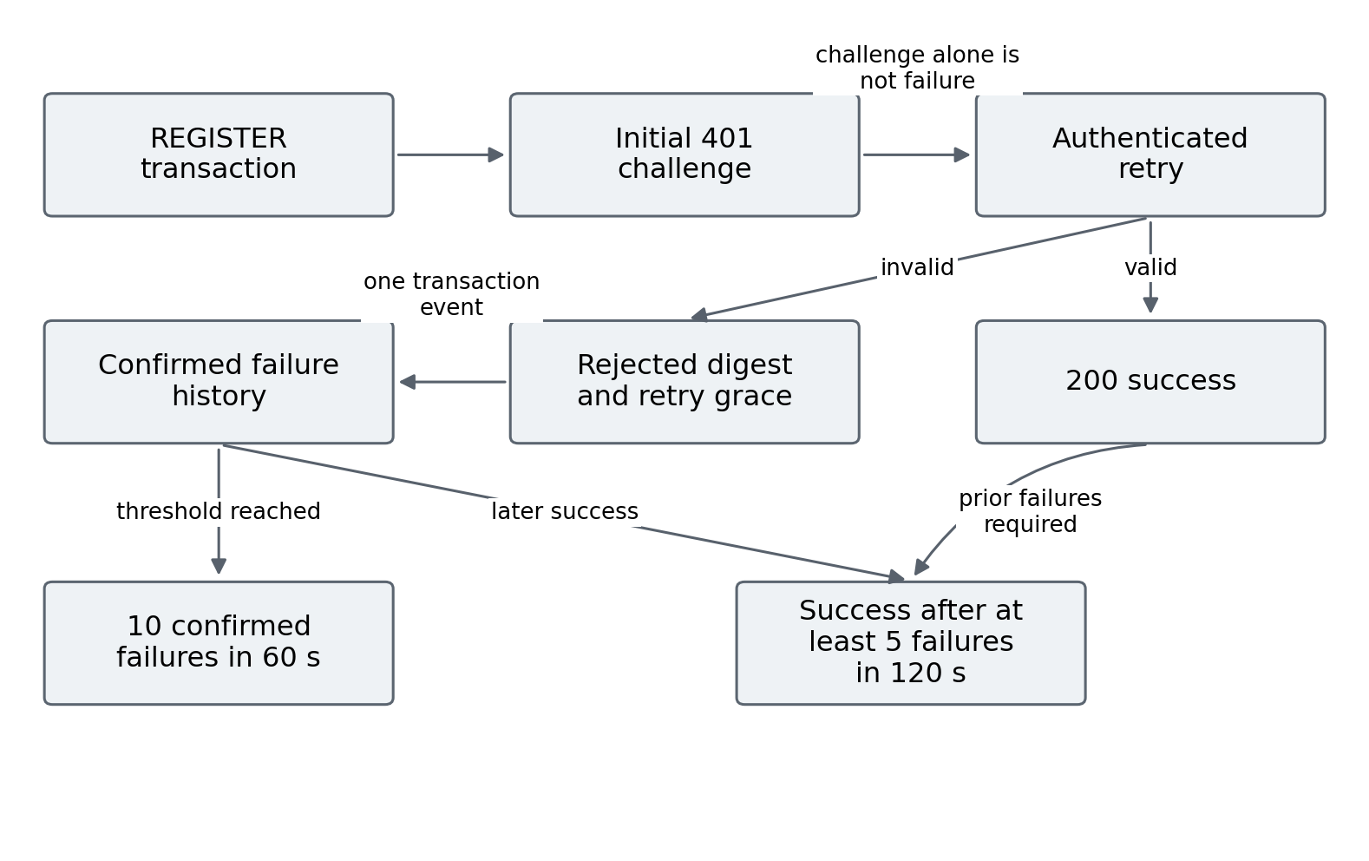
Figure 4.1 Confirmed authentication failure and recovery logic
The V6 reconnaissance rule tracks distinct OPTIONS targets rather than treating every OPTIONS message as malicious. Five distinct targets within ten seconds generate the reconnaissance stage. The authentication stage requires ten confirmed rejections in sixty seconds. These development thresholds are explicit experimental settings, not universal operational limits.

Recovery and Linked Call Progression
V6 stores failures per source IP and account. A successful registration after at least five failures in 120 seconds emits SUSPECTED_COMPROMISE. A linked lab INVITE within the next 120 seconds emits SUSPECTED_OUTBOUND_ATTEMPT. Subsequent SIP completion and independently added CDRs support ANSWERED_EMULATED_OUTBOUND in archived analysis. A valid registration proves credential acceptance, not theft.
The separate burst extension emits CALL_BURST on the third distinct lab INVITE within sixty seconds. Repeated packets for the same call are not extra calls. As shown in Figure 4.2, the burst stage uses attempts at event time, while SIP completion and CDRs are later corroboration. CALL_BURST does not imply a premium destination or verified unauthorized expenditure.
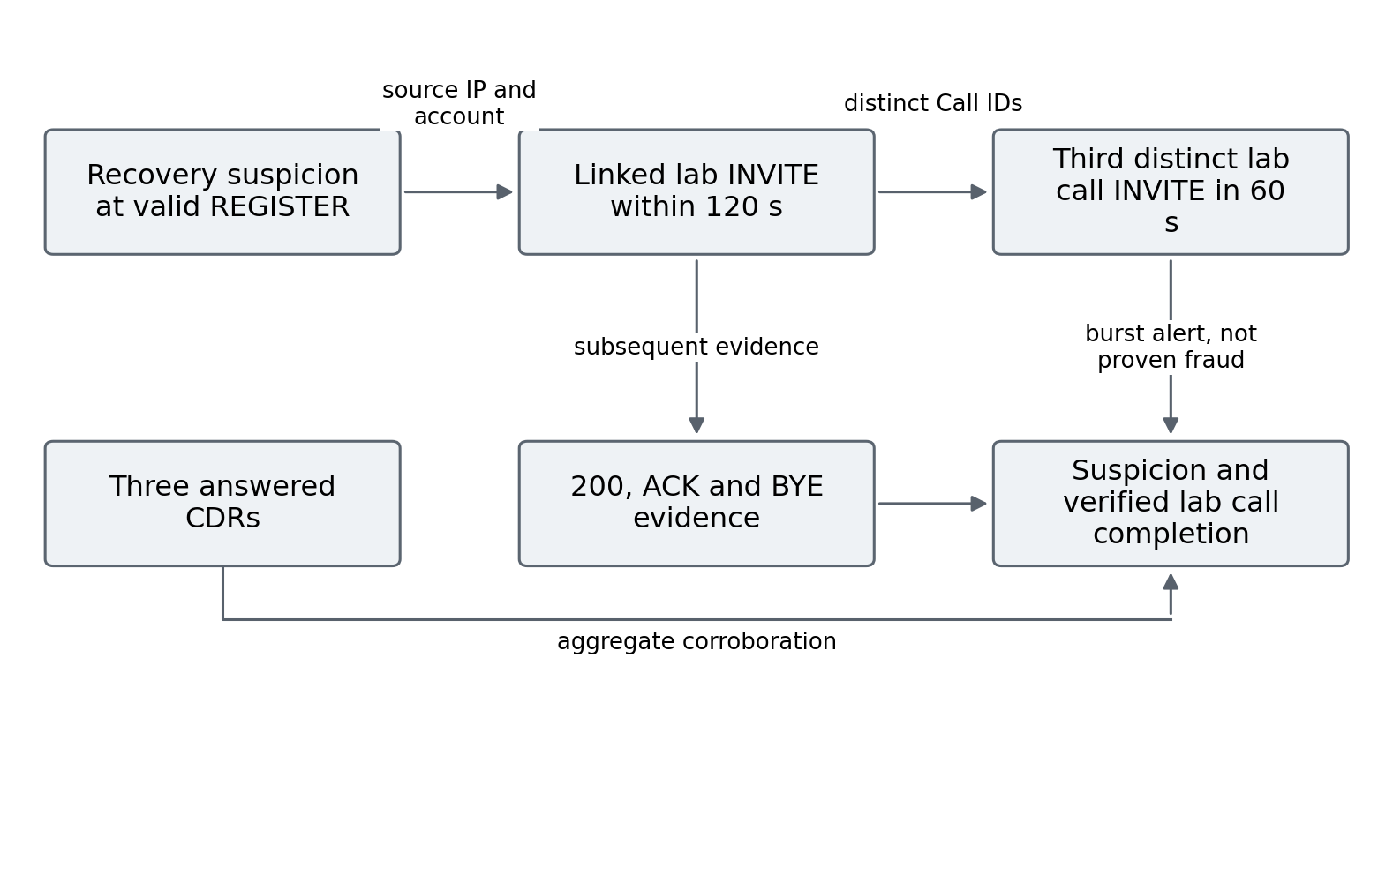
Figure 4.2 Recovery call attempts and independent completion evidence

Lightweight Review Priority
The frozen logistic model standardizes the four causal features, applies the saved coefficients and produces a score. A score below 0.4 is LOWER priority, 0.4 to below 0.6 is REVIEW, and at least 0.6 is HIGHER. These categories add review metadata to the rule result. The score is not a calibrated probability of real-world fraud, and no category automatically blocks or hides the alert.
The model file records training IDs, feature statistics, coefficients and hashes. The live ML service was separately validated with B016 using the frozen file. That validation confirms delivery of the score, rather than demonstrating that the score distinguishes matched authorization roles.

Internal and External Realizations
The internal C module was compiled for the Pi Asterisk 20.6.0 build and installed by the user. It subscribes to restricted security events from the lab generator and accounts 1001 and 1002. It has no call-control code. Live auth-only A000 to A002 validated a normal registration, ten failed passwords, and six failures followed by valid registration. The module was unloaded after testing.
The external process accepts normalized lab events over loopback. A capability-enabled tcpdump streams restricted packets into tshark; the collector forwards relevant fields to the service. Figure 4.3 defines the earlier shared-authentication delivery paths. That first pilot excluded ML and call stages. The later five-stage native observer and external path were tested separately in B030 to B036, as reported in Section 5.9.
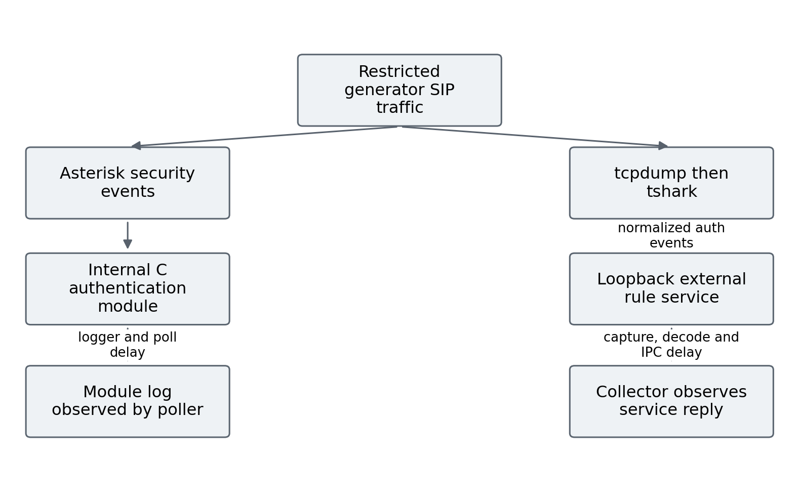
Figure 4.3 Shared authentication deployment paths and observation endpoints

Reproducibility and Implementation Boundaries
Every run retains source hashes and its declared manifest. The online adapter replay matched the frozen ordered V6 stages in 34 of 34 saved runs, covering 253 adapted events and 37 alerts. This is a compatibility check on inspected captures, not a new predictive evaluation or proof of live latency.
CDR snapshots preserve a before-prefix and identify added answered calls for the controlled route. The later native observer covers five online stages in a bounded pilot. Production calling priors, robust concurrent SIP-to-CDR linkage, automatic mitigation and production load testing remain outside the measured implementation.

Permission Layer and Causal Replay Implementation
Figure 4.4 shows the separate context extension. The original V6 source remains frozen at SHA-256 c4b9231a89a815e93f1264119e229df1a563d574ba4b6a7e357d8125983eb2b4. The evaluator invokes that unchanged logic on each causal prefix, substitutes an empty CDR view, and records online stages only. A parity assertion compares those stages with the original offline evaluator after prediction. This descriptive verification does not feed CDRs into the detector.
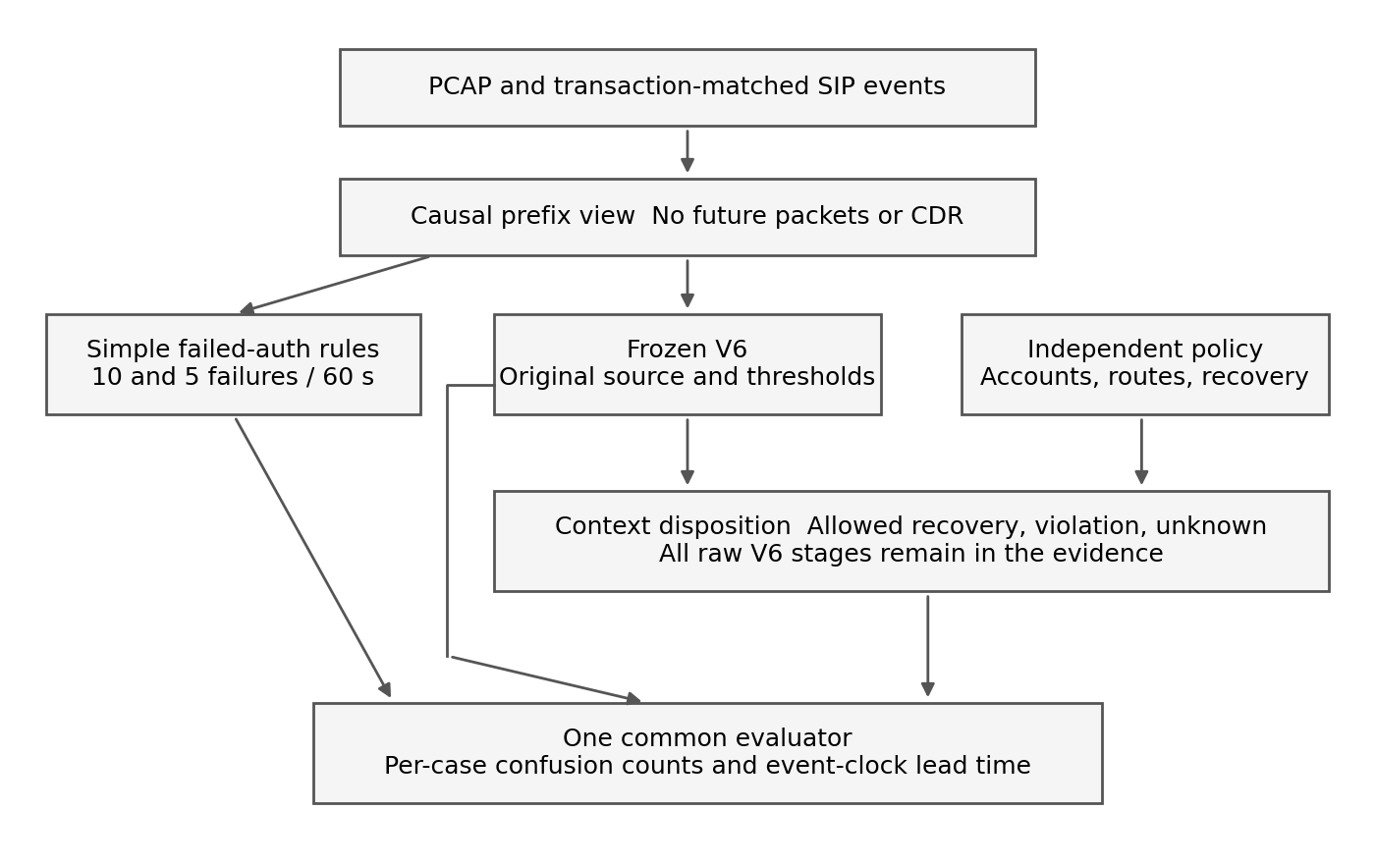
Figure 4.4 Frozen stage logic and independent context in the common evaluator
The permission layer retains reconnaissance and authentication-attack review. For recovery and linked-call stages, it checks source/account permission, the predeclared recovery time window, failure allowance and destination policy. Allowed recovery receives an authorized_recovery_review disposition. Missing evidence retains actionable review. Every observed INVITE outside a known account destination allowlist additionally emits DESTINATION_POLICY_VIOLATION, even if V6 emitted no preceding stage.
Ten implementation checks cover initial unauthenticated 401 responses, separate accounts sharing one IP, expiry of failures, frozen-stage progression, authorized recovery, forbidden destinations, missing recovery context, future packet leakage, indistinguishable hidden roles and undefined metric denominators. The checked code and permission matrix are hashed before the fresh batch. Portable read-only reproduction subsequently matches every prediction and confusion count in all twelve cases.

Results and Discussion
Results are organized by evidence family so that event metrics, development scenario coverage, fresh causal evaluation and deployment timing retain their own denominators. A suspicion alert is evaluated against an assigned role but is not presented as proof of credential theft.

Earlier Loopback Baseline and Boundary Findings
The earlier labelled Python loopback benchmark used fixed rapid request blocks. All three attack-labelled blocks were detected in eleven repeated runs. Tables 5.1 and 5.2 retain those historical results. The reported FRAUD_BURST label concerns generated INVITE patterns and is not evidence of answered provider calls. These event-level results cannot be compared directly with the later F-series scenario-level metrics.
Table 5.1 Historical loopback scenario timing
Stage | Detection rate | Mean TTD (s) | Median TTD (s) | Range (s) | SD (s)
Reconnaissance | 11/11 (100%) | 1.8647 | 1.9554 | 1.4934–2.2792 | 0.2211
Authentication attack | 11/11 (100%) | 2.2866 | 2.3128 | 1.8869–2.5398 | 0.1972
Fraud burst | 11/11 (100%) | 0.8244 | 0.8238 | 0.6724–0.9470 | 0.1001
Table 5.2 Historical loopback event metrics
Metric | Mean across stored baseline runs
Precision | 1.0000
Recall | 0.7111
F1-score | 0.8312
False-positive rate | 0.0000
The twelve-scenario boundary experiment detected three of eight attack-labelled cases and avoided alerts in four controls. Below-threshold and low-and-slow cases were missed. This motivated the longer confirmed-failure history and explicit progression rather than claiming the rapid baseline represented broad robustness.

Registered Scenario Coverage
The F01 to F12 development set contains six benign and six simulated attack scenarios. Table 5.3 shows that V6 flagged all six simulated cases and one benign recovery case. The false-positive rate is one of six benign scenarios, not one of twelve total cases. The set was used during detector development and is not a new holdout.
Table 5.3 F-series scenario confusion counts and metrics
Detector | TP FP TN FN | Precision | Recall | F1 | FPR
V3 | 4 2 4 2 | 0.667 | 0.667 | 0.667 | 0.333
V5 | 5 1 5 1 | 0.833 | 0.833 | 0.833 | 0.167
V6 | 6 1 5 0 | 0.857 | 1.000 | 0.923 | 0.167
V6 improves coverage on this set, but its benign recovery alert exposes an intent boundary. Authorized users who recover from repeated wrong passwords and simulated unauthorized users with the same SIP sequence can produce the same evidence. This is the reason for using suspected-stage names and preserving administrator review.

Common Onset Archived Timing
The timing audit uses the first captured request as a common onset for F05 and the six simulated attack cases. Table 5.4 reports the first alert of any stage. It is an archived policy-time comparison; the first alerts can differ in stage and risk. A dash indicates no alert.
Table 5.4 Archived seconds to first alert from a common onset
Case | Assigned truth | V3 | V5 | V6
F05 | Benign | 9.785 | — | 16.298
F07 | Simulated attack | 4.004 | 4.004 | 4.004
F08 | Simulated attack | 5.243 | 5.243 | 5.243
F09 | Simulated attack | 4.007 | 10.006 | 10.006
F10 | Simulated attack | — | 29.853 | 29.853
F11 | Simulated attack | 8.057 | — | 13.619
F12 | Simulated attack | — | 29.770 | 29.770
Reconnaissance timing is equal in F07 and F08. V6 alerts later than V3 in F09 and F11; confirmed-rejection semantics and stage requirements explain why the first-any-alert endpoint alone is not a quality measure. F10 and F12 are covered by V5/V6 but missed by V3. Universal earlier detection is therefore not demonstrated.
Recovery review precedes the first linked INVITE by approximately 1.70 seconds in simulated F11/F12 and 1.72 seconds in benign F05. This is useful pre-call suspicion, but it does not satisfy a claim of verified fraud or automatically count as the proposal high-risk endpoint. H1 is not supported as a general earlier-detection claim.

Frozen Causal Model Evaluation
The fresh B006 to B015 evaluation contains five matched profiles with opposite assigned roles. Each case has three completed lab calls and three answered CDRs, giving thirty independently checked calls. The model uses only the four causal features at REGISTER success. Table 5.5 pairs the scores by profile, and Figure 5.1 makes their near-overlap visible.
Table 5.5 Opposite role scores from the frozen causal model
Authorized | Score | Simulated role | Score | Both priorities
B006 | 0.3969 | B011 | 0.3971 | LOWER
B012 | 0.4708 | B007 | 0.4716 | REVIEW
B008 | 0.5385 | B013 | 0.5382 | REVIEW
B014 | 0.5760 | B009 | 0.5830 | REVIEW
B010 | 0.7336 | B015 | 0.7327 | HIGHER
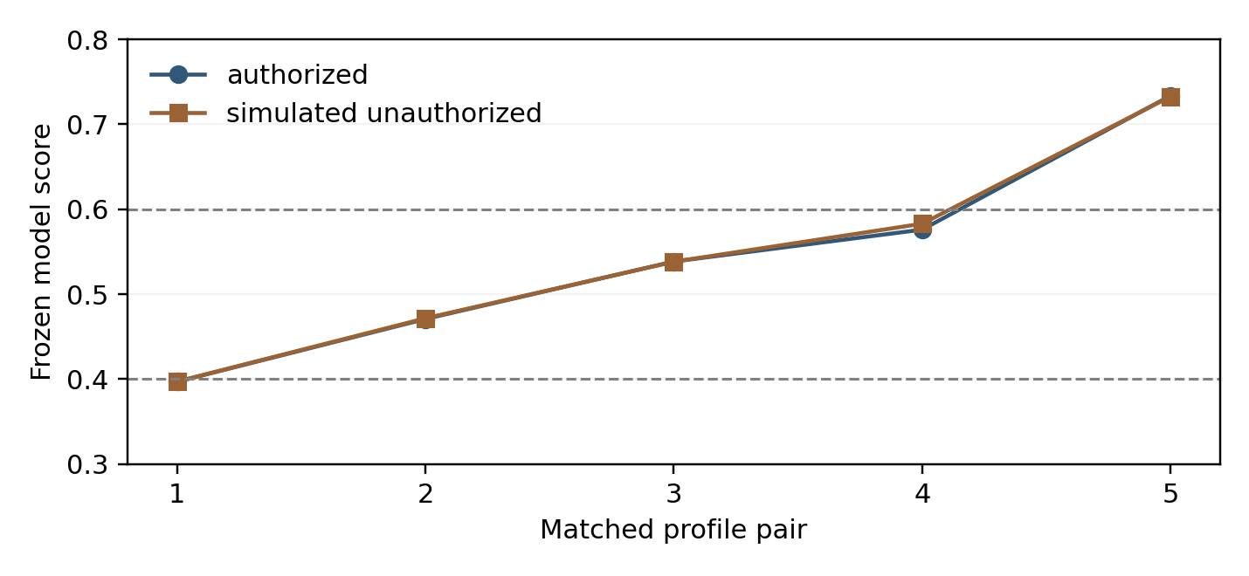
Figure 5.1 Frozen model scores on five matched profiles
Every matched pair receives the same priority category. LOWER contains one authorized and one simulated case; REVIEW contains three of each; HIGHER contains one of each. At the higher-priority threshold of 0.6, precision is 1/2 and recall of the five simulated roles is 1/5. These describe a priority subset, not automatic blocking or a population fraud classifier.
Rule recovery alerts remain visible in all ten cases. The model therefore demonstrates integration and a reproducible negative result: no separation of the assigned intents and no false-alert reduction were established. H2 is not supported. Independent authorization, destination policy or historical behaviour would be required to supply information absent from the matched SIP profiles.

Live Integration and Shared Authentication Delivery
Live case B016 verified six rejections, valid registration, three completed calls and the unchanged ML review score of 0.4733. Its five live alerts had observed packet-to-decision median 362.630 ms and range 112.713 to 942.540 ms; median service handling was 0.122834 ms. The difference separates capture and delivery from service computation. One case is not a latency distribution.
T001 to T006 then compared the shared authentication stage without calls or ML. OFF generated no review, and each enabled case generated one review. Table 5.6 reports authenticated successful REGISTER request to observed alert availability.
Table 5.6 Shared authentication observed alert availability
Case | Mode | Observed availability ms
T001 | OFF | —
T002 | INTERNAL | 1.790
T003 | EXTERNAL | 274.645
T004 | EXTERNAL | 574.066
T005 | INTERNAL | 1.808
T006 | OFF | —
The internal endpoint is when a poller sees an Asterisk module log line, including logger delivery and two-millisecond polling. The external endpoint is when the collector sees a service reply, including capture, decoder and IPC delay. The two internal observations are lower on this Pi, but they are not exact decision timestamps or a controlled comparison of complete detector algorithms. H3 receives limited pilot support for observed delivery latency only.

Call Setup and Resource Pilot
The separate call pilot uses the same six-failure recovery profile and three sequential SIPp UAS calls per case. Six accepted cases provide eighteen distinct completed calls and eighteen answered six-second CDRs. Seven cases were attempted overall, giving twenty-one calls including the excluded B024. B024 produced a repeated authenticated REGISTER with the same Call-ID and CSeq 2 and seven auth log lines. The original exact-count gate failed, so B024 was retained, B025/B026 were not run, and B027/B028/B029 were declared as a replacement block.
As shown in Table 5.7 and Figure 5.2, setup medians vary across cases. The start is the first generator INVITE and the end is the first PBX INVITE 200 response for the same Call-ID, including authentication. Calls within a case are clustered observations, not eighteen independent deployment replications.
Table 5.7 Accepted call setup cases
Case | Mode | Block | Median ms | Three calls ms
B021 | OFF | 1 | 45.972 | 19.879, 45.972, 55.738
B022 | INTERNAL | 1 | 16.100 | 16.100, 84.192, 13.037
B023 | EXTERNAL | 1 | 26.004 | 11.087, 26.004, 51.898
B027 | EXTERNAL | 2 | 78.351 | 78.351, 40.644, 124.027
B028 | INTERNAL | 2 | 35.571 | 35.614, 35.571, 14.649
B029 | OFF | 2 | 54.484 | 54.484, 16.750, 56.377
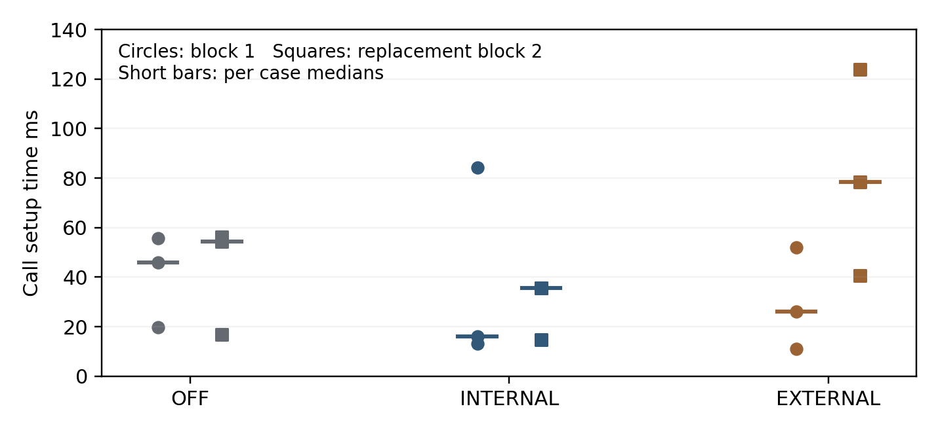
Figure 5.2 Individual call setup times and per case medians
Table 5.8 Within block setup differences relative to OFF
Block | Enabled mode | Enabled minus OFF median ms
1 | INTERNAL | -29.872
1 | EXTERNAL | -19.968
2 | INTERNAL | -18.913
2 | EXTERNAL | +23.867
The external difference changes sign between blocks. Lower internal medians do not demonstrate a speed improvement because this small nonrandomized WLAN pilot cannot isolate network and host variation. No consistent causal overhead effect or production acceptance threshold is established.
Table 5.9 Process observations during accepted call traffic
Process | CPU percent of one core | Peak RSS MiB
Asterisk PBX | 0.202 to 0.231 | 94.73 to 96.23
External collector | 0.050 to 0.076 | 17.22 to 17.41
External rule service | 0 to 0.025 | 17.47 to 17.67
External tshark decoder | 0.025 to 0.051 | 151.97 to 152.97
Sampling uses the first generator REGISTER through the last generator-leg BYE plus 0.5 seconds. Startup and offline extraction are excluded. Zero CPU means below sampling resolution; process tails may be missed and RSS may count shared pages. PBX memory rises between blocks across modes and is not attributed to the native module. Kernel, WLAN and whole-system costs are not isolated.

Research Questions and Hypotheses
Table 5.10 Evidence based answers and remaining scope
Question | Finding | Scope
RQ1 | Confirmed failures, distinct targets and linked recovery/call events describe suspicion | Authorization remains ambiguous; production priors absent
RQ2 and H1 | Coverage improves in the F-series; universally earlier first alerts are not shown | Inspected development traces and differing stage semantics
RQ3 and H2 | Frozen ML gives the same category to every matched opposite-role pair | No demonstrated intent or false-alert improvement
RQ4 and H3 | Later five-stage parity and lower native decision medians in a bounded pilot | Timing origins differ; causal overhead, load and maintainability unmeasured
The architecture supports an interpretable review of protocol progression. It does not infer authorization from identical traffic, and the title term adaptive refers to research refinement and optional priority scoring rather than demonstrated autonomous online learning. Proposed mitigation must remain distinct from the observation-only implementation.

Limitations and Exploratory Extensions
The development and fresh evaluation sets are small constructed workloads from one generator and PBX. The context experiment adds twelve frozen-protocol cases on one day, rather than a production sample. Permissions are laboratory administrator records. An attacker operating within allowed policy can remain hidden, while an authorized recovery without observed permission can still alert. CDRs validate completion but do not supply a representative normal-call baseline. Different native and external timing origins constrain latency comparisons.
Four new REGISTER controls validate known single-account, known two-account shared-source and unused-identity patterns. They do not establish five legitimate accounts behind NAT, concurrent mixed sessions or packet-loss robustness. The public flooding benchmark remains a separate task. The new permission layer was evaluated through causal replay, so its live delivery, stability and operational enforcement are unmeasured. No source or threshold changed after the fresh capture batch.

Later Five Stage Deployment Pilot
The later B030 to B036 pilot extends the earlier authentication-only deployment work. Seven declared cases passed independent checks, with twenty-one answered six-second isolated calls. B030 is an authorized benign smoke case, while six primary cases contain eighteen calls. The enabled native and external paths reproduced the declared five online stage categories and frozen ML metadata tolerances. Table 5.11 reports descriptive packet-to-decision medians from this later pilot.
Table 5.11 Later native and external stage decision medians
Stage | Native ms | External ms | Observations per path
Reconnaissance | 0.085 | 628.500 | 2
Authentication attack | 1015.987 | 1907.184 | 2
Recovery review | 4.709 | 394.017 | 2
Linked outbound attempt | 0.090 | 522.112 | 6
Distinct call burst | 0.091 | 640.665 | 2
The authentication row includes a one-second rejection grace. Recovery and other stages use different packet timing origins; native decision and logged observation availability also differ. Native call-setup medians of 60.539 and 43.350 ms exceeded the corresponding OFF medians of 15.710 and 12.900 ms in these nonrandomized WLAN blocks. External medians were 38.099 and 19.613 ms. Faster native alert decisions therefore do not establish zero call-setup cost or a causal overhead effect. B030 generated CALL_BURST despite being authorized, and all four primary enabled cases received HIGHER ML priority. These are behaviour and deployment findings, not a fresh fraud-intent evaluation.

Fresh Permission Context Comparison
On 12 October 2026, C001 to C012 all passed the predeclared exact authentication-count, SIP completion, PCAP-drop, CDR-delta and cleanup gates. The batch contains fifty confirmed wrong-password dialogs and nine answered isolated calls. No case was replaced or excluded. Table 5.12 and Figure 5.3 show the same-case comparisons; Table 5.13 preserves the case-level decisions. The two assigned roles contain six cases each.
Table 5.12 Fresh case confusion counts and balanced accuracy
Method | TP | FP | TN | FN | Balanced accuracy | False alert rate
Auth 10 | 1 | 0 | 6 | 5 | 58.3% | 0.0%
Auth 5 | 5 | 2 | 4 | 1 | 75.0% | 33.3%
V6 | 5 | 2 | 4 | 1 | 75.0% | 33.3%
V6 + context | 5 | 1 | 5 | 1 | 83.3% | 16.7%
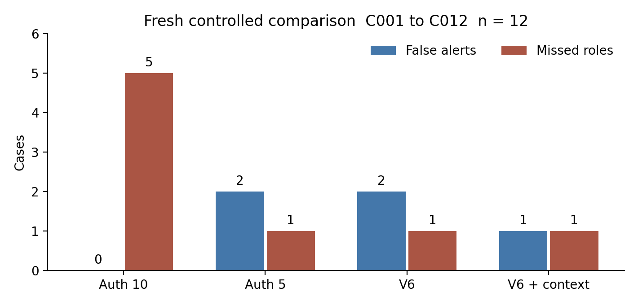
Figure 5.3 False alerts and missed assigned roles in twelve fresh cases
Table 5.13 Fresh case decisions from the common evaluator
Case | Role | Account | Destination | Fails | Auth 10 | Auth 5 | V6 | Context
C001 | B | 1001 | 88001 | 0 | 0 | 0 | 0 | 0
C002 | B | 1002 | 88002 | 0 | 0 | 0 | 0 | 0
C003 | B | 1001 | 88001 | 6 | 0 | 1 | 1 | 0
C004 | B | 1002 | 88002 | 6 | 0 | 1 | 1 | 1
C005 | B | 1001 | No call | 2 | 0 | 0 | 0 | 0
C006 | B | 1002 | No call | 2 | 0 | 0 | 0 | 0
C007 | S | 1001 | 88002 | 6 | 0 | 1 | 1 | 1
C008 | S | 1002 | 88001 | 6 | 0 | 1 | 1 | 1
C009 | S | 1001 | 88002 | 0 | 0 | 0 | 0 | 1
C010 | S | 1002 | No call | 10 | 1 | 1 | 1 | 1
C011 | S | 1001 | 88001 | 6 | 0 | 1 | 1 | 0
C012 | S | 1002 | 88002 | 6 | 0 | 1 | 1 | 1
B denotes the assigned benign role and S the scripted simulated-abuse role. A value of 1 means at least one qualifying online alert during the complete case, rather than proof of fraud. Context reduces the false-alert count from two to one: C003 receives authorized recovery review, while C004 retains actionable review because its recovery permission is unavailable. Context detects C009 at the forbidden INVITE despite no failed-authentication precursor. However, it misses C011, whose observed account, destination and maintenance permission match benign C003. Thus V6 and context miss different cases.
Context precision, recall and F1 are each 0.833 on this set. The balanced-accuracy increase from 0.750 to 0.833 describes one additional correct case out of twelve. It is not an ML improvement, a population estimate or evidence that the permissions reveal every unauthorized actor. C003/C011 deliberately demonstrate that identical policy-observable conditions can receive the same disposition despite opposite assigned roles.
Table 5.14 Early warning coverage on five simulated role call cases
Method | Before INVITE | At INVITE | Missed | Median positive lead s
Auth 10 | 0/5 | 0 | 5 | No warning
Auth 5 | 4/5 | 0 | 1 | 7.972
V6 | 4/5 | 0 | 1 | 2.989
V6 + context | 2/5 | 2 | 1 | 2.995
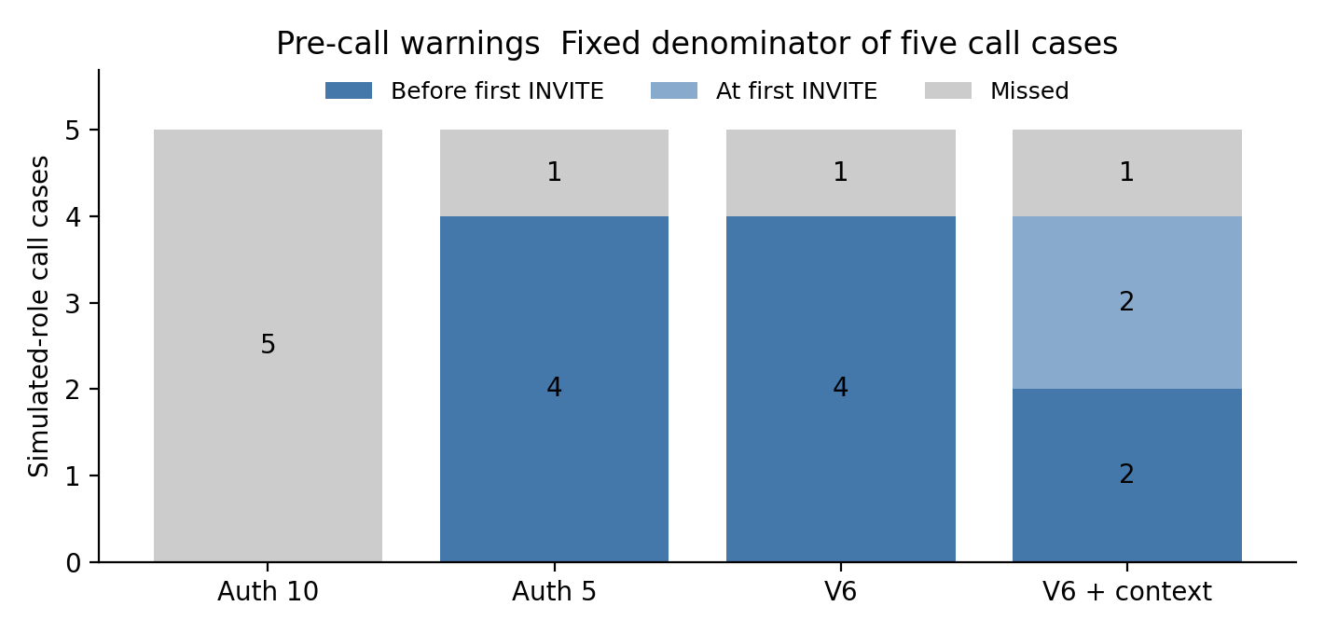
Figure 5.4 Pre call coverage with missed and at attempt cases retained
The five-failure simple baseline and V6 both warn before the first INVITE in four of five simulated-role call cases. Their positive lead medians are 7.972 s and 2.989 s respectively. Context warns early in two of five, with a positive lead median of 2.995 s, alerts at the first INVITE in C007 and C009, and misses C011. At-attempt alerts and the missed case remain explicit in Table 5.14 and Figure 5.4. The data support a precision and coverage tradeoff rather than a general claim that progression or context always warns earlier than simpler rules. Actual live availability of the new context layer was not measured.

Fresh REGISTER Controls and Reproducibility
Four separately declared REGISTER-only controls each sent six unauthenticated requests, with no INVITE, no CDR change and no PBX configuration change. All request and response transactions were independently verified in PBX-side captures. The original P002 timeout remains incomplete. P102 is new traffic using a revised send-only generator and PCAP response verification; it does not prove the original generator receive path has been repaired.
Table 5.15 Four new bounded REGISTER controls
Case | Targets | Distinct identities | Unknown requests | Diversity reviews
P101 | 1001 repeated | 1 | 0 | 0
P102 | 1001 and 1002 | 2 | 0 | 0
P103 | 9001 repeated | 1 | 6 | 0
P104 | 9001 to 9006 | 6 | 6 | 1
The two configured-account controls produce no diversity review. One unused identity also produces none. The six-unused-identity control reaches the five-distinct-target review threshold. This tests account diversity and known/unknown policy context, not malicious intent. Two configured accounts do not establish a five-user legitimate NAT baseline. The controls remain separate from the twelve role-labelled cases and are not pooled into their confusion matrices.
Baseline and evaluation freezes retain original code, dataset-split, model, policy and manifest hashes. All thirty-four historical PCAP hashes were checked without relabelling those observations as new tests. The twelve new PCAP hashes, final result hashes and deterministic predictions were rechecked. The portable reproduce_results.py script reproduces all twelve predictions and all four confusion matrices without network or PBX access. After traffic, the PBX had zero active calls, both temporary routes were absent and the native module was unloaded.

Conclusion and Future Work

Conclusions
The research produced a reproducible SIP progression prototype with protocol-aware authentication, entity-linked recovery suspicion, distinct-call burst events, causal ML review priority and two bounded deployment realizations. Independent packets, authentication logs and answered CDRs make its lab behaviour auditable.
The research establishes interpretable progression with an explicit authorization ambiguity boundary. The new context layer improves balanced accuracy from 75.0% to 83.3% on twelve fresh controlled role-labelled cases by reducing one false alert and changing which case is missed. It also reduces pre-call warning coverage from four of five to two of five simulated-role call cases. The five-failure baseline warns earlier than V6 in the comparable call cases. These results qualify the early-fraud claim and show why accuracy, permission evidence and warning time must be reported together.
The later native and external pilot covers five online stages and has lower native decision medians on this Pi, while call-setup results remain variable and noncausal. H1 is not supported as a universal earlier-warning claim. H2 is unsupported for the frozen ML score; the separate context result cannot be attributed to ML. H3 has bounded latency and stage-parity evidence, while maintainability, acceptable production overhead and safe mitigation remain unestablished.

Objective Coverage
Table 6.1 Coverage of the Section 3 proposal objectives
Objective | Implemented and evaluated | Remaining qualification
O1 indicators | Confirmed auth semantics, target diversity and recovery/call linkage | No universal intent separator or production prior
O2 progression | Frozen V6 plus separate permission-conditioned review and twelve fresh cases | Allowed-policy hidden roles remain ambiguous; early-warning tradeoff
O3 deployment | External and native five-stage observers; bounded live pilot | Production generality, throughput and maintenance unmeasured
O4 ML refinement | Frozen causal model and fresh matched evaluation | Implementation complete; claimed improvement not demonstrated
O5 evaluation | Common confusion, event-clock lead times, live pilots and reproducible freezes | Production baseline, causal load and mitigation not evaluated
The proposal contains two objective formulations. Table 6.1 follows the O1 to O5 practical focus in its Research Objectives and Research Questions section. It distinguishes completing an experiment from supporting the expected improvement. Objective coverage is therefore qualified rather than reported as total completion.

Future Work
Future evaluation should obtain independently administered production permissions and recovery records, collect consented normal behaviour from multiple entities and networks, and prospectively test frozen candidates on new days and concurrent sessions. The present two-account control should be extended to legitimate larger NAT groups. SIP-to-CDR identity linkage and retransmission controls need broader validation before records become entity-level behavioural priors.
The implemented native stage pilot should next undergo repeated matched load, stability, upgrade and recovery tests. The context layer needs live delivery and operator-disposition testing. A mitigation prototype should be evaluated separately for false-positive disruption. These extensions remain future work; the present conclusions apply to an auditable controlled prototype and its measured evidence.

References
[1] J. Rosenberg et al., “SIP: Session Initiation Protocol,” RFC 3261, IETF, Jun. 2002, doi: 10.17487/RFC3261.
[2] Asterisk Project, “Overview - Asterisk REST Interface (ARI),” Asterisk Documentation. [Online]. Available: https://docs.asterisk.org/Configuration/Interfaces/Asterisk-REST-Interface-ARI/. [Accessed: 12-Oct-2026].
[3] Asterisk Project, “CDR Specification,” Asterisk Documentation. [Online]. Available: https://docs.asterisk.org/Configuration/Reporting/Call-Detail-Records-CDR/CDR-Specification/. [Accessed: 12-Oct-2026].
[4] Asterisk Project, “Overview - Reporting,” Asterisk Documentation. [Online]. Available: https://docs.asterisk.org/Configuration/Reporting/. [Accessed: 12-Oct-2026].
[5] L. Manunza, S. Marseglia, and S. P. Romano, “Kerberos: A real-time fraud detection system for IMS-enabled VoIP networks,” Journal of Network and Computer Applications, vol. 80, pp. 22–34, Feb. 2017, doi: 10.1016/j.jnca.2016.12.018.
[6] D. Seo, H. Lee, and E. Nuwere, “SIPAD: SIP–VoIP anomaly detection using a stateful rule tree,” Computer Communications, vol. 36, no. 5, pp. 562–574, Mar. 2013, doi: 10.1016/j.comcom.2012.12.004.
[7] S. Chiappetta, C. Mazzariello, R. Presta, and S. P. Romano, “An anomaly-based approach to the analysis of the social behavior of VoIP users,” Computer Networks, vol. 57, no. 6, pp. 1545–1559, Apr. 2013, doi: 10.1016/j.comnet.2013.02.009.
[8] O. S. Younes, “A hybrid deep learning model for detecting DDoS flooding attacks in SIP-based systems,” Computer Networks, vol. 240, Art. no. 110146, Feb. 2024, doi: 10.1016/j.comnet.2023.110146.
[9] D. Golait and N. Hubballi, “Detecting anomalous behavior in VoIP systems: A discrete event system modeling,” IEEE Transactions on Information Forensics and Security, vol. 12, no. 3, pp. 730–745, Mar. 2017, doi: 10.1109/TIFS.2016.2632071.
[10] X. Hu et al., “BTG: A bridge to graph machine learning in telecommunications fraud detection,” Future Generation Computer Systems, vol. 137, pp. 274–287, Dec. 2022, doi: 10.1016/j.future.2022.07.020.
[11] L. Ren et al., “Dynamic graph neural network-based fraud detectors against collaborative fraudsters,” Knowledge-Based Systems, vol. 278, Art. no. 110888, Oct. 2023, doi: 10.1016/j.knosys.2023.110888.
[12] K. Dassouki, H. Safa, M. Nassar, and A. Hijazi, “Protecting from cloud-based SIP flooding attacks by leveraging temporal and structural fingerprints,” Computers & Security, vol. 70, pp. 618–633, 2017, doi: 10.1016/j.cose.2017.08.003.
[13] H. Sengar, D. Wijesekera, H. Wang, and S. Jajodia, “VoIP intrusion detection through interacting protocol state machines,” in Proc. International Conference on Dependable Systems and Networks (DSN’06), 2006.
[14] W. Nazih, W. S. Elkilani, H. Dhahri, and T. Abdelkader, “Survey of countering DoS/DDoS attacks on SIP based VoIP networks,” Electronics, vol. 9, no. 11, Art. no. 1827, 2020, doi: 10.3390/electronics9111827.
[15] A. Aziz, Real-time Detection & Mitigation of SIP-based VoIP Toll Fraud Attacks, Ph.D. dissertation, University of Duisburg-Essen, Essen, Germany, 2024.
[16] A. Aziz, D. Hoffstadt, E. Rathgeb, and T. Dreibholz, “A Distributed Infrastructure to Analyse SIP Attacks in the Internet,” in IFIP Networking Conference, Trondheim, Norway, 2014.
[17] T. Cejka, V. Bartos, L. Truxa, and H. Kubatova, “Using application-aware flow monitoring for SIP fraud detection,” in Intelligent Mechanisms for Network Configuration and Security, vol. 9122, Cham: Springer, 2015, pp. 87–99, doi: 10.1007/978-3-319-20034-7_10.
[18] T. Kapourniotis, T. Dagiuklas, C. G. Polyzos, and P. Alefragkis, “Scam and fraud detection in VoIP networks: Analysis and countermeasures using user profiling,” in 2011 50th FITCE Congress, 2011, pp. 1–5, doi: 10.1109/FITCE.2011.6133427.

Appendices

A Progression Logic and Causal Scoring
The following pseudocode summarizes the implementation. Full Python, SIPp XML and C module sources are retained in the experiment repository rather than reproduced in the thesis body.
for each normalized event in event-time order:
prune histories by source IP and account
add only confirmed digest rejection events
on successful REGISTER with at least five failures in 120 seconds:
emit SUSPECTED_COMPROMISE
score only features available at this event
attach LOWER REVIEW or HIGHER priority without suppressing rule evidence
on a linked distinct lab INVITE within 120 seconds:
emit SUSPECTED_OUTBOUND_ATTEMPT
on the third distinct call within 60 seconds:
emit CALL_BURST

B Frozen Model Configuration
Table A.1 Frozen logistic feature scaling and coefficients
Feature | Mean | Scale | Coefficient
failures_120s | 6.500000 | 1.565248 | 0.177752
peak_failures_10s | 4.700000 | 0.900000 | 0.123668
failure_span_s | 12.960280 | 5.638711 | 0.127886
first_failure_to_success_s | 16.051260 | 5.650309 | 0.155683
Intercept: 0.003881613. Priority cut points: 0.4 and 0.6. Training episodes: D007, D008, D009, D010, D011, D019, D020, D021, D022, D023. The score is evaluated only at the eligible successful registration event.

C Evidence and Source Index
The canonical root is /home/astrix/sip-fraud-research on Astrix-lab. Raw captures, manifests, logs, CDR snapshots and independent checks are retained. Dataset families overlap where a capture is replayed, so their sizes must not be added as independent samples.
Table A.2 Canonical evidence directories
Result family | Relative directory
Registered F-series | datasets/f-series-evaluation/20260930T094922Z
Archived ordering audit | datasets/online-prototype-audit-20261001
Fresh causal evaluation | datasets/causal-ml-holdout-20261001
Live causal integration | datasets/live-ml-20261001/B016
Auth delivery pilot | datasets/deployment-auth-comparison-20261002
Call pilot and failed capture record | datasets/deployment-call-comparison-20261002
Replacement block | datasets/deployment-call-comparison-replacement-20261002
Raw call captures | datasets/burst-lab-20261001/development
Full-stage deployment | datasets/full-stage-deployment-comparison-20261002
New policy, code, metrics and captures | accelerated-20261012
Portable deterministic replay | accelerated-20261012/reproduce_results.py
Key sources include candidate_v5_replay.py, progression_v6_development.py, external_event_service.py, external_event_service_ml.py, lab_burst_runner.py, verify_burst_run.py and the separate deployment measurement and audit scripts. The shared-auth external collector deliberately does not forward INVITE events. The module binary remains installed but was unloaded after validation.

D Reproducibility Checksums
Frozen V5: e23ffd00ef931c23b1e2a4e9b0fccb6731d57025f94dbdc3a9045a75de825004
Frozen V6: c4b9231a89a815e93f1264119e229df1a563d574ba4b6a7e357d8125983eb2b4
Causal model: ece43b48eb1d98115c2796735c67fc80589f8ff85d51765e78d373e3079ee30d
Causal holdout manifest: 652e68d674fa5bac4909cc407206bcb991b60301bba8aab75eef145790afdaa5
Auth manifest: 13dd84d26470f1f063b9a2734118b490ba318e746fe00e2c521268457a2cf78d
Combined call summary: 712001679d2f0aeee31b471b71b3e006ee283ad9f627381fd36ad9003e31e9df

