# Introduction

### 1.1Introduction of Proposed project:

E-learning is the delivery if learning and training through digital resources. Although e-learning is based on formalized learning, it is provided through electronic devices such as computer, tablets and even cellular phones that are connected to the internet.

“E-learning” is designed to give student to learn anywhere at any time, to give student facility to choose many classes and option to learn more efficiently. We have used waterfall model in our project.

### 1.2Problem Statement:

* Making sure people can get online, making surethe things people learn are good, and helping people who need extra help.
* If proper guidance is not giving to the students, they may not fully engage in the lesson on their own.
* Going to the university to attend lectures during the pandemic carries risks.
* The entire university cost is more than online lectures.

### 1.3Objectives

* Meet the learning style or needs for students.
* Use E-learning to make learning better and more effective.

### Scope and limitation Scope

* User can learn anywhere and anytime.
* User can easily communicate and express themselves.

### Limitations

* There is no physical communication between teacher and student.
* This system does not support money transaction.
* This system can only be used when you are connected to the internet. If you are not connected to the internet, you will not be able to access or use this system.

Literature Review

For this project, we have researched and analyzed some if the related websites like google and YouTube to gather information for our project. We found out websites and application are also providing the service as we offering but our project has only gather ides from those project our project is totally different and got more features than those other websites.

E-learning today gained so much popularity because it essential technologies are working out at huge steps. We are even offered to provide video and audio of the lecturer for better study for the students. In this benefits why to go out somewhere else when all you have to do is attend, choose the course, stay in your comfortable place and start gathering knowledge. All the management will be done by the user and provide all the course and keep all the database of the User. E-learning can help students to gather more knowledge apart from school education.

According to the Nepal Telecommunication Authority, 90.56% of the population in Nepal has access to the internet. In Nepal, the internet has reached rural and urban-rural fringe areas (areas between urban and rural) but there are no quality education providers, no better schools, and no adequate teachers. We cannot say about the people in rural areas but for those who are in urban rural fringe areas, eLearning would be the best choice. Meanwhile, the government has also been very supportive as they have decided to provide soft loans of up to Rs. 80000 to students of government schools and those in higher education to procure laptops.

Other flaw we saw was that their UI/design were not appealing at all in terms of our design.

## Methodology

We are using waterfall methodology, for the development of the project. This project has specific time, documentation and the fixed requirements, which make waterfall method more approval system development lifecycle.

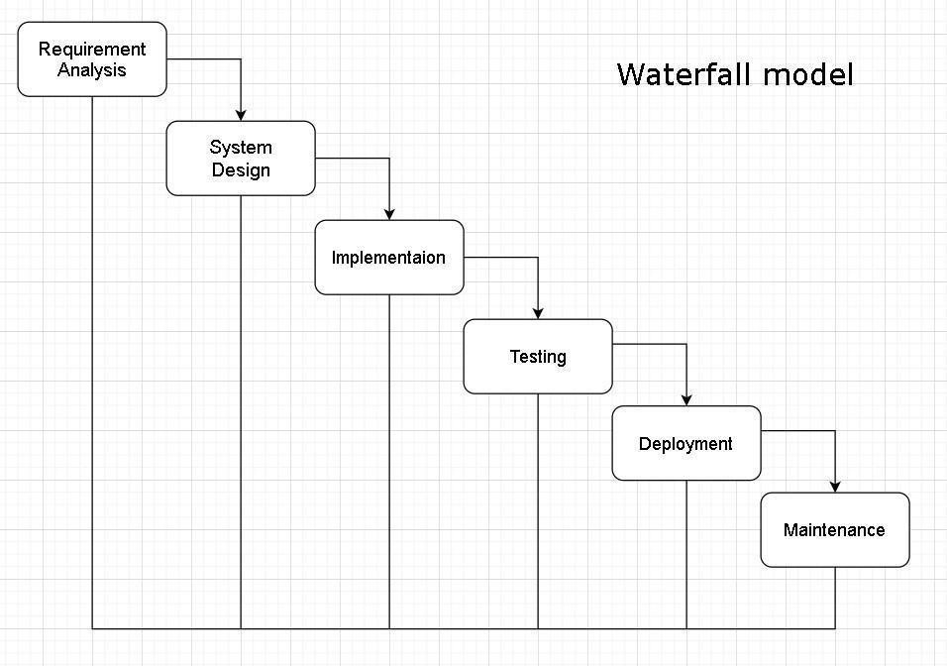

The Waterfall methodology — also known as the Waterfall model — is a sequential development process that flows like a waterfall through all phases of a project (analysis, design, development, and testing, for example), with each phase completely wrapping up before the next phase begins. When compared with other methodologies, Waterfall focuses most on a clear, defined set of steps. The Waterfall Model Was the first process model. Our project requirements are expected to remain relatively stable throughout the development process, so waterfall method is suitable. The waterfall method offers a well-defined structure, making it easier to plan and manage the project. Each phase has clear objectives, deliverables, and dependencies, which provides a clear roadmap for the project team.

# System Analysis:

System Analysis is the process in which a system is studied in such way that an information system can be analyses, modelled, and a logical alternative can be chosen. It is conducted for the purpose of studying a system or its parts in order to identify its objectives.

### Requirements Identification:

Requirement analysis is done while developing a system and before implementing it, it is necessary to analyses the whole system requirement. It is categories into mainly two parts:

1. Functional Requirements
2. Non-functional Requirements

For any system there are functional and non-functional requirements to be considered while determining the requirements of the system. The functional requirements are user “visible” features that are typically initiated by stakeholders of the system, such as generate report, login, and signup. On the other hand, non-functional requirements are requirements that describe how the system will do what it is supposed to do, for example, usability, reliability & availability, performance, security and maintainability.

**Functional Requirements:** The requirement that has been used in the project as the functional requirements generally includes the function such as input, the processing and the final output. The functional requirements in the project are mentioned below.

1. User module

* Users will be able to register and login.
* User can look at their course they have added.
* User can search different course.
* User can get pdf and videos after updating each products.
* Users can logout after you finish using the system.

.

1. Admin module

* Admin can see course details.
* Admin can manage user (add, update, delete).
* Admin can add and delete courses.
* Admin can see the registered users.
* Admin has right to delete the user.

**Non-Functional Requirements:** The non-functional requirement specifies how the system works. The non-functional requirements included in the project are:

Here are some bullet points of non-functional requirements for an e-learning system based on waterfall model:

* Security – Our e-learning system, such as encryption, authentication, and access control.
* Maintainability - The system should be easy to maintain and update. New course modules and features are easy to add.
* Portability - The system should be portable across devices like mobile, tablets, laptops, etc.
* Accessibility - The interface should follow accessibility standards to support students with disabilities.
* Reusability - The UI components, course content modules, and other elements should be reusable across the system. Duplication of effort should be minimized.

### Feasibility Study:

A feasibility study is an analysis that consider all of a project’s affecting factors like economic, technical, legal and scheduling considerations.

#### i. Technical Feasibility:

* The UI of our project is very simple.
* User will require internet browser and internet to use it.

1. Economic Feasibility: Before the development of a system, the proposed system be studied whether or not it is within the budget estimated. The project that we are developing is within the cost estimation. The project cost is less and no more burdens are needed. For making this system, existing and available hardware and software will be used so there will be no cost rather than the internet connection.
2. Operational Feasibility: these include the reliability, maintainability, usability, supportability. The proposed system is operationally feasible as it is reliable for all type of user i.e whether or not the user has the knowledge of computer or not. This system uses simple technology to design. So, it is user friendly.

### Development software:

The following software is used for the development of the system.

* + Vs Code
  + Apache [xampp]

### Front End:

* + HTML
  + CSS
  + JavaScript

### Back End:

* + PHP
  + MYSQL

ii. Schedule Feasibility: The system that we developed is scheduling feasible as it does not require more time for the development phase. The data collection takes more time to collect the data about for the development phase. The data collection takes more time to collect the data about various products and the quality. After data is collected, the other development phase can be within a month.

### Er-diagram:

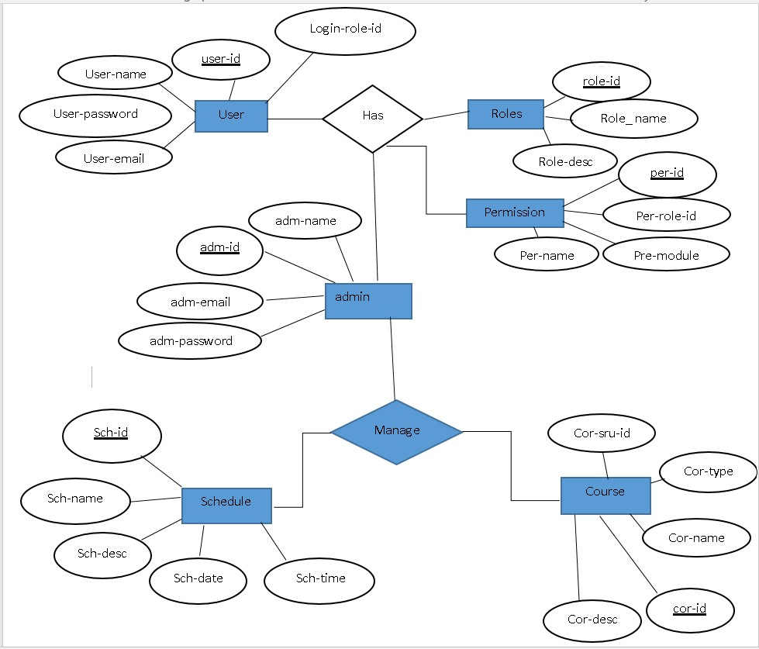

**User-Case diagram:**

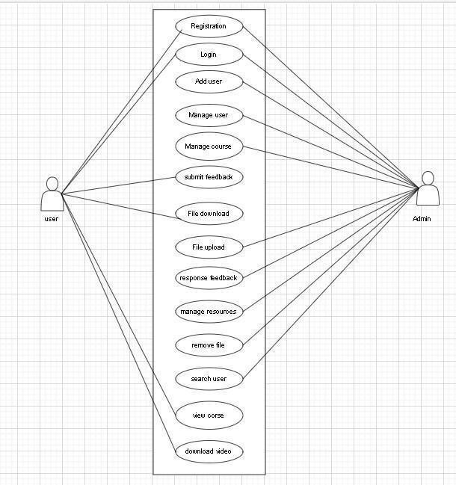

### DFD for E Learning system

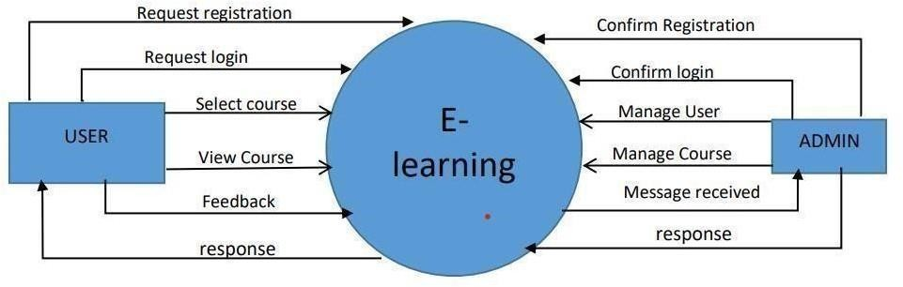

#### level DFD for user

1. level DFD for Admin

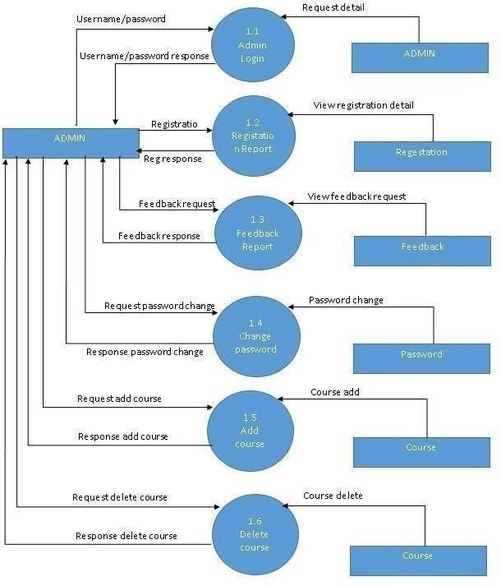

### Gantt chat

A Gantt chart is used for planning projects of all sizes, and it is useful way if showing what work is scheduled to be done on a specific day. It can also help you view the start and end dates if a project in one simple chart. In our project, we use Ms. Excel for developing the Gantt chart which is shown below in the figure.

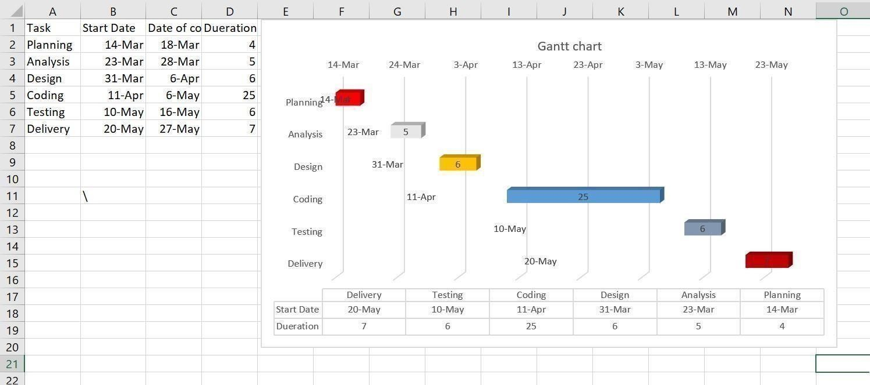

Fig: Gantt chart of e-learning

# Conclusion

Overall, the E-learning manager system will provide the service that education sector has to offer to the User/Student. Student will be able to study couches according to their preference through online within their comfort zone without even steeping one step. Our E-learning system will meet up all the expectations.

**[NOTE: All the limitation shown above will be soon after successful testing of the completed system and taking some reviews and feedbacks form the users.]**

# Reference

Project Sample (Proposal):

[https://bcanotesnepal.com/bca-fourth-semester-project-sample-fot-project-i-bca-tu/] E-learning management system:

<https://www.youtube.com/playlist?list=PLbGui_ZYuhiihdSW-kg50d0L4or1DWvko>DFD contain:

<http://ww16.1000project.org/?sub1=20230322-0117-5256-82f0-1222b5c23670>