Snakemake BCL Conversion Pipeline
Automated workflow for Illumina (MiSeq i100 / NovaSeqX) sequencing data processing, quality control, and report generation.

Workflow Diagram
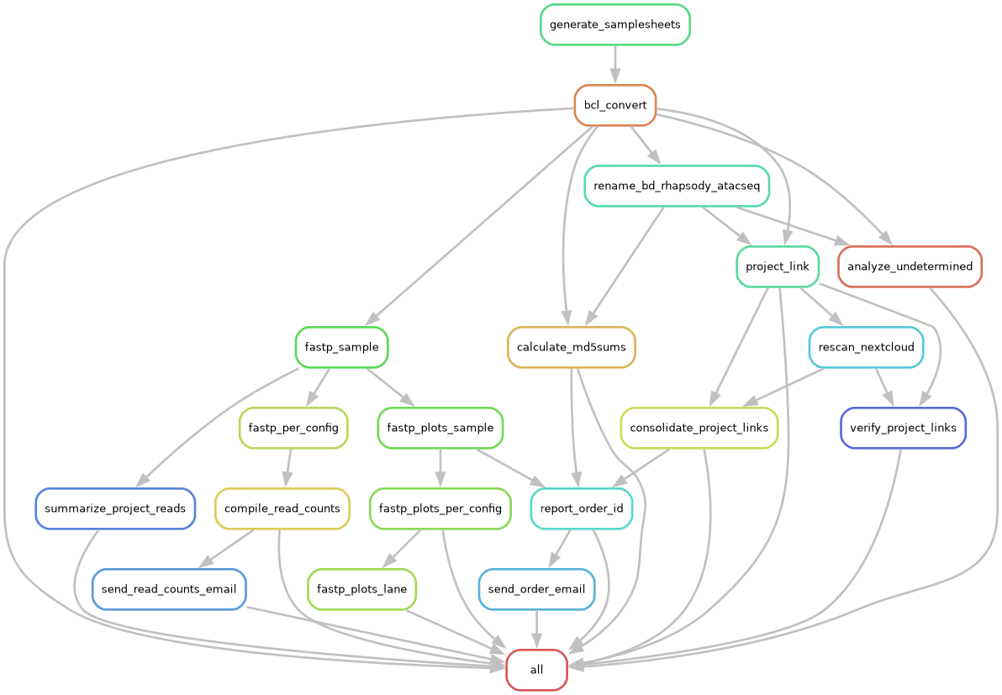
Workflow Rule Graph

Overview
This Snakemake pipeline handles the complete sequencing data processing workflow: 1. BCL Conversion - DRAGEN BCL-to-FASTQ conversion with per-lane sample sheets 2. File Renaming - Systematic renaming based on lane, group, position, and barcode 3. Quality Analysis - FastP quality metrics for all samples 4. Visualization - Quality plots (mean Phred scores, base composition) 5. Report Generation - Comprehensive HTML reports grouped by Order ID with embedded plots and download instructions 6. Read Count Compilation - Lane-level read counts formatted as CSV, aggregated per library 7. Email Notifications - Automated email delivery of reports and read counts

Environment
Python and the bioinformatics CLIs are provisioned with pixi from pixi.toml (locked in pixi.lock). Install pixi once, then let it build the environment:
curl -fsSL https://pixi.sh/install.sh | bash # one-time install
pixi install # solve/create env from pixi.lock
Run any command inside the environment with pixi run, or use the predefined tasks:
pixi run snakemake -n # dry run
pixi run all # full workflow (snakemake --cores 8)
pixi run dry-run # preview
pixi run convert output/lane1
pixi manages Python (pandas, openpyxl, numpy, matplotlib, pillow, pyyaml, reportlab), Snakemake, and the bioconda CLIs (fastqc, flexbar, seqtk, fqtk). Two dependencies remain system-level and are not installed by pixi:
- DRAGEN (/opt/dragen/<ver>/bin/dragen) — licensed, FPGA-tied; must be on PATH.
- An optional custom flexbar build referenced by flexbar_bin in the config. A bioconda flexbar is provided by pixi; point flexbar_bin at it to drop the custom build.
The legacy bcl_convert mamba/conda environment is being retired in favor of pixi.

Key Files
- Snakefile - Main workflow definition; imports rules from src/workflow_defs.smk
- snakemake_config.yaml - Base configuration (paths, threads, email settings)
- snakemake_config_project.yaml - Project-specific configuration (overrides base settings)
- metadata/*.xlsx - Excel metadata with Summary sheet and per-project sheets
- src/RunInfo_nn.xml - Normalized run configuration (auto-generated)

Platforms & Auto-Detection
This pipeline supports two Illumina platforms/configurations. The platform is auto-detected from the metadata workbook at workflow start (no config flag needed):
Aspect | MiSeq i100 | NovaSeqX
Detection | Has a Barcode Entries sheet, no Summary sheet | Has a Summary sheet
Lanes | Single lane (lane1) | Up to 8 lanes (lane1…lane8)
Groups | Single group per lane | Multiple groups per lane
Order IDs | Inferred from Lab ID column of the first sheet | Read from the Summary sheet
Example data_dir | /staging/nextcloud/Miseqi100/<run> | /staging/nextcloud/NovaseqX/<run>
The workflow prints Detected MiSeq metadata format (or proceeds with the NovaSeqX Summary-sheet path) so you can confirm which mode is active. This run (iR011) is a MiSeq i100 run.

Configuration
Edit snakemake_config_project.yaml (project overrides layered over snakemake_config.yaml).
MiSeq i100 example (this run):
library_name: "iR011" # Run identifier
metadata: "metadata/06262026_BXA66618-2426_iR011.xlsx"
data_dir: "/staging/nextcloud/Miseqi100/20260626_SH00564_0020_ASC2231455-SC3"
lanes: [1,2,3,4,5,6,7,8] # Superset; only lane1 is used for MiSeq
email_sender: "kstachel@uci.edu"
email_recipient: "kstachel@uci.edu"
NovaSeqX example:
library_name: "xR077" # Run identifier
metadata: "metadata/251219_23G5F2LT3_10B_PE151_xR077.xlsx"
data_dir: "/staging/nextcloud/NovaseqX/20260115_LH00626_0088_A233NM2LT4"
lanes: [1,2,3,4,5,6,7,8] # Lanes to process (auto-detected from BaseCalls)
email_sender: "kstachel@uci.edu"
email_recipient: "kstachel@uci.edu"

Metadata Format

NovaSeqX (Summary-sheet format)
- Summary sheet (header at row 3):
  - Lane, Gr (Group), Project Name, Masking, Fastq Link
- Per-project sheets with sample details:
  - Lane, Group, Sample Name, i7 Barcode Sequence, i5 Barcode Sequence
Masking format: R1:151, I1:8, I2:8, R2:151 → generates OverrideCycles

MiSeq i100 (simple format)
- A Barcode Entries sheet with per-sample barcodes (no Summary sheet)
- The first sheet’s Lab ID column supplies both project labels (e.g. PaegB) and Order IDs (e.g. 0626I-08); order IDs match the pattern \d+I-\d+
- All samples are assigned to a single lane (lane1) and single group

Workflow Steps
Configs are identified per lane as lane{N} (e.g. lane1). MiSeq i100 runs use only lane1; NovaSeqX runs may use lane1 through lane8. Generated sample sheets, renaming maps, and per-lane artifacts live under results/lane{N}/.

1. Sample Sheet Generation (automatic)
- Parses metadata Excel file
- Generates per-lane sample sheets in results/lane{N}/SampleSheet_lane{N}.csv
- Creates renaming maps in results/lane{N}/renaming_map_lane{N}.csv
- Produces Flexbar barcode files for Flexbar-tagged projects

2. BCL Conversion
snakemake --cores 8 output/lane1
- Runs DRAGEN BCL Convert per lane configuration
- Applies OverrideCycles from metadata masking field
- Creates project subdirectories
- Renames FASTQ files using renaming map: {Run}-L{Lane}-G{Group}-P{Position}-{Barcode}

3. Quality Analysis (FastP)
snakemake --cores 4 results/fastp_lane1.done
- Runs FastP on all samples per config
- Outputs JSON stats to results/fastp/lane{N}/{project}/{sample}.json

4. Quality Plots
snakemake --cores 4 results/lane1/fastp_plots_lane1.done
- Generates mean Phred and base composition plots
- Outputs PNG files to results/fastp_plots/lane{N}/{project}/{sample}-*.png

5. Project/Order Reports
snakemake --cores 1 Reports/order_0626I-08/index.html
- Creates comprehensive HTML reports grouped by Order ID
- Includes summary of all projects associated with the order
- Embeds quality plots as base64 images
- Includes download instructions (browser, wget, HPC) and sorted md5 checksums
- Outputs:
  - Reports/order_{id}/index.html
  - Reports/order_{id}/md5sums.txt
  - Reports/order_{id}/Download_Instructions.pdf
  - Reports/{project}/lane{lane}/index.html

6. Read Count Compilation
snakemake --cores 1 results/iR011-count.csv
- Aggregates read counts across all lanes
- Formats as CSV with lane/group/sample/counts columns
- Sorted by read count (descending) per lane

7. Email Delivery
snakemake --cores 1 Reports/iR011_read_counts_email.done
- Sends read count CSV as attachment
- Uses SMTP (smtp.uci.edu:25)

Common Commands
Dry run (see what would execute):
snakemake -n
Run entire workflow:
snakemake --cores 8
Run specific project report:
snakemake --cores 4 Reports/MyProject/index.html
Analyze undetermined indices:
snakemake --cores 1 results/undetermined_indices/lane1.csv
Force re-run a specific rule:
snakemake --cores 4 -R compile_read_counts
View rule graph:
snakemake --rulegraph | dot -Tpdf > rulegraph.pdf
View complete dependency graph:
snakemake --dag | dot -Tpdf > dag.pdf

Output Structure
output/
lane{N}/
{project}/
{Run}-L{Lane}-G{Group}-P{Position}-{Barcode}-R1.fastq.gz
{Run}-L{Lane}-G{Group}-P{Position}-{Barcode}-R2.fastq.gz
results/
lane{N}/
SampleSheet_lane{N}.csv
renaming_map_lane{N}.csv
fastp/
lane{N}/{project}/{sample}.json
fastp_plots/
lane{N}/{project}/{sample}-mean_phred.png
lane{N}/{project}/{sample}-base_comp.png
undetermined_indices/
lane{N}.csv
{library}-count.csv
Reports/
order_{id}/
index.html
md5sums.txt
Download_Instructions.pdf
email_sent.done
{project}/
lane{lane}/
index.html
md5sums.txt
{library}_read_counts_email.done

Undetermined Reads
Two config options control how Undetermined (unassigned) reads are handled per lane:
- keep_undetermined_configs - lanes whose Undetermined FASTQs are retained instead of deleted after conversion. Example: keep_undetermined_configs: ['lane1']
- report_undetermined_configs - lanes where Undetermined reads are treated as a normal sample: renamed into the lane’s first project directory and flowed through the full pipeline (fastp QC, read counts, md5sums, nextcloud links, and the per-order HTML report). Lanes listed here are automatically added to keep_undetermined_configs. Example: report_undetermined_configs: ['lane1']
Undetermined reads are also kept automatically when a flexbar_barcodes_{config_id}.txt file exists for the lane.

Email Configuration
The workflow uses src/send_email.py with support for: - Plain text or HTML content - File attachments - Configurable SMTP settings (default: smtp.uci.edu:25)
For OAuth2 (Gmail): - Set up Google Cloud OAuth2 credentials - Store client_secret.json and token.json in workspace - Modify send_email.py to use google-auth libraries - Set environment variables for credential paths

Troubleshooting
Missing lanes in workflow: - Check detected_lanes output at workflow start - Verify data_dir in config points to the correct run directory (with Data/Intensities/BaseCalls)
BCL conversion fails: - Verify data_dir and run_info_path are correct - Check DRAGEN is available: which dragen - Review OverrideCycles match actual run cycles
No samples in report: - Check metadata Excel file has correct sheet names and headers - Verify projects are listed in Summary sheet - Look for “PROJECTS found in SampleSheet” in workflow output
md5 mismatches: - Re-run specific project: snakemake -R report_project --cores 1 Reports/{project}/md5sums.txt - Verify FASTQ files weren’t modified after generation

Advanced Features
Flexbar / inline demultiplexing (for Flexbar-tagged projects): - Requires barcode FASTA files (auto-generated from metadata) - flexbar_barcode_leader_n sets leading bases (e.g. a UMI) before the inline barcode in R1 (0 = barcode at position 1; 5 for PAREseq-style U5I6 libraries) - flexbar_retry_min_reads triggers a reverse-complement retry pass if no sample exceeds the threshold after the forward pass - Processes undetermined reads
Excluding orders: - Set exclude_order_ids: ["0626I-08"] to skip processing, reports, and emails for specific Order IDs
Scratch space for conversion: - Set scratch_dir to fast local NVMe; DRAGEN writes FASTQs there first, then moves them to output/ (avoids writing directly to slow JBOD/network storage)
Tile-specific processing: - Set tiles: "1_1101" in config for subset processing - Useful for test runs or debugging

Notes
- Run commands via pixi run (environment provisioned from pixi.toml / pixi.lock)
- The workflow auto-detects lanes from the BaseCalls directory
- Sample sheets are generated once at workflow start from metadata
- md5 checksums are sorted by position number (P001, P002, …)
- Reports include embedded images for email compatibility
- 2-week data retention policy is noted in all reports

