# Data access pathways

The purpose of this page is to document data access request pathways and the associated documentation to support each route.

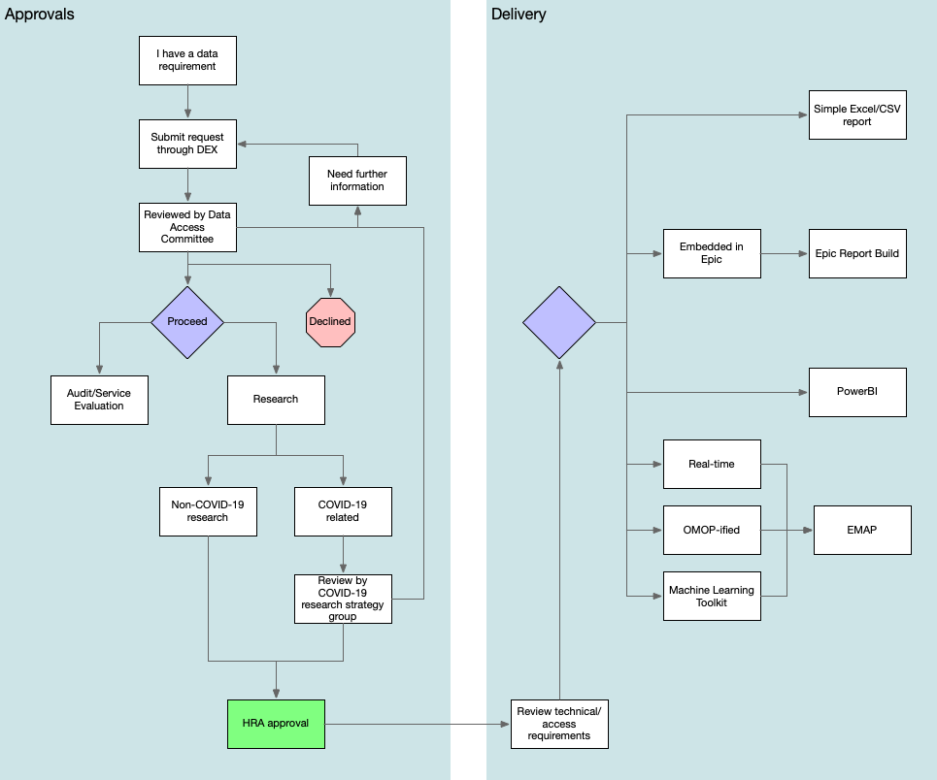

## Decision points

* Are you doing research or audit/service evaluation? Read the guidance and use the [HRA tool](http://www.hra-decisiontools.org.uk/research/).