Which amplifications reach the protein: a gene-intrinsic account of copy-number-to-protein transmission, with application to antibody-drug conjugate target selection in 3q-amplified non-small-cell lung cancer
Gene-intrinsic transmission of copy-number to protein, and application to ADC target selection in 3q-amplified NSCLC

Abstract
Somatic copy-number amplification is pervasive in cancer, but its functional consequence is realised only if the extra gene dosage reaches the protein, and that transmission is attenuated gene by gene. Using matched proteogenomic profiles across six tumour types, we build a leakage-safe model that predicts, per case and per gene, whether an amplified gene is over-expressed at the protein level, and we ask what the model is detecting. On the highly amplified 3q cohort the model reaches an area under the precision-recall curve of 0.7515 against a base rate of 0.4191 (lift 1.79); on the pan-cancer cohort it reaches 0.6465 against 0.3983 (lift 1.62). Its distinctive value is not average discrimination but resolution within the highly amplified regime, where copy number alone is uninformative. Four independent lines of evidence then show that the transmission the model detects is a stable, gene-intrinsic property. It transfers across tumour lineages (mean pairwise rank concordance 0.840, Kendall W 0.867). It is predictable from external gene properties alone, with no protein-derived feature, at a leave-gene-out rank correlation of 0.547. It is not positional: holding out entire chromosome arms changes that correlation by 0.001. And its mechanism reconciles with post-transcriptional buffering, dominated by gene dosage-sensitivity and protein biophysics. Adding a protein-protein interaction network improves prediction only by widening gene coverage, not because interaction topology is intrinsically informative. Applied to antibody-drug conjugate target selection in 3q-amplified non-small-cell lung cancer, and filtered on five orthogonal axes, this framework yields three surface targets that survive every axis (ATP13A3, ATP1B3, PLSCR1) and holds back two that are high on transmission but carry a specific liability (TFRC, essential; ITGB5, lineage-unstable). About two thirds of per-gene transmission variance remains unexplained by gene properties, so the framework is a gene-intrinsic prior over the genome, not a per-gene oracle; we make that bound explicit with a kept-in error, AP2M1.
All model metrics are reported on unique (case, gene) pairs, deduplicated, with the random-precision base rate beside every area under the precision-recall curve as lift. Seed 2 throughout; British spelling; numeric section references.
1. Introduction
Somatic copy-number alteration is among the most pervasive classes of genomic change in cancer, spanning whole-chromosome aneuploidy through arm-level and focal events (Beroukhim et al. 2010, 10.1038/nature08822; Zack et al. 2013, 10.1038/ng.2760). Recurrent amplifications draw particular interest because they recur across tumours on regions harbouring oncogenic drivers, and because the genes they carry are, in principle, dosage-elevated and therefore candidate dependencies and therapeutic targets (Sanchez-Vega et al. 2018, 10.1016/j.cell.2018.03.035). The functional consequence of an amplification, however, is realised at the level of protein, and the path from gene dosage to protein is neither direct nor uniform. An account that stops at the DNA, or even at the transcript, can mislead about which genes are actually over-produced.
That path is attenuated. Gene dosage propagates towards protein through transcription and then translation, and the signal is buffered at more than one step, so that protein abundance is partially decoupled from copy number across many genes (Goncalves et al. 2017, 10.1016/j.cels.2017.08.013). A well-characterised contributor is the stoichiometric control of protein complexes, in which a subunit produced in excess of its partners is degraded rather than accumulated (Stingele et al. 2012, 10.1038/msb.2012.40; Sousa et al. 2019, 10.1074/mcp.RA118.001280). Crucially, the degree of buffering is gene-specific: some amplifications transmit fully to protein while others are largely buffered (Vogel and Marcotte 2012, 10.1038/nrg3185), and recent work resolves how buffering depends on complex membership and dosage-sensitivity (Heller et al. 2026, 10.1038/s44320-026-00187-9). The practical implication is that copy number alone is a weak guide to which amplified genes are over-expressed at the protein level, which is the level that determines function and therapeutic accessibility.
Large proteogenomic efforts now quantify copy number, RNA and protein in common tumours across several tumour types (Gillette et al. 2020, 10.1016/j.cell.2020.06.013; Li et al. 2023, 10.1016/j.ccell.2023.06.009), making it possible to ask, gene by gene and case by case, whether an amplification reaches the protein, and to model the determinants of transmission from data rather than to assume them.
The translational setting is amplification of chromosome arm 3q, a recurrent event in squamous malignancies and in non-small-cell lung cancer more broadly (McCaughan et al. 2010, 10.1164/rccm.201001-0005OC; Jeon et al. 2023, 10.1111/1759-7714.15045). The amplified region is large and contains many co-amplified genes whose individual transmission to protein is not established. Because so many genes are amplified together, 3q-amplified non-small-cell lung cancer is a context in which distinguishing the amplifications that reach surface protein from those that do not is both difficult and directly useful. That usefulness is sharpest for antibody-drug conjugates, an expanding modality (Nelson et al. 2023, 10.1146/annurev-med-071322-065903) whose viability depends on the target being abundantly and selectively present as protein on the cell surface (Gazzah et al. 2022, 10.1016/j.annonc.2021.12.012). An amplified gene is an attractive target only if its amplification produces surface protein; selecting on copy number or transcript alone risks committing a programme to genes whose protein is attenuated.
This work develops an attenuation-aware framework that predicts protein-level transmission within an amplified region and gates the result on surface localisation. Its central claim, established here from four independent directions, is that transmission is a stable, gene-intrinsic property, and that this is precisely what makes a transmission-aware prior useful for target selection where copy number is blind.
2. Methods
2.1 Data and cohorts
The framework is built on matched proteogenomic profiles (copy number, RNA, protein) across six tumour types (LSCC, LUAD, GBM, PDA, CCRCC, UCEC), with an independent cohort reserved for transfer assessment. Two analysis cohorts are used throughout: a pan-cancer cohort (ALL) and a 3q-amplified cohort (3Q). Amplification is defined as a ploidy-adjusted copy number above one together with an integer copy number of at least three (the R4 definition), the regime in which copy number alone ceases to discriminate protein outcome.
2.2 Outcome and leakage-safe design
The outcome is protein-derived: whether an amplified gene is over-expressed at the protein level in a given case. No protein-derived feature is ever used as a predictor. Splits are grouped by case and fixed across all experiments for comparability; any value propagated over a network or neighbourhood is computed from training-fold cases only and recomputed per fold, so that validation cases never inform their own features. This design is verified rather than asserted: a per-fold leakage self-check confirms zero train-test feature overlap on every fold-aware feature.
2.3 Model, evaluation and deduplication
The model is a gradient-boosted decision ensemble (XGBoost, 600 trees, single-thread, seed 2), with feature groups chosen by forward group selection. Five-fold stacking produces byte-identical duplicate (case, gene) rows that inflate both the base rate and the area under the precision-recall curve, so every metric is computed after deduplication to unique (case, gene) pairs. The random-precision base rate is reported beside every area under the precision-recall curve as lift, and precision-at-K per case and per-subtype lift are used for cross-cohort reads.
2.4 The four gene-intrinsic experiments
Four post-hoc experiments, none of which retrains the model beyond a leave-tumour-out refit, test whether the transmission the model detects is gene-intrinsic: a transfer experiment across the six lineages (Section 3.2); a gene-intrinsic transmissibility predictor built from external features alone (Section 3.3); a positional control that holds out whole chromosome arms (Section 3.4); and a network-integration experiment that asks whether a protein-protein interaction network adds anything beyond gene coverage (Section 3.6). The mechanism is then reconciled with an independent post-transcriptional buffering analysis (Section 3.5).
3. Results
3.1 A transmission model whose value is in the amplified regime
On the R4 amplified cohorts the model discriminates protein-level over-expression well above the base rate. In the pan-cancer ALL cohort it reaches an area under the precision-recall curve of 0.6465 against a base rate of 0.3983 (lift 1.62); in the 3q-amplified 3Q cohort it reaches 0.7515 against 0.4191 (lift 1.79). Per-tumour lifts are consistent across lineages (Table 2, Table 1), ranging in ALL from 1.50 (PDA) to 1.71 (LSCC). The point of the model is not that it beats copy number on average, but that it resolves which amplifications reach the protein inside the highly amplified regime, where copy number is uninformative by construction. That resolution is only worth trusting if it reflects something stable about the genes rather than an artefact of any one cohort. The next four sections show that it does.
Table 2. Per-tumour area under the precision-recall curve and lift, ALL cohort.
tumor_code | n | base_rate | aupr | lift
LSCC | 173125 | 0.419 | 0.717 | 1.712
LUAD | 179784 | 0.417 | 0.685 | 1.642
UCEC | 62958 | 0.420 | 0.679 | 1.615
CCRCC | 80052 | 0.403 | 0.610 | 1.512
PDA | 59846 | 0.376 | 0.564 | 1.502
GBM | 144446 | 0.347 | 0.528 | 1.522

Table 1. Per-tumour area under the precision-recall curve and lift, 3Q cohort.
tumor_code | n | base_rate | aupr | lift
LUAD | 6403 | 0.440 | 0.786 | 1.788
LSCC | 14255 | 0.436 | 0.786 | 1.803
UCEC | 2859 | 0.422 | 0.772 | 1.831
CCRCC | 2435 | 0.427 | 0.726 | 1.702
PDA | 2316 | 0.371 | 0.625 | 1.683
GBM | 3835 | 0.344 | 0.594 | 1.725

3.2 Transmission transfers across tumour lineages
Leaving out one tumour type at a time and ranking genes by predicted transmission in the held-out lineage, the per-gene rankings agree across the six lineages at a mean pairwise rank concordance of 0.840 (range 0.782 to 0.901) and a Kendall coefficient of concordance of 0.867 (Figure 18a; Table 6). Against a null that holds the models fixed and permutes the outcome label, the observed concordance stands far outside the null (standardised distance +271.5; permutation p at the resampling floor). A gene's transmission propensity is therefore not a lineage-specific accident; it transfers. The median across-lineage stability ratio is 3.6, and 990 of 6,715 genes (14.7 per cent) are strictly stable at a ratio of at most two. A genuinely context-dependent tail of 633 genes (9.4 per cent) moves substantially by lineage; these are named rather than hidden (Table 6, Figure 4), and they matter for target selection because a lineage-unstable gene is a poorer target than its pan-cancer rank suggests.
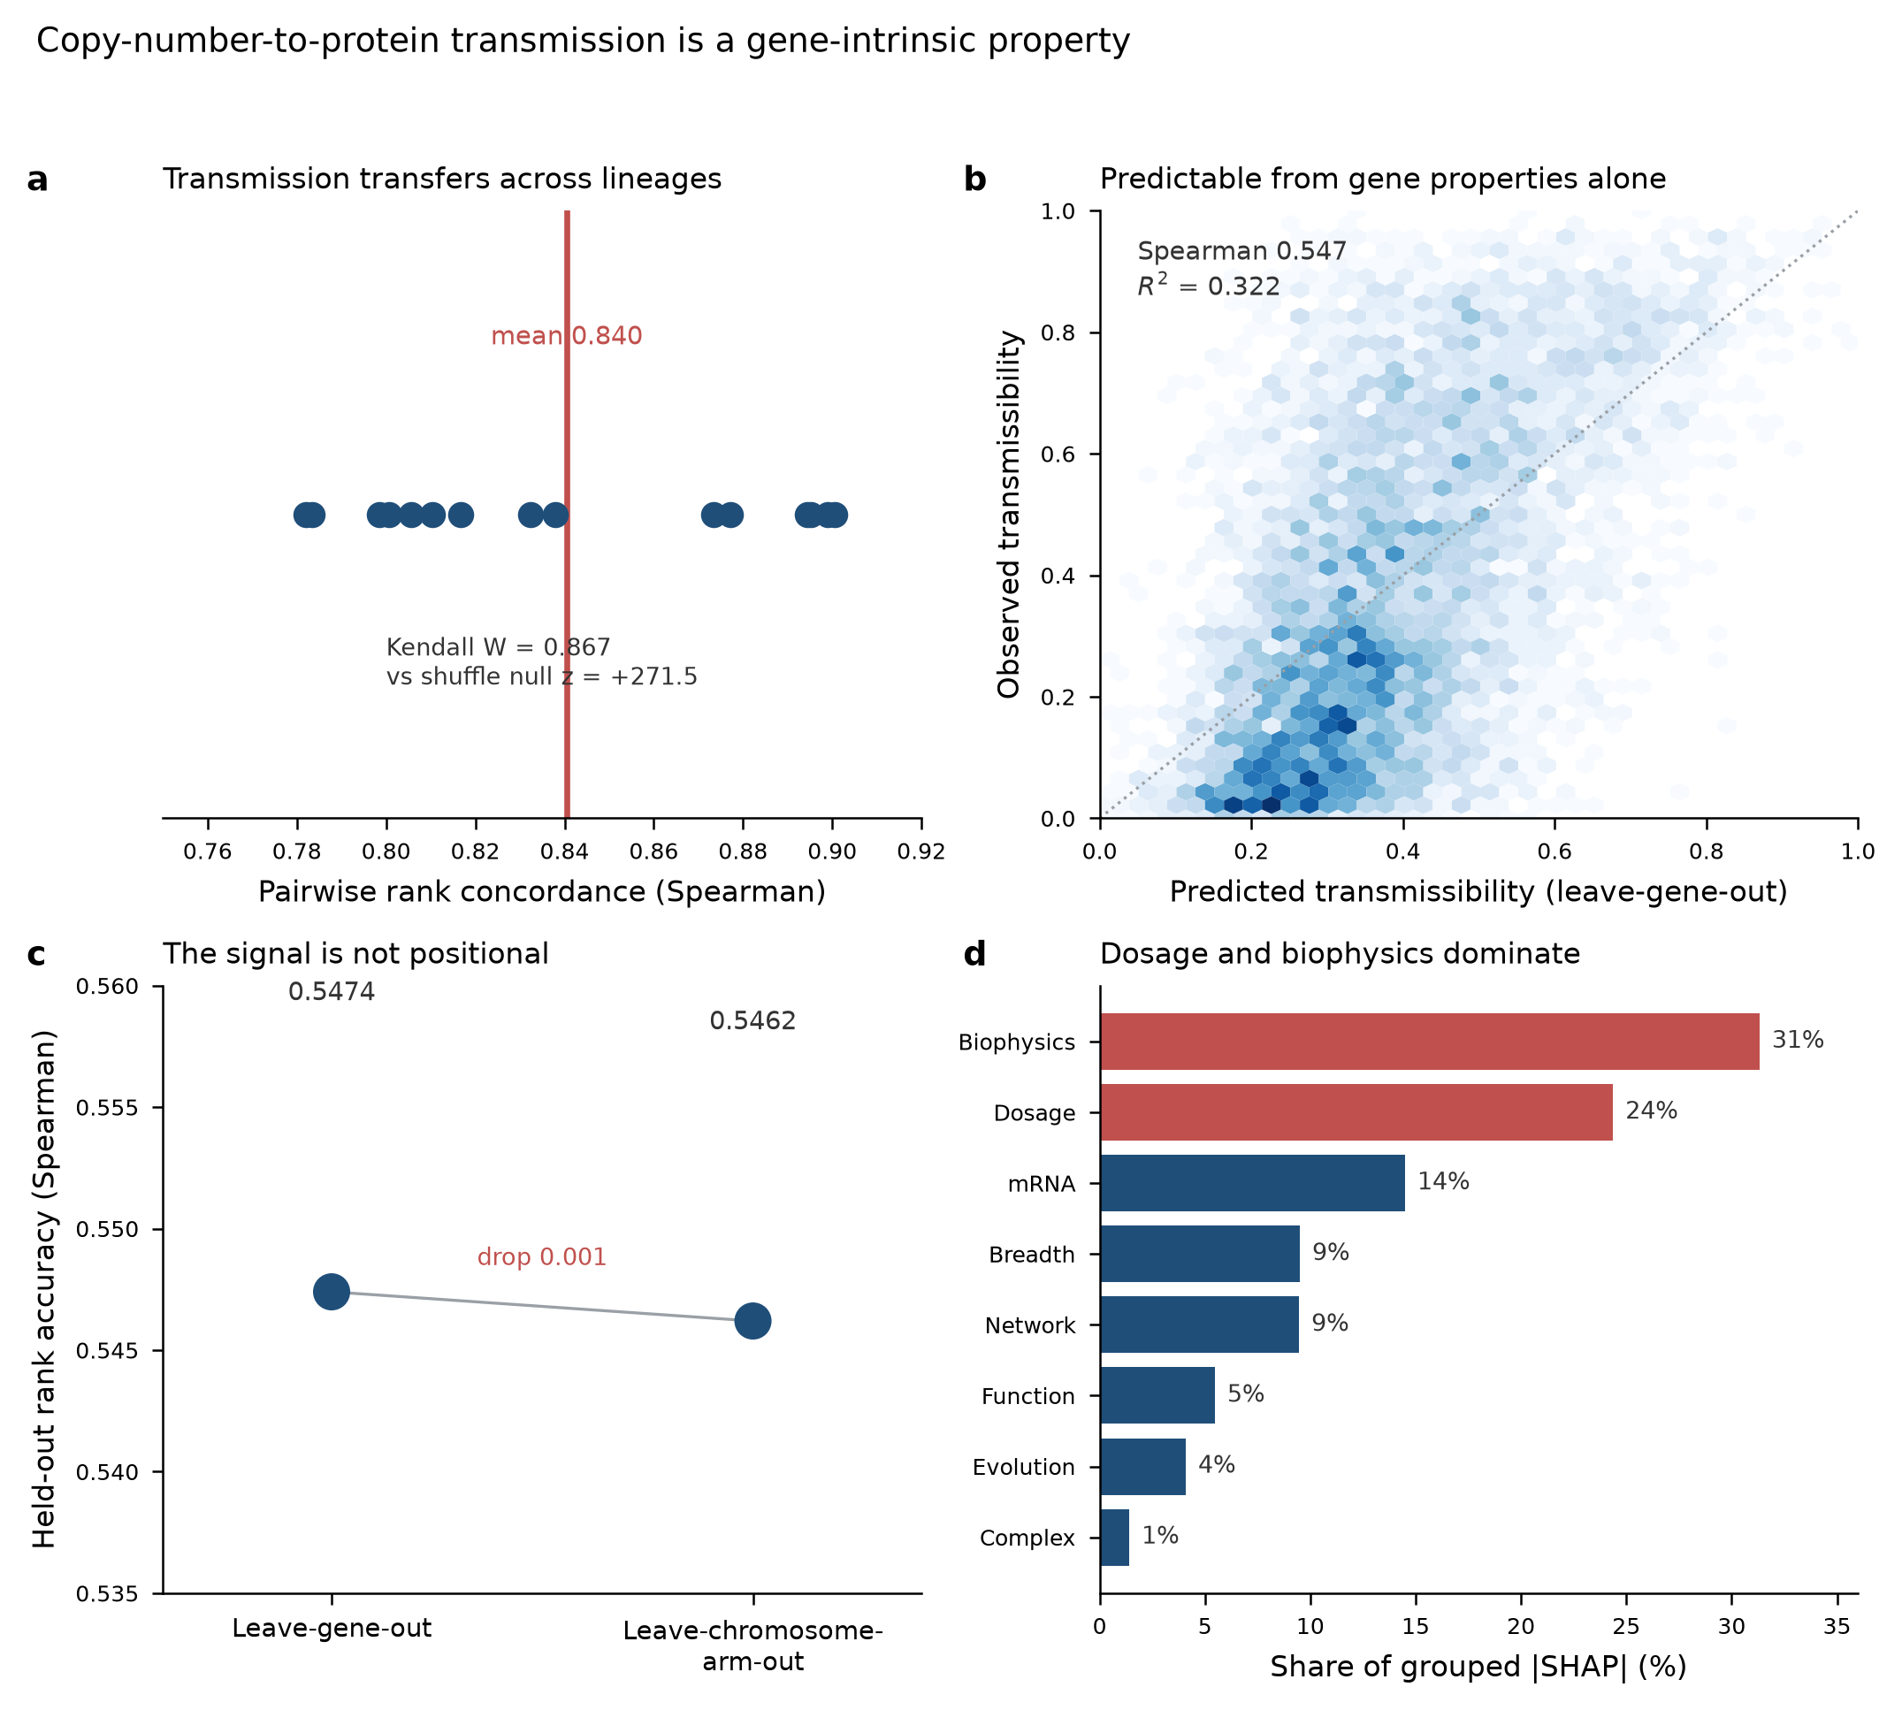
Figure 18. Copy-number-to-protein transmission is a gene-intrinsic property: (a) it transfers across lineages, (b) it is predictable from gene properties alone, (c) it is not positional, and (d) dosage and biophysics dominate the mechanism.
Table 6. Cross-lineage transmission stability (representative rows; full table 6,715 genes). Per-lineage transmission percentile, across-lineage SD, stability ratio, and stability/context flags.
gene | mean_pct | across_sd | stability_ratio | is_stable | is_context_dependent
GATM | 0.397 | 0.452 | 8.050 | False | True
DSP | 0.736 | 0.415 | 9.562 | False | True
KRT17 | 0.491 | 0.406 | 9.654 | False | True
KRT7 | 0.456 | 0.403 | 9.733 | False | True
AGR2 | 0.508 | 0.402 | 11.394 | False | True
COL1A1 | 0.675 | 0.400 | 5.706 | False | True
ERBB2 | 0.528 | 0.383 | 6.522 | False | True
SERPINE2 | 0.506 | 0.379 | 5.523 | False | True
OLFM4 | 0.260 | 0.379 | 6.386 | False | True
MAPT | 0.195 | 0.377 | 34.876 | False | True
CRYAB | 0.458 | 0.376 | 7.396 | False | True
KRT19 | 0.749 | 0.376 | 12.242 | False | True

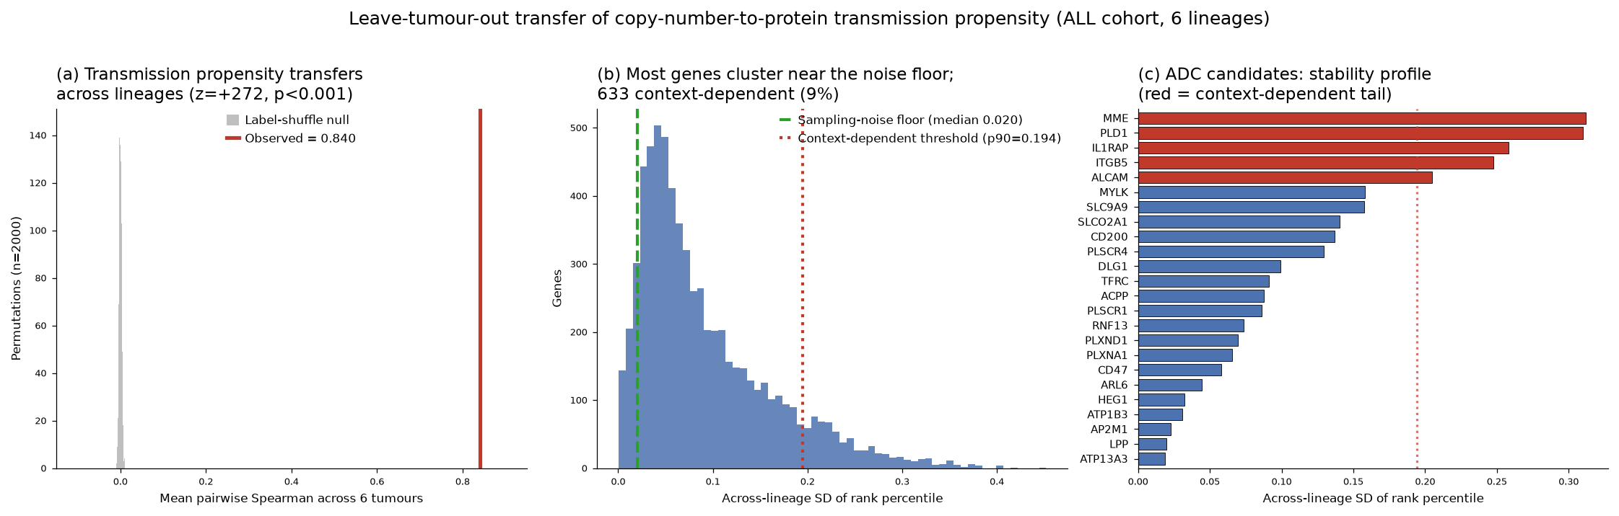
Figure 4. Cross-lineage transmission stability. Genes ranked by across-lineage variability; the context-dependent tail is highlighted.
3.3 Transmission is predictable from gene properties alone
If transmission is gene-intrinsic, it should be predictable from properties of the gene measured independently of any proteomics. Using only external features (dosage sensitivity, protein biophysics, mRNA, evolution, complex membership, network centrality, expression breadth) and a leave-gene-out design, the predictor recovers the observed transmissibility at a rank correlation of 0.547 and an R-squared of 0.322 (Figure 18b; Figure 7; Table 14). No protein-derived feature enters the predictor; the outcome is the protein-derived quantity. This is the strongest form of the gene-intrinsic claim: a gene's coupling can be anticipated before its protein is measured. The predictor is deliberately conservative on the one borderline feature group (expression breadth), whose removal lowers the correlation only to 0.518.
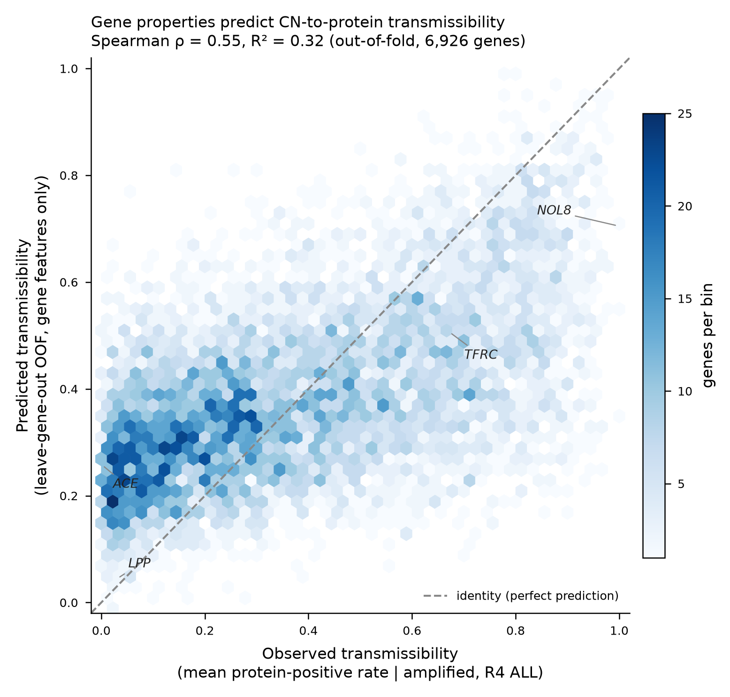
Figure 7. Predicted versus observed transmissibility (leave-gene-out). Rank correlation 0.547, R-squared 0.322.
Table 14. Transmissibility model performance: full model, model without the borderline breadth group, and permutation null.
config | cv | spearman | r2 | aupr | aupr_lift | perm_p | perm_z
all_features_incl_G8 | leave-gene-out 10-fold | 0.547 | 0.322 | 0.783 | 1.565 | nan | nan
excl_G8 | leave-gene-out 10-fold | 0.518 | 0.295 | 0.771 | 1.541 | nan | nan
permutation_null_B1000 | leave-gene-out 10-fold | 0.551 | nan | nan | nan | 0.001 | 35.000

3.4 The signal is not positional
Transmissibility could in principle be an artefact of genomic position, a gene inheriting its apparent coupling from strong co-amplified neighbours. A leave-chromosome-arm-out control, which holds out all arms in turn so no gene is predicted using a same-arm neighbour, gives a rank correlation of 0.5462 against the leave-gene-out 0.5474, a drop of 0.001 (Figure 18c; Table 15). The coupling is a property of the gene, not of its address. This control is what licenses treating the predictor's output as a gene-level prior rather than a positional summary.
Table 15. Positional control: leave-gene-out versus leave-chromosome-arm-out rank accuracy.
control | spearman | r2 | aupr | random_ap | n_scored
leave_gene_out | 0.547 | 0.322 | 0.783 | 0.500 | 6926
leave_chromosome_arm_out | 0.546 | 0.321 | 0.780 | 0.500 | 6926

3.5 The mechanism reconciles with post-transcriptional buffering
TreeSHAP attributes the prediction to protein biophysics and dosage-sensitivity first (biophysics 31 per cent, dosage 24 per cent of grouped attribution; mRNA 15 per cent, expression breadth and network 9 to 10 per cent each, evolution 4 per cent, complex 1 per cent) (Figure 18d; Figure 8; Table 16). Dosage-sensitivity dominates exactly as an independent buffering analysis predicts: on the residual readout of post-transcriptional buffering, dosage-sensitivity features add +0.104 in rank terms over baseline, almost three times the +0.036 contributed by complex membership, and once dosage annotations are present the additional value of complex membership collapses to +0.0019. The apparent essentiality sign is a coding convention, not a contradiction: the negative-is-essential encoding correlates -0.345 with transmissibility and the positive-is-essential encoding +0.375, both meaning that more essential genes transmit more, the same biology the buffering analysis reports at -0.29 to -0.33. The two analyses, built on different readouts, converge on gene dosage-sensitivity as the operative property.
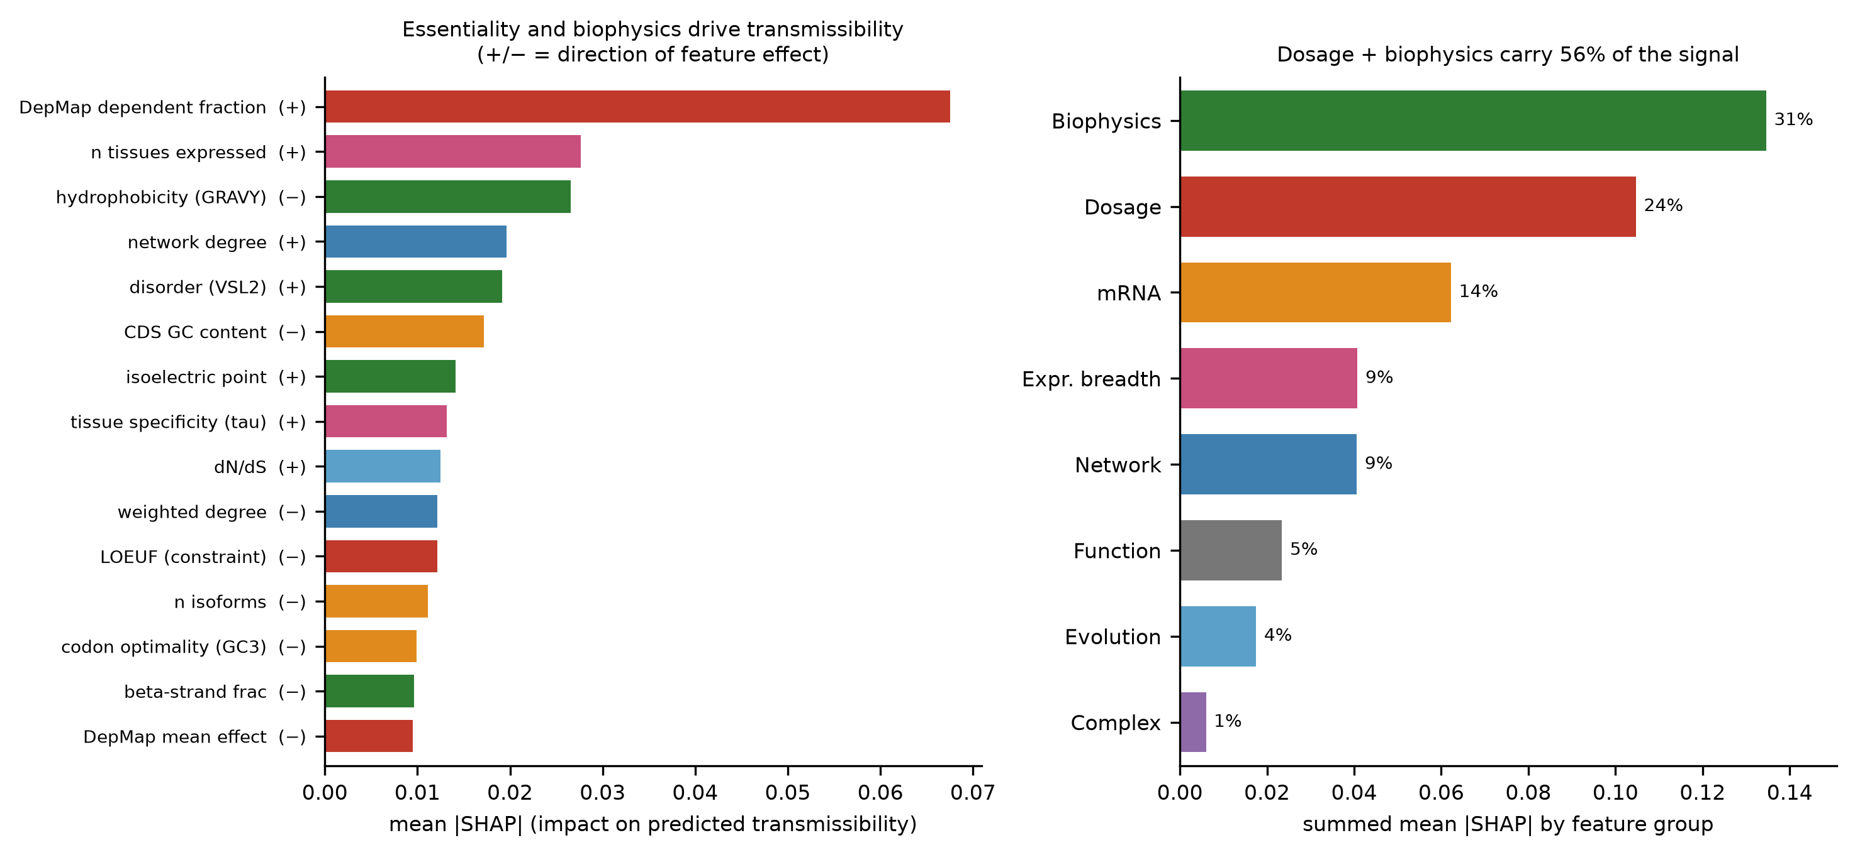
Figure 8. TreeSHAP feature attribution, grouped by feature family; dosage-sensitivity and biophysics dominate.
Table 16. TreeSHAP grouped feature-group attribution (top features shown; full table 47 rows).
feature | group | mean_abs_shap | shap_value_corr
dep_frac_dependent | G1 | 0.068 | 0.913
n_tissues_expressed | G8 | 0.028 | 0.525
gravy | G3 | 0.027 | -0.821
degree | G9 | 0.020 | 0.833
vsl2_disorder | G3 | 0.019 | 0.686
gc_content | G5 | 0.017 | -0.858
isoelectric_point | G3 | 0.014 | 0.329
tau | G8 | 0.013 | 0.042
dn_ds | G6 | 0.012 | 0.145
weighted_degree | G9 | 0.012 | -0.176
gnomad_LOEUF | G1 | 0.012 | -0.683
n_isoforms | G5 | 0.011 | -0.714

3.6 The network adds coverage, not a new mechanism
A protein-protein interaction network improves prediction in both cohorts when stacked on the incumbent model (STRING stack: ALL +0.057, 3Q +0.049 in area under the precision-recall curve; Table 18; Figure 15), and all improvements clear a 10,000-permutation label-shuffle null with the models held fixed (Table 20). But once the network is restricted to the genes the incumbent KEGG neighbourhood already covers, the advantage nearly vanishes (ALL +0.004; 3Q -0.015, no evidence of improvement). The relationship is monotonic in coverage: the sparser the network, the more the swap arms lose, and the weakest network (OmniPath, 43 to 46 per cent coverage) loses outright (Table 20; Figure 17; Table 23). The network helps by widening the gene set for which any neighbourhood feature can be computed, not because interaction topology is intrinsically more informative than pathway membership. This is itself a gene-intrinsic result: the coupling does not need the network; the network is a coverage device. The co-prediction structure within 3q is consistent with this reading, showing coherent complex-level co-regulation among 3q genes broadly (CORUM enrichment, 19 of 21 complexes at FDR below 0.05 in the 3Q cohort; Table 17) rather than a tight module among any small set of named genes.
Table 18. Network head-to-head: incumbent KEGG versus KEGG+STRING stack, STRING-swap, and coverage-matched arms.
cohort | arm | dedup_aupr | delta_vs_A | lift
ALL | A_incumbent_kegg | 0.646 | 0.000 | 1.623
ALL | B_kegg_plus_string | 0.703 | 0.057 | 1.766
ALL | C_string_swaps_kegg | 0.684 | 0.037 | 1.717
ALL | Cprime_string_coverage_matched | 0.650 | 0.004 | 1.632
3Q | A_incumbent_kegg | 0.751 | 0.000 | 1.793
3Q | B_kegg_plus_string | 0.800 | 0.049 | 1.909
3Q | C_string_swaps_kegg | 0.766 | 0.015 | 1.829
3Q | Cprime_string_coverage_matched | 0.737 | -0.015 | 1.759
3Q | Cprime2_both_restricted | 0.722 | -0.030 | 1.722

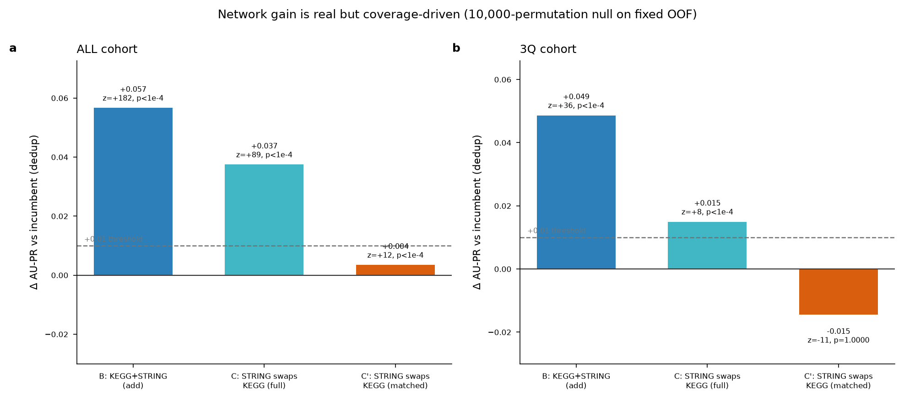
Figure 15. Network head-to-head AU-PR deltas versus the incumbent KEGG model, both cohorts.
Table 20. Network robustness across three networks and two confidence thresholds.
analysis | network | cohort | variant | delta_vs_A | z | p_value | p_display | coverage
permutation_null_10k | STRING700 | ALL | B_stack | 0.057 | 182.0 | 0.000 | p<1e-4 | nan
permutation_null_10k | STRING700 | ALL | C_swap | 0.037 | 88.800 | 0.000 | p<1e-4 | nan
permutation_null_10k | STRING700 | ALL | Cprime_matched | 0.004 | 11.800 | 0.000 | p<1e-4 | nan
permutation_null_10k | STRING700 | 3Q | B_stack | 0.049 | 35.800 | 0.000 | p<1e-4 | nan
permutation_null_10k | STRING700 | 3Q | C_swap | 0.015 | 8.400 | 0.000 | p<1e-4 | nan
permutation_null_10k | STRING700 | 3Q | Cprime_matched | -0.015 | -10.800 | 1.000 | p=1.0000 | nan
network_variant_robustness | STRING700 | ALL | B_stack | 0.057 | nan | nan | nan | 0.912
network_variant_robustness | STRING700 | ALL | C_swap | 0.037 | nan | nan | nan | 0.912
network_variant_robustness | STRING700 | ALL | Cprime_matched | 0.004 | nan | nan | nan | 0.912
network_variant_robustness | STRING700 | 3Q | B_stack | 0.049 | nan | nan | nan | 0.900
network_variant_robustness | STRING700 | 3Q | C_swap | 0.015 | nan | nan | nan | 0.900
network_variant_robustness | STRING700 | 3Q | Cprime_matched | -0.015 | nan | nan | nan | 0.900
network_variant_robustness | STRING900 | ALL | B_stack | 0.051 | nan | nan | nan | 0.770
network_variant_robustness | STRING900 | ALL | C_swap | 0.030 | nan | nan | nan | 0.770
network_variant_robustness | STRING900 | ALL | Cprime_matched | 0.002 | nan | nan | nan | 0.770
network_variant_robustness | STRING900 | 3Q | B_stack | 0.042 | nan | nan | nan | 0.801
network_variant_robustness | STRING900 | 3Q | C_swap | 0.041 | nan | nan | nan | 0.801
network_variant_robustness | STRING900 | 3Q | Cprime_matched | -0.028 | nan | nan | nan | 0.801
network_variant_robustness | OmniPath | ALL | B_stack | 0.026 | nan | nan | nan | 0.430
network_variant_robustness | OmniPath | ALL | C_swap | -0.018 | nan | nan | nan | 0.430
network_variant_robustness | OmniPath | ALL | Cprime_matched | -0.037 | nan | nan | nan | 0.430
network_variant_robustness | OmniPath | 3Q | B_stack | 0.017 | nan | nan | nan | 0.462
network_variant_robustness | OmniPath | 3Q | C_swap | -0.033 | nan | nan | nan | 0.462
network_variant_robustness | OmniPath | 3Q | Cprime_matched | -0.076 | nan | nan | nan | 0.462

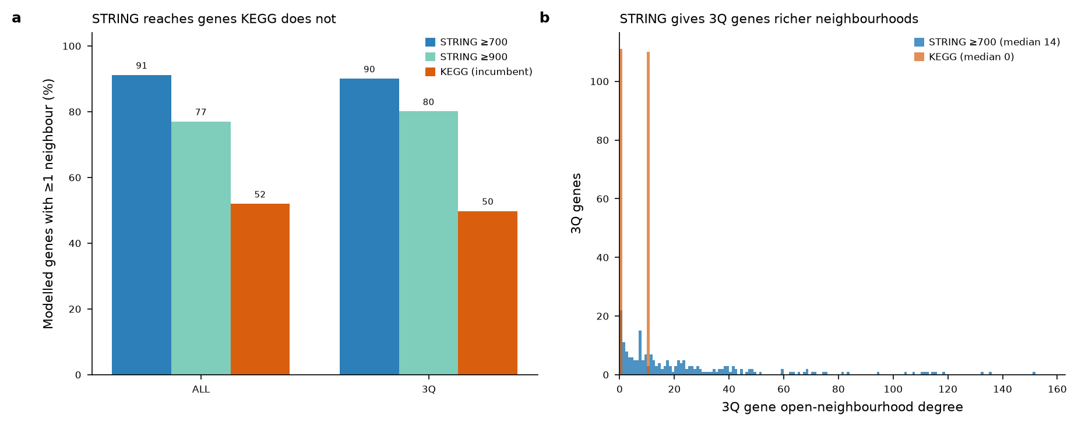
Figure 17. Network coverage of the modelled genes as a function of network and confidence threshold.
Table 23. Network coverage of the modelled gene set by KEGG, STRING (two thresholds) and OmniPath.
cohort | n_modelled | string700_covered | string700_frac | string900_covered | string900_frac | kegg_covered | kegg_frac
ALL | 6926 | 6314 | 0.912 | 5335 | 0.770 | 3599 | 0.520
3Q | 221 | 199 | 0.900 | 177 | 0.801 | 110 | 0.498

Table 17. Five-gene co-prediction support in the 3Q cohort.
gene | in_top100_matrices | tumours_present | top_copred_partners | copred_with_other_query_genes | supports_tight_cluster_claim
ACTL6A | 0/6 | NONE | nan | none (no two query genes co-occur in any top-100) | NO
TBL1XR1 | 5/6 | CCRCC,LSCC,LUAD,PDA,UCEC | KDM3A (1.00); SNRNP200 (1.00); PRPF8 (1.00); RIF1 (1.00); MSH6 (1.00); MCM4 (1.00) | none (no two query genes co-occur in any top-100) | NO
POLR2H | 0/6 | NONE | nan | none (no two query genes co-occur in any top-100) | NO
FNDC3B | 0/6 | NONE | nan | none (no two query genes co-occur in any top-100) | NO
NMD3 | 0/6 | NONE | nan | none (no two query genes co-occur in any top-100) | NO

3.7 The join between the prior and the transfer result
The transmissibility predictor and the transfer experiment measure two different quantities and must not be conflated. The predictor estimates a gene's average transmission across the pan-cancer cohort; the transfer experiment measures the variance of that transmission across lineages. A gene can therefore be high on average yet lineage-unstable, with no inconsistency between the two results. ITGB5 is the worked example: the predictor ranks it high (percentile 0.71), while the transfer experiment places it in the context-dependent tail (stability ratio 6.5). Both readings are correct; they answer different questions, and a target-selection argument needs both.
4. Application: antibody-drug conjugate target selection in 3q-amplified non-small-cell lung cancer
The four evidence lines are not an end in themselves; they are the filter that turns a ranked list of amplified surface proteins into a defensible shortlist. Each of the 24 hardened 3q surface candidates is scored on five orthogonal axes at once (Table 26): the gene-intrinsic transmissibility prior, the observed model transmission, network isolation, transfer context-dependence, and buffering or essentiality liability.
Table 26. Consolidated antibody-drug conjugate candidate table: 24 surface candidates scored on five orthogonal axes with the corroboration-guard verdict.
gene | predicted_percentile | agreement | mean_transmission_prob | network_isolated | transfer_context_dependent | transfer_stability_ratio | essentiality_toxicity_flag | dep_mean_effect | consolidated_verdict
ATP13A3 | 0.743 | both_high | 0.693 | True | False | 2.861 | False | -0.019 | CLEAN LEAD
ATP1B3 | 0.677 | both_high | 0.569 | True | False | 4.855 | False | -0.400 | CLEAN LEAD
PLSCR1 | 0.599 | both_high | 0.493 | False | False | 3.830 | False | 0.075 | CLEAN LEAD
TFRC | 0.780 | both_high | 0.744 | False | False | 5.282 | True | -0.940 | CAVEATED (prior-high): essentiality-toxicity
ITGB5 | 0.709 | both_high | 0.653 | False | True | 6.500 | False | -0.477 | CAVEATED (prior-high): lineage-risk
AP2M1 | 0.675 | intrinsic_only | 0.103 | False | False | 8.312 | True | -0.807 | CAVEATED: essentiality-toxicity
CD47 | 0.647 | intrinsic_only | 0.258 | False | False | 3.038 | False | 0.036 | candidate
RNF13 | 0.554 | intrinsic_only | 0.545 | True | False | 4.718 | False | 0.016 | candidate
ACPP | 0.473 | both_low | 0.166 | True | False | 4.665 | False | nan | candidate
PLXND1 | 0.450 | both_low | 0.512 | False | False | 2.417 | False | -0.016 | CAVEATED: buffering
SLC9A9 | 0.443 | both_low | 0.228 | True | False | 5.783 | False | 0.042 | candidate
PLD1 | 0.421 | context_boosted | 0.552 | True | True | 13.402 | False | -0.023 | CAVEATED: lineage-risk
ARL6 | 0.373 | both_low | 0.102 | True | False | 4.561 | False | 0.109 | candidate
HEG1 | 0.286 | both_low | 0.111 | False | False | 4.526 | False | 0.122 | candidate
ALCAM | 0.227 | both_low | 0.544 | True | True | 5.299 | False | -0.041 | CAVEATED: lineage-risk
DLG1 | 0.187 | both_low | 0.396 | True | False | 3.356 | False | 0.022 | candidate
SLCO2A1 | 0.155 | both_low | 0.205 | True | False | 2.965 | False | -0.107 | candidate
PLSCR4 | 0.152 | both_low | 0.230 | True | False | 4.649 | False | 0.122 | candidate
IL1RAP | 0.130 | context_boosted | 0.557 | True | True | 6.626 | False | 0.050 | CAVEATED: lineage-risk
CD200 | 0.118 | both_low | 0.144 | False | False | 5.043 | False | 0.074 | candidate
MME | 0.100 | both_low | 0.105 | False | True | 9.842 | False | -0.007 | CAVEATED: lineage-risk
MYLK | 0.055 | both_low | 0.166 | False | False | 3.808 | False | 0.095 | candidate
PLXNA1 | 0.039 | context_boosted | 0.473 | False | False | 1.945 | False | 0.002 | candidate
LPP | 0.003 | both_low | 0.684 | False | False | 4.383 | False | 0.060 | CAVEATED: buffering

The prior is neither better nor worse on the surface proteins that matter here than it is genome-wide: rank accuracy on the 24 candidates is 0.553, essentially identical to the whole-atlas 0.547. That equivalence is important because it means the honest bound carries over directly. An R-squared of 0.322 leaves roughly two thirds of per-gene transmission variance unexplained by gene properties, and for 6 of the 24 candidates that residual flips the call relative to the prior. The prior is a gene-intrinsic prior over the genome, not a per-gene oracle.
AP2M1 is the clearest single illustration of that limit, and it is more convincing than the caveat stated in the abstract because it is an error kept in the table rather than removed from it. AP2M1 ranks high enough on the prior to be noticed (predicted percentile 0.68) and is an essential gene, yet its observed transmission is only 0.10: the prior over-predicts it substantially. A per-gene oracle would not do this; a gene-intrinsic prior that captures average behaviour and misses gene-specific regulation will, and pointing to a kept-in over-prediction is the most direct evidence of the bound.
Applying the corroboration guard, of the five candidates the prior labels high on both predicted and observed transmission, three survive every axis: ATP13A3, ATP1B3 and PLSCR1 (Table 26; Figure 16). These carry none of the five flags. The word for them is proportionate: they are the leads that survive every axis, not validated targets. Consistent with the honest bound, these are transcript-level and prediction-level calls, not surface-protein measurements, and about two thirds of per-gene variance remains unexplained; each would require direct measurement of surface-protein abundance and tumour-versus-normal selectivity before it could be called a target.
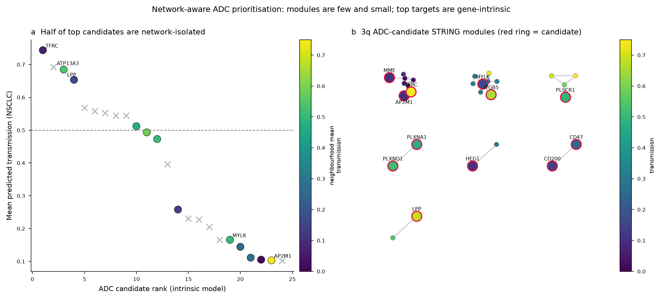
Figure 16. Network-aware ADC modules within the 3q surface set; twelve of 24 candidates are network-isolated.
The remaining two prior-high candidates are held back deliberately, each for a specific and different reason. TFRC has the highest predicted transmissibility of all 24 (percentile 0.78) and the highest observed transmission (0.74); it is genuinely the strongest transmitter in the set. But its DepMap dependency effect of -0.94 marks it as broadly essential, an on-target-toxicity liability that narrows its therapeutic window regardless of how well it transmits. ITGB5 is corroborated high by the prior (percentile 0.71) yet sits in the context-dependent transfer tail (stability ratio 6.5): its high pan-cancer rank is not a promise of stability in any given lineage. Corroboration by the prior is not the same as clean, and the guard exists precisely to stop a strong transmitter being silently re-promoted to a lead. Twelve further candidates are network-isolated among 3q genes, which reinforces rather than weakens their gene-intrinsic reading: their transmission is not a neighbourhood effect. The honest translational position is three leads that survive every filter, with TFRC and ITGB5 named and held back, not quietly dropped or quietly restored.
5. Discussion
The result of this work is a single claim with a translational corollary. The claim is that copy-number-to-protein transmission is a stable, gene-intrinsic, positional-free property: it transfers across lineages, it is predictable from gene biology measured without any proteomics, it survives holding out whole chromosome arms, and it reconciles mechanistically with post-transcriptional buffering through gene dosage-sensitivity. The four experiments approach the claim from independent directions and converge, which is stronger evidence than any one of them alone, because their failure modes do not overlap: transfer could hold while prediction failed, prediction could hold on positional confounding, and none of these would survive if the signal were a cohort-specific artefact.
The corollary is that a transmission-aware prior is most useful exactly where copy number is blind. In the highly amplified 3q region, where many genes are co-amplified and copy number cannot discriminate protein outcome, a gene-intrinsic prior over transmission adds real information, and gating it on surface localisation and on four orthogonal liability axes yields a shortlist that is defensible on its face. Three surface leads survive every axis; two strong transmitters are held back on named, specific liabilities.
The bounds are as important as the claim, and stated plainly. First, the prior explains about a third of per-gene transmission variance, so it ranks the genome well but mispredicts individual genes, AP2M1 being the kept-in example; the leads are prediction-level and transcript-level calls, not surface-protein measurements, and the next step for any lead is direct protein-level and selectivity measurement. Second, the network result is deliberately deflationary: interaction topology does not add a mechanism beyond gene coverage, and the analysis does not pursue network biology as an explanation. Third, the co-prediction structure within 3q reflects complex-level co-regulation among 3q genes broadly rather than a tight module among any small named set; the co-prediction score measures concordance of model outputs, which need not imply functional co-regulation, and genes may share feature profiles without being mechanistically linked. Where individual 3q genes such as ACTL6A have been discussed as exemplars of chromatin-related co-amplification, that chromatin work is parallel and collaborative to this thesis and is not claimed as a result of it; within the present analysis, only the transmission and co-prediction structure is load-bearing, and only TBL1XR1 among the frequently named 3q genes behaves as a consistent co-prediction hub, coupling with replication and chromatin machinery rather than with a specific 3q trio.
The framework is deliberately leakage-safe and reproducible: the outcome is never a predictor, splits are fixed and grouped by case, neighbourhood features are recomputed per fold from training cases only and verified to have zero train-test overlap, metrics are deduplicated, and the random baseline is reported beside every score. Within those constraints, the contribution is an attenuation-aware account of which amplifications reach the protein, and a principled, honestly bounded way to turn that account into antibody-drug conjugate target hypotheses where the amplification signal alone cannot.
References
1. Beroukhim2010. Nature (2010). DOI: 10.1038/nature08822. PMID: 20164920.
2. Zack2013. Nature Genetics (2013). DOI: 10.1038/ng.2760. PMID: 24071852.
3. SanchezVega2018. Cell (2018). DOI: 10.1016/j.cell.2018.03.035. PMID: 29625050.
4. Goncalves2017. Cell Systems (2017). DOI: 10.1016/j.cels.2017.08.013. PMID: 29032074.
5. Stingele2012. Molecular Systems Biology (2012). DOI: 10.1038/msb.2012.40. PMID: 22968442.
6. Sousa2019. Molecular &amp; Cellular Proteomics (2019). DOI: 10.1074/mcp.RA118.001280. PMID: 31239291.
7. Vogel2012. Nature Reviews Genetics (2012). DOI: 10.1038/nrg3185. PMID: 22411467.
8. Gillette2020. Cell (2020). DOI: 10.1016/j.cell.2020.06.013. PMID: 32649874.
9. Li2023. Cancer Cell (2023). DOI: 10.1016/j.ccell.2023.06.009. PMID: 37582339.
10. Heller2026. Molecular Systems Biology (2026). DOI: 10.1038/s44320-026-00187-9. PMID: 41571838.
11. McCaughan2010. American Journal of Respiratory and Critical Care Medicine (2010). DOI: 10.1164/rccm.201001-0005OC. PMID: 20299530.
12. Jeon2023. Thoracic Cancer (2023). DOI: 10.1111/1759-7714.15045. PMID: 37469197.
13. Nelson2023. Annual Review of Medicine (2024). DOI: 10.1146/annurev-med-071322-065903. PMID: 37758237.
14. Gazzah2022. Annals of Oncology (2022). DOI: 10.1016/j.annonc.2021.12.012. PMID: 35026412.

