# Data Management for Advanced Research: Managing Your Data

## Today’s Topics

* UCLA Library Data Science Center / Social Science Data Archive
* The role of data in your research
* Reference and Data Discovery
* Resources, tools and support available to students at UCLA
* Publishing and Data Management Plans

## UCLA Library Data Science Center

### (formally: Social Science Data Archive)

### YRL 20136, 2nd floor

* Part of UCLA since 1961
* [About the Data Archive](https://www.library.ucla.edu/social-science-data-archive/about-data-archive)
* Bacame part of the library in 2014.
* Services available to all UCLA faculty and students
* Holdings include public opinion polls, census data, crime stats, political and social behavior, etc.

<https://www.library.ucla.edu/location/social-science-data-archive>

## Data Archive: Our services

* Reference: assist students to find and use data
* Data Management Plans
* Metadata
* Provide training: [Software/Library carpentry](https://software-carpentry.org/) / [Software Carpentry R-language](https://www.library.ucla.edu/events/software-carpentry-workshop-r-version)  
  
* Host events and lectures: [Data Archive News and Upcoming Events](https://www.library.ucla.edu/location/social-science-data-archive)

## Our Services and the Data Life Cycle

The Data Archive provides data services that are tied to the data life-cycle.*“Data archiving is a process, not an end state where data is simply turned over to a repository at the conclusion of a study. Rather, data archiving should begin early in a project and incorporate a schedule for depositing products over the course of a project’s life cycle and for the creation and preservation of accurate metadata, ensuring the usability of the research data itself. Such practices would incorporate archiving as part of the research method.” Preserving Research Data, Jacobs and Humphrey (2004)*

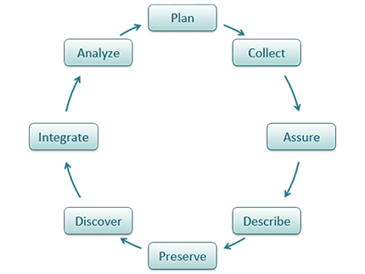

illustration: DatOne Data Life Cycle

##### [illustration: DatOne Data Life Cycle](https://www.dataone.org/data-life-cycle)

## Data Management Plans

A data management plan is a document that describes what you will do with your data *during* your research and *after* you complete your research.

## Required By:

* Funding Agencies
* Publishing
* Sharing and Archiving Data
* Reproducibility of Research
* Lastly, regardless of the requirements, good data management is an essential skill for researchers.

## Basic Elements of a Data Management Plan

* Data Description
* Format(s)
* Documentation
* Privacy and ownership
* Acess and sharing
* Cost

[ICPSR Handout] [NSF Handout]

## Getting Help with Data Management Plans

* Data Science Center / Social Science Data Archive
* Open Science Foundation: [Creating a data management plan (DMP)](http://help.osf.io/m/bestpractices/l/618674-creating-a-data-management-plan-dmp)
* ICPSR: [Data Management Plans](https://www.icpsr.umich.edu/icpsrweb/content/deposit/guide/chapter1.html)
* DMPTool: [DMPTool](https://dmptool.org/)

## DMPTool

#### [https://dmptool.org](https://dmptool.org/)

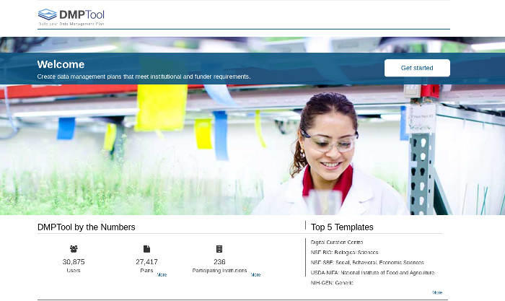

## Access and Sharing: Where to put data

* UCLA DataDen
* Dataverse
  + Data Science Center curated
  + Self-curated
  + Harvard Hosted
* OSF: Open Science Foundation
* ICPSR: Inter-university Consortium for Political and Social Research

## OSF : Open Science Foundation

#### <https://osf.io/>

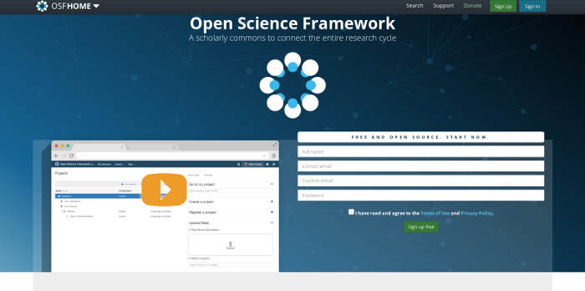

## Center for Open Science

#### <https://cos.io/>

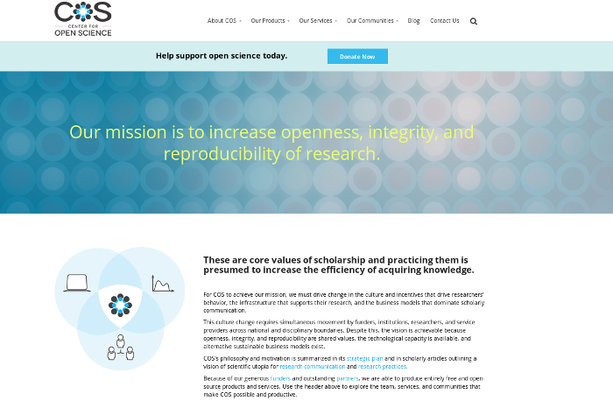

## Dataverse: Harvard Hosted

#### <https://dataverse.harvard.edu/>

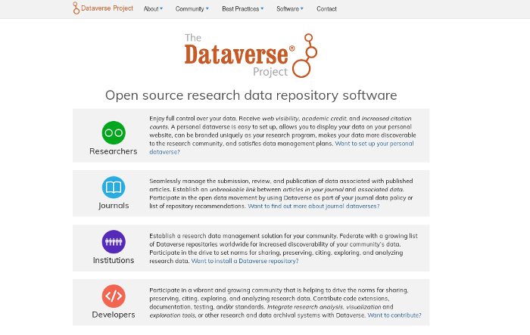

## UCLA DataDen

#### <https://dataden.library.ucla.edu/>

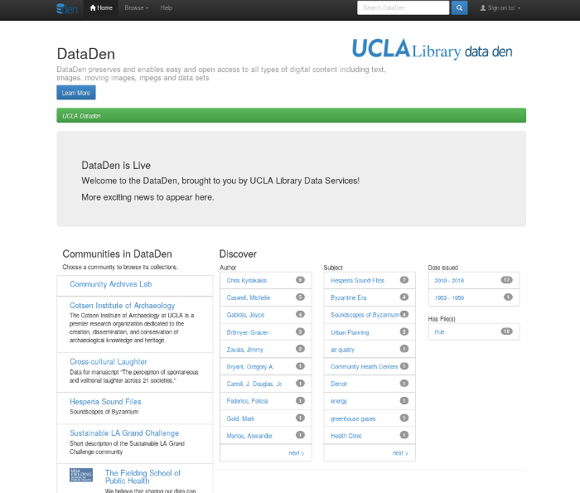

illustration: UCLA DataDen

## ICPSR Data Site

#### Inter-university Consortium for Political and Social Research [http://www.icpsr.umich.edu](http://www.icpsr.umich.edu/)

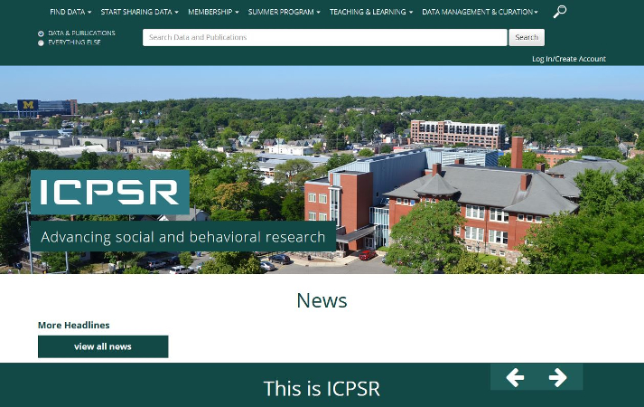

illustration: ICPSR

## Questions?

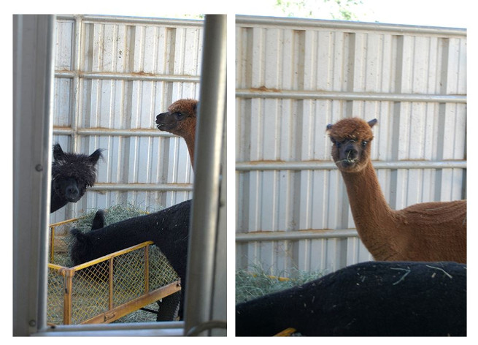

illustration: Questions

## Problems ?

## The Data Archive is here to help

YRL, 2nd Floor, Room 21536 [ucla-data-archive@googlegroups.com](mailto:ucla-data-archive@googlegroups.com) 310-825-0716 Tim Dennis, Director of the Data Archive Jamie Jamison, Collection Manager