Accessibility Report: Contrast Over Images/Gradients (Verification)
Date: 2026-08-03
“Contrast over images” item from the accessibility backlog: axe-core could not conclusively judge text-over-image/gradient backgrounds on ~half the routes (“incomplete” results), requiring a manual visual/computational check.

Method
- Built the production static export (yarn build) and served it locally so every route resolves independently (not an SPA fallback).
- Ran axe-core via Playwright, using Firefox as the browser engine, scoped to the color-contrast rule across all 22 routes.
- For every element axe marked “incomplete” (i.e., it couldn’t determine the background due to a gradient, pseudo-element, or overlapping element), we extracted the actual computed background/gradient colors and text color, then calculated the real WCAG contrast ratio by hand.
- Cross-checked results with screenshots.

Result: All text-over-gradient/image elements pass WCAG AA
Element | Location | Background | Text Color | Contrast Ratio | WCAG AA (4.5:1)
“California Latino Neighborhood Statistics” hero banner | Homepage | Gradient #005587 → #1B3F60 | White | 7.93:1 | ✅ Pass (exceeds AAA)
“Extreme Heat Days” / “PM2.5 Exposure” / “Asthma ER Visits” stat cards | Homepage | Same brand gradient | White | 7.93:1 | ✅ Pass (exceeds AAA)
“Extreme Heat” / “Air Pollution” legend chips | Homepage (county profile lookup) | Near-white pill #fcfcfc | Dark navy #003d57 | 11.34:1 | ✅ Pass
The legend chips were flagged by axe as “background gradient” but are actually solid near-white pills. The problem was that axe just couldn’t resolve the overlapping absolutely-positioned divs used for the shadow/border effect. Not an actual gradient-over-text case.

Screenshots
Hero banner (gradient background):

Figure 1. Hero banner with white text on blue gradient
Stat card (gradient background):
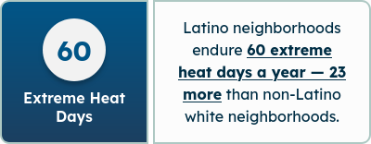
Figure 2. Stat card with white text on blue gradient
Legend chips (solid near-white background, flagged as gradient by mistake):
Figure 3. Legend chips with dark navy text on near-white pills
Conclusion: No contrast issues exist for text placed over images or gradients anywhere in the app. This backlog item can be closed.

False Positives (not gradient/image related)
Several routes (/home, /contact, /newsroom, /our-team, /technical-documentation, /additional-resources) showed “incomplete — background gradient” on plain black headings. These are placeholder/stub MDX pages with no gradient in their ancestor chain. This appears to be axe mis-attributing a nearby loading-spinner gradient. No real contrast risk, so safe to ignore, though these pages should be removed eventually since they aren’t used. (Real navigation goes to: /, /impact/research, /impact/newsroom, /impact/partners, /policy-toolkits, /faqs, /our-data, /about/our-team, /resource-directory; all served by their own dedicated page.js files with real content.)

Bonus Finding: Fixed
While running the tests, axe found a genuine, unrelated contrast violation on /our-data:
- 13 instances of white text on filter-tag/topic buttons using background colors #3c87c3 (Demographic Indicators) and #338f87 (Heat Exposure).
- Measured contrast: 3.85–3.87:1 — below the WCAG AA minimum of 4.5:1 for normal-size text.
Fix applied: Darkened the two failing colors slightly (same hue, minimal visual change) in src/app/our-data/page.js:
Category | Before | After | Contrast Before | Contrast After
Demographic Indicators | #3c87c3 | #3679b0 | 3.86:1 ❌ | 4.65:1 ✅
Heat Exposure | #338F87 | #2e817a | 3.87:1 ❌ | 4.63:1 ✅
All other category tag colors (Air Pollutants, Social Determinants of Health, Vulnerable Populations, Health Outcomes & Conditions, Environmental Hazards) were already passing and were left unchanged.
Verified with a rebuild + re-run of the axe color-contrast rule on /our-data: 0 violations (down from 13). Visual check confirms tags still read clearly and match the existing design language.
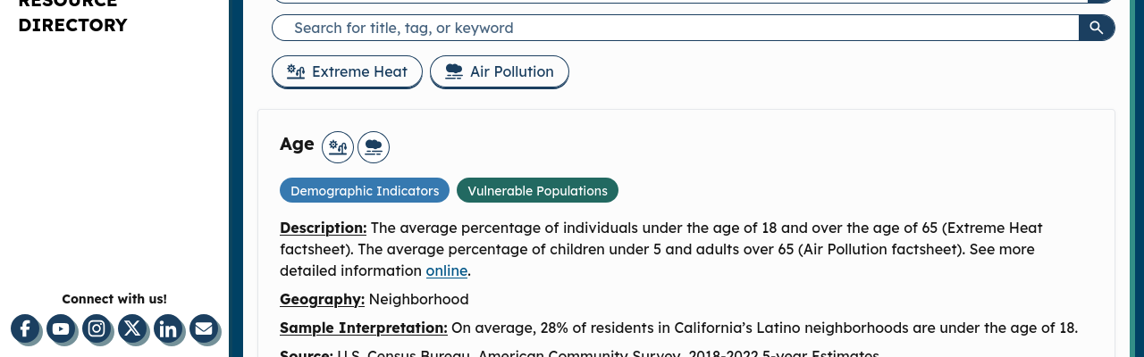
Figure 5. Our Data page tag pills after contrast fix

