## **Nintendo Labo Cardboard Construction Techniques**

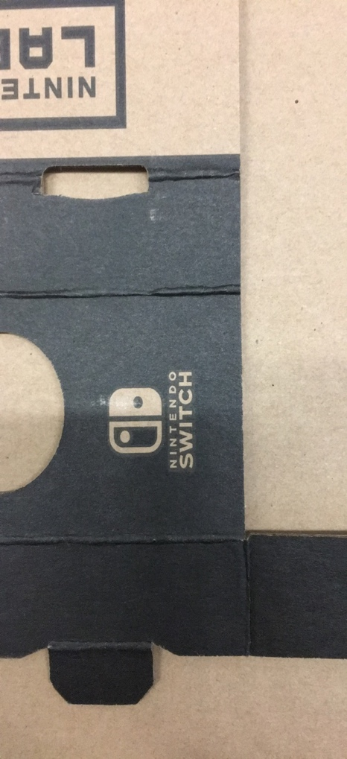

Figure 1: 6-sided tab extends from reverse trapezoidal indent. Curved slot is placed in center of edge. This ensures accurate fit.

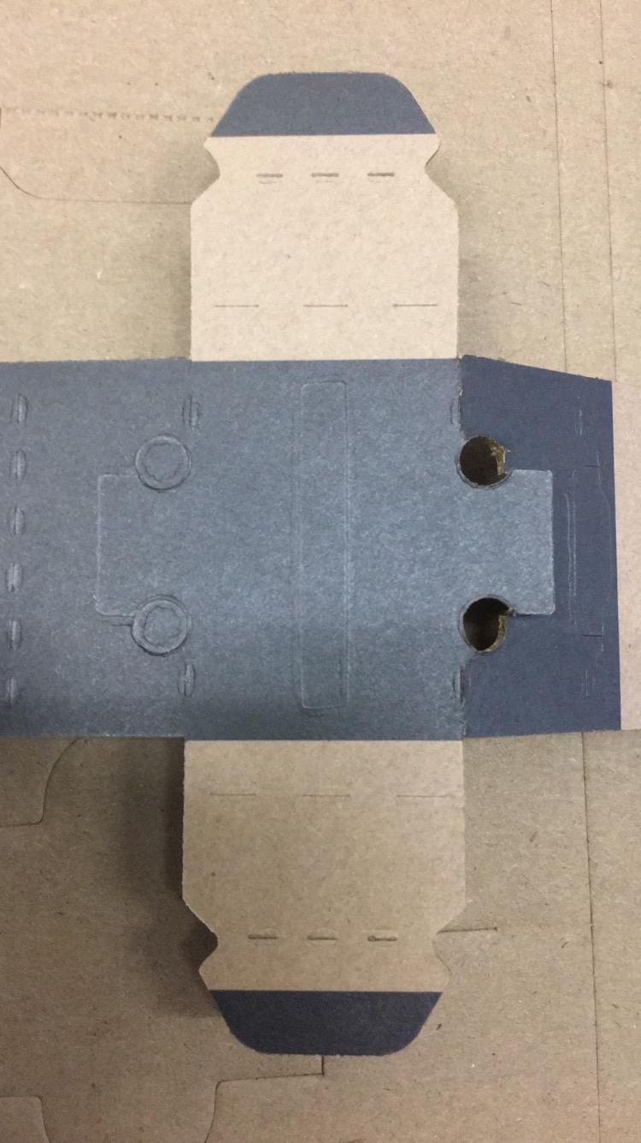

Figure 2: Locking tabs extend from trapezoidal feature. Slot has holes on both sides.

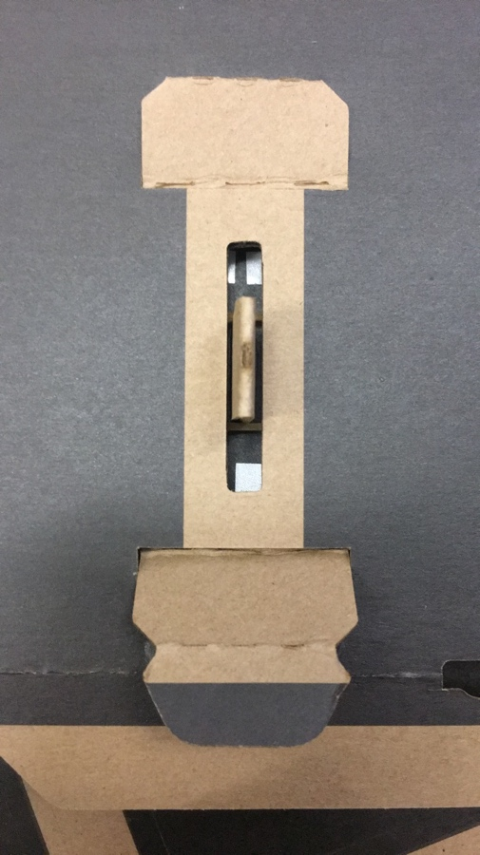

Figure 3: Locking tabs used in a reversed, flush mount of a rubber-band-switch mechanism. This is very secure.

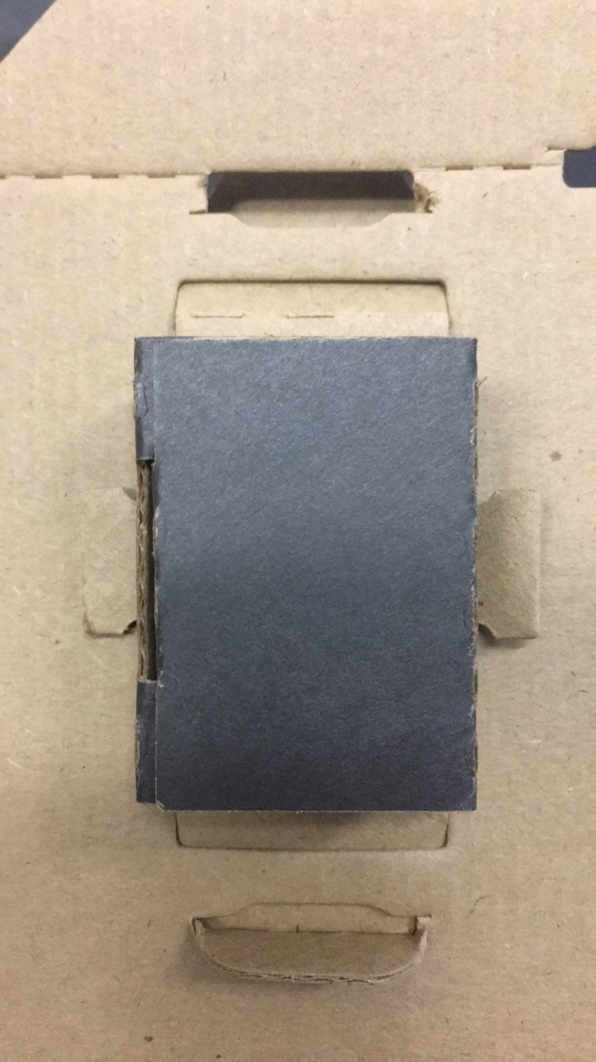

Figure 4: Backside of locking tabs used in reverse, flush mount.

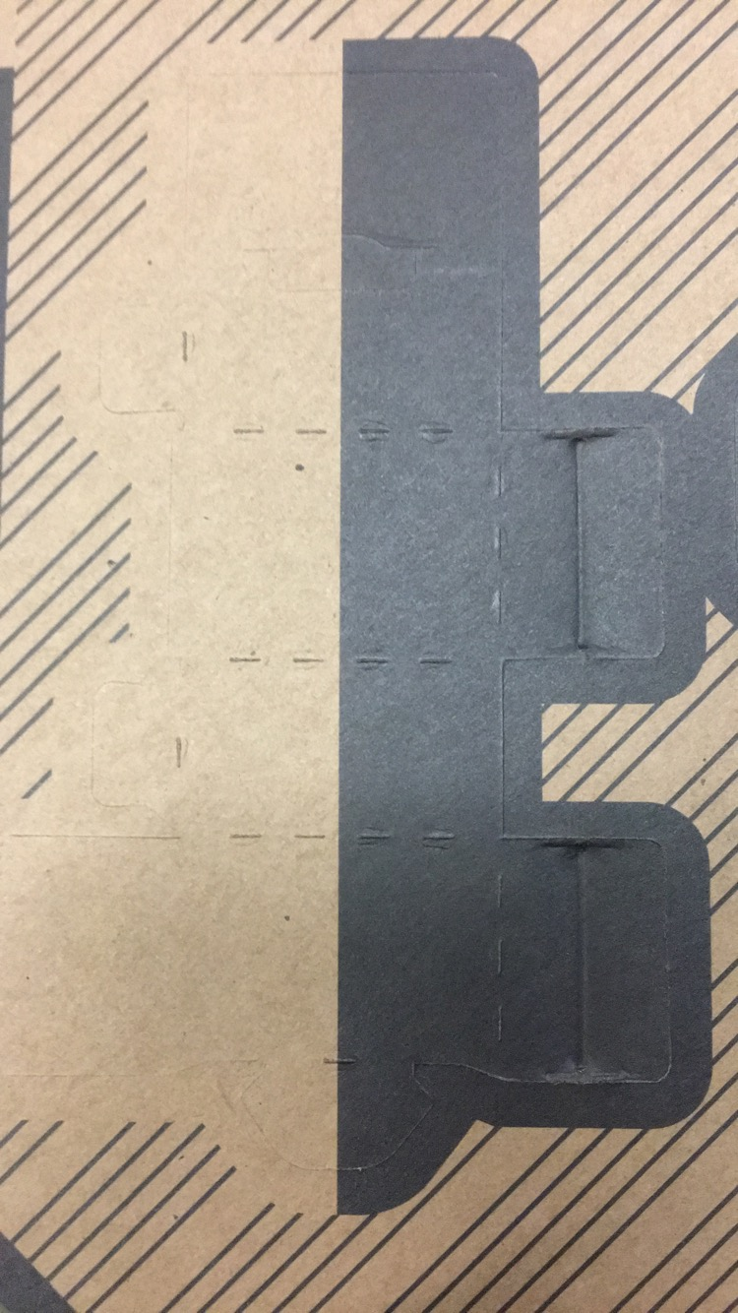

Figure 5: Indent pattern enable springy folds and/or extra thickness.

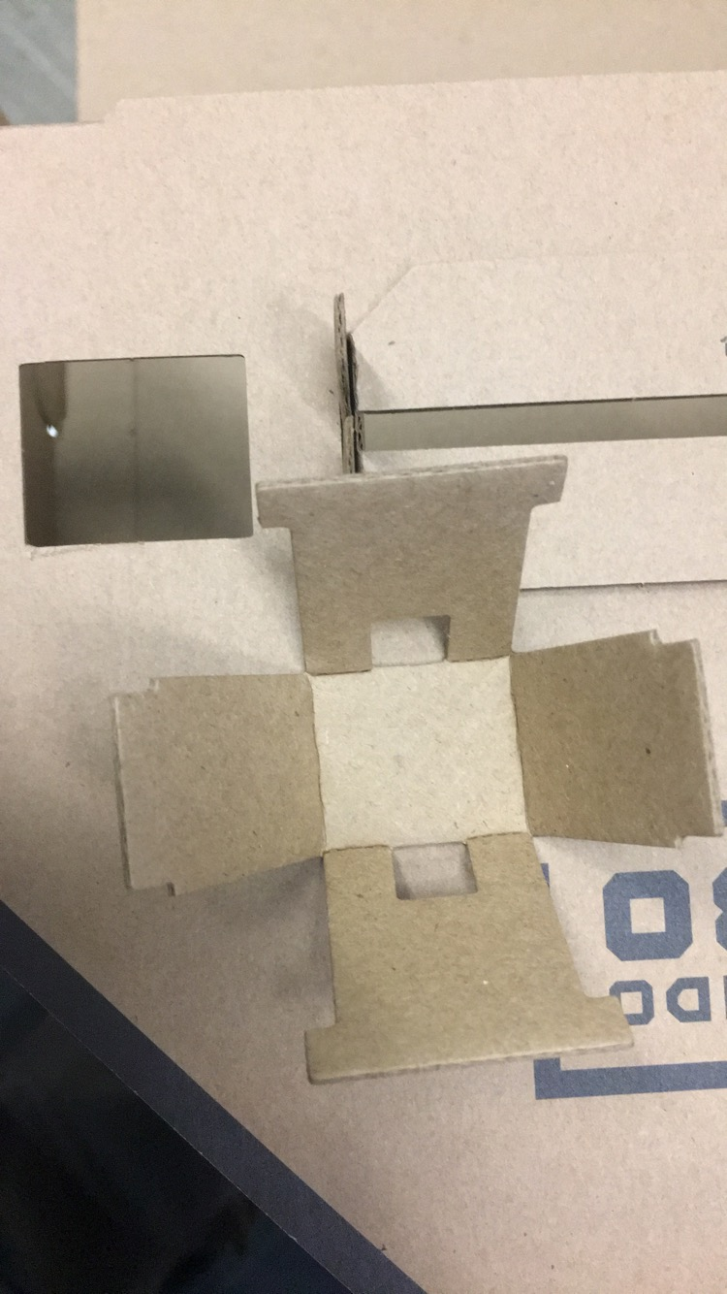

Figure 6: Component without fold-in tabs is held together by another component.

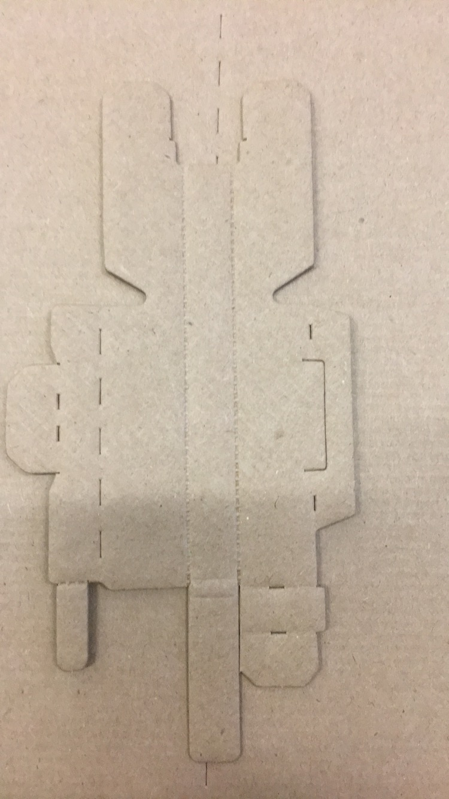

Figure 7: Varied perforation techniques are used. Dashed lines create the best folds but are less springy than dotty lines. Solid lines are cutouts. Perforation pattern is centered and does not continue to the edge.

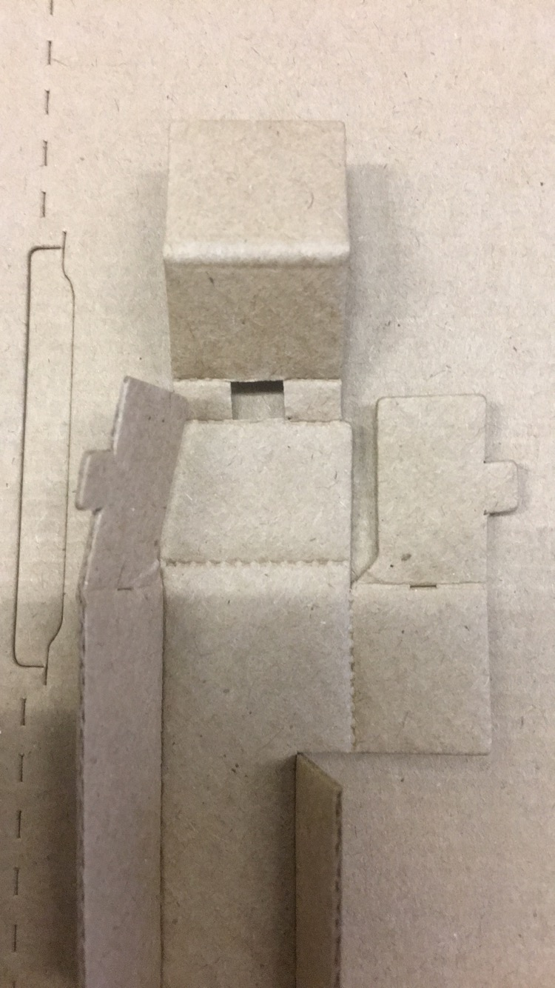

Figure 8: Space is left to carefully account for thickness of four layers of cardboard in a convex wrap-around fold.

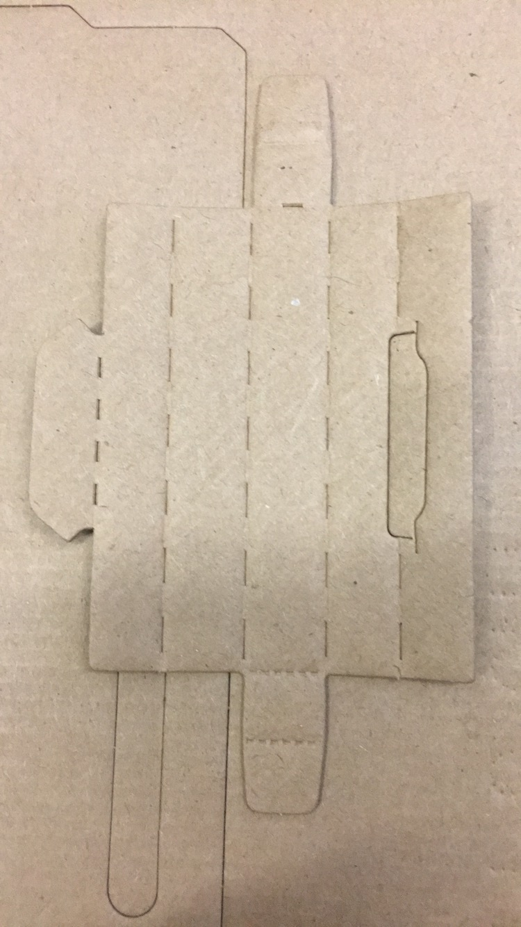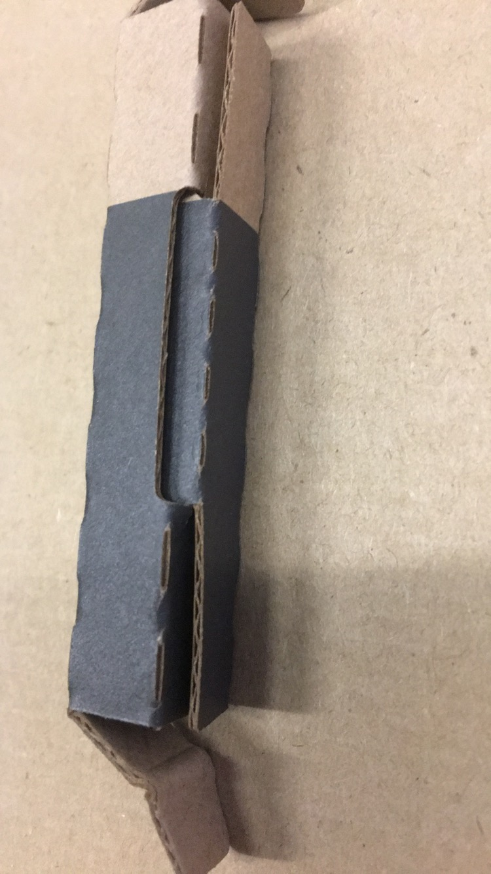

Figure 9: Locking tab is used with centered slot with side slits. Side slits on slots make it easier to assemble small pieces.

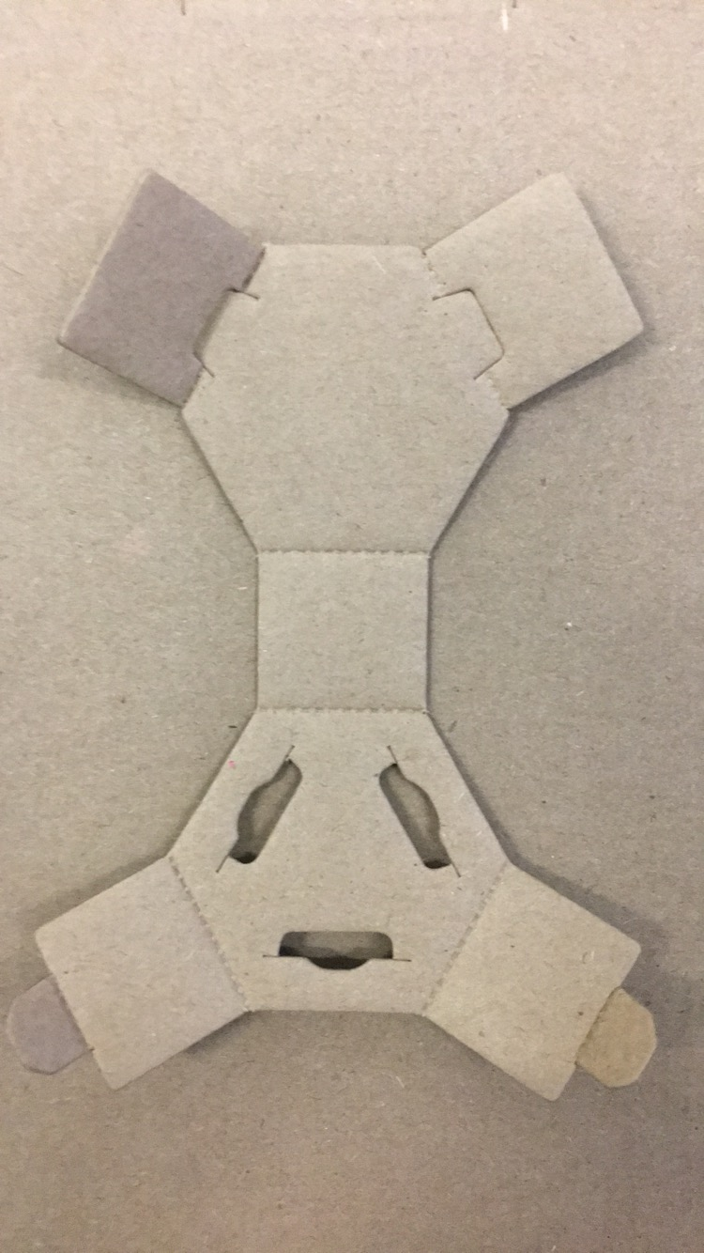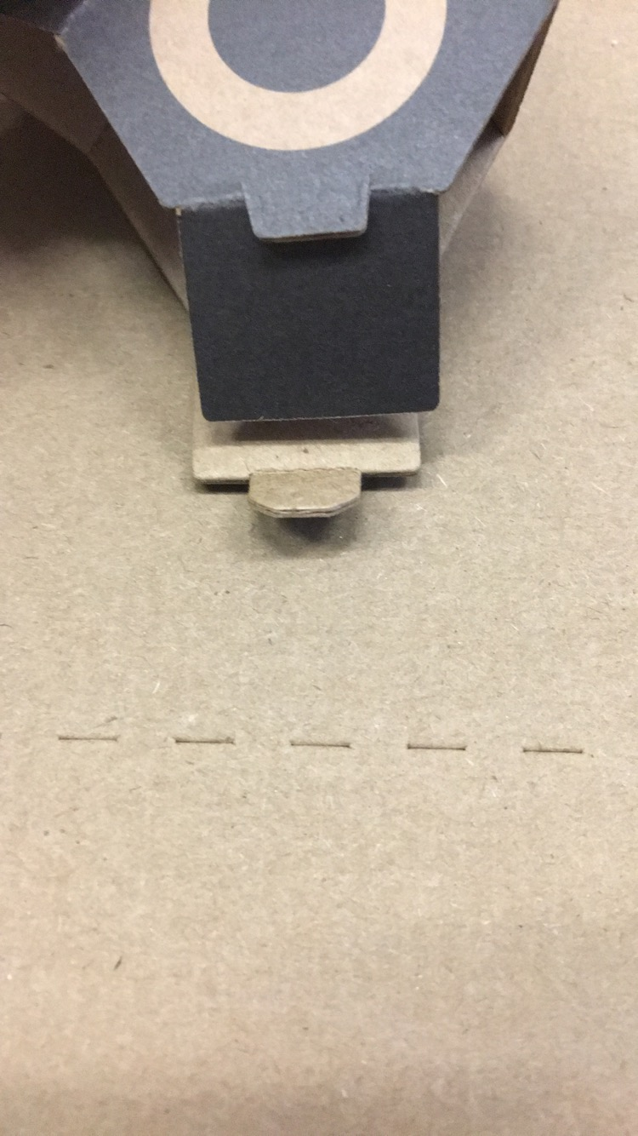

Figure 10: Slot has extrusion over it, this seems to help make the slot larger, enabling the tab to attach more securely.