**Design Brief**

Energy 2 – Group 1

# Problem Statement

In a time where our ecological limitations are apparent, pragmatic solutions to imminent problems must be sought. An example of such a case is lighting within households for the internally displaced population (IDP) of Kathmandu, Nepal. Specifically, 3903 inhabitants (2052 Male, 1851 Female) [1] who reside in the 11 settlements along the Bagmati River. At present only 11% of the aforementioned citizens have access to a reliable source of lighting [2]. Consequently, there is an increased reliance upon fuel-based technologies such as kerosene lamps which command a significant proportion (18.5%) of monthly income [3]. This projects aims to set up a network of energy generators which ensures sufficient lighting for the community which would enhance economic, educational and social activities beyond the daylight hours. Thus, such solutions can be affordable, safe and environmentally friendly.

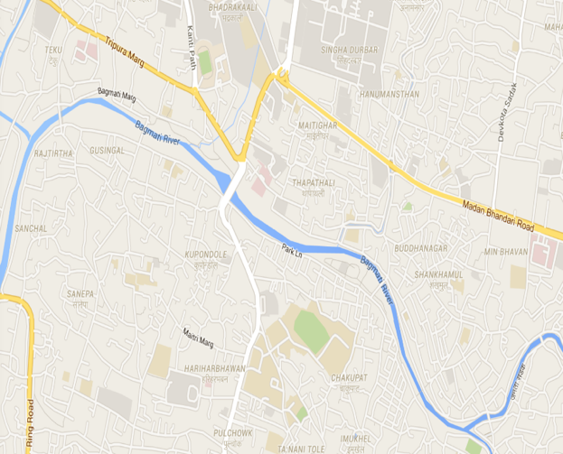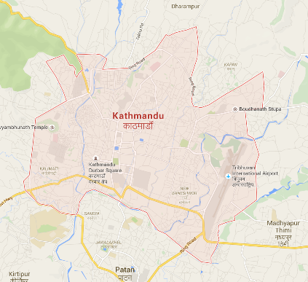

*Figure 1: Target IDP settlements along the Bagmati River in Kathmandu, Nepal*

# Stakeholders

|  |  |  |
| --- | --- | --- |
| **Parties involved** | **Considerations/Concerns** | **Needs** |
| IDP along Bagmati riverbank | Safe, environmentally, sustainable and accessible source for women and children to use. | Lighting sources to carry out economic, social and educational activities. |
| Ministries of Energy, Water and Electricity Authority | State of current infrastructure. Suitable distributors. Corruption. | Provision of lighting that is acceptable, accessible and readily available. |
| Investors – StoreDot, Chatham House | The capability of the workforce.  Purchasing power of the IDP.  The amount of needed investment. | Return of investment.  Profit maximization.  Cost minimization. |

# Design objectives

The solutions should endeavor to:

* Deliver reliable lighting for households, which provides freedom for night activities. Assessed by monitoring the reduced blackouts frequency and labour time devoted to collection of lighting fuel.
* Provide a timely lighting solution, within a 6-month period that can work in combination with long-term solutions. Assessed through project management.
* Be socially sustainable. Assessed by the up-keep and use of solutions delivered through educating the population on the importance of a mutually agreed solutions.
* Be robust and portable. Determined by the design and quality-of-build of the implemented solutions.
* Be environmentally safe. Measured by carrying out impact-assessment using measurements in households’ pre/post-implementation.
* Reduce the household finances spent on lighting. Assessed through user surveys.

# Engineering skills

* Social Perceptiveness: Be cognizant of cultural compromises of the defined population and their readiness to adopt new lighting technologies.
* Building and Construction: Knowledge of materials, methods, and the tools involved in the construction and maintenance of energy generation/distribution/storage.
* Safety and Security: Knowledge of relevant equipment, policies, procedures, and strategies to promote effective local, state, or national security operations for the protection of people and property
* Systems Evaluation: Identifying measures of system performance and actions needed to improve performance, relative to the goals of the system (provide sufficient community lighting).

# Funding

Our solutions will seek to acquire financial and resource donations, as well as project partnerships.

**Financial aid** from *research companies and non-government organizations* with links and vested interest in Nepalese relief efforts (Mercycorps). *International governments* (UK/Dutch) that currently fund relief organisation (Chatham House); to collect research statistics.

**Resource aid** from *Businesses* such as Storedot [4] can provide rechargeable batteries, which enhances public perception and allows feedback to be obtained. Alternatively, crowdfunding initiatives can be used (Greenlight Planet). [5]

Funding might be limited from the private sector and *international governments* [6] (China/India) since their have financial motivations not met by our objective (non-profit lighting solutions).

# Risks and Constraints

Risks:

* High humidity in region can lead to mechanical solution’s degradation.
* Insufficient user education could result in accidents and project failures.
* Local residents may resist new technology.
* Increased comfort may dissuade IDP returning to villages

Constraints:

* Potential difficulty implementing the solution around the Bagmati River due to high pollution.
* Geographical terrain can make logistical activities difficult.
* Financial projections could be higher than forecast.
* Local resources may not satisfy solution demands.

# Bibliography

[1] Lumanti Support Group for Shelter, 2008. Status of Squatter Communities along Bagmati River and its tributaries in Kathmandu Valley, s.l. [Online] Available at: http://www.ciud.org.np/urban-dabali/index.php?q=content/report-squatter-and-slum-settlements-kathmandu. [Accessed 3 Jun. 2016]

[2] Chatham House Report for the Moving Energy Initiative, November 2015. Heat, Light and Power for Refugees Saving Lives, Reducing Costs, s.l [Online] Available at: https://www.chathamhouse.org/sites/files/chathamhouse/publications/research/20151117HeatLightPowerRefugeesMEILahnGrafhamExecSummary.pdf. [Accessed 3 Jun. 2016].

[3] Shrestha, H. (2016). Nepalese exhaust over 85% of income on consumption | Nepal Mountain News. [Online] Nepalmountainnews.com. Available at: http://www.nepalmountainnews.com/cms/2015/09/18/nepalis-exhaust-over-85-of-income-on-consumption/ [Accessed 3 Jun. 2016].

[4] StoreDot. (2016). *StoreDot*. [Online] Available at: http://www.store-dot.com [Accessed 3 Jun. 2016].

[5] Indiegogo. (2016). *HELP POWER NEPAL: Send Solar Lights to Nepal*. [Online] Available at: https://www.indiegogo.com/projects/help-power-nepal-send-solar-lights-to-nepal# [Accessed 3 Jun. 2016].

[6] BBC, (2016). [Online] Available at: (http://www.bbc.co.uk/news/world-south-asia-12846672) [Accessed 3 Jun. 2016].