

Name _______________

Date _______________

Stream _______________

1. Draw a map of the site. Label inflows, outflows, and shoreline features.
2. Physical observations of the water:

___ Clear ___ Cloudy ___ Litter/debris ___ Algal bloom

Do you have any other observations?

1. Wildlife:

___ Fish ___ Birds ___ Insects ___ Amphibians ___ Turtles ___ Domestic animals

Did you observe any other wildlife?

1. Water quality

|  |  |  |  |
| --- | --- | --- | --- |
| Parameter | Sampling Location | | |
|  | Inflow | Outflow | Shoreline |
| Water Temperature |  |  |  |
| Conductivity |  |  |  |
| pH |  |  |  |
| Phosphate |  |  |  |
| Ammonia |  |  |  |
| Nitrate |  |  |  |
| Total Inorganic Nitrogen |  |  |  |

**Interpreting Results**

1. Does the water have enough oxygen to support a healthy fish population?

|  |  |
| --- | --- |
| Dissolved Oxygen Level | |
| < 2.0 | Fish can live for only short periods |
| 2.0 - 3.0 | Few fish can survive for extended periods |
| 3.0 - 5.0 | Fish grow and develop slowly |
| > 6.0 | Healthful for most fish |



1. Does the pH support freshwater aquatic life?
2. How does the conductivity compare to other freshwater ecosystems?

|  |  |
| --- | --- |
| Conductivity (µS/cm) | Assessment |
| 0 - 200 | Pristine |
| 200 - 1,000 | “Normal” for most major rivers |
| 1,000 - 10,000 | Saline/impacted condition |

1. What is the “trophic state” of each lake?

|  |  |  |
| --- | --- | --- |
| Trophic State | Nutrient concentrations | |
| Oligotrophic | Phosphorus | 0 - 0.01 ppm |
| Nitrogen | 0 - 0.2 ppm |
| Mesotrophic | Phosphorus | 0.01 - 0.03 ppm |
| Nitrogen | 0.2 - 0.6 ppm |
| Eutrophic | Phosphorus | 0.03 - 0.05 ppm |
| Nitrogen | 0.6 - 1.0 ppm |
| Hypereutrophic | Phosphorus | > 0.05 ppm |
| Nitrogen | > 1 ppm |

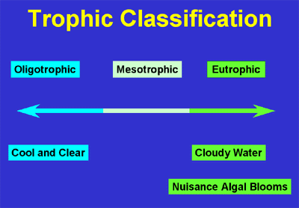

1. Does one of the lakes have better water quality than the other? Why?