# Introduction to Online Maps

Connecticut Environmental Conditions Online (CT ECO) is a mapping website for viewing and exploring geographic data using only a web browser. You will explore several interactive map viewers on this site, take “screen shots” or pictures of the maps and assemble them in a powerpoint file to create a map book of one location showing lots of characteristics about that place.

The mapbook template is a guide and contains the maps listed below. These data layers are described in detail in Data Guides on the CT ECO website, http://cteco.uconn.edu/guides/data.htm. Feel free to make changes or add additional maps that may be of interest to you.

**Base Maps**

Map 1: Spring Aerial Imagery

Map 2: Hillshade Elevation

Map 3: Boundaries/Streets

**Land Resources**

Map 4: Hydric Soils

Map 5: Farmland Soils

Map 6: Open Space

Map 7: Critical Habitat & Natural Diversity DB Areas

**Water Resources**

Map 8: Watersheds, Hydrography & Wellhead protection areas

Map 9: Water Quality: Surface & Groundwater

## More about CT ECO

### <http://cteco.uconn.edu>

CT ECO is a partnership between UConn CLEAR and Connecticut DEEP (Department of Energy and Environmental Protection). The website provides different ways (pdfs, interactive viewers and map services) for users to see and interact with Connecticut’s natural resource mapping layers.

In this activity, you will use the CT ECO Aerial Viewer, Elevation Viewer, Simple Viewer and Advanced Viewer to generate images of maps to copy/paste into a map book.



## Getting Started

A mapbook is a book of maps of the same location.

First, **view the sample mapbook** located at <http://nrca.uconn.edu/teachers/materials/> (look for Mapbook Sample link). Notice how it is a series of consistent pages that show different characteristics for the same location.

Now, **choose your location**. We suggest focusing on (approximately) the town level. Options could be the community where you live, or the community where your high school is located.

My Mapbook will be for ________________________________________________

### Mapbook File

* Go to <http://nrca.uconn.edu/teachers/materials/> and find the **Mapbook Template** link.
* Click on the link and **save the powerpoint file** to your flash (or hard) drive called *location*Mapbook.ppt where *location* will be the focus of your mapbook.

You will create your mapbook by completing the mapbook powerpoint template that you just downloaded and saved. You will add a picture of each map to your powerpoint using the Snipping Tool (PC) or Mac shortcuts.

### How to use the Snipping Tool on a PC

The Snipping Tool takes a “picture” of whatever you are viewing on the screen. Then you can either copy it for pasting or save it with a name. You will use the snipping tool to take pictures of maps and add them to your map book.

* Go to the **Start Menu** and start typing *snipping* until the **Snipping Tool** shows on the list. Alternatively, go to the **Start Menu** > **All Programs** > **Accessories** > **Snipping Tool.**
* Click on it to open the **Snipping Tool**.
* Click **New** and **draw a box** around what you want to “take a picture of” on your screen.
* When you release your mouse, your capture will show.
* 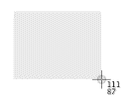Use the icon to **Save** or **Copy** your image. Note that you can also save the file and give it a name. 

### Screenshots on a Mac

* Press Shift-Command-4. The pointer changes to a crosshair.
* Move the crosshair to where you want to start the screenshot, then drag to select an area. While dragging, you can hold Shift, Option, or Space bar to change the way the selection moves.
* When you've selected the area you want, release your mouse or trackpad button. To cancel, press the Esc (Escape) key before you release the button.
* Find the screenshot as a .png file on your desktop.

Follow these instructions to explore some Connecticut mapping resources and to add the maps to your mapbook using the snipping tool/screenshot. Don’t worry if your individual maps are not perfectly aligned – close is good enough for this exercise!

**NOTE:** **These instructions are also available in the notes section of each slide in your mapbook powerpoint template.**

**Aerial Imagery**

The **Connecticut Aerial Imagery Viewer** on CT ECO contains most of Connecticut’s digital aerial imagery.

* 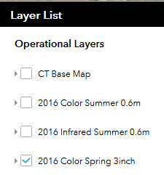Go to the CT ECO website <http://cteco.uconn.edu>.
* Find **Map Viewers**.
* Find **Aerial Imagery Viewer** and click **Go to Viewer**.
* Zoom to your location. You can enter an address in the Geocoder if you wish.
* Click on the **Layers** button in the upper right-hand corner  to see all of the available layers. Turn on **2016 Color Spring 3inch**.
* Take a snip, copy and paste on the slide 2016 Spring Aerial Imagery. Resize or crop if necessary.

**Hillshade (Elevation)**

The **CT ECO Elevation (Lidar) Viewer** contains a virtual mosaic of elevation data in the form of hillshade, shaded relief, slope and aspect.

* Go back to the **Viewers** page on the CT ECO website <http://cteco.uconn.edu> and find the **Elevation (Lidar) Viewer.**
* Click **Go to Viewer**.
* Zoom to your location.
* Take a snip, copy and paste on the slide Hillshade. Resize or crop if necessary.

**Boundaries & Streets**

The **CT ECO Simple Viewer** is designed for viewing a standard boundaries and streets base map or recent aerial imagery plus ONE natural resource theme at a time.

* Go back to the **Viewers** page on the CT ECO website <http://cteco.uconn.edu> and find the **Simple Map Viewer.**
* Click **Go to Viewer**.
* Zoom to your location. The standard Towns boundary layer will already be turned on. 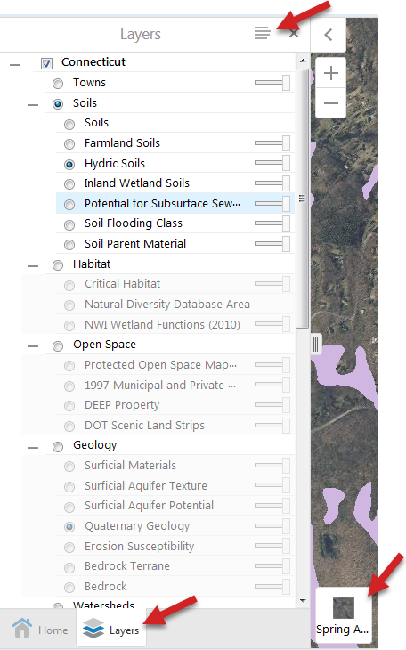
* Take a snip, copy and paste on the slide Boundaries & Streets. Resize or crop if necessary.

**Hydric Soils**

* Locate the **Layers tab** in the lower left. 
* Zoom to your location.
* Click on the radio button next to **Soils** and then the radio button next to **Hydric Soils**.
* Change the **Basemap** (lower right of the layer list) to **Spring Aerial**.
* Take a snip, copy and paste on the slide Hydric Soils. Resize or crop if necessary.

*Note that the legend snip on the slide came from the* ***Show Legend*** *tab next to the Layers heading*.

**Farmland Soils**

* Return to the **Simple Map Viewer** on CT ECO.
* 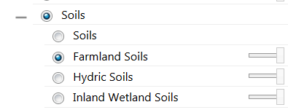Uncheck the radio button next to **Hydric Soils** and instead turn on **Farmland Soils**.
* Take a snip, copy and paste on the slide Farmland Soils. Resize or crop if necessary.

**Open Space**

* Return to the **Simple Map Viewer** on CT ECO.
* Check the radio button next to **Open Space** and then check the radio button next to **Protected Open Space Mapping**.
* **NOTE**: some towns do not have this data layer available; if so the town will be “grayed out” rather than displaying colored open space parcels. If this is true for your town don’t sweat it, just move on!
* Take a snip, copy and paste on the slide Open Space. Resize or crop if necessary.

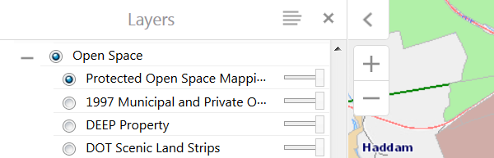

**Critical Habitat & Natural Diversity Database Areas**

The **CT ECO Advanced Viewer** is designed for viewing multiple natural resource layers at once and contains more tools than the Simple Viewer does. So, we’ll use the Advanced Viewer to make a few thematic maps that require two or more data layers.

* Go back to the **Viewers** page on the CT ECO website <http://cteco.uconn.edu> and find the **Advanced Map Viewer.**
* Click **Go to Viewer**. The viewer is a draft so click the **“beta viewer” link in the first line of text**.
* Locate the **Layers tab** in the lower left. 
* Zoom to your location.
* **Uncheck** the box next to **Towns**.
* Expand the **+** next to **Bioscience** and click on
  + **Critical Habitat** and
  + **Natural Diversity Database Area**
* Change the **Basemap** back to the original Basemap.
* Take a snip, copy and paste on the slide Critical Habitat & Natural Diversity DB Area. Resize or crop if necessary.

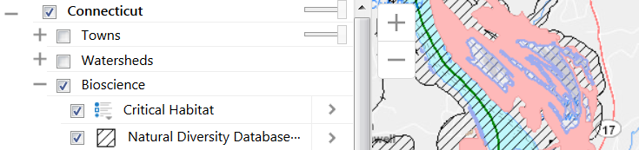

**Water Resources**

* Go back to the **Advanced Map Viewer**.
* Turn off (uncheck) the habitat layers you just used.
* Expand the **+** next to **Watersheds** and click on
  + **DEEP Regional Basins**,
  + **DEEP Subregional Basins** and
  + **DEEP Local Basins**.
* Expand the **+** next to **Water Resources** and click on
  + **Hydrography** and
  + **Wellhead Protection Areas**.
* Change the **Basemap** to **Hillshade**.
* Take a snip, copy and paste on the slide Water Resources. Resize or crop if necessary.

**Water Quality**

* Go back to the **Advanced Map Viewer**.
* Turn off (uncheck) the water layers you just used.
* Expand the **+** next to **Water Quality** and click on
  + **Surface Water Quality**
  + **Ground Water Quality**
* Change the **Basemap** back to the original Basemap.
* Take a snip, copy and paste on the slide Water Resources. Resize or crop if necessary.

Be sure to save your work!