 

## Materials List

* LID walking tour map
* LID walking tour observation chart
* WikiWatershed Runoff Simulation Tool (Micro Site Storm Model) activity
* 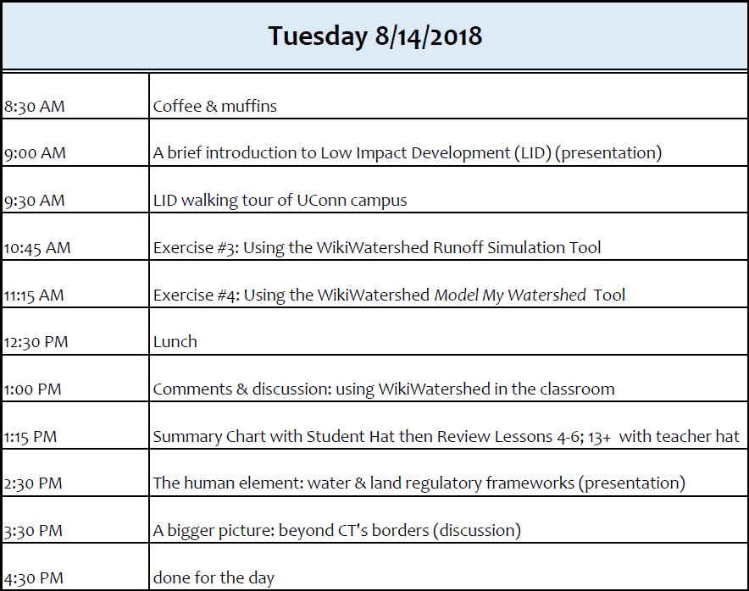WikiWatershed Model My Watershed Tool activity

# TUESDAY