 

## Materials List

* LID 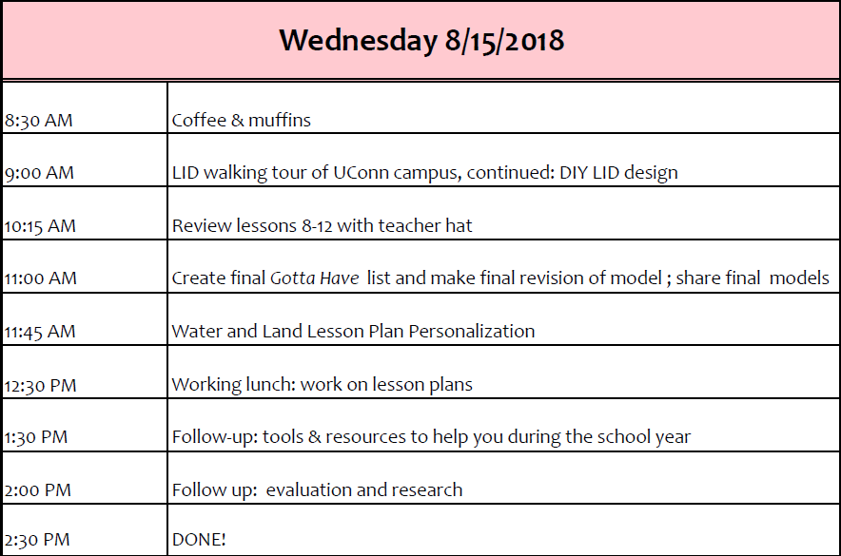walking tour, DIY design

# WEDNESDAY