CE100 Algorithms and Programming II

Heap/Heap Sort

Author: Asst. Prof. Dr. Uğur CORUH

## CE100 Algorithms and Programming II

## Week-4 (Heap/Heap Sort)

#### Spring Semester, 2021-2022

Download [DOC](ce100-week-4-heap.md_doc.pdf), [SLIDE](ce100-week-4-heap.md_slide.pdf), [PPTX](ce100-week-4-heap.md_slide.pptx)

## Heap/Heap Sort

## Outline (1)

* Heaps
  + Max / Min Heap
* Heap Data Structure
  + Heapify
    - Iterative
    - Recursive

## Outline (2)

* Extract-Max
* Build Heap

## Outline (3)

* Heap Sort
* Priority Queues
* Linked Lists
* Radix Sort
* Counting Sort

## Heapsort

* Worst-case runtime: $O\left(nlgn\right)$
* Sorts in-place
* Uses a special data structure (heap) to manage information during execution of the algorithm
  + Another design paradigm

## Heap Data Structure (1)

* Nearly complete binary tree
  + Completely filled on all levels except possibly the lowest level

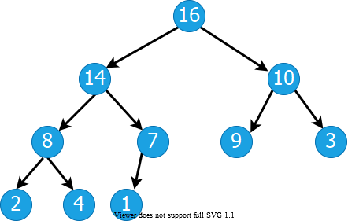

alt:“alt” height:350px center

## Heap Data Structure (2)

* **Height of node i:** Length of the longest simple downward path from **i** to a **leaf**
* **Height of the tree:** height of the **root**

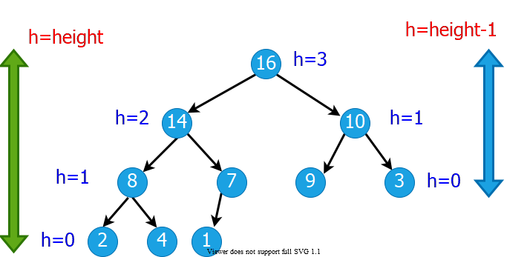

alt:“alt” height:400px center

## Heap Data Structures (3)

* **Depth of node i:** Length of the simple downward path from the **root** to node **i**

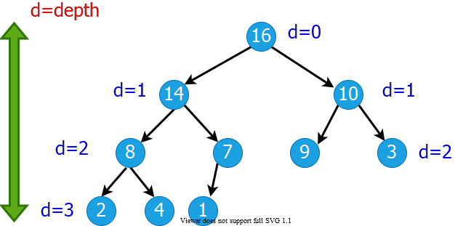

alt:“alt” height:350px center

## Heap Property: Min-Heap

* The **smallest** element in any subtree is the **root** element in a **min-heap**
* **Min heap:** For every node **i** other than **root**, $A\left[parent\left(i\right)\right]≤A\left[i\right]$
  + Parent node is always smaller than the child nodes

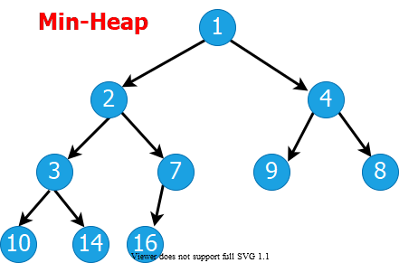

alt:“alt” height:350px center

## Heap Property: Max-Heap

* The **largest** element in any subtree is the **root** element in a **max-heap**
  + We will focus on max-heaps
* **Max heap:** For every node **i** other than **root**, $A\left[parent\left(i\right)\right]≥A\left[i\right]$
  + Parent node is always larger than the child nodes

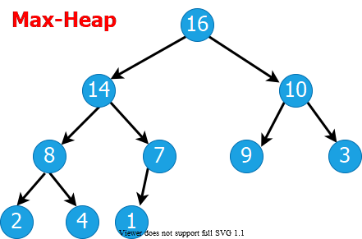

alt:“alt” height:350px center

## Heap Data Structures (4)

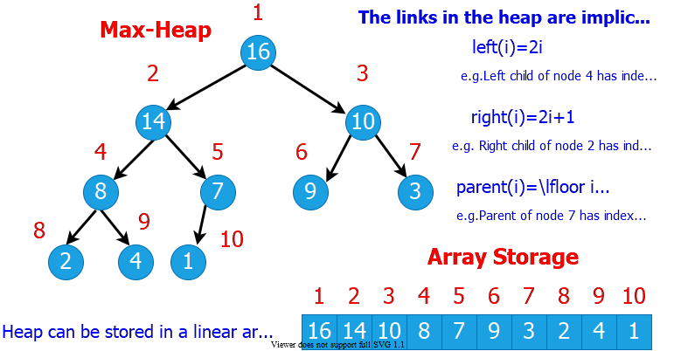

alt:“alt” height:500px center

## Heap Data Structures (5)

* Computing left child, right child, and parent indices very fast
  + **left(i) = 2i $⇒$** binary left shift
  + **right(i) = 2i+1 $⇒$** binary left shift, then set the lowest bit to 1
  + **parent(i) = floor(i/2) $⇒$** right shift in binary
* $A\left[1\right]$ is always the **root** element
* Array $A$ has two attributes:
  + **length(A):** The number of elements in $A$
  + **n = heap-size(A):** The number elements in $heap$

$n≤length\left(A\right)$

## 

## Heap Operations : EXTRACT-MAX (1)

EXTRACT-MAX(A, n)  
 max = A[1]  
 A[1] = A[n]  
 n = n - 1  
 HEAPIFY(A, 1,n)  
 return max

## Heap Operations : EXTRACT-MAX (2)

* Return the max element,and reorganize the heap to maintain heap property

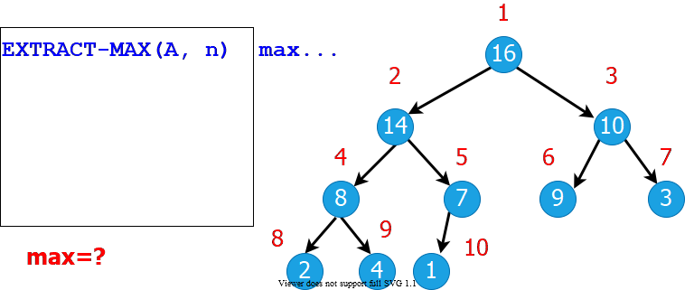

alt:“alt” height:400px center

## Heap Operations: HEAPIFY (1)

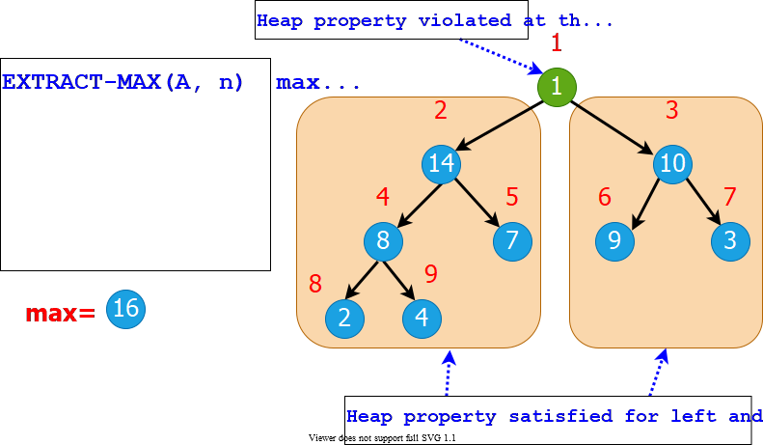

alt:“alt” height:500px center

## Heap Operations: HEAPIFY (2)

* Maintaining heap property:
  + Subtrees rooted at $left\left[i\right]$ and $right\left[i\right]$ are already heaps.
  + But, $A\left[i\right]$ may violate the heap property (i.e., may be smaller than its children)
* **Idea:** Float down the value at $A\left[i\right]$ in the heap so that subtree rooted at $i$ becomes a heap.

## Heap Operations: HEAPIFY (2)

HEAPIFY(A, i, n)  
 largest = i   
   
 if 2i <= n and A[2i] > A[i] then   
 largest = 2i;  
 endif  
   
 if 2i+1 <= n and A[2i+1] > A[largest] then   
 largest = 2i+1;  
 endif  
  
 if largest != i then  
 exchange A[i] with A[largest];  
 HEAPIFY(A, largest, n);  
 endif

## Heap Operations: HEAPIFY (3)

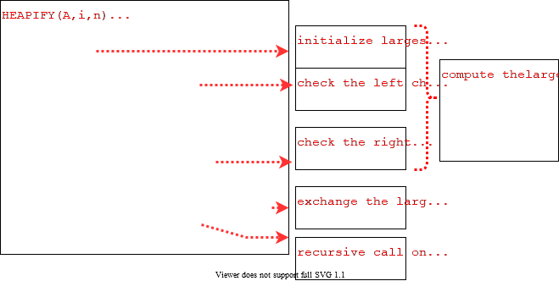

alt:“alt” height:500px center

## Heap Operations: HEAPIFY (4)

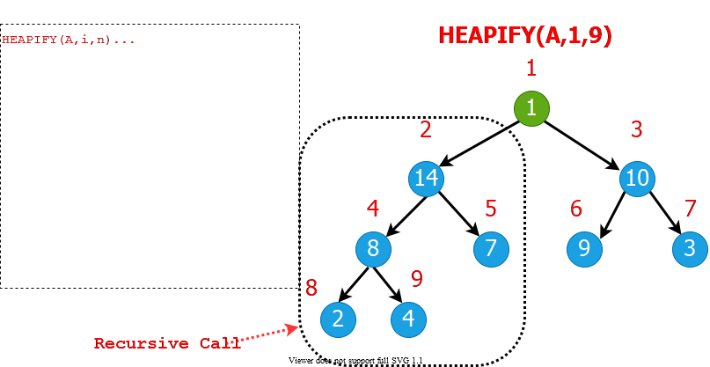

alt:“alt” height:500px center

## Heap Operations: HEAPIFY (5)

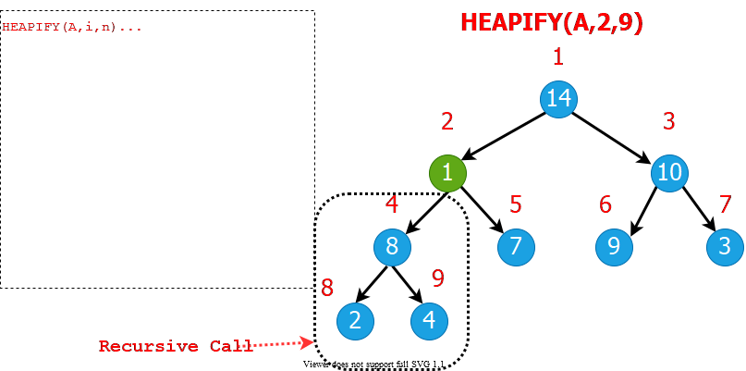

alt:“alt” height:500px center

## Heap Operations: HEAPIFY (6)

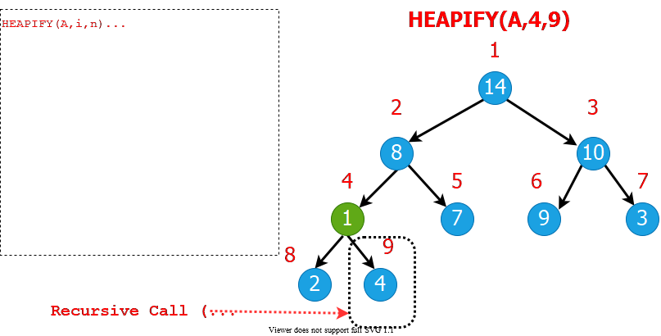

alt:“alt” height:500px center

## Heap Operations: HEAPIFY (7)

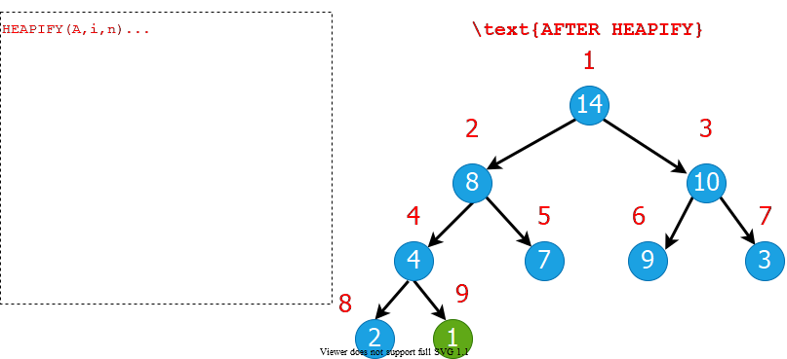

alt:“alt” height:500px center

## Heap Operations: HEAPIFY (8)

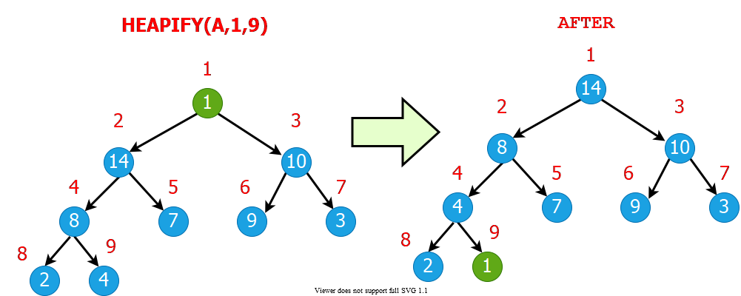

alt:“alt” height:500px center

## Intuitive Analysis of HEAPIFY

* Consider $HEAPIFY\left(A,i,n\right)$
  + let $h\left(i\right)$ be the height of node $i$
  + at most $h\left(i\right)$ recursion levels
    - Constant work at each level: $Θ\left(1\right)$
  + Therefore $T\left(i\right)=O\left(h\left(i\right)\right)$
* Heap is almost-complete binary tree
$h\left(n\right)=O\left(lgn\right)$

* Thus $T\left(n\right)=O\left(lgn\right)$

## Formal Analysis of HEAPIFY

* **What is the recurrence?**
  + Depends on the size of the **subtree** on which recursive call is made
    - In the next, we try to compute an **upper bound** for this **subtree**.

## Reminder: Binary trees

* For a complete binary tree:
  + $\#$ of nodes at depth $d$: $2^{d}$
  + $\#$ of nodes with depths less than $d$: $2^{d}−1$

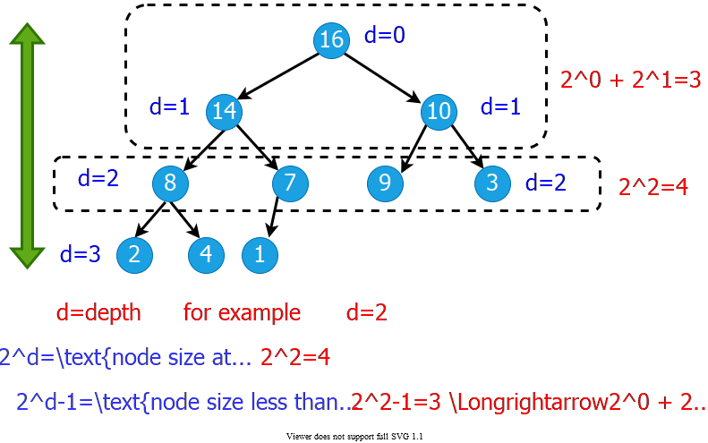

alt:“alt” height:450px center

## Formal Analysis of HEAPIFY (1)

* Worst case occurs when last row of the subtree $S_{i}$ rooted at node $i$ is **half full**
$T\left(n\right)≤T\left(\left|S_{L\left(i\right)}\right|\right)+Θ\left(1\right)$

* $S_{L\left(i\right)}$ and $S_{R\left(i\right)}$ are complete binary trees of heights $h\left(i\right)−1$ and $h\left(i\right)−2$, respectively

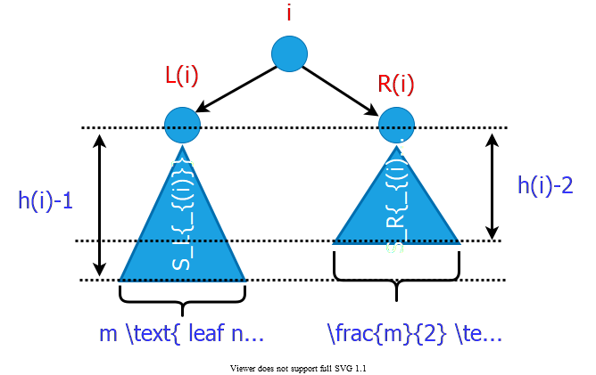

alt:“alt” height:350px center

## Formal Analysis of HEAPIFY (2)

* Let $m$ be the number of **leaf nodes** in $S_{L\left(i\right)}$

$\left|S_{L\left(i\right)}\right|=\overset{ext.}{\overbrace{m}}+\overset{int.}{\overbrace{\left(m–1\right)}}=2m–1$

$\left|S_{R\left(i\right)}\right|=\overset{ext.}{\overbrace{\frac{m}{2}}}+\overset{int.}{\overbrace{\left(\frac{m}{2}–1\right)}}=m–1$

$\left|S_{L\left(i\right)}\right|+\left|S_{R\left(i\right)}\right|+1=n$

## Formal Analysis of HEAPIFY (2)

$$\begin{matrix}\left(2m–1\right)+\left(m–1\right)+1 & =n \\ m & =\left(n+1\right)/3 \\ \left|S_{L\left(i\right)}\right| & =2m–1 \\ & =2\left(n+1\right)/3–1 \\ & =\left(2n/3+2/3\right)–1 \\ & =\frac{2n}{3}−\frac{1}{3}≤\frac{2n}{3} \\ T\left(n\right) & ≤T\left(2n/3\right)+Θ\left(1\right) \\ T\left(n\right) & =O\left(lgn\right)\end{matrix}$$

* **By CASE-2 of Master Theorem $⇒$ $T\left(n\right)=Θ\left(n^{log_{b}^{a}}lgn\right)$**

## Formal Analysis of HEAPIFY (2)

* Recurrence: $T\left(n\right)=aT\left(n/b\right)+f\left(n\right)$
* *Case 2: $\frac{f\left(n\right)}{n^{log_{b}^{a}}}=Θ\left(1\right)$*
* i.e., $f\left(n\right)$ and $n^{log_{b}^{a}}$ grow at similar rates
* **Solution: $T\left(n\right)=Θ\left(n^{log_{b}^{a}}lgn\right)$**
  + $T\left(n\right)≤T\left(2n/3\right)+Θ\left(1\right)$ (drop constants.)

$T\left(n\right)≤Θ\left(n^{log_{3}^{1}}lgn\right)$

$T\left(n\right)≤Θ\left(n^{0}lgn\right)$

$T\left(n\right)=O\left(lgn\right)$

## 

## HEAPIFY: Efficiency Issues

* **Recursion vs Iteration:**
  + In the absence of tail recursion, **iterative version** is in general **more efficient** because of the **pop/push** operations **to/from** stack at each **level of recursion**.

## Heap Operations: HEAPIFY (1)

**Recursive**

HEAPIFY(A, i, n)  
 largest = i   
  
 if 2i <= n and A[2i] > A[i] then   
 largest = 2i  
  
 if 2i+1 <= n and A[2i+1] > A[largest] then   
 largest = 2i+1  
  
 if largest != i then  
 exchange A[i] with A[largest]  
 HEAPIFY(A, largest, n)

## Heap Operations: HEAPIFY (2)

**Iterative**

HEAPIFY(A, i, n)  
 j = i  
 while(true) do  
 largest = j   
  
 if 2j <= n and A[2j] > A[j] then   
 largest = 2j  
  
 if 2j+1 <= n and A[2j+1] > A[largest] then   
 largest = 2j+1  
  
 if largest != j then  
 exchange A[j] with A[largest]  
 j = largest  
 else return

## Heap Operations: HEAPIFY (3)

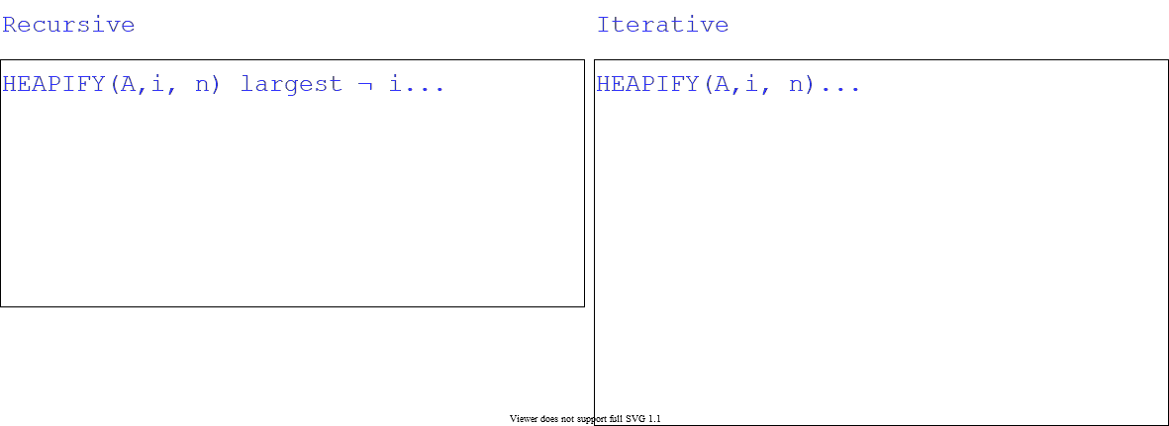

alt:“alt” height:500px center

## Heap Operations: Building Heap

* Given an arbitrary array, how to build a heap from scratch?
* **Basic idea:** Call $HEAPIFY$ on each node bottom up
  + Start from the leaves (which trivially satisfy the heap property)
  + Process nodes in bottom up order.
  + When $HEAPIFY$ is called on node $i$, the subtrees connected to the $left$ and $right$ subtrees already satisfy the heap property.
* 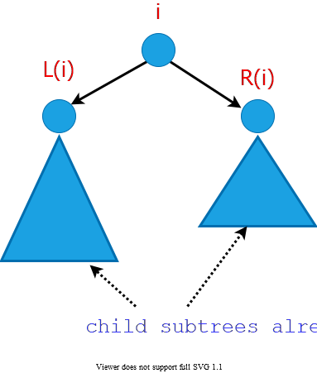
* alt:“alt” height:300px center

## Storage of the leaves

* **Lemma:** The last $⌈\frac{n}{2}⌉$ nodes of a heap are all leaves.

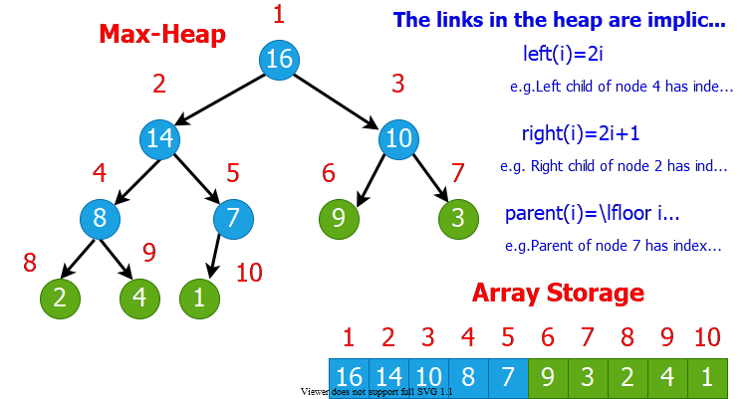

bg right w:600

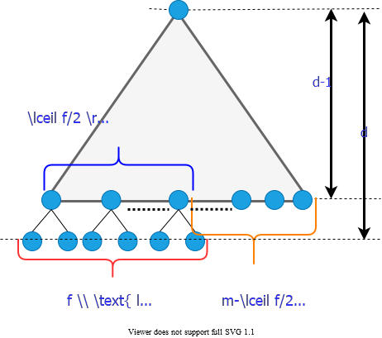

bg right w:600

* asdasdsdas
* asdsadsa
* asdas

## References

* [Introduction to Algorithms, Third Edition | The MIT Press](https://mitpress.mit.edu/books/introduction-algorithms-third-edition)
* [Bilkent CS473 Course Notes (new)](http://nabil.abubaker.bilkent.edu.tr/473/)
* [Bilkent CS473 Course Notes (old)](http://cs.bilkent.edu.tr/~ugur/teaching/cs473/)
* [Insertion Sort - GeeksforGeeks](https://www.geeksforgeeks.org/insertion-sort/)
* [NIST Dictionary of Algorithms and Data Structures](https://xlinux.nist.gov/dads/)
* [NIST - Dictionary of Algorithms and Data Structures](https://xlinux.nist.gov/dads/)

TODO