CE100 Algorithms and Programming II

Huffman Coding

Author: Asst. Prof. Dr. Uğur CORUH

## CE100 Algorithms and Programming II

## Week-9 (Huffman Coding)

#### Spring Semester, 2021-2022

Download [DOC](ce100-week-9-huffman.tr.md_doc.pdf), [SLIDE](ce100-week-9-huffman.tr.md_slide.pdf), [PPTX](ce100-week-9-huffman.tr.md_slide.pptx)

## Huffman Coding

## Outline

* Heap Data Structure (Review Week-4)
* Heap Sort (Review Week-4)
* Huffman Coding

## **Huffman Codes**

## Huffman Codes for Compression

* Widely used and very effective for data compression
* Savings of 20% - 90% typical
  + (depending on the characteristics of the data)
* **In summary:** Huffman’s greedy algorithm uses a **table of frequencies** of character occurrences to build up an optimal way of **representing each character as a binary string**.

## Binary String Representation - **Example**

* Consider a data file with:
  + 100K characters
  + Each character is one of $\{a,b,c,d,e,f\}$
* Frequency of each character in the file:
  + **frequency: $\overset{45K}{\overbrace{a}},\overset{13K}{\overbrace{b}},\overset{12K}{\overbrace{c}},\overset{16K}{\overbrace{d}},\overset{9K}{\overbrace{e}},\overset{5K}{\overbrace{f}}$**
* **Binary character code:** Each character is represented by a unique binary string.
* **Intuition:**
  + Frequent characters $⇔$ shorter codewords
  + Infrequent characters $⇔$ longer codewords

## Binary String Representation - **Example**

$$\begin{matrix}\text{characters} & a & b & c & d & e & f \\ \text{frequency} & 45K & 13K & 12K & 16K & 9K & 5K \\ \text{fixed-length} & 000 & 001 & 010 & 011 & 100 & 101 \\ \text{variable-length(1)} & 0 & 101 & 100 & 111 & 1101 & 1100 \\ \text{variable-length(2)} & 0 & 10 & 110 & 1110 & 11110 & 11111\end{matrix}$$

* How many total bits needed for **fixed-length** codewords? $100K×3=300K bits$
* How many total bits needed for **variable-length(1)** codewords? $45K×1+13K×3+12K×3+16K×3+9K×4+5K×4=224K$
* How many total bits needed for **variable-length(2)** codewords? $45K×1+13K×2+12K×3+16K×4+9K×5+5K×5=241K$

## Prefix Codes

* **Prefix codes:** No codeword is also a prefix of some other codeword
* **Example:**
$$\begin{matrix}\text{characters} & a & b & c & d & e & f \\ \text{codeword} & 0 & 101 & 100 & 111 & 1101 & 1100\end{matrix}$$

* It can be shown that:
  + Optimal data compression is achievable with a **prefix code**
* In other words, optimality is not lost due to **prefix-code** restriction.

## Prefix Codes: Encoding

$$\begin{matrix}\text{characters} & a & b & c & d & e & f \\ \text{codeword} & 0 & 101 & 100 & 111 & 1101 & 1100\end{matrix}$$

* **Encoding:** Concatenate the codewords representing each character of the file
* **Example:** Encode file “abc” using the codewords above
$abc⇒0.101.100⇒0101100$

* **Note:** “.” denotes the concatenation operation. It is just for illustration purposes, and does not exist in the encoded string.

## Prefix Codes: Decoding

* Decoding is quite simple with a prefix code
* The first codeword in an encoded file is unambiguous
  + *because no codeword is a prefix of any other*
* **Decoding algorithm:**
  + Identify the initial codeword
  + Translate it back to the original character
  + Remove it from the encoded file
  + Repeat the decoding process on the remainder of the encoded file.

## Prefix Codes: Decoding - Example

$$\begin{matrix}\text{characters} & a & b & c & d & e & f \\ \text{codeword} & 0 & 101 & 100 & 111 & 1101 & 1100\end{matrix}$$

* Example: Decode encoded file $001011101$

$001011101$

$0.01011101$

$0.0.1011101$

$0.0.101.1101$

$0.0.101.1101$

$aabe$

## Prefix Codes

* Convenient representation for the prefix code:
  + a binary tree whose leaves are the given characters
* Binary codeword for a character is the path from the root to that character in the binary tree
* “ $0$” means “**go to the left child**”
* “ $1$” means “**go to the right child**”

## Binary Tree Representation of Prefix Codes

* **Weight of an internal node:** sum of weights of the leaves in its subtree
* The binary tree corresponding to the fixed-length code

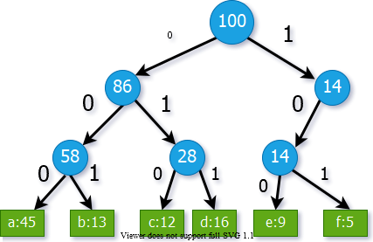

center h:450px

## Binary Tree Representation of Prefix Codes

* **Weight of an internal node:** sum of weights of the leaves in its subtree
* The binary tree corresponding to the **optimal variable-length** code
* An optimal code for a file is always represented by a **full binary tree**

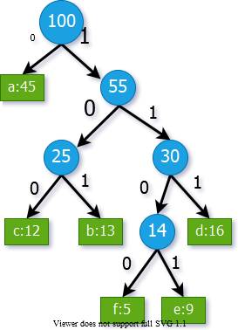

bg right:40% h:600px

## Full Binary Tree Representation of Prefix Codes

* Consider an **FBT** corresponding to an optimal prefix code
* It has $\left|C\right|$ leaves (external nodes)
* One for each letter of the alphabet where $C$ is the alphabet from which the characters are drawn
* **Lemma:** An **FBT** with $\left|C\right|$ external nodes has exactly $\left|C\right|−1$ internal nodes

## Full Binary Tree Representation of Prefix Codes

* Consider an $FBT$ $T$, corresponding to a prefix code.
* **Notation**:
  + $f\left(c\right)$: frequency of character c in the file
  + $d_{T}\left(c\right)$: depth of $c$’s leaf in the $FBT$ $T$
  + $B\left(T\right)$: the number of bits required to encode the file
* What is the length of the codeword for $c$?
  + $d_{T}\left(c\right)$, same as the depth of $c$ in $T$
* How to compute $B\left(T\right)$, cost of tree $T$?



## Cost Computation - **Example**



$$\begin{matrix}B\left(T\right)= & \left(45×1\right)+\left(12×3\right)+ \\ & \left(13×3\right)+\left(16×3\right)+ \\ & \left(5×4\right)+\left(9×4\right) \\ = & 224\end{matrix}$$

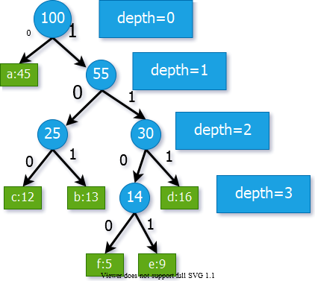

bg right:50% h:500px

## Prefix Codes

* **Lemma:** Let each internal node i is labeled with the sum of the weight $w\left(i\right)$ of the leaves in its subtree
* Then


* *where $I_{T}$ is the set of internal nodes of $T$*
* **Proof:** Consider a leaf node $c$ with $f\left(c\right)$& $d_{T}\left(c\right)$
  + Then, $f\left(c\right)$ appears in the weights of $d_{T}\left(c\right)$ internal node
  + along the path from $c$ to the root
  + Hence, $f\left(c\right)$ appears $d_{T}\left(c\right)$ times in the above summation

## Cost Computation - **Example**





$$\begin{matrix}B\left(T\right)= & 100+55+ \\ & 25+30+14 \\ = & 224\end{matrix}$$

bg right:50% h:500px

## Constructing a Huffman Code

* **Problem Formulation:** For a given character set C, construct an optimal prefix code with the minimum total cost
* **Huffman** invented a **greedy algorithm** that constructs an optimal prefix code called a **Huffman code**
* The greedy algorithm
  + builds the **FBT** corresponding to the optimal code in a **bottom-up** manner
  + begins with a set of $\left|C\right|$ leaves
  + performs a sequence of $\left|C\right|−1$“**merges**” to create the final tree

## Constructing a Huffman Code

* A **priority queue $Q$** , keyed on $f$, is used to identify the two **least-frequent** objects to merge
* The result of the **merger** of two objects is a **new object**
  + inserted into the priority queue according to its frequency
  + which is the sum of the frequencies of the two objects merged

## Constructing a Huffman Code

* Priority queue is implemented as a binary heap
* Initiation of $Q$ ($\text{BUILD-HEAP}$): $O\left(n\right)$ time
* $\text{EXTRACT-MIN}$& $\text{INSERT}$ take $O\left(lgn\right)$ time on $Q$ with $n$ objects

## Constructing a Huffman Code

$$\begin{matrix} & \text{HUFFMAN}\left(c\right) \\ & n←\left|C\right| \\ & Q←\text{BUILD-HEAP}\left(c\right) \\ & for i←1 to n−1 do \\ & z←\text{ALLOCATE-NODE}\left(\right) \\ & x←left\left[z\right]←\text{EXTRACT-MIN}\left(Q\right) \\ & y←right\left[z\right]←\text{EXTRACT-MIN}\left(Q\right) \\ & f\left[z\right]←f\left[x\right]←f\left[y\right] \\ & \text{INSERT}\left(Q,z\right) \\ & return \text{EXTRACT-MIN}\left(Q\right)⊲\text{one object left in} Q\end{matrix}$$

## Constructing a Huffman Code - **Example**

* Start with one leaf node for each character
* The $2$ nodes with the least frequencies: $f\&e$
* Merge $f\&e$ and create an internal node
* Set the internal node frequency to $5+9=14$

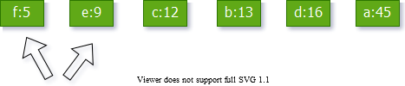

center h:300px

## Constructing a Huffman Code - **Example**

* The 2 nodes with least frequencies: $b\&c$

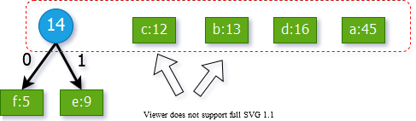

center h:400px

## Constructing a Huffman Code - **Example**

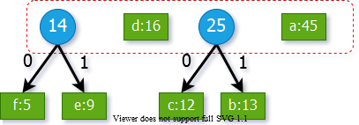

center h:350px

## Constructing a Huffman Code - **Example**

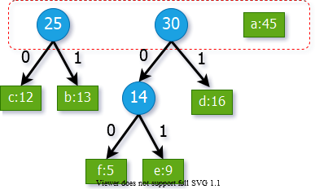

bg right:50% h:350px

## Constructing a Huffman Code - **Example**

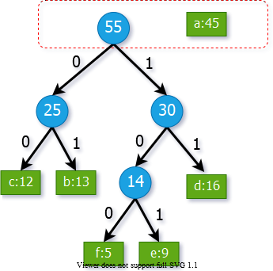

bg right:50% h:600px

## Constructing a Huffman Code - **Example**

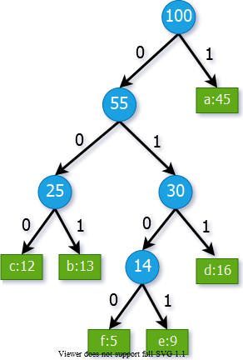

bg right:50% h:600px

## Correctness Proof of Huffman’s Algorithm

* **We need to prove:**
  + The greedy choice property
  + The optimal substructure property
* **What is the greedy step in Huffman’s algorithm?**
  + *Merging the two characters with the lowest frequencies*
* *We will first prove the greedy choice property*

## Greedy Choice Property

* **Lemma 1:** Let $x\&y$ be two characters in $C$ having the **lowest frequencies**.
* Then, $∃$ an optimal prefix code for $C$ in which the codewords for $x\&y$ have the same length and differ only in the last bit
* **Note:** *If $x\&y$ are merged in Huffman’s algorithm, their codewords are guaranteed to have the same length and they will differ only in the last bit*.
  + *Lemma 1* states that there exists an optimal solution where this is the case.

## Greedy Choice Property - Proof

* Outline of the proof:
  + Start with an arbitrary optimal solution
  + Convert it to an optimal solution that satisfies the greedy choice property.
* **Proof:** Let $T$ be an arbitrary optimal solution where:
  + $b\&c$ are the sibling leaves with the **max depth**
  + $x\&y$ are the characters with the **lowest frequencies**

## Greedy Choice Property - Proof

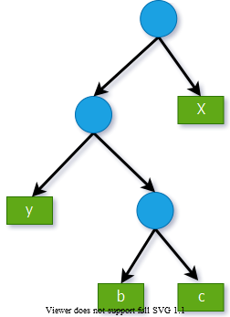

bg right:50% h:600px

* Reminder:
  + $b\&c$ are the nodes with max depth
  + $x\&y$ are the nodes with min freq.
* Without loss of generality, assume:
$f\left(x\right)≤f\left(y\right)$

$f\left(b\right)≤f\left(c\right)$

* Then, it must be the case that:

$f\left(x\right)≤f\left(b\right)$

$f\left(y\right)≤f\left(c\right)$

## Greedy Choice Property - Proof

* $T⇒T′$: exchange the positions of the leaves $b\&x$
* $T′⇒T″$: exchange the positions of the leaves $c\&y$

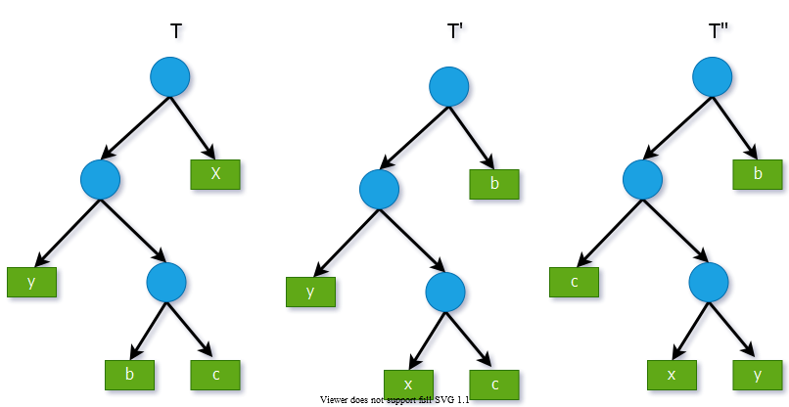

center h:400px

## Greedy Choice Property - Proof

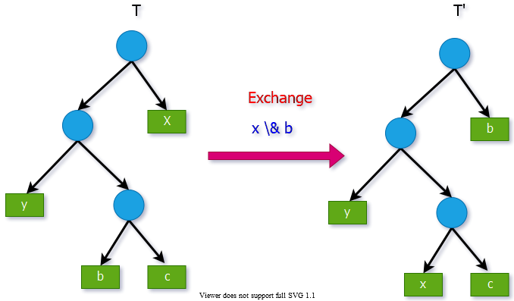

center h:500px

## Greedy Choice Property - Proof

* **Reminder:** Cost of tree $T′$


* How does $B\left(T′\right)$ compare to $B\left(T\right)$?
* **Reminder: $f\left(x\right)≤f\left(b\right)$**
  + $d_{T′}\left(x\right)=d_{T}\left(b\right)$ and $d_{T′}\left(b\right)=d_{T}\left(x\right)$

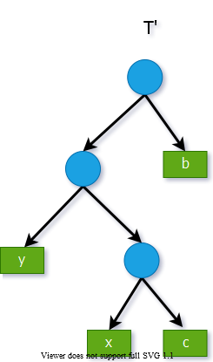

bg right:50% h:500px

## Greedy Choice Property - Proof

* **Reminder: $f\left(x\right)≤f\left(b\right)$**
  + $d_{T′}\left(x\right)=d_{T}\left(b\right)$ and $d_{T′}\left(b\right)=d_{T}\left(x\right)$
* The difference in cost between $T$ and $T′$:



## Greedy Choice Property - Proof

$$\begin{matrix}B\left(T\right)−B\left(T′\right)=\left(f\left[b\right]−f\left[x\right]\right)\left(d_{T}\left(b\right)+d_{T}\left(x\right)\right)\end{matrix}$$

* Since $f\left[b\right]−f\left[x\right]≥0$ and $d_{T}\left(b\right)≥d_{T}\left(x\right)$
  + therefore $B\left(T′\right)≤B\left(T\right)$
* In other words, $T′$ is also optimal

## Greedy Choice Property - Proof

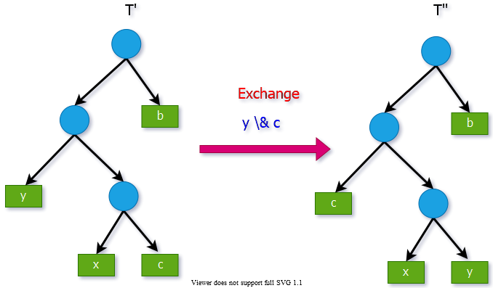

center h:450px

## Greedy Choice Property - Proof

* We can similarly show that
 $B\left(T′\right)−B\left(T″\right)≥0⇒B\left(T″\right)≤B\left(T′\right)$

 + which implies $B\left(T″\right)≤B\left(T\right)$
* Since $T$ is optimal $⇒B\left(T″\right)=B\left(T\right)⇒T″$ is also optimal
* **Note: $T″$** contains our greedy choice:
  + Characters $x\&y$ appear as sibling leaves of max-depth in $T″$
* Hence, the proof for the greedy choice property is complete

## Greedy-Choice Property of Determining an Optimal Code

* **Lemma 1** implies that
  + process of building an optimal tree
  + by mergers can begin with the greedy choice of merging
  + those two characters with the lowest frequency
* We have already proved that, that is,
  + the total cost of the tree constructed
  + is the **sum** of the **costs** of its **mergers** (**internal nodes**) **of all possible mergers**
* At each step **Huffman chooses** the merger that incurs the **least cost**

## Optimal Substructure Property

* Consider an optimal solution $T$ for alphabet $C$. Let $x$ and $y$ be any two sibling leaf nodes in $T$. Let $z$ be the parent node of $x$ and $y$ in $T$.
* Consider the subtree $T′$ where $T′=T–\{x,y\}$.
  + Here, consider z as a new character, where
$f\left[z\right]=f\left[x\right]+f\left[y\right]$

* **Optimal substructure property: $T′$** must be optimal for the alphabet $C′$, where $C′=C–\{x,y\}∪\{z\}$

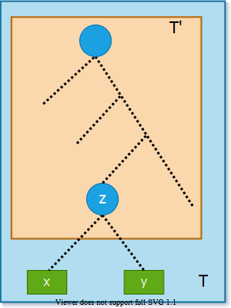

bg right:30% h:500px

## Optimal Substructure Property - Proof

Reminder:



Try to express $B\left(T\right)$ in terms of $B\left(T′\right)$.

**Note:** All characters in $C′$ have the same depth in $T$ and $T′$.



$$B\left(T\right)=B\left(T′\right)–cost\left(z\right)+cost\left(x\right)+cost\left(y\right)$$

bg right:30% h:500px

## Optimal Substructure Property - Proof

Reminder:





$$\begin{matrix}B\left(T\right) & =B\left(T′\right)–cost\left(z\right)+cost\left(x\right)+cost\left(y\right) \\ & =B\left(T′\right)−f\left[z\right].d_{T}\left(z\right)+f\left[x\right].d_{T}\left(x\right)+f\left[y\right].d_{T}\left(y\right) \\ & =B\left(T′\right)−f\left[z\right].d_{T}\left(z\right)+\left(f\left[x\right]+f\left[y\right]\right)\left(d_{T}\left(z\right)+1\right) \\ & =B\left(T′\right)−f\left[z\right].d_{T}\left(z\right)+f\left[z\right]\left(d_{T}\left(z\right)+1\right) \\ & =B\left(T′\right)−f\left[z\right]\end{matrix}$$

$$\begin{matrix}d_{T}\left(x\right)=d_{T}\left(z\right)+1 \\ d_{T}\left(y\right)=d_{T}\left(z\right)+1\end{matrix}$$

$$\begin{matrix}B\left(T\right)=B\left(T′\right)+f\left[x\right]+f\left[y\right]\end{matrix}$$

bg right:30% h:500px

## Optimal Substructure Property - Proof

* We want to prove that $T′$ is optimal for
$C′=C–\{x,y\}∪\{z\}$

* Assume by contradiction that that there exists another solution for $C′$ with smaller cost than $T′$. Call this solution $R′$:
$B\left(R′\right)<B\left(T′\right)$

* Let us construct another prefix tree $R$ by adding $x\&y$ as children of $z$ in $R′$



$$\begin{matrix}B\left(T\right)=B\left(T′\right)+f\left[x\right]+f\left[y\right]\end{matrix}$$

bg right:30% h:500px

## Optimal Substructure Property - Proof

* Let us construct another prefix tree $R$ by adding $x\&y$ as children of $z$ in $R′$.
* We have:
$B\left(R\right)=B\left(R′\right)+f\left[x\right]+f\left[y\right]$

* In the beginning, we assumed that:
$B\left(Rʹ\right)<B\left(T′\right)$

* So, we have:

$B\left(R\right)<B\left(T′\right)+f\left[x\right]+f\left[y\right]=B\left(T\right)$

**Contradiction! Proof complete**



bg right:30% h:500px

## Greedy Algorithm for Huffman Coding - Summary

* For the greedy algorithm, we have proven that:
  + **The greedy choice property** holds.
  + **The optimal substructure property** holds.
* So, the greedy algorithm is optimal.

## References

* [Introduction to Algorithms, Third Edition | The MIT Press](https://mitpress.mit.edu/books/introduction-algorithms-third-edition)
* [Bilkent CS473 Course Notes (new)](http://nabil.abubaker.bilkent.edu.tr/473/)
* [Bilkent CS473 Course Notes (old)](http://cs.bilkent.edu.tr/~ugur/teaching/cs473/)

$−End−Of−Week−9−Course−Module−$